Pattern | Sample Image | Average Picture Level (APL) | Usage | Advantages | Disadvantages
3-Bar Video Signal |  | 50% | - Has been the default luminance test pattern for the display industry  - Initially developed for use with CRT displays | - Already referenced by ENERGY STAR, CEC and IEC  - Pattern widely available on DVD or Blu-ray test discs  - Common sense appeal – midway between full white and full black | - APL higher than typical TV program content  - No reference point for vertical centering  - Forces plasma displays into a power limiting state, producing a lower luminance level than with test patterns with lower APLs  - Industry experts recommend moving to a pattern more representative of broadcast content  - IEC is considering moving to a new test pattern in the next revision of 62087  - Static pattern – not representative of dynamic video typical of TV program content
9-Point Video Signal |  | 17% | - Used by Chinese TV test procedure and ISO/IEC test procedure for front projectors | - Arguably, achieves more accurate absolute measurements for plasmas  - White target is in the middle of screen | - As part of a luminance ratio may disproportionately disadvantage some plasmas  - APL lower than typical TV program content  - Static pattern – not representative of dynamic video typical of TV program content
DOE 5-Point Video Signal |  | 34% | - Developed by DOE as part of this proposed test procedure | - APL of typical broadcast content  - White target is in the middle of screen  - Similar in appearance to an available VESA 5-point pattern (RT01BN) | - Static pattern – not representative of dynamic video typical of TV program content
Dynamic Video Signal | 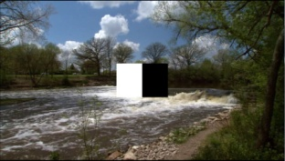 | ~34% | - In development by DOE and IEC as part of this proposed test procedure and IEC’s next update | - APL of typical broadcast content  - Not a static image – representative of dynamic video typical of TV program content  - May be taken forward by IEC and become part of IEC 62087 update. | - Pattern not yet finalized by DOE and IEC  - Measurement procedure yet to be determined

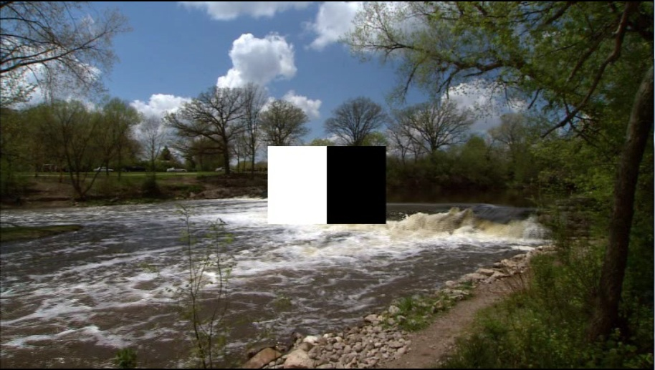

This pattern was created using the IEC 62087 2008 test clip with black and white squares in the center of the screen as measurement points.

