**Room Illuminance Measurements During TV Viewing: Pilot Study**

U.S. Department of Energy

August 31, 2011

**Background and Introduction**

It is increasingly common for televisions and computer monitors to include a feature called automatic brightness control (ABC). This feature is intended to adjust screen luminance (cd/m2) in response to changes in room illuminance (lux). The principle behind ABC is straightforward: all other things being equal, any display’s picture will consume less energy and look better to the eye[1] if its brightness is scaled in some fashion to the amount of ambient light in the room. This minimizes the need for the eye to adjust rapidly to large changes in lighting levels from one part of the field of view to another.

In order to determine appropriately representative illuminance levels, it is helpful to understand the range of illuminance values observed in the places where people watch television (TV). There are currently only limited data available concerning room illuminance levels. Two key questions on this topic could benefit from further in-field data and analysis:

* The **first question** is whether and to what extent illuminance levels in a room vary depending on where the illuminance measurements are taken in a given room (e.g. in the center of the room, on the couch, or at the TV).Various measurements are taken to determine if there are **variations in illuminance levels across a room**. *These variations are assessed using one-time static measurements taken at different locations in the room*.
* The **second** **question** is which illuminance conditions are prevalent when people watch TV. Various measurements are also taken to determine **TV viewing illuminance levels**. *These viewing levels are**assessed by continuously recording light levels at the TV and simultaneously recording TV on-times over an extended period of time (e.g. a week or more)*.

DOE has taken room illuminance measurements as part of a nine-home pilot study, the results of which are set out in this document. Although the study has all the usual limitations of a small pilot study (sample size, time duration, seasonality, geography, multiple measurers, etc.), it has, nonetheless, yielded useful results. DOE further notes that although the first question is valuable in addressing the method for measuring room illuminance of ABC-enabled TVs, answering the second question (by measuring illuminance levels at the TV over time) is important in determining the room illuminance levels at which ABC-enabled TVs should be measured.

The following section summarizes the results from the two types of measurements DOE has taken. The subsequent section sets out the methodologies used. The next two sections set out the actual measurement results taken in the nine homes. Additional data from the TV viewing illuminance level measurements are presented in the Appendix.

**Executive Summary**

DOE took one-time static room illuminance measurements at different locations in TV viewing rooms, as well as recorded light levels continuously at the TV simultaneously with TV power (to determine on-mode operation as defined by IEC 62087-2011), in nine households for a week or more over a 4-week period from mid-May to mid-June 2011.

A total of 144 **static** room illuminance measurements were made, ranging from 1 to 347 lux, with a mean of 85 lux and a median of 46 lux.

A total of 95 **TV viewing session[2]** room illuminance measurements were made, ranging in duration from 10 minutes to over 5 hours. Thirty-one, or about one-third, of the TV viewing sessions took place during the day (defined as 6 am to 6 pm), and 64, or about two-thirds, were at night (6 pm to 6 am). For daytime measurements, the range of room illuminance was 0 to 499 lux, with a mean of 116 lux and a median of 81 lux, whereas for nighttime measurements, the range was 0 to 106 lux, with a mean of 19 lux and a median of 12 lux. Across all room illuminance measurements, the mean was 51 lux and the median was 17 lux.

While limited, the TV viewing session data were sufficient to sample a variety of times of day, viewing durations and room illuminance conditions. For many households, data showed repetitive patterns of TV room illuminance (similar times of day, duration and room illuminance levels), indicating that with more extended measurement duration, average behavior might be captured. The data indicate that approximately two-thirds of TV viewing sessions take place in the evenings, when outdoor light levels are very low or zero. Despite the observation that some people actively increase light levels when watching TV (presumably by turning on room lights), average nighttime room illuminance levels were significantly lower than during daytime. About 86 percent of TV room illuminance measurements were less than 100 lux.

Room illuminance levels at which ABC is measured (ABC levels) need to both span the range of levels at which people watch TV as well as focusing on the levels at which TV is most frequently viewed. The limited data available suggest that hardly any viewing occurs at 0 lux, but a large proportion of viewing instances (more than 50 percent) occur at or under 20. The data further suggest little viewing occurs above 200 lux (about 5 percent), but that 300 lux seems to be a mid-point representation of the upper end of the scale. In between these two points, significant viewing occurs between 20 and 200 lux. These data suggest that approximately 5% of all TV viewing sessions occur between 0 and 1 lux, 50% between 1 and 20 lux, 20% between 20 and 50 lux, 20% between 50 and 200 lux, and 5% above 200 lux. See Figure S1 for an illustration of these levels.

Time-of-day viewing data is set out in Figures S2 and S3.

**Figure S1. Cumulative Distribution of Average TV Viewing Session Room Illuminances, with Colored Bands Indicating Candidate Illuminance Level.** (Note logarithmic horizontal axis; 0 lux measurements ignored).

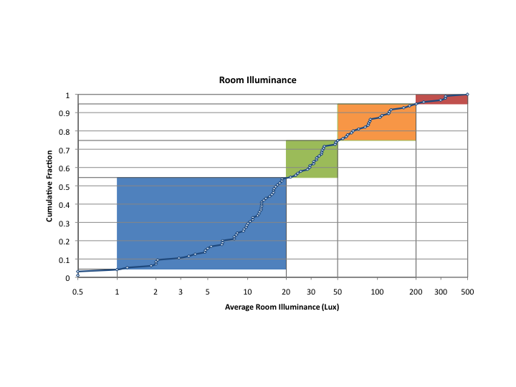

**Figures S2 and S3. Average Session Room Illuminance of TV Viewing Sessions. S2 (left) Split and S3 (right) stacked by time of day for comparison.**

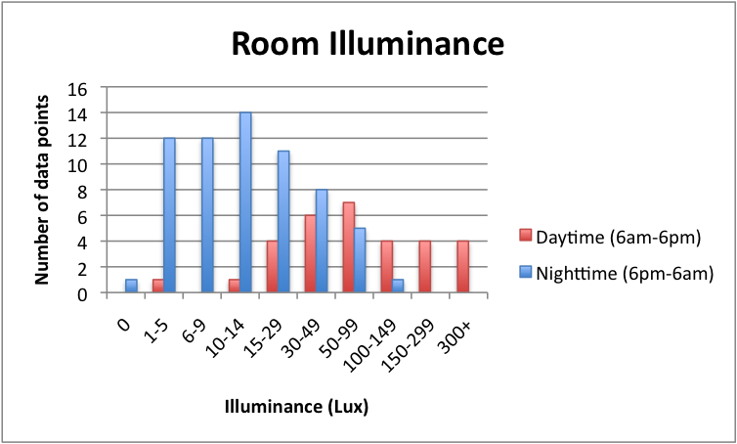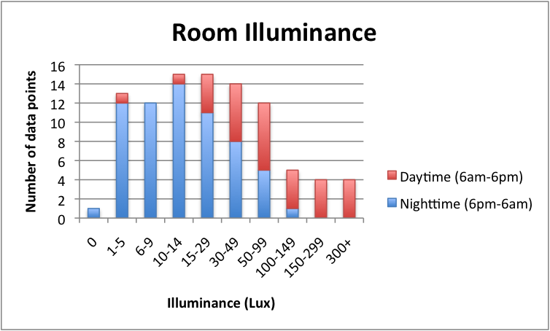

Many more measurements are necessary to firmly establish the average and range of room illuminance levels in U.S. homes. Measurements of the same households multiple times throughout a calendar year are probably also necessary, in order to capture variations in room illuminance (and possible user behavior) in different seasons.

**Methodology**

The methodology outlined below was adopted to distinguish between illuminance levels found generally in a room in which a TV is found, as compared to the conditions in that room when the TV is actually being viewed. These conditions can vary widely (see Results section below), depending on the degree to which sunlight enters the room. TV watchers can modify room illuminance levels before watching TV, by adjusting window shades or artificial light sources, or both. In order to obtain meaningful results applicable to TV viewing conditions, this study measured room illuminance with room lighting conditions set up by viewers the way that they are when the TV is being watched (sometimes coordinating the correct time of day). This study also measured room illuminance levels and TV power consumption simultaneously (to determine when the TV is on) for an extended period of time (e.g., a week or two) and correlated the data. The resulting data are useful to assist in determining which illuminance conditions are most prevalent when people watch TVs as well as the overall range of illuminance levels at which people commonly watch TVs. Measurements were taken at the participants’ homes in the primary room where the TV is watched. The general characteristics of the room and the TV were recorded (such as brand, screen size, year, and technology type).

For the measurement of **static room illuminance levels**, the participants were asked to set the room to the typical lighting conditions they use to watch the TV for the time of day that the measurements were being conducted. Light meters (Professional Measurement LX-1128SD) were placed under various lighting conditions (roughly 50% daytime and 50% nighttime) at five different positions (defined as A through E in Figure 1 and Figure 2 below, adapted from Leslie & Conway, 1993[3]). The measurements were taken with the illuminance meter facing upward (toward the ceiling) and, where possible, on a tripod, at locations **A**, **B**, and **C**, and facing outward (in the same direction as the TV screen, towards the viewer) at locations marked **D** and **E.** Locations **A** through **E** correspond to the following generic room locations:

* **A** was the center of the room, which was found by the point at which two tightly stretched strings secured to the corners of the room cross. The height was be 45 inches above the floor – the approximate height of a typical seated TV viewer’s eyes.
* **B** was the primary viewer’s seated location, centered left/right relative to the TV’s location and measured 45 inches above the floor.
* **C** was centered on the top of the TV cabinet
* **D** was the center of the TV screen
* **E** was the position of the TV’s ABC light sensor, if available. In most cases, this was near the lower left or lower right corner of the TV’s cabinet, on the front side. If a light sensor was not present the measurement was done on the bezel (edge of TV) on either lower corner of the TV. The meter was placed in a manner so as not to interfere with the operation of the ABC light sensor itself, if ABC was enabled on the TV.

A simple sketch, similar to Figure 2, was drawn for each room, indicating room dimensions, the locations of the TV, main seating area, windows, and artificial light sources, the artificial light source type (halogen, CFL, etc) and rated wattages. Locations A, B, C, D and E were marked on that sketch. Geographic location, TV diagonal screen size (in inches), and other TV characteristics (e.g., brand, year, technology type) were also recorded. For each set of test conditions, the measured illuminance values in positions A through E were recorded, along with the times and dates of each measurement, outdoor lighting conditions, window shade position and lighting conditions of the room. Any other factors that may have an influence on the illuminance level were also be recorded.

Figure 1. Three Dimensional Illumination of a Typical Living Room Illustrating Points D and E for Illuminance Measurement

**D**

**E**

Figure 2. Floor Plan View/View from Above of a Typical Living Room Illustrating Points A, B and C for Illuminance Measurement



**B**

**A**

**C**

For rooms with windows or receiving daylight from an adjacent room, least two sets of measurements were made: one on a sunny day and one at night. Where possible, the measurements were repeated under different outdoor lighting conditions (e.g., sunny, overcast), with blinds open and closed, with room lighting on and off, and with the TV on and off[4] to note how the measured values changed.

The measurements were taken in a way that ensured that the measurement technique had no significant influence on the measurement values. The most common unwanted influence was in darker rooms where the person doing the measurement had the potential to affect the measurement by causing shadowing over the sensor or reflecting light into the sensor. For the purposes of this study a significant effect is considered to be a 10% variation between actual illuminance and measured illuminance. The use of a tripod and/or a remote sensor, where possible, helped to achieve this condition.

For measurement of **TV viewing session room illuminance levels**, light meters were installed on the lower bezel of TVs with the aperture plane parallel to the TV screen, corresponding to position E. A power meter (Electronic Educational Devices WattsUp Pro) was installed on the TV to simultaneously measure when the TV was on. Participants were instructed to light their rooms normally when using their TVs. Both meters were set to record data averaged over 10-minute intervals, in order to make several measurements of room illuminance during a typical TV viewing session.

Meters were retrieved after a minimum period of approximately one week for data download and analysis, and some households metered for two, closely-spaced one week periods. The minimum of one week was chosen in order to capture both weekday and weekend viewing activity. The short duration of this pilot study did not allow for several weeks of data to be collected, which would have captured important variations in occupant schedules and natural light conditions (ideally, such a study would have been conducted repeatedly throughout a calendar year in order to capture variations in room illuminance in different seasons).

TV viewing sessions were defined as periods when TV electrical power exceeded the standby threshold for the TV, which was easily discernible from the data. The minimum, maximum and mean illuminance levels were calculated separately for each defined viewing session. In order to identify TV viewing sessions in the light meter data accurately, the internal clocks of the illuminance meter and the power meter were synchronized to less than half the metering interval. The clocks were also synchronized to within a few minutes of the local time, in order to facilitate time-of-day analysis of light levels and viewing habits. These illuminance and power data then form the event history of a household.

Basic demographic information, such as the number and ages of household occupants, and the room in which the TV screen is located was collected. Screen size, technology (CRT, LCD, etc.), year of manufacture, brand and model number were also recorded. The general geographic location was noted to enable investigation of regional differences. See Table 1.

**Results**

Basic information about the nine households involved in this pilot study is set out in Table 1 below. The following two sections describe the results from each of the two types of measurements:

1. **Variation in illuminance levels across a room** – assessed using one-time static measurements taken at different locations in the room; and
2. **TV viewing illuminance levels** – assessed by continuously recording light levels at the TV and simultaneously recording TV on-times over an extended period of time (e.g., a week or more).

**Table 1. Basic household and TV information**

|  |  |  |  |  |  |  |  |  |  |  |  |  |
| --- | --- | --- | --- | --- | --- | --- | --- | --- | --- | --- | --- | --- |
| **House-hold #** | **Year manuf'd** | **Screen size (diag. in.)** | **Tech-nology type** | **Room in home** | **State** | **Number of Full-Time Occupants** | | | | | | |
| **Total** | **Pre-School Children (ages 0-5)** | **Children (ages 6-11)** | **Teen-agers (ages 12-17)** | **Young Adults (ages 18-34)** | **Middle-Aged Adults (ages 35-64)** | **Seniors (ages 65+)** |
| 1 | 2009 | 32 | LCD | Living room | CA | 3 | 0 | 1 | 0 | 0 | 2 | 0 |
| 2 | 2010 | 40 | LCD | Living room | CA | 2 | 0 | 0 | 0 | 2 | 0 | 0 |
| 3 | 2002 | 32 | CRT | Living room | CA | 3 | 1 | 0 | 0 | 2 | 0 | 0 |
| 4 | 2009 | 32 | LCD | Living room | CO | 3 | 0 | 0 | 0 | 1 | 1 | 1 |
| 5 | 2002 | 57 | Projection | Living room | CO | 4 | 0 | 0 | 2 | 0 | 2 | 0 |
| 6 | 2009 | 40 | LCD | Living room | CO | 2 | 0 | 0 | 0 | 0 | 2 | 0 |
| 7 | 2001 | 20 | CRT | Living room | CA | 3 | 1 | 0 | 0 | 2 | 0 | 0 |
| 8 | 2009 | 55 | LED LCD | Game room | CO | 2 | 0 | 0 | 0 | 0 | 2 | 0 |
| 9 | 2009 | 46 | LED LCD | Living room | CO | 2 | 0 | 0 | 0 | 0 | 2 | 0 |

1. **Static Room Illuminance Measurements: measuring variation in illuminance levels across a room**

Table 2 summarizes static room illuminance measurements, and Table 3 provides all measurements taken along with averages and summary statistics. The mean and median room illuminance measurements, when taking static measurements, were 85 lux and 46 lux, respectively. The mean and median room illuminance measurements at position E were 66 lux and 24 lux, respectively, somewhat less than the overall values.

**Table 2. Basic information for Static Room Illuminance Measurements**

|  |  |
| --- | --- |
| Number of households | 9 |
| Number of measurements | 144 |
| Average number of measurements per household | 16 |
| Diagonal screen size range | 20” to 57” |
| Average room illuminance | 46 lux (median), 85 lux (mean) |

**Table 3. Static Room Illuminance Measurements**

|  |  |  |  |  |  |  |  |  |  |  |  |  |
| --- | --- | --- | --- | --- | --- | --- | --- | --- | --- | --- | --- | --- |
| **Household #** | **Date in 2011** | **Time** | **Outside light conditions** | **Blinds** | **Room lighting** | **TV** | **Lux at location A (center of room)** | **Lux at location B (viewing position)** | **Lux at location C (top center of TV display)** | **Lux at location D (center of TV display)** | **Lux at location E (TV display light sensor)** | **Mean** |
| 1 | 5/17 | 18:00 | overcast | closed | off | off | 8 | 36 | 12 | 19 | 18 | 19 |
| 1 | 5/17 | 18:00 | overcast | closed | on | off | 122 | 41 | 51 | 21 | 31 | 53 |
| 1 | 5/17 | 18:00 | overcast | closed | on | on | n/a | n/a | n/a | n/a | 31 | 31 |
| 1 | 5/17 | 18:00 | overcast | open | off | off | 16 | 134 | 32 | 96 | 104 | 76 |
| 2 | 5/20 | 21:30 | dark | closed | on | off | 26 | 24 | 17 | 12 | 13 | 18 |
| 2 | 5/30 | 14:50 | sunny | closed | off | off | 78 | 86 | 47 | 25 | 24 | 52 |
| 2 | 5/30 | 15:00 | sunny | closed | off | on | 79 | 75 | 46 | 25 | 37 | 52 |
| 2 | 5/30 | 15:00 | sunny | open | off | on | 339 | 347 | 111 | 94 | 154 | 209 |
| 2 | 5/30 | 15:00 | sunny | open | off | off | 340 | 346 | 115 | 95 | 157 | 211 |
| 3 | 5/25 | 20:39 | dark | closed | on | on | 20 | 50 | 15 | 15 | n/a | 25 |
| 3 | 6/4 | 15:22 | light overcast | closed | off | off | 71 | 120 | 52 | 58 | n/a | 75 |
| 4 | 5/26 | 17:00 | sunny | open | off | off | 43 | 35 | 23 | 40 | 39 | 36 |
| 4 | 6/2 | 21:35 | dark | closed | on | on | 4 | 8 | 1 | 3 | 3 | 4 |
| 5 | 5/26 | 18:45 | Sunny | Open | Off | On | 88 | 110 | 33 | 128 | 87 | 89 |
| 5 | 5/26 | 21:05 | Dark | Closed | On | On | 10 | 9 | 5 | 9 | 9 | 8 |
| 5 | 6/2 | 7:45 | Sunny | Open | Off | Off | 54 | 74 | 12 | 31 | 31 | 40 |
| 5 | 6/9 | 19:00 | sunny | open | off | on | 72 | 67 | 30 | 115 | 10 | 59 |
| 5 | 6/9 | 22:30 | dark | open | on | on | 4 | 76 | 5 | 8 | 9 | 20 |
| 5 | 6/9 | 7:30 | sunny | open | off | on | 90 | 60 | 40 | 155 | 155 | 100 |
| 6 | 5/23 | 17:00 | sunny | open | off | on | 215 | 230 | 289 | 259 | 286 | 256 |
| 6 | 5/23 | 21:00 | dark | closed | on | on | 22 | 29 | 10 | 9 | 11 | 16 |
| 6 | 5/23 | 17:00 | sunny | open | off | on | 215 | 230 | 289 | 259 | 286 | 256 |
| 6 | 5/23 | 21:00 | dark | closed | on | on | 22 | 29 | 10 | 9 | 11 | 16 |
| 7 | 6/3 | 21:30 | dark | open | on | on | 17 | 22 | 10 | 17 | 15 | 16 |
| 7 | 6/4 | 12:30 | overcast | open | off | off | 310 | 345 | 333 | 258 | 220 | 293 |
| 8 | 6/9 | 19:00 | sunny | open | off | off | n/a | 196 | n/a | n/a | n/a | 196 |
| 8 | 6/10 | 8:00 | sunny | open | off | off | n/a | 146 | n/a | 112 | n/a | 129 |
| 9 | 6/16 | 18:00 | sunny | open | off | off | 325 | 300 | n/a | n/a | n/a | 313 |
| 9 | 6/16 | 18:00 | sunny | closed | off | off | 38 | 38 | 12 | 12 | 12 | 22 |
| 9 | 6/16 | 21:00 | dark | closed | on | on | 25 | 39 | 11 | 11 | 11 | 19 |
| 9 | 6/16 | 21:00 | dark | closed | on | off | 24 | 38 | 12 | 12 | 11 | 19 |
| 9 | 6/16 | 21:00 | dark | closed | off | on | 3 | 1 | 1 | 1 | 1 | 1 |
|  |  |  |  |  |  |  |  |  |  |  |  |  |
| Mean |  |  |  |  |  |  | 92 | 108 | 58 | 66 | 66 | 85 |
| Median |  |  |  |  |  |  | 43 | 67 | 20 | 25 | 24 | 46 |
| Minimum |  |  |  |  |  |  | 3 | 1 | 1 | 1 | 1 | 1 |
| Maximum |  |  |  |  |  |  | 340 | 347 | 333 | 259 | 286 | 313 |

1. **TV Viewing Session Room Illuminance Measurements: measuring TV viewing illuminance levels**

Table 4 summarizes results of the TV viewing session room illuminance measurements, Table 5 provides a breakdown of each viewing session recorded, and Figures 1-9 summarize results in various ways.

Figure 3 and Figure 4show the number of TVs by screen size and technology type, respectively.

Figure 5 shows the distribution of TV viewing session durations, ranging from 10 minutes to more than 5 hours, with an average of approximately 1.5 hours. There appeared to be a higher frequency of long TV viewing sessions (>3 hours) in the evening (defined as 6 pm to 6 am), and a higher frequency of short TV viewing sessions (< 1 hour) during the day.

Figure 6 to Figure 8 show that approximately two-thirds of viewing sessions took place in the evening, with mean light levels much lower during evening (19 lux) than during the day (116 lux). Viewing session room illuminance varied from 0 to almost 500 lux. As mentioned below, room illuminance at other times (e.g., when TV was off) varied up to nearly 1,000 lux.

Figure 9 shows all TV viewing session measurements ordered by room illuminance to create a cumulative probability distribution. Because measurements are concentrated at low lux levels (Figure 9-A), the data are also plotted logarithmically (Figure 9-B) to make these low lux measurements more discernible. A logarithmic representation also more accurately reflects the way the eye perceives illuminance, e.g., a change from 10 to 20 lux is perceived as approximately the same increase in relative brightness as a change from 100 to 200 lux. The point at which the cumulative probability reaches 50 percent indicates the median room illuminance level (17 lux). One sees that about 30 percent of the measurements were less than 10 lux, and 86 percent of TV room illuminance measurements were less than 100 lux.

Figure 10 shows example time series room illuminance data for four households, illustrating how room illuminance varies over the course of several days. For some households, room illuminance varied up to nearly 1,000 lux when the TV was off (e.g., Figure 10-A). In Figure 10-B, both room illuminance and TV power are shown to illustrate how the coincident data is used to identify TV viewing sessions. Appendix A shows the remaining time series data not depicted in Figure 10.

From the time series data shown in Figure 10, we see that some viewers actively increased room illuminance levels when watching TV, presumably by turning on lights (e.g., Figure 10-B and Figure 10-D). However, despite this tendency, mean nighttime room illuminance levels were significantly lower than during the daytime. We did not, however, detect decreases in daytime room illuminance during TV viewing in any of the time series.

Figure 11 shows time series room illuminance data for one household, plotted so that each day is aligned over the same 24-hour period to highlight daily variations in viewing times and illuminance levels. One sees clearly, for instance, frequent nighttime TV viewing accompanied by increases in room illuminance (e.g., switching on lights).

**Table 4. Basic Information for TV Viewing Session Room Illuminance Measurements**

|  |  |
| --- | --- |
| Number of households | 9 |
| Number of viewing sessions | 95 |
| Average number of sessions per household | 10.6 |
| Period of metering | 5/18/11 to 6/17/11 (varied with household) |
| Average period of metering | 11 days (median), 12 days (mean) |
| Diagonal screen size range | 20” to 57” |
| Viewing duration range | 0:10 to 5:30 |
| Average viewing duration | 1:30 (median), 1:42 (mean) |
| Average viewing time of day | 7:29 pm (median), 4:19 pm (mean) |
| Number of daytime sessions (6am-6pm) | 31 |
| Number of nighttime sessions (6pm-6am) | 64 |
| Average daytime room illuminance | 81 (median), 116 lux (mean) |
| Average nighttime room illuminance | 12 (median), 19 lux (mean) |
| Average room illuminance | 17 lux (median), 51 lux (mean) |
| Daytime room illuminance range | 0 to 499 lux |
| Nighttime room illuminance range | 0 to 106 lux |

**Table 5. TV viewing session room illuminance measurements**

|  |  |  |  |  |  |  |  |  |
| --- | --- | --- | --- | --- | --- | --- | --- | --- |
| **Household #** | **Session #** | **Start date** | **Start time** | **Duration** | **Average time** | **Mean lux** | **Min lux** | **Max lux** |
| 1 | 1 | 5/18/11 | 21:00 | 0:50 | 21:25 | 1 | 0 | 4 |
| 1 | 2 | 5/20/11 | 18:52 | 2:00 | 19:52 | 19 | 5 | 45 |
| 1 | 3 | 5/27/11 | 19:41 | 2:00 | 20:41 | 13 | 0 | 66 |
| 1 | 4 | 5/28/11 | 17:42 | 3:00 | 19:12 | 106 | 1 | 279 |
| 1 | 5 | 6/4/11 | 17:24 | 0:40 | 17:44 | 338 | 164 | 585 |
| 1 | 6 | 6/6/11 | 18:44 | 0:40 | 19:04 | 4 | 4 | 4 |
| 2 | 1 | 5/20/11 | 23:41 | 0:50 | 0:06 | 14 | 12 | 16 |
| 2 | 2 | 5/21/11 | 17:32 | 0:20 | 17:42 | 14 | 12 | 15 |
| 2 | 3 | 5/22/11 | 11:23 | 2:50 | 12:48 | 24 | 16 | 29 |
| 2 | 4 | 5/22/11 | 19:03 | 1:30 | 19:48 | 7 | 2 | 11 |
| 2 | 5 | 5/23/11 | 21:05 | 1:40 | 21:55 | 13 | 11 | 16 |
| 2 | 6 | 5/24/11 | 8:15 | 0:30 | 8:30 | 73 | 48 | 114 |
| 2 | 7 | 5/24/11 | 19:06 | 2:10 | 20:11 | 4 | 1 | 9 |
| 2 | 8 | 5/25/11 | 16:57 | 0:50 | 17:22 | 34 | 31 | 37 |
| 2 | 9 | 5/25/11 | 20:37 | 3:00 | 22:07 | 16 | 15 | 17 |
| 2 | 10 | 5/26/11 | 20:28 | 2:00 | 21:28 | 16 | 16 | 16 |
| 2 | 11 | 5/27/11 | 18:39 | 1:40 | 19:29 | 11 | 1 | 22 |
| 2 | 12 | 5/27/11 | 23:40 | 1:30 | 0:25 | 16 | 16 | 17 |
| 2 | 13 | 5/28/11 | 9:40 | 1:50 | 10:35 | 66 | 56 | 84 |
| 2 | 14 | 5/28/11 | 12:00 | 1:50 | 12:55 | 48 | 32 | 58 |
| 2 | 15 | 5/28/11 | 20:11 | 0:20 | 20:21 | 17 | 16 | 17 |
| 2 | 16 | 5/29/11 | 11:02 | 3:00 | 12:32 | 30 | 34 | 27 |
| 2 | 17 | 5/30/11 | 11:13 | 2:10 | 12:18 | 60 | 50 | 65 |
| 3 | 1 | 5/26/11 | 20:09 | 0:30 | 20:24 | 12 | 9 | 14 |
| 3 | 2 | 5/27/11 | 20:15 | 1:00 | 20:45 | 8 | 0 | 14 |
| 3 | 3 | 5/29/11 | 20:13 | 2:20 | 21:23 | 13 | 4 | 14 |
| 3 | 4 | 5/31/11 | 19:59 | 0:50 | 20:24 | 2 | 0 | 5 |
| 4 | 1 | 5/26/11 | 21:17 | 1:40 | 22:07 | 10 | 3 | 21 |
| 4 | 2 | 5/28/11 | 17:17 | 1:50 | 18:12 | 35 | 22 | 66 |
| 4 | 3 | 5/28/11 | 21:37 | 2:40 | 22:57 | 3 | 3 | 3 |
| 4 | 4 | 5/29/11 | 19:47 | 1:50 | 20:42 | 6 | 2 | 14 |
| 4 | 5 | 5/30/11 | 20:07 | 2:40 | 21:27 | 2 | 1 | 6 |
| 4 | 6 | 5/31/11 | 18:07 | 0:20 | 18:17 | 25 | 23 | 27 |
| 5 | 1 | 5/26/11 | 21:43 | 2:00 | 22:43 | 8 | 0 | 11 |
| 5 | 2 | 5/27/11 | 7:43 | 1:10 | 8:18 | 161 | 109 | 208 |
| 5 | 3 | 5/28/11 | 23:53 | 0:30 | 0:08 | 5 | 1 | 10 |
| 5 | 4 | 5/29/11 | 15:33 | 0:20 | 15:43 | 87 | 81 | 92 |
| 5 | 5 | 5/29/11 | 22:43 | 0:40 | 23:03 | 11 | 10 | 11 |
| 5 | 6 | 5/30/11 | 16:53 | 5:10 | 19:28 | 38 | 1 | 81 |
| 5 | 7 | 5/31/11 | 7:43 | 0:50 | 8:08 | 39 | 99 | 195 |
| 5 | 8 | 5/31/11 | 12:33 | 0:20 | 12:43 | 81 | 80 | 83 |
| 5 | 9 | 5/31/11 | 15:13 | 0:50 | 15:38 | 89 | 82 | 98 |
| 5 | 10 | 5/31/11 | 20:33 | 2:00 | 21:33 | 10 | 0 | 12 |
| 5 | 11 | 6/1/11 | 7:43 | 1:00 | 8:13 | 125 | 59 | 158 |
| 5 | 12 | 6/1/11 | 18:53 | 3:10 | 20:28 | 13 | 9 | 27 |
| 5 | 13 | 6/10/11 | 18:24 | 3:10 | 19:59 | 64 | 2 | 151 |
| 5 | 14 | 6/11/11 | 22:04 | 0:10 | 22:09 | 13 | 13 | 13 |
| 5 | 15 | 6/12/11 | 9:44 | 0:10 | 9:49 | 337 | 337 | 337 |
| 5 | 16 | 6/14/11 | 7:24 | 1:10 | 7:59 | 201 | 142 | 259 |
| 5 | 17 | 6/14/11 | 19:04 | 3:10 | 20:39 | 33 | 1 | 95 |
| 5 | 18 | 6/15/11 | 7:34 | 1:10 | 8:09 | 230 | 165 | 292 |
| 5 | 19 | 6/15/11 | 21:34 | 1:30 | 22:19 | 12 | 0 | 16 |
| 6 | 1 | 5/26/11 | 21:00 | 3:00 | 22:30 | 2 | 0 | 10 |
| 6 | 2 | 5/27/11 | 23:50 | 0:40 | 0:10 | 2 | 0 | 8 |
| 6 | 3 | 5/28/11 | 7:50 | 0:20 | 8:00 | 88 | 81 | 91 |
| 6 | 4 | 5/28/11 | 18:40 | 5:00 | 21:10 | 55 | 10 | 218 |
| 6 | 5 | 5/29/11 | 13:00 | 2:30 | 14:15 | 31 | 5 | 166 |
| 6 | 6 | 5/29/11 | 20:30 | 3:10 | 22:05 | 33 | 25 | 35 |
| 6 | 7 | 5/30/11 | 18:40 | 1:50 | 19:35 | 38 | 0 | 105 |
| 6 | 8 | 5/31/11 | 9:30 | 1:50 | 10:25 | 110 | 2 | 243 |
| 6 | 9 | 6/10/11 | 21:30 | 0:50 | 21:55 | 1 | 0 | 6 |
| 6 | 10 | 6/11/11 | 8:50 | 0:20 | 9:00 | 36 | 19 | 61 |
| 6 | 11 | 6/11/11 | 19:50 | 4:10 | 21:55 | 16 | 0 | 178 |
| 6 | 12 | 6/12/11 | 8:50 | 0:50 | 9:15 | 0 | 0 | 1 |
| 6 | 13 | 6/12/11 | 10:00 | 0:40 | 10:20 | 17 | 1 | 22 |
| 6 | 14 | 6/12/11 | 13:50 | 0:20 | 14:00 | 123 | 119 | 131 |
| 6 | 15 | 6/12/11 | 18:40 | 4:10 | 20:45 | 15 | 0 | 28 |
| 6 | 16 | 6/13/11 | 19:40 | 2:30 | 20:55 | 5 | 3 | 11 |
| 6 | 17 | 6/14/11 | 21:10 | 2:40 | 22:30 | 0 | 0 | 0 |
| 7 | 1 | 6/7/11 | 21:16 | 1:10 | 21:51 | 10 | 9 | 10 |
| 7 | 2 | 6/8/11 | 18:07 | 4:50 | 20:32 | 29 | 10 | 102 |
| 7 | 3 | 6/9/11 | 6:37 | 0:20 | 6:47 | 26 | 21 | 32 |
| 7 | 4 | 6/10/11 | 17:29 | 3:30 | 19:14 | 58 | 11 | 206 |
| 7 | 5 | 6/11/11 | 9:20 | 2:20 | 10:30 | 179 | 87 | 253 |
| 7 | 6 | 6/11/11 | 14:30 | 0:40 | 14:50 | 499 | 483 | 509 |
| 7 | 7 | 6/12/11 | 9:11 | 1:30 | 9:56 | 129 | 86 | 165 |
| 7 | 8 | 6/12/11 | 13:11 | 5:30 | 15:56 | 310 | 53 | 509 |
| 7 | 9 | 6/12/11 | 19:11 | 1:00 | 19:41 | 38 | 22 | 50 |
| 7 | 10 | 6/13/11 | 4:12 | 0:40 | 4:32 | 5 | 4 | 5 |
| 7 | 11 | 6/13/11 | 17:33 | 4:30 | 19:48 | 39 | 10 | 181 |
| 7 | 12 | 6/14/11 | 18:34 | 0:30 | 18:49 | 50 | 48 | 53 |
| 7 | 13 | 6/14/11 | 19:44 | 1:50 | 20:39 | 19 | 10 | 37 |
| 7 | 14 | 6/15/11 | 17:05 | 3:00 | 18:35 | 86 | 23 | 286 |
| 7 | 15 | 6/16/11 | 20:56 | 1:10 | 21:31 | 11 | 11 | 12 |
| 7 | 16 | 6/17/11 | 4:37 | 0:30 | 4:52 | 5 | 4 | 5 |
| 8 | 1 | 6/11/11 | 21:06 | 2:20 | 22:16 | 10 | 0 | 14 |
| 8 | 2 | 6/13/11 | 20:16 | 1:30 | 21:01 | 18 | 10 | 33 |
| 8 | 3 | 6/15/11 | 19:36 | 1:50 | 20:31 | 48 | 0 | 168 |
| 9 | 1 | 6/9/11 | 22:25 | 0:10 | 22:30 | 1 | 0 | 1 |
| 9 | 2 | 6/10/11 | 22:25 | 2:10 | 23:30 | 7 | 0 | 12 |
| 9 | 3 | 6/12/11 | 0:15 | 1:00 | 0:45 | 8 | 0 | 12 |
| 9 | 4 | 6/13/11 | 21:15 | 1:10 | 21:50 | 13 | 12 | 15 |
| 9 | 5 | 6/13/11 | 23:45 | 1:30 | 0:30 | 9 | 0 | 12 |
| 9 | 6 | 6/15/11 | 17:45 | 0:20 | 17:55 | 22 | 17 | 28 |
| 9 | 7 | 6/16/11 | 19:45 | 1:20 | 20:25 | 8 | 1 | 39 |

Figure 3. Diagonal Screen Sizes of TVs in Households

Figure 4. Technology Type of TVs in Households

Figure 5. TV Viewing Session Duration

(A) Split by Time of Day (Daytime and Nighttime)

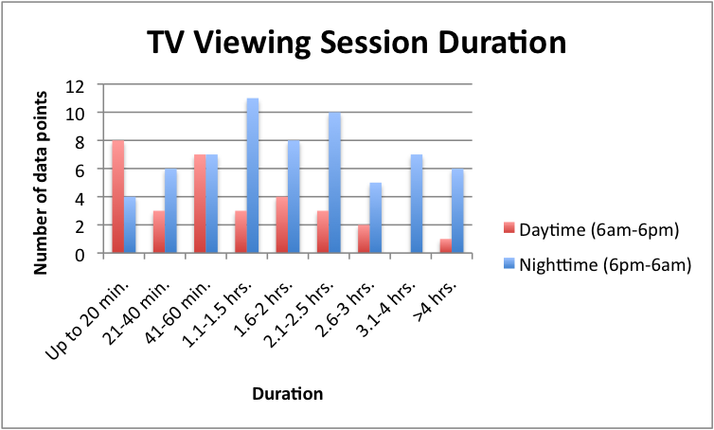

(B) Total across all measurements (stacked by Daytime and Nighttime)

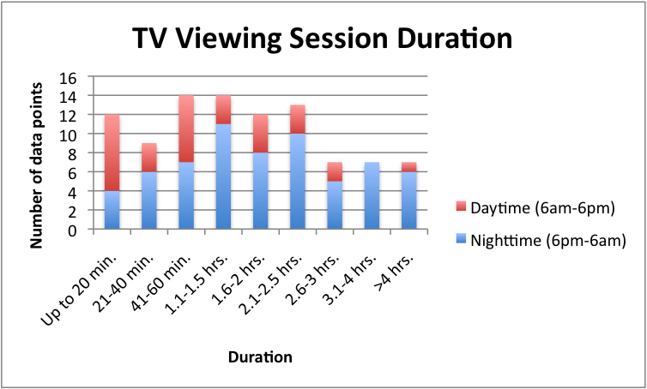

Figure 6Figure 4. Average Session Room Illuminance of TV Viewing Sessions

(A) Split by Time of Day (Daytime and Nighttime)



(B) Total across all measurements (stacked by Daytime and Nighttime)



Figure 7. Viewing Time of Day of TV Viewing Sessions

Figure 8. Average Session Room Illuminance versus Viewing Time of Day

Figure 9. Cumulative Distribution of Average TV Viewing Session Room Illuminances

(A) Absolute room illuminance cumulative distribution

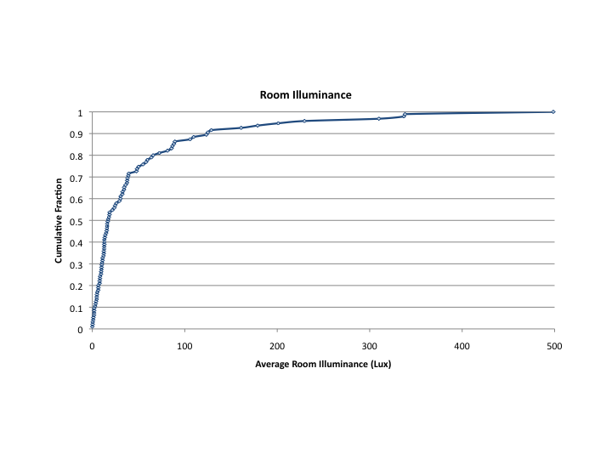

(B) Logarithmic room illuminance cumulative distribution (0 lux measurements ignored)

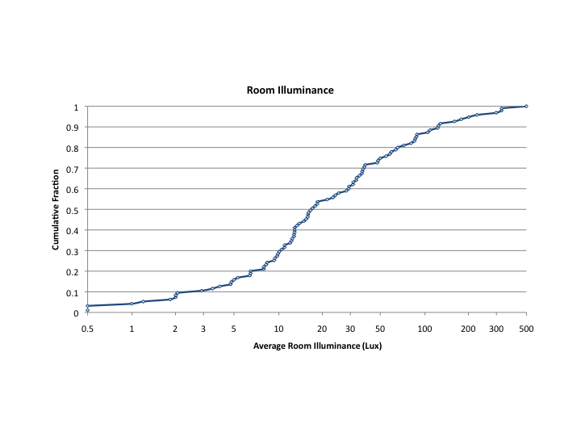

Figure 10. Room illuminance time series for selected households. Gray indicates room illuminance at all times, and black indicates illuminance during TV viewing sessions.

(A) Household 1 (first metering week): Note high room illuminance during periods when TV is off.

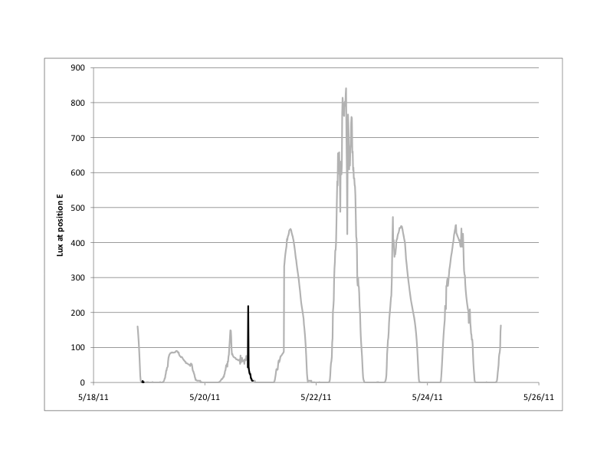

(B) Household 2. Note the evening room lighting coinciding with TV viewing most nights, with occasional viewing at other times with higher illuminance levels (presumably natural light). Shown are: (i) Room illuminance and (ii) TV power.

(i) 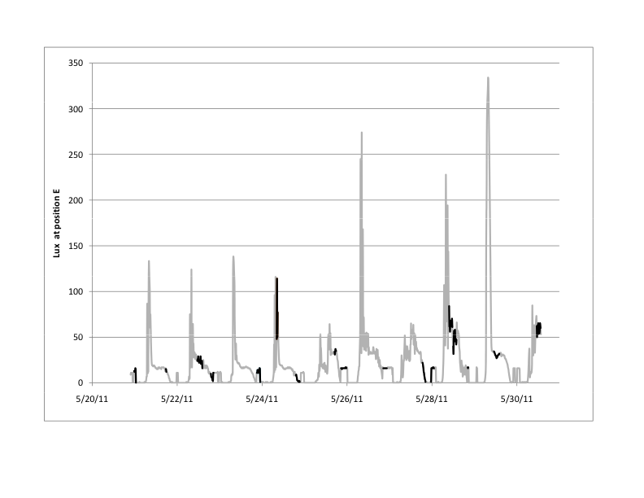

(ii) 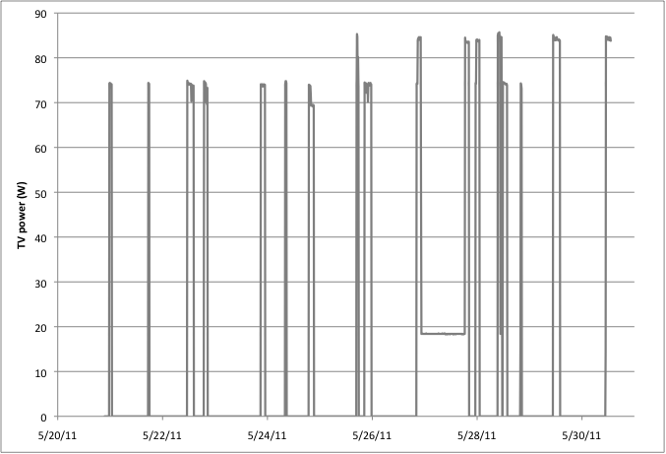(C) Household 7. In this example, viewers appear not to alter lighting when watching TV, and viewing occurs over a wide range of illuminance levels.

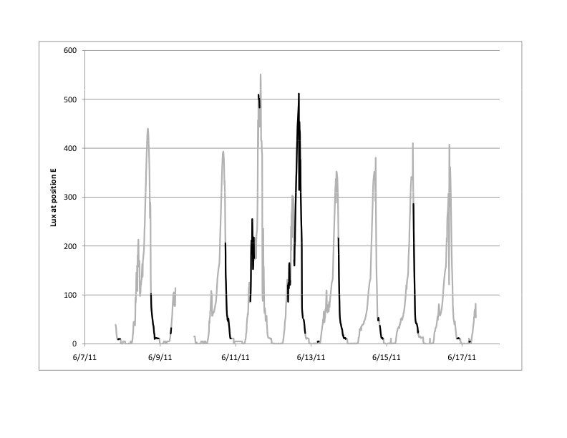

(D) Household 9. Example of generally low room illuminance, but with clear use of room lighting for TV viewing in late evenings.

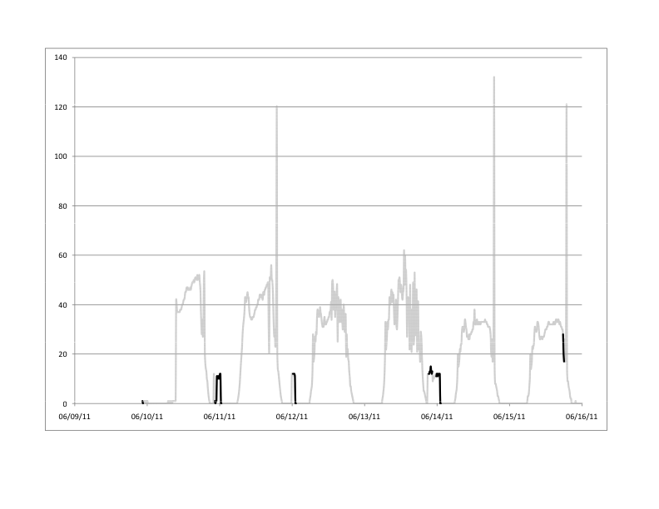

Figure 11. Daily variation in room illuminance levels (shown for household 2 as an example). Blue indicates room illuminance at all times, and black symbols indicate illuminance during TV viewing sessions.

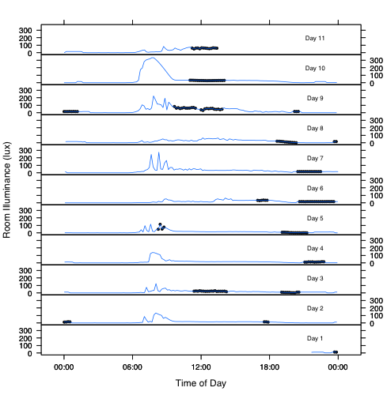

**Appendix A. Other TV room illuminance data**

**Figure A-1. Room illuminance time series for other households.** Gray indicates room illuminance at all times, and black indicates illuminance during TV viewing sessions.

(A)Household 1 (second metering week)

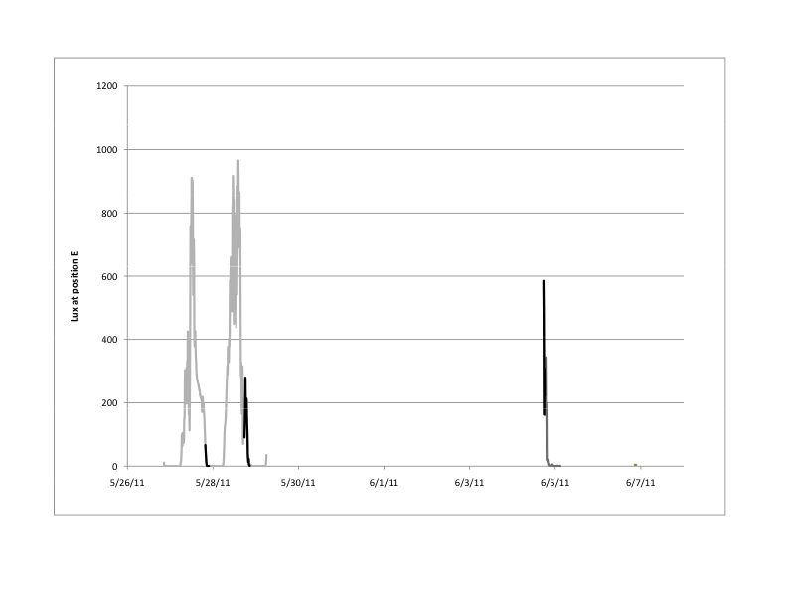

(B) Household 3 (note light meter generally only switched on during TV viewing).

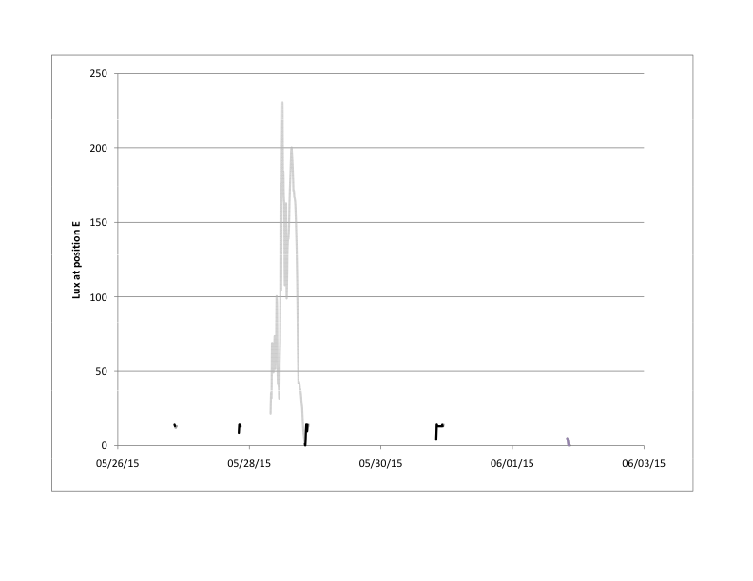

(C) Household 4

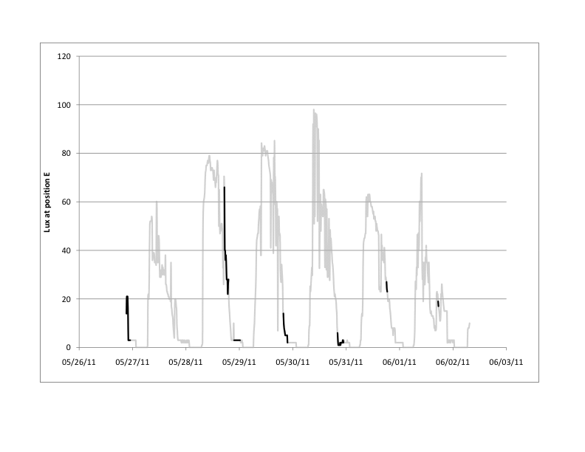

(D)Household 5 (first metering week)

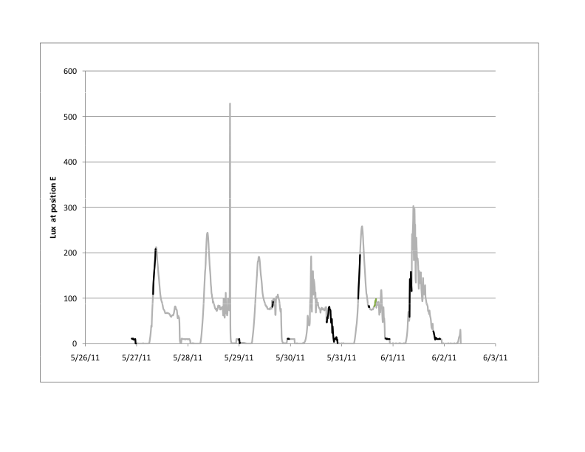

(E) Household 5 (second metering week)

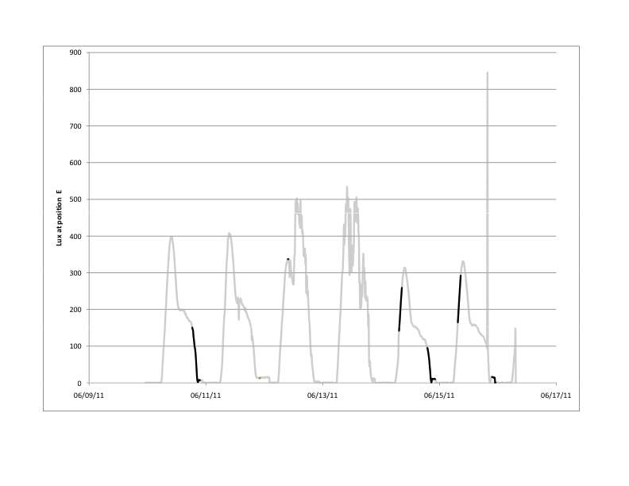

(F) Household 6 (first metering week ) 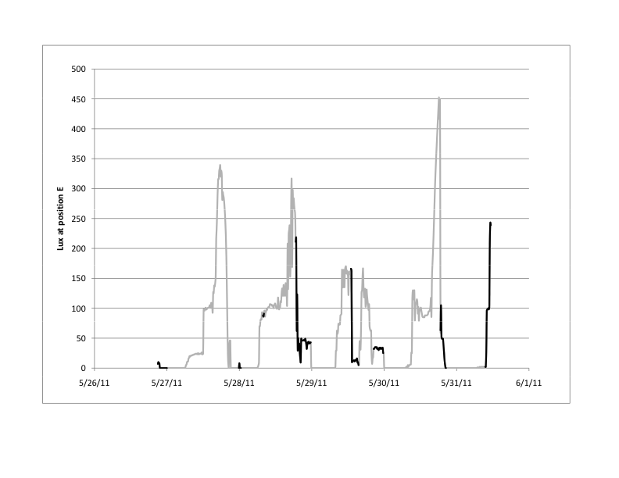

(G) Household 6 (second metering week)

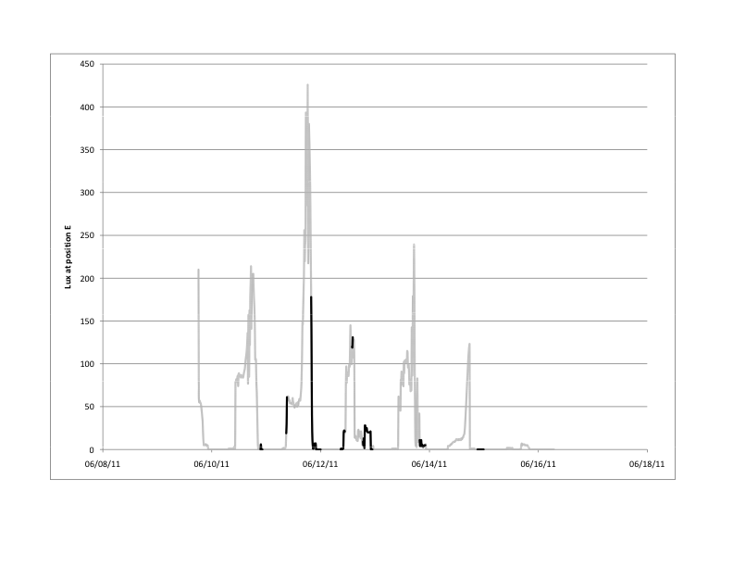

(H) Household 8

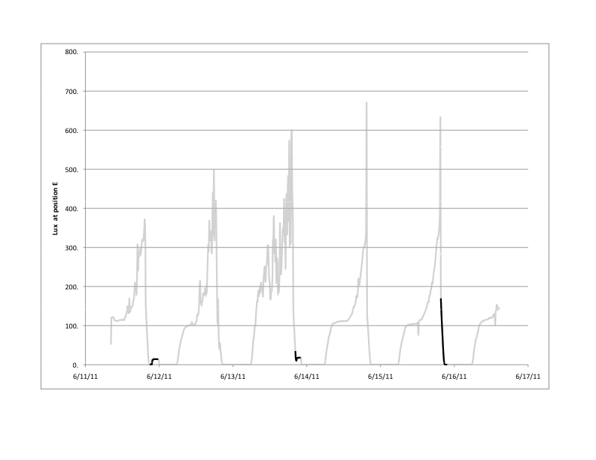

1. A recent study conducted in Japan found that young and old subjects alike preferred to increase screen luminance steadily as room illuminance increased. This trend was robust across different average picture levels. See Fig. 7 in T. Matsumoto et al. (2011) “18.2: Distinguished Paper: Appropriate Luminance of LCD-TV Screens under Actual Viewing Conditions at Home,” *Society for Information Display (SID) 11 Digest*, 221-224.
2. A TV viewing session runs from the time the TV was switched on to the time it was switched off.
3. Russell P. Leslie and Kathryn M. Conway (1993), *The Lighting Pattern Book for Homes*, Lighting Research Center, p. 40.
4. Illuminance and luminance values may both change considerably with the TV on, depending on the average picture level (APL) of the source material.