
EERE Total

Custom View: 10/1/09 - 9/30/10
October 1, 2009 12:00:00 AM – September 30, 2010 11:59:59 PM
Table of Contents
Overview Dashboard (pre-v8.0) 4
Top Visitors 5
Domain Names 11
Top-Level Domain Types 14
Regions 17
Countries 19
North American States and Provinces 22
Cities 25
Visits: Frequency 28
Visits Trend 30
Visits by Number of Pages Viewed 32
Visit Duration by Visits 35
Visit Duration by Page Views 38
Pages 41
Page Views Trend 48
Downloaded Files 50
Entry Pages 54
Exit Pages 60
Single-Page Visits 66
Path Analysis: All Entry Pages 72
Paths, Forward: All Entry Pages 85
Referring Site 98
Referring Domain 101
Referring Page 104
Search Phrases 107
Search Keywords 115

Overview Dashboard (pre-v8.0)
This dashboard provides an overview of the data available in the report template. You can click a graph title to navigate to the corresponding report page.

Visits Trend
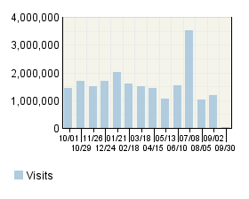

Visitor Summary
Visitors | 16,200,451
Visitors Who Visited Once | 14,056,784
Visitors Who Visited More Than Once | 2,143,667
Avg Visits per Visitor | 1.31

Visit Summary
Visits | 21,189,933
Average per Day | 58,054
Average Visit Duration | 00:07:30
Median Visit Duration | 00:02:21
International Visits | 39.98%
Visits of Unknown Origin | 0.36%
Visits from Your Country: United States (US) | 59.67%

Page Views Trend
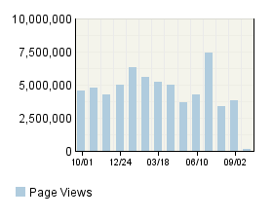

Page View Summary
Page Views | 63,520,212
Average per Day | 174,027
Page Views per Visit | 3

Top Visitors
This report provides information about individual visitor activity on your site. Top visitors are identified by cookie, IP address, or domain name, with the most accurate identification method taking priority. If you use cookies to track visits, Webtrends can differentiate between traffic from different visitors with the same IP address.

Top Visitors
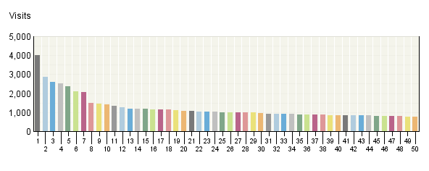

Top Visitors
 | Visitor | Visits | % Visits | Hits
1. | crawler6132.ask.com_​Mozilla/​5.0 (X11; U; Linux i686; en-​US; rv:1.9.0.11) Gecko GranParadiso/​3.0.11 | 3,991 | 0% | 15,380
2. | 165.130.136.206_​Mozilla/​4.0 (compatible; MSIE 6.0; Windows NT 5.1; SV1; .NET CLR 1.1.4322; .NET CLR 2.0.50727) | 2,855 | 0% | 29,226
3. | 165.130.136.210_​Mozilla/​4.0 (compatible; MSIE 6.0; Windows NT 5.1; SV1; .NET CLR 1.1.4322; .NET CLR 2.0.50727) | 2,608 | 0% | 24,813
4. | localhost_​Mozilla/​4.0 (compatible; MSIE 6.0; Windows NT 5.1; SV1) | 2,517 | 0% | 19,968
5. | 165.130.136.208_​Mozilla/​4.0 (compatible; MSIE 6.0; Windows NT 5.1; SV1; .NET CLR 1.1.4322; .NET CLR 2.0.50727) | 2,356 | 0% | 26,460
6. | ip-​78-​137-​163-​133.dedi.digiweb.ie_​Mozilla/​5.0 (X11; U; Linux i686; en-​US; rv:1.9.0.11) Gecko GranParadiso/​3.0.11 | 2,113 | 0% | 3,061
7. | 38.98.19.96_​Mozilla/​5.0 (SnapPreviewBot) Gecko/​20061206 Firefox/​1.5.0.9 | 2,058 | 0% | 3,817
8. | 168.244.164.220_​Mozilla/​5.0 (X11; U; Linux i686; en-​US; rv:1.8.0.6) Gecko/​20060728 Firefox/​1.5.0.6 | 1,477 | 0% | 7,576
9. | doegate-​1.doe.gov_​Mozilla/​4.0 (compatible; MSIE 7.0; Windows NT 5.1; .NET CLR 1.1.4322; .NET CLR 2.0.50727; .NET CLR 3.0.04506.30; .NET CLR 3.0.04506.648; InfoPath.2) | 1,462 | 0% | 5,711
10. | 192.234.136.23_​Mozilla/​4.0 (compatible; MSIE 6.0; Windows NT 5.1; SV1; .NET CLR 1.1.4322; .NET CLR 2.0.50727; InfoPath.1) | 1,413 | 0% | 6,284
11. | doegate-​1.doe.gov_​Mozilla/​4.0 (compatible; MSIE 7.0; Windows NT 5.1; .NET CLR 1.1.4322; .NET CLR 2.0.50727; InfoPath.1; .NET CLR 3.0.4506.2152; .NET CLR 3.5.30729) | 1,331 | 0% | 4,777
12. | doegate-​1.doe.gov_​Mozilla/​4.0 (compatible; MSIE 8.0; Windows NT 5.1; Trident/​4.0; .NET CLR 1.1.4322; .NET CLR 2.0.50727; InfoPath.1; .NET CLR 3.0.4506.2152; .NET CLR 3.5.30729) | 1,275 | 0% | 12,274
13. | tc-​gw.exabot.com_​Mozilla/​5.0 (compatible; Konqueror/​3.5; Linux) KHTML/​3.5.5 (like Gecko) (Exabot-​Thumbnails) | 1,201 | 0% | 1,987
14. | doegate-​1.doe.gov_​Mozilla/​4.0 (compatible; MSIE 7.0; Windows NT 5.1; Trident/​4.0; .NET CLR 1.1.4322; .NET CLR 2.0.50727; InfoPath.1; .NET CLR 3.0.4506.2152; .NET CLR 3.5.30729) | 1,175 | 0% | 2,784
15. | doegate-​1.doe.gov_​Mozilla/​4.0 (compatible; MSIE 8.0; Windows NT 5.1; Trident/​4.0; .NET CLR 1.1.4322; .NET CLR 2.0.50727; .NET CLR 3.0.4506.2152; .NET CLR 3.5.30729; InfoPath.2; MS-​RTC LM 8) | 1,166 | 0% | 12,835
16. | dinar.nccr.epa.gov_​Mozilla/​4.0 (compatible; MSIE 7.0; Windows NT 5.1; InfoPath.1; .NET CLR 1.1.4322; .NET CLR 2.0.50727) | 1,157 | 0% | 10,398
17. | localhost_​Mozilla/​4.0 (compatible; MSIE 7.0; Windows NT 5.1) | 1,148 | 0% | 4,759
18. | doegate-​1.doe.gov_​Mozilla/​4.0 (compatible; MSIE 6.0; Windows NT 5.1; SV1; .NET CLR 1.1.4322; .NET CLR 2.0.50727; InfoPath.1) | 1,134 | 0% | 10,863
19. | natdw.nrel.gov_​Mozilla/​4.0 (compatible; MSIE 6.0; Windows NT 5.1; SV1; .NET CLR 2.0.50727; .NET CLR 3.0.4506.2152; .NET CLR 3.5.30729; InfoPath.2; MS-​RTC LM 8) | 1,124 | 0% | 57,219
20. | doegate-​1.doe.gov_​Mozilla/​4.0 (compatible; MSIE 6.0; Windows NT 5.1; SV1; .NET CLR 1.1.4322; .NET CLR 2.0.50727; .NET CLR 3.0.04506.30; .NET CLR 3.0.04506.648; .NET CLR 3.5.21022; InfoPath.2) | 1,060 | 0% | 3,910
21. | doegate-​1.doe.gov_​Mozilla/​4.0 (compatible; MSIE 6.0; Windows NT 5.1; SV1; .NET CLR 1.1.4322; .NET CLR 2.0.50727; InfoPath.1; .NET CLR 3.0.04506.30; .NET CLR 3.0.04506.648; .NET CLR 3.5.21022) | 1,051 | 0% | 15,135
22. | doegate-​1.doe.gov_​Mozilla/​4.0 (compatible; MSIE 6.0; Windows NT 5.1; SV1; .NET CLR 1.1.4322; .NET CLR 2.0.50727; .NET CLR 3.0.4506.2152; .NET CLR 3.5.30729; InfoPath.2; MS-​RTC LM 8) | 1,039 | 0% | 5,338
23. | 198.179.147.171_​Mozilla/​4.0 (compatible; MSIE 6.0; Windows NT 5.1; Kmart; Q312461; SHC; SV1; .NET CLR 1.1.4322; .NET CLR 2.0.50727; .NET CLR 3.0.04506.30; .NET CLR 3.0.04506.648; .NET CLR 3.0.4506.2152; .NET CLR 3.5.30729) | 1,031 | 0% | 4,060
24. | doegate-​1.doe.gov_​Mozilla/​4.0 (compatible; MSIE 7.0; Windows NT 5.1; Trident/​4.0; .NET CLR 1.1.4322; .NET CLR 2.0.50727; .NET CLR 3.0.4506.2152; .NET CLR 3.5.30729; InfoPath.2) | 1,029 | 0% | 18,238
25. | doegate-​1.doe.gov_​Mozilla/​4.0 (compatible; MSIE 6.0; Windows NT 5.1; SV1; .NET CLR 1.1.4322; .NET CLR 2.0.50727; InfoPath.1; .NET CLR 3.0.04506.648; .NET CLR 3.5.21022) | 1,011 | 0% | 9,833
26. | doegate-​1.doe.gov_​Mozilla/​4.0 (compatible; MSIE 7.0; Windows NT 5.1; CWADS32; .NET CLR 1.1.4322; .NET CLR 2.0.50727; .NET CLR 3.0.04506.648; .NET CLR 3.5.21022; MS-​RTC LM 8; InfoPath.2) | 1,003 | 0% | 2,954
27. | doegate-​1.doe.gov_​Mozilla/​4.0 (compatible; MSIE 7.0; Windows NT 5.1; .NET CLR 1.1.4322; .NET CLR 2.0.50727; .NET CLR 3.0.4506.2152; .NET CLR 3.5.30729; InfoPath.2) | 998 | 0% | 3,826
28. | 165.130.136.206_​Mozilla/​4.0 (compatible; MSIE 6.0; Windows NT 5.1; SV1; .NET CLR 2.0.50727; .NET CLR 1.1.4322) | 998 | 0% | 3,726
29. | doegate-​1.doe.gov_​Mozilla/​4.0 (compatible; MSIE 6.0; Windows NT 5.1; SV1; .NET CLR 1.1.4322; .NET CLR 2.0.50727; InfoPath.1; .NET CLR 3.0.4506.2152; .NET CLR 3.5.30729) | 977 | 0% | 25,258
30. | doegate-​1.doe.gov_​Mozilla/​4.0 (compatible; MSIE 8.0; Windows NT 5.1; Trident/​4.0; .NET CLR 1.1.4322; .NET CLR 2.0.50727; .NET CLR 3.0.4506.2152; .NET CLR 3.5.30729; InfoPath.2) | 939 | 0% | 66,074
31. | ip-​78-​137-​163-​133.dedi.digiweb.ie_​Mozilla/​5.0 (X11; U; Linux i686; en-​US; rv:1.9a1) Gecko/​20070308 Minefield/​3.0a1 | 932 | 0% | 1,498
32. | doegate-​1.doe.gov_​Mozilla/​4.0 (compatible; MSIE 6.0; Windows NT 5.1; SV1; .NET CLR 1.1.4322; .NET CLR 2.0.50727; .NET CLR 3.0.04506.648; .NET CLR 3.5.21022; InfoPath.2) | 931 | 0% | 4,067
33. | localhost_​Mozilla/​4.0 (compatible; MSIE 6.0; Windows NT 5.1; SV1; .NET CLR 2.0.50727) | 918 | 0% | 2,122
34. | natdw.nrel.gov_​Mozilla/​4.0 (compatible; MSIE 8.0; Windows NT 5.1; Trident/​4.0; .NET CLR 2.0.50727; .NET CLR 3.0.4506.2152; .NET CLR 3.5.30729; InfoPath.2; MS-​RTC LM 8) | 910 | 0% | 15,526
35. | gao-​ng.gao.gov_​Mozilla/​4.0 (compatible; MSIE 6.0; Windows NT 5.1; .NET CLR 2.0.50727; .NET CLR 1.1.4322) | 887 | 0% | 11,819
36. | doegate-​1.doe.gov_​Mozilla/​4.0 (compatible; MSIE 7.0; Windows NT 5.1; Trident/​4.0; .NET CLR 1.1.4322; InfoPath.1; .NET CLR 2.0.50727; .NET CLR 3.0.4506.2152; .NET CLR 3.5.30729) | 883 | 0% | 5,225
37. | doegate-​1.doe.gov_​Mozilla/​4.0 (compatible; MSIE 8.0; Windows NT 5.1; Trident/​4.0; .NET CLR 1.1.4322; .NET CLR 2.0.50727; InfoPath.2; .NET CLR 3.0.4506.2152; .NET CLR 3.5.30729) | 870 | 0% | 44,986
38. | 165.130.136.210_​Mozilla/​4.0 (compatible; MSIE 6.0; Windows NT 5.1; SV1; .NET CLR 2.0.50727; .NET CLR 1.1.4322) | 860 | 0% | 3,355
39. | doegate-​1.doe.gov_​Mozilla/​4.0 (compatible; MSIE 6.0; Windows NT 5.1; SV1; .NET CLR 1.1.4322; InfoPath.1; .NET CLR 2.0.50727; .NET CLR 3.0.4506.2152; .NET CLR 3.5.30729; MS-​RTC LM 8) | 851 | 0% | 5,414
40. | 165.130.136.208_​Mozilla/​4.0 (compatible; MSIE 6.0; Windows NT 5.1; SV1; .NET CLR 2.0.50727; .NET CLR 1.1.4322) | 850 | 0% | 3,180
41. | 198.179.147.71_​Mozilla/​4.0 (compatible; MSIE 6.0; Windows NT 5.1; Kmart; Q312461; SHC; SV1; .NET CLR 1.1.4322; .NET CLR 2.0.50727; .NET CLR 3.0.04506.30; .NET CLR 3.0.04506.648; .NET CLR 3.0.4506.2152; .NET CLR 3.5.30729) | 850 | 0% | 2,311
42. | natdw.nrel.gov_​Mozilla/​4.0 (compatible; MSIE 6.0; Windows NT 5.1; SV1; .NET CLR 2.0.50727; .NET CLR 3.0.4506.2152; .NET CLR 3.5.30729; InfoPath.2; MS-​RTC LM 8; .NET CLR 1.1.4322) | 848 | 0% | 26,626
43. | hn.kd.ny.adsl_​Mozilla/​4.0 (compatible; MSIE 6.0; Windows NT 5.1; SV1) | 836 | 0% | 1,467
44. | localhost_​Mozilla/​4.0 (compatible; MSIE 8.0; Windows NT 5.1; Trident/​4.0) | 831 | 0% | 2,405
45. | doegate-​1.doe.gov_​Mozilla/​4.0 (compatible; MSIE 6.0; Windows NT 5.1; SV1; .NET CLR 1.1.4322; InfoPath.1; .NET CLR 2.0.50727; .NET CLR 3.0.4506.2152; .NET CLR 3.5.30729) | 807 | 0% | 34,009
46. | doegate-​1.doe.gov_​Mozilla/​4.0 (compatible; MSIE 8.0; Windows NT 5.1; Trident/​4.0; .NET CLR 1.1.4322; InfoPath.1; .NET CLR 2.0.50727; .NET CLR 3.0.4506.2152; .NET CLR 3.5.30729) | 801 | 0% | 24,283
47. | doegate-​1.doe.gov_​Mozilla/​4.0 (compatible; MSIE 8.0; Windows NT 5.1; Trident/​4.0; InfoPath.2) | 793 | 0% | 20,865
48. | 64.171.157.201_​Mozilla/​4.0 (compatible; MSIE 7.0; Windows NT 5.1; .NET CLR 1.1.4322; .NET CLR 2.0.50727; .NET CLR 3.0.04506.30; .NET CLR 3.0.04506.648; .NET CLR 3.0.4506.2152; .NET CLR 3.5.30729) | 783 | 0% | 6,955
49. | doegate-​1.doe.gov_​Mozilla/​4.0 (compatible; MSIE 6.0; Windows NT 5.1; SV1; .NET CLR 1.1.4322; .NET CLR 2.0.50727; .NET CLR 3.0.4506.2152; .NET CLR 3.5.30729; InfoPath.2) | 773 | 0% | 50,472
50. | doegate-​1.doe.gov_​Mozilla/​4.0 (compatible; MSIE 7.0; Windows NT 5.1; .NET CLR 1.1.4322; .NET CLR 2.0.50727; .NET CLR 3.0.04506.30; InfoPath.2) | 772 | 0% | 4,584
 | Subtotal for rows 1–50 | 61,683 | 0.29% | 689,713
 | Other | 21,149,558 | 99.71% | 62,830,499
 | Total | 21,211,241 | 100.00% | 63,520,212
Items 1–50 of 5,000

Top Visitors - Help Card
Column Definitions

Visitor
The IP address, domain name, or cookie of the visitor.

Visits
Number of times the specified visitor visited your site. A visit is a series of actions that begins when a visitor views their first page from the server, and ends when the visitor leaves the site or remains idle beyond the idle-time limit. The default idle-time limit is thirty minutes. This time limit can be changed by the system administrator.

Hits
Number of hits attributed to the specified visitor. Each file requested by a visitor registers as a hit. There can be several hits on each page. While the volume of hits reflects the amount of server traffic, it is not an accurate reflection of the number of pages viewed.

—
Report Descriptions
Consider the visitors who use the site most, and tailor your site to their interests and needs. If your site is an intranet, notice which employees use the site most, and find out what they like about it. You might also get feedback from those who use it the least and find out what they are looking for.

Note:If a visitor has a dynamic IP address, or if a group of visitors are behind a proxy server or firewall, this data might be misleading. In the case of a dynamic IP address, multiple IP addresses could be shown for a single visitor, and in the case of a firewall or proxy server, one IP address could be used by more than one visitor.

Domain Names
This report lists the domain names that generate the most activity to your web site. Because the data for this report is obtained solely from DNS lookups, it can differ from the data presented in the Organizations report, which is based on both GeoTrends and DNS lookups.

Domain Names
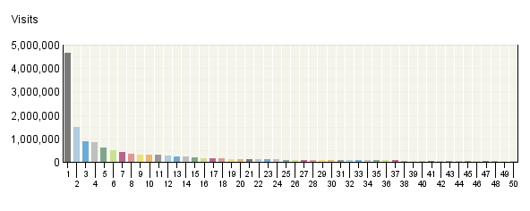

Domain Names
 | Domain Name | Visits | % Visits | Hits
1. | Unresolved IP Address | 4,640,413 | 22% | 13,389,407
2. | comcast.​net | 1,471,766 | 7% | 5,069,385
3. | rr.​com | 896,779 | 4% | 3,070,951
4. | verizon.​net | 833,023 | 4% | 2,948,346
5. | sbcglobal.​net | 613,416 | 3% | 2,106,731
6. | aol.​com | 490,130 | 2% | 529,003
7. | cox.​net | 407,966 | 2% | 1,451,219
8. | bellsouth.​net | 328,952 | 2% | 1,186,916
9. | charter.​com | 309,060 | 1% | 1,059,313
10. | hinet.​net | 291,396 | 1% | 488,282
11. | rogers.​com | 286,767 | 1% | 582,276
12. | qwest.​net | 274,989 | 1% | 981,894
13. | shawcable.​net | 245,402 | 1% | 497,120
14. | dsl.​bell.​ca | 214,064 | 1% | 435,245
15. | optonline.​net | 187,665 | 1% | 611,021
16. | doe.​gov | 169,270 | 1% | 1,356,291
17. | saudi.​net.​sa | 165,677 | 1% | 223,850
18. | prod-​infinitum.​com.​mx | 156,664 | 1% | 238,758
19. | embarqhsd.​net | 130,610 | 1% | 461,056
20. | nrel.​gov | 128,384 | 1% | 737,855
21. | comcastbusin​ess.​net | 127,277 | 1% | 520,086
22. | myvzw.​com | 124,042 | 1% | 427,987
23. | t-​dialin.​net | 113,047 | 1% | 158,640
24. | swbell.​net | 99,145 | 0% | 345,010
25. | windstream.​net | 91,919 | 0% | 335,145
26. | pacbell.​net | 91,000 | 0% | 306,471
27. | telus.​net | 89,105 | 0% | 183,918
28. | veloxzone.​com.​br | 80,155 | 0% | 96,054
29. | brasilteleco​m.​net.​br | 78,850 | 0% | 89,637
30. | mc.​videotron.​ca | 77,142 | 0% | 145,875
31. | bigpond.​net.​au | 69,951 | 0% | 127,197
32. | mchsi.​com | 67,813 | 0% | 244,197
33. | tedata.​net | 64,910 | 0% | 136,425
34. | telesp.​net.​br | 61,325 | 0% | 77,033
35. | centurytel.​net | 58,202 | 0% | 212,474
36. | isp.​belgacom.​be | 57,398 | 0% | 89,082
37. | suddenlink.​net | 57,272 | 0% | 201,457
38. | btcentralplu​s.​com | 55,252 | 0% | 117,136
39. | mindspring.​com | 52,389 | 0% | 178,413
40. | optusnet.​com.​au | 51,965 | 0% | 86,487
41. | localhost | 50,042 | 0% | 113,576
42. | spcsdns.​net | 49,126 | 0% | 157,898
43. | frontiernet.​net | 48,665 | 0% | 171,390
44. | cgocable.​net | 48,002 | 0% | 97,757
45. | rima-​tde.​net | 47,530 | 0% | 128,987
46. | wildblue.​net | 44,724 | 0% | 96,745
47. | virtua.​com.​br | 44,582 | 0% | 71,291
48. | mycingular.​net | 43,135 | 0% | 96,019
49. | ameritech.​net | 42,367 | 0% | 149,150
50. | singnet.​com.​sg | 42,161 | 0% | 45,451
 | Subtotal for rows 1–50 | 14,270,886 | 67.35% | 42,631,907
 | Other | 6,919,047 | 32.65% | 20,888,305
 | Total | 21,189,933 | 100.00% | 63,520,212
Items 1–50 of 2,000

Domain Names - Help Card
Column Definitions

Domain Name
The text name (for example, webtrends.com) corresponding to the visitor's IP address. The domain name can be determined from any of the following methods:

- The domain was logged by the web server.
- The IP address matched an Intranet Domain configuration within the Admin Console.
- DNS resolution.

IP addresses that do not resolve to a domain by these methods are categorized as follows:

- Reserved IP Address - The IP address falls within a block of reserved addresses. For example, 192.168.x.x and 10.x.x.x addresses are reserved for private networks.
- Unresolved IP Address - Category for IP addresses that did not resolve to a domain (perhaps because DNS resolution was disabled).

The domain name shown is the second-level domain name, such as webtrends.com. For example, all visitors from sales.webtrends.com, us.sales.webtrends.com, and service.webtrends.com are combined in the statistics for webtrends.com. If the top-level domain name is a country code, then the third-level domain name is shown also (for example, anycompany.com.au).

To search for information about who owns a domain, including how to contact the owner, perform a WHOIS lookup for the domain name atwww.networksolutions.com.

Visits
Number of visits to your site from this domain name. A visit is a series of actions that begins when a visitor views their first page from the server, and ends when the visitor leaves the site or remains idle beyond the idle-time limit. The default idle-time limit is thirty minutes. This time limit can be changed by the system administrator.

Hits
Number of hits to your site from this domain name. Each file requested by a visitor registers as a hit. There can be several hits on each page. While the volume of hits reflects the amount of server traffic, it is not an accurate reflection of the number of pages viewed.

—
Report Descriptions
Use this information when you are interested in high-level domain names of visitors generating the most activity to your web site.

Top-Level Domain Types
This report provides a breakdown of top-level domain types.

Top-​Level Domain Types
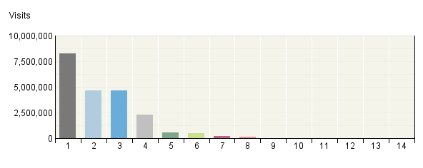

Top-​Level Domain Types
Top-Level Domain Types | Visits | % Visits | Hits
Network | 8,264,598 | 39% | 25,654,947
Commercial | 4,655,052 | 22% | 12,906,491
Unresolved IP Address | 4,640,659 | 22% | 13,390,159
Unknown | 2,266,137 | 11% | 5,108,562
Government | 528,275 | 2% | 3,129,116
Education | 490,841 | 2% | 2,032,141
Organization | 180,505 | 1% | 715,911
Military | 124,632 | 1% | 489,950
ARPANET | 33,569 | 0% | 76,942
Informational | 2,540 | 0% | 4,978
Business | 2,447 | 0% | 8,938
International | 582 | 0% | 1,798
Reserved IP Address | 68 | 0% | 236
Personal | 28 | 0% | 43
Total | 21,189,933 | 100.00% | 63,520,212

Top-Level Domain Types - Help Card
Column Definitions

Reserved IP Address
The IP address falls within a block of reserved addresses. For example, 192.168.x.x and 10.x.x.x addresses are reserved for private networks.

Unresolved IP Address
Category for IP addresses that did not resolve to a domain (perhaps because DNS resolution was disabled).

Unknown
The domain suffix did not match any of the top-level domain categories.

Top-Level Domain
The suffix of a domain name. A top-level domain can be based on the type of organization (.com, .edu, .museum, .name, etc) or it can be a country code (.uk, .de, .jp, .us, etc.). The top-level domain can be used to identify the type of web site. The following is a partial list of how this report categorizes top-level domains:

- ARPANET: .arpa
- Commercial: .com .co .com.[country code] .co.[country code] .firm.co .firm.ve .ltd.uk .info .biz
- Education: .edu .edu.[country-code] .ed.[country code] .ac.[country code] .school.[country code] .k12.[country code] .re.kr .sch.uk .edunet.tn
- International: .int .int.co .int.ve .intl.tn
- Government: .gov .gov.[country code] .gove.[country code] .go.[country code]
- Military: .mil .mil.[country code]
- Network: .net .ad.jp .ne.kr .net.[country code]
- Organization: .org .or .org.[country code] .or.[country code]
- Personal: .name

Visits
Number of visits to your site from the specified top-level domain. A visit is a series of actions that begins when a visitor views their first page from the server, and ends when the visitor leaves the site or remains idle beyond the idle-time limit. The default idle-time limit is thirty minutes. This time limit can be changed by the system administrator.

Hits
Number of hits to your site from the specified top-level domain. Each file requested by a visitor registers as a hit. There can be several hits on each page. While the volume of hits reflects the amount of server traffic, it is not an accurate reflection of the number of pages viewed.

—
Report Descriptions
Consider which types of organizations are interested in your site, and consider how you can interest other types of organizations.

Note:This information can be displayed only if reverse DNS lookups have been performed. Even when DNS lookups are performed, some IP addresses cannot be resolved to a domain name.

Total- This represents the total visits or hits where there was sufficient information to identify the top-level domain. This number may be less than the total activity overall.

Regions
This report identifies the top geographic regions of the visitors to your site. Use this report to understand how broadly your site is used.

Regions
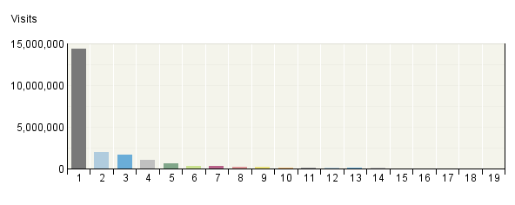

Regions
 | Regions | Visits | % Visits
1. | North America | 14,358,626 | 68%
2. | Asia | 1,951,917 | 9%
3. | Western Europe | 1,674,153 | 8%
4. | Middle East | 998,424 | 5%
5. | South America | 610,164 | 3%
6. | Australia | 317,094 | 1%
7. | Eastern Europe | 311,468 | 1%
8. | Northern Africa | 221,100 | 1%
9. | Northern Europe | 197,377 | 1%
10. | Caribbean Islands | 103,785 | 0%
11. | Unknown Region | 101,934 | 0%
12. | Unspecified Region | 75,368 | 0%
13. | Western Africa | 73,216 | 0%
14. | Southern Africa | 68,258 | 0%
15. | Pacific Islands | 46,298 | 0%
16. | Eastern Africa | 42,164 | 0%
17. | Central America | 32,467 | 0%
18. | Central Africa | 6,114 | 0%
19. | Antarctica | 6 | 0%
 | Total | 21,189,933 | 100.00%
Items 1–19 of 19

Regions - Help Card
Column Definitions

Regions
The geographic part of the world where visitors to your web site are located. "Unspecified Region" represents visitors whose geographic region could not be determined. "Unknown Region" represents visitors whose country has been determined but not identified with a specific region. If the Webtrends GeoTrends Database is turned on for this profile, the region is determined by looking up the visitor's IP address in this database. If GeoTrends is not enabled, the region will be determined from the domain name.

Visits
Number of visits from this geographic region. A visit is a series of actions that begins when a visitor views their first page from the server, and ends when the visitor leaves the site or remains idle beyond the idle-time limit. The default idle-time limit is thirty minutes. This time limit can be changed by the system administrator.

%
Percentage of total visits that were from this geographic region.

—
Report Descriptions
This information can help you meet the needs of your target audience as well as discover new audiences. Consider how you can make the content comprehensive and relevant to an international audience.

Values for "Unspecified Region" represent visitors whose geographic region cannot be determined. Values for "Unknown Region" represent visitors whose country can be determined but whose country is not associated with a specific region. Values for "Unknown States" or "Unknown Cities" represent hits for which the IP address does not match an entry in GeoTrends database. This is the case for countries that do not have states or simply entries for which this information was not provided in the GeoTrends database.

Note:Use this information carefully because it is based on Internet registration, and may not always be an accurate identifier of the visitor's actual location.

Countries
This report identifies the top countries of the visitors to your site. Use this report to understand how broadly your site is used.

Countries
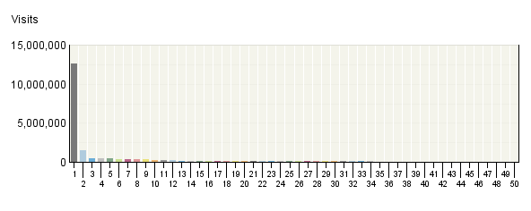

Countries
 | Countries | Visits | % Visits
1. | United States (US) | 12,643,036 | 60%
2. | Canada (CA) | 1,488,649 | 7%
3. | Taiwan (TW) | 449,701 | 2%
4. | Brazil (BR) | 411,521 | 2%
5. | Saudi Arabia (SA) | 404,759 | 2%
6. | United Kingdom (UK) | 358,779 | 2%
7. | Germany (DE) | 354,341 | 2%
8. | China (CN) | 330,095 | 2%
9. | Australia (AU) | 317,094 | 1%
10. | India (IN) | 236,322 | 1%
11. | Mexico (MX) | 226,915 | 1%
12. | Qatar (QA) | 181,006 | 1%
13. | Viet Nam (VN) | 165,364 | 1%
14. | Netherlands (NL) | 156,527 | 1%
15. | Belgium (BE) | 143,084 | 1%
16. | Italy (IT) | 125,907 | 1%
17. | Singapore (SG) | 123,453 | 1%
18. | Spain (ES) | 112,865 | 1%
19. | Malaysia (MY) | 110,266 | 1%
20. | France (FR) | 108,579 | 1%
21. | Egypt (EG) | 107,379 | 1%
22. | Philippines (PH) | 98,248 | 0%
23. | Hong Kong (HK) | 84,867 | 0%
24. | Norway (NO) | 75,629 | 0%
25. | Unknown Country | 75,368 | 0%
26. | Serbia (RS) | 72,144 | 0%
27. | Japan (JP) | 71,107 | 0%
28. | Austria (AT) | 68,993 | 0%
29. | Israel (IL) | 68,464 | 0%
30. | Iran (IR) | 67,994 | 0%
31. | Korea (South) (KR) | 65,119 | 0%
32. | Pakistan (PK) | 62,189 | 0%
33. | South Africa (ZA) | 61,455 | 0%
34. | Portugal (PT) | 60,259 | 0%
35. | Greece (GR) | 57,247 | 0%
36. | Ireland (IE) | 55,544 | 0%
37. | Sweden (SE) | 54,093 | 0%
38. | Thailand (TH) | 51,324 | 0%
39. | Indonesia (ID) | 48,580 | 0%
40. | Poland (PL) | 46,823 | 0%
41. | Turkey (TR) | 46,500 | 0%
42. | Morocco (MA) | 45,844 | 0%
43. | Oman (OM) | 45,276 | 0%
44. | United Arab Emirates (AE) | 41,828 | 0%
45. | New Zealand (NZ) | 39,437 | 0%
46. | Colombia (CO) | 38,753 | 0%
47. | Russian Federation (RU) | 38,103 | 0%
48. | Denmark (DK) | 37,761 | 0%
49. | Venezuela (VE) | 35,811 | 0%
50. | Romania (RO) | 35,576 | 0%
 | Subtotal for rows 1–50 | 20,205,978 | 95.36%
 | Other | 983,955 | 4.64%
 | Total | 21,189,933 | 100.00%
Items 1–50 of 200

Countries - Help Card
Column Definitions

Countries
If the Webtrends GeoTrends Database is turned on for this profile, the country is determined by looking up the visitor's IP address in this database. If GeoTrends is not enabled, the country will be determined from the domain name.

Visits
Number of visits from the specified country. A visit is a series of actions that begins when a visitor views their first page from the server, and ends when the visitor leaves the site or remains idle beyond the idle-time limit. The default idle-time limit is thirty minutes. This time limit can be changed by the system administrator.

%
Percentage of total visits from the specified country.

Unknown Country
The country associated with the visitor's domain name could not be determined.

—
Report Descriptions
This information can help you meet the needs of your target audience as well as discover new audiences. Consider how you can make the content comprehensive and relevant to an international audience.

Note:Use this information carefully because it is based on Internet registration, and may not always be an accurate identifier of the visitor's actual location.

North American States and Provinces
If the Webtrends GeoTrends Database is enabled for this profile, this report shows the visits to your site segmented by the originating North American state or province of the visitor.

North American States and Provinces
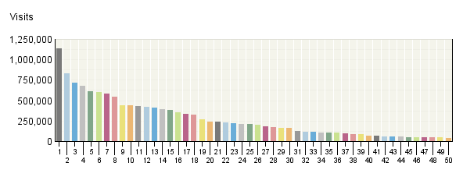

North American States and Provinces
 | States and Provinces | Visits | % Visits
1. | California | 1,136,787 | 8%
2. | Texas | 828,229 | 6%
3. | New York | 720,411 | 5%
4. | Ontario | 676,581 | 5%
5. | Virginia | 612,726 | 4%
6. | Florida | 600,105 | 4%
7. | Illinois | 585,129 | 4%
8. | Pennsylvania | 547,888 | 4%
9. | D.C. | 441,117 | 3%
10. | Colorado | 438,789 | 3%
11. | New Jersey | 433,452 | 3%
12. | Ohio | 418,109 | 3%
13. | Massachusetts | 406,818 | 3%
14. | Georgia | 390,382 | 3%
15. | Washington | 378,015 | 3%
16. | Michigan | 352,014 | 3%
17. | AOL | 337,530 | 2%
18. | North Carolina | 329,105 | 2%
19. | Missouri | 267,016 | 2%
20. | Maryland | 239,501 | 2%
21. | British Columbia | 237,790 | 2%
22. | Minnesota | 229,808 | 2%
23. | Quebec | 222,721 | 2%
24. | Wisconsin | 214,042 | 2%
25. | Arizona | 210,972 | 2%
26. | Tennessee | 199,102 | 1%
27. | Alberta | 180,252 | 1%
28. | Indiana | 173,052 | 1%
29. | Connecticut | 164,501 | 1%
30. | Oregon | 159,626 | 1%
31. | Louisiana | 121,434 | 1%
32. | Kansas | 114,708 | 1%
33. | Alabama | 112,553 | 1%
34. | South Carolina | 107,821 | 1%
35. | Oklahoma | 107,536 | 1%
36. | Kentucky | 101,088 | 1%
37. | Iowa | 94,753 | 1%
38. | Utah | 86,893 | 1%
39. | Nevada | 83,709 | 1%
40. | Nebraska | 68,143 | 0%
41. | Arkansas | 64,951 | 0%
42. | New Mexico | 61,508 | 0%
43. | Maine | 60,375 | 0%
44. | New Hampshire | 59,155 | 0%
45. | Rhode Island | 51,320 | 0%
46. | Mississippi | 50,164 | 0%
47. | Manitoba | 46,449 | 0%
48. | West Virginia | 44,492 | 0%
49. | Idaho | 44,438 | 0%
50. | Hawaii | 42,400 | 0%
 | Subtotal for rows 1–50 | 13,655,460 | 97.55%
 | Other | 343,150 | 2.45%
 | Total | 13,998,610 | 100.00%
Items 1–50 of 65

North American States and Provinces - Help Card
Column Definitions

States and Provinces
If the Webtrends GeoTrends Database is turned on for this profile, the location is determined by looking up the visitor's IP address in this database.

Visits
Number of visits from this state or province. A visit is a series of actions that begins when a visitor views their first page from the server, and ends when the visitor leaves the site or remains idle beyond the idle-time limit. The default idle-time limit is thirty minutes. This time limit can be changed by the system administrator.

%
Percentage of total visits from this state or province.

—
Report Descriptions
This information can help you meet the needs of your target audience as well as discover new audiences. Consider how you can make the content comprehensive and relevant to an international audience.

Note:Use this information carefully, because it is based on Internet registration and may not always be an accurate identifier of the visitor's actual location.

Cities
If the Webtrends GeoTrends Database is enabled for this profile, this report shows visits to your site segmented by the originating city of the visitor.

Cities
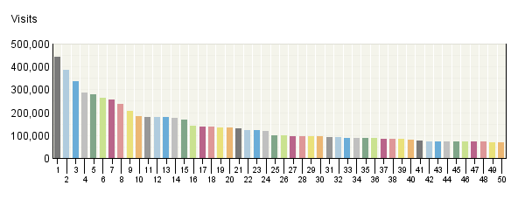

Cities
 | City | Visits | % Visits
1. | Washington, D.C., United States | 441,116 | 2%
2. | Riyadh, Saudi Arabia | 386,785 | 2%
3. | AOL, AOL, United States | 337,530 | 2%
4. | New York, New York, United States | 286,615 | 1%
5. | Chicago, Illinois, United States | 280,169 | 1%
6. | Taipei, Taiwan | 262,762 | 1%
7. | Atlanta, Georgia, United States | 256,625 | 1%
8. | Toronto, Canada | 236,468 | 1%
9. | Chantilly, Virginia, United States | 205,707 | 1%
10. | Philadelphia, Pennsylvania, United States | 184,820 | 1%
11. | Doha, Qatar | 181,006 | 1%
12. | Montreal, Canada | 180,199 | 1%
13. | Houston, Texas, United States | 177,482 | 1%
14. | Los Angeles, California, United States | 175,331 | 1%
15. | Sao Paulo, Brazil | 169,820 | 1%
16. | Dallas, Texas, United States | 142,910 | 1%
17. | Seattle, Washington, United States | 137,481 | 1%
18. | Denver, Colorado, United States | 136,002 | 1%
19. | Mexico City, Mexico | 133,943 | 1%
20. | Golden, Colorado, United States | 132,210 | 1%
21. | Boston, Massachusetts, United States | 130,250 | 1%
22. | Singapore, Singapore | 123,427 | 1%
23. | Tampa, Florida, United States | 122,316 | 1%
24. | Hanoi, Viet Nam | 117,791 | 1%
25. | Phoenix, Arizona, United States | 100,016 | 0%
26. | London, United Kingdom | 99,788 | 0%
27. | Kuala Lumpur, Malaysia | 96,972 | 0%
28. | Richardson, Texas, United States | 96,446 | 0%
29. | Miami, Florida, United States | 94,750 | 0%
30. | Minneapolis, Minnesota, United States | 94,465 | 0%
31. | St Louis, Missouri, United States | 93,340 | 0%
32. | Calgary, Canada | 91,436 | 0%
33. | Austin, Texas, United States | 89,070 | 0%
34. | Sydney, Australia | 87,792 | 0%
35. | Vancouver, Canada | 87,703 | 0%
36. | San Francisco, California, United States | 86,261 | 0%
37. | Brussels, Belgium | 85,651 | 0%
38. | New Delhi, India | 84,496 | 0%
39. | Hong Kong, Hong Kong | 84,347 | 0%
40. | Pleasanton, California, United States | 80,501 | 0%
41. | Newark, New Jersey, United States | 76,968 | 0%
42. | Baltimore, Maryland, United States | 74,386 | 0%
43. | Columbus, Ohio, United States | 73,949 | 0%
44. | Makati, Philippines | 73,883 | 0%
45. | Raleigh, North Carolina, United States | 73,800 | 0%
46. | Amsterdam, Netherlands | 72,074 | 0%
47. | Elmhurst, Illinois, United States | 71,135 | 0%
48. | Madrid, Spain | 71,065 | 0%
49. | Indianapolis, Indiana, United States | 69,634 | 0%
50. | Orlando, Florida, United States | 68,288 | 0%
 | Subtotal for rows 1–50 | 7,116,981 | 34.02%
 | Other | 13,800,407 | 65.98%
 | Total | 20,917,388 | 100.00%
Items 1–50 of 1,000

Cities - Help Card
Column Definitions

City
If the Webtrends GeoTrends Database is turned on for this profile, the location is determined by looking up the visitor's IP address in this database.

Visits
Number of visits from this city. A visit is a series of actions that begins when a visitor views their first page from the server, and ends when the visitor leaves the site or remains idle beyond the idle-time limit. The default idle-time limit is thirty minutes. This time limit can be changed by the system administrator.

%
Percentage of total visits from this city.

—
Report Descriptions
This information can help you meet the needs of your target audience as well as discover new audiences. Consider how you can make the content comprehensive and relevant to an international audience.

Note:Use this information carefully because it is based on Internet registration, and may not always be an accurate identifier of the visitor's actual location.

Visits: Frequency
This report shows the visit frequency of your top visitors, allowing you to evaluate overall site loyalty.

Visits: Frequency
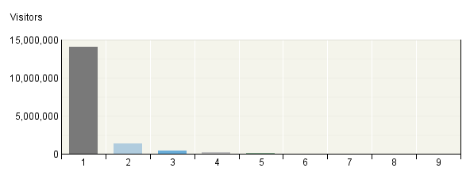

Visits: Frequency
Number of Visits | Visitors | % Visitors
1 visit | 14,056,784 | 87%
2 visits | 1,352,636 | 8%
3 visits | 371,060 | 2%
4 visits | 156,276 | 1%
5 visits | 80,945 | 0%
6 visits | 47,441 | 0%
7 visits | 30,850 | 0%
8 visits | 20,884 | 0%
9 visits | 15,084 | 0%
Other | 68,491 | 0.42%
Total | 16,200,451 | 100.00%

Visits: Frequency - Help Card
Column Definitions

Number of Visits
The number of visits by each visitor during the period of the report.

Visitors
Number of individuals who came to your site the amount of times specified in the Number of Visits column.

%
Percentage of visitors who came to your site the amount of times specified in the Number of Visits column.

—
Report Descriptions
This information can indicate whether or not your site compels visitors to return. Updating web site content is one way to draw return visitors.

Visits Trend
This report helps you determine traffic patterns within the day, week, or month so you can adjust your web site strategy to anticipate peaks and times of low activity. The trend intervals displayed depend on the selected report period.

Visits Trend
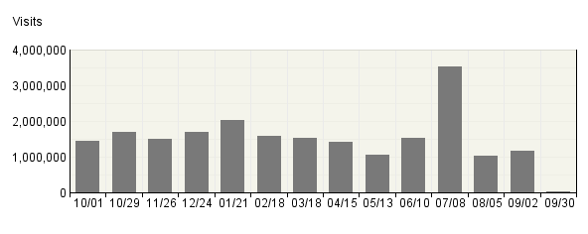

Visits Trend
Time Interval | Visits | % Visits
10/​01 | 1,433,548 | 7%
10/​29 | 1,688,332 | 8%
11/​26 | 1,491,044 | 7%
12/​24 | 1,698,024 | 8%
01/​21 | 2,022,073 | 10%
02/​18 | 1,586,051 | 7%
03/​18 | 1,519,398 | 7%
04/​15 | 1,426,264 | 7%
05/​13 | 1,052,024 | 5%
06/​10 | 1,521,041 | 7%
07/​08 | 3,531,906 | 17%
08/​05 | 1,017,182 | 5%
09/​02 | 1,172,504 | 6%
09/​30 | 30,542 | 0%
Total | 21,189,933 | 100.00%

Visits Trend - Help Card
Column Definitions

Time Interval (hour, day, etc.)
A one-year report displays monthly time increments. A one-quarter report displays weekly time increments. A one-month report or a one-week report displays daily time increments. A daily report displays hourly time increments. An hour-long interval marked 12:00, for example, includes all activity between 12:00 and 12:59.

Visits
Number of visits to your site during the specified time interval. A visit is a series of actions that begins when a visitor views their first page from the server, and ends when the visitor leaves the site or remains idle beyond the idle-time limit. The default idle-time limit is thirty minutes. This time limit can be changed by the system administrator.

%
Percentage of visits to your site during the specified time interval compared with all visits to your site during the report period.

—
Report Descriptions
Periods of less activity can be considered good times for maintenance and content improvement.

Visits by Number of Pages Viewed
This report shows you how many times visitors viewed one page, how many viewed two pages, etc.

Visits by Number of Pages Viewed
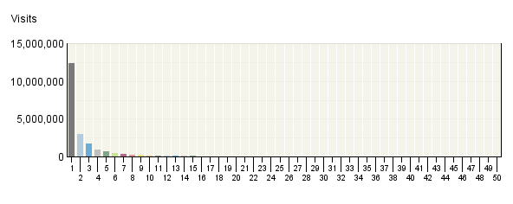

Visits by Number of Pages Viewed
 | Number of Pages Viewed | Visits | % Visits
1. | 1 Page | 12,313,979 | 58%
2. | 2 Pages | 2,943,769 | 14%
3. | 3 Pages | 1,758,409 | 8%
4. | 4 Pages | 962,100 | 5%
5. | 5 Pages | 728,825 | 3%
6. | 6 Pages | 455,458 | 2%
7. | 7 Pages | 377,748 | 2%
8. | 8 Pages | 258,455 | 1%
9. | 9 Pages | 222,794 | 1%
10. | 10 Pages | 162,436 | 1%
11. | 11 Pages | 142,822 | 1%
12. | 12 Pages | 108,151 | 1%
13. | 13 Pages | 95,453 | 0%
14. | 14 Pages | 75,263 | 0%
15. | 15 Pages | 67,610 | 0%
16. | 16 Pages | 54,430 | 0%
17. | 17 Pages | 48,908 | 0%
18. | 18 Pages | 40,611 | 0%
19. | 19 Pages | 36,509 | 0%
20. | 20 Pages | 30,705 | 0%
21. | 21 Pages | 28,072 | 0%
22. | 22 Pages | 23,735 | 0%
23. | 23 Pages | 21,801 | 0%
24. | 24 Pages | 18,994 | 0%
25. | 25 Pages | 17,176 | 0%
26. | 26 Pages | 15,078 | 0%
27. | 27 Pages | 13,822 | 0%
28. | 28 Pages | 12,245 | 0%
29. | 29 Pages | 11,066 | 0%
30. | 30 Pages | 9,740 | 0%
31. | 31 Pages | 9,003 | 0%
32. | 32 Pages | 8,202 | 0%
33. | 33 Pages | 7,437 | 0%
34. | 34 Pages | 6,805 | 0%
35. | 35 Pages | 6,222 | 0%
36. | 36 Pages | 5,578 | 0%
37. | 37 Pages | 5,345 | 0%
38. | 38 Pages | 4,802 | 0%
39. | 39 Pages | 4,472 | 0%
40. | 40 Pages | 4,190 | 0%
41. | 41 Pages | 3,804 | 0%
42. | 42 Pages | 3,457 | 0%
43. | 43 Pages | 3,421 | 0%
44. | 44 Pages | 3,079 | 0%
45. | 45 Pages | 2,882 | 0%
46. | 46 Pages | 2,702 | 0%
47. | 47 Pages | 2,448 | 0%
48. | 48 Pages | 2,279 | 0%
49. | 49 Pages | 2,170 | 0%
50. | 50 Pages | 1,929 | 0%
 | Subtotal for rows 1–50 | 21,146,391 | 99.80%
 | Other | 43,207 | 0.20%
 | Total | 21,189,598 | 100.00%
Items 1–50 of 100

Visits by Number of Pages Viewed - Help Card
Column Definitions

Number of Pages Viewed
The number of pages viewed during a visit. If the visitor viewed only non-page files such as a .gif or a .jpeg, the count of pages viewed is zero for that visit.

Visits
Number of visits by visitors who viewed the specified number of pages. A visit is a series of actions that begins when a visitor views their first page from the server, and ends when the visitor leaves the site or remains idle beyond the idle-time limit. The default idle-time limit is thirty minutes. This time limit can be changed by the system administrator.

%
Percentage of total visits by people who viewed the specified number of pages.

—
Report Descriptions
You can use this information to quickly find out the number and percentages of viewers who read a given number of pages on your site. If most visitors only view a few pages, it may indicate that they cannot find the content they are looking for.

Visits with 0 pages are visits where the only hits are to files that do not constitute pages, such as images.

Visit Duration by Visits
This report shows the number and percentages of visits over selected visit lengths.

Visit Duration in Minutes by Visits
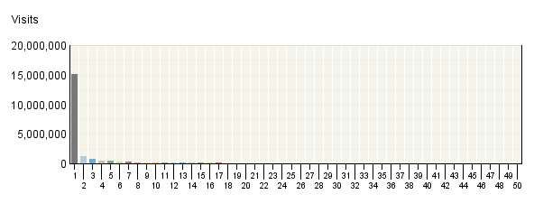

Visit Duration by Visits
 | Visit Duration in Minutes | Visits | % Visits
1. | 0-​1 | 15,184,099 | 72%
2. | 1-​2 | 1,281,226 | 6%
3. | 2-​3 | 773,694 | 4%
4. | 3-​4 | 531,914 | 3%
5. | 4-​5 | 398,679 | 2%
6. | 5-​6 | 312,633 | 1%
7. | 6-​7 | 257,697 | 1%
8. | 7-​8 | 215,722 | 1%
9. | 8-​9 | 184,614 | 1%
10. | 9-​10 | 159,947 | 1%
11. | 10-​11 | 140,695 | 1%
12. | 11-​12 | 125,279 | 1%
13. | 12-​13 | 112,468 | 1%
14. | 13-​14 | 102,638 | 0%
15. | 14-​15 | 93,513 | 0%
16. | 15-​16 | 86,205 | 0%
17. | 16-​17 | 80,280 | 0%
18. | 17-​18 | 74,853 | 0%
19. | 18-​19 | 70,011 | 0%
20. | 19-​20 | 66,279 | 0%
21. | 20-​21 | 62,948 | 0%
22. | 21-​22 | 58,987 | 0%
23. | 22-​23 | 56,523 | 0%
24. | 23-​24 | 53,350 | 0%
25. | 24-​25 | 50,789 | 0%
26. | 25-​26 | 48,745 | 0%
27. | 26-​27 | 46,385 | 0%
28. | 27-​28 | 44,291 | 0%
29. | 28-​29 | 42,500 | 0%
30. | 29-​30 | 42,619 | 0%
31. | 30-​31 | 29,475 | 0%
32. | 31-​32 | 24,850 | 0%
33. | 32-​33 | 22,687 | 0%
34. | 33-​34 | 20,389 | 0%
35. | 34-​35 | 18,981 | 0%
36. | 35-​36 | 17,056 | 0%
37. | 36-​37 | 16,090 | 0%
38. | 37-​38 | 14,783 | 0%
39. | 38-​39 | 13,803 | 0%
40. | 39-​40 | 13,121 | 0%
41. | 40-​41 | 12,337 | 0%
42. | 41-​42 | 11,396 | 0%
43. | 42-​43 | 10,746 | 0%
44. | 43-​44 | 10,033 | 0%
45. | 44-​45 | 9,448 | 0%
46. | 45-​46 | 8,948 | 0%
47. | 46-​47 | 8,426 | 0%
48. | 47-​48 | 7,891 | 0%
49. | 48-​49 | 7,479 | 0%
50. | 49-​50 | 7,042 | 0%
 | Subtotal for rows 1–50 | 21,044,564 | 99.32%
 | Other | 145,034 | 0.68%
 | Total | 21,189,598 | 100.00%
Items 1–50 of 61

Visit Duration by Visits - Help Card
Column Definitions

Visit Duration in Minutes
The number of minutes your web site was viewed.

Visits
Number of visitors who viewed your page for the specified duration of time. A visit is a series of actions that begins when a visitor views their first page from the server, and ends when the visitor leaves the site or remains idle beyond the idle-time limit. The default idle-time limit is thirty minutes. This time limit can be changed by the system administrator.

%
Percentage of visitors who viewed your page for the specified duration of time.

—
Report Descriptions
This information tells you how many visitors view your site for specific intervals of time.

Visit Duration by Page Views
This report shows the number and percentages of pages views over selected visit lengths.

Visit Duration in Minutes by Page Views
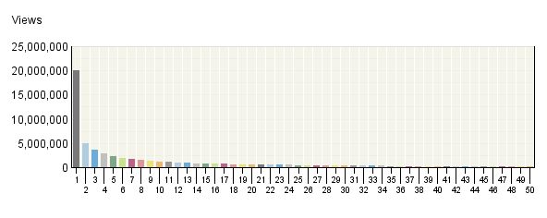

Visit Duration by Page Views
 | Visit Duration in Minutes | Views | % Views
1. | 0-​1 | 19,989,559 | 31%
2. | 1-​2 | 5,034,562 | 8%
3. | 2-​3 | 3,683,661 | 6%
4. | 3-​4 | 2,884,090 | 5%
5. | 4-​5 | 2,375,581 | 4%
6. | 5-​6 | 1,993,226 | 3%
7. | 6-​7 | 1,736,956 | 3%
8. | 7-​8 | 1,514,245 | 2%
9. | 8-​9 | 1,348,707 | 2%
10. | 9-​10 | 1,205,266 | 2%
11. | 10-​11 | 1,086,078 | 2%
12. | 11-​12 | 992,751 | 2%
13. | 12-​13 | 909,797 | 1%
14. | 13-​14 | 845,433 | 1%
15. | 14-​15 | 779,390 | 1%
16. | 15-​16 | 734,849 | 1%
17. | 16-​17 | 695,350 | 1%
18. | 17-​18 | 651,288 | 1%
19. | 18-​19 | 612,248 | 1%
20. | 19-​20 | 589,220 | 1%
21. | 20-​21 | 566,181 | 1%
22. | 21-​22 | 531,069 | 1%
23. | 22-​23 | 514,273 | 1%
24. | 23-​24 | 486,817 | 1%
25. | 24-​25 | 467,767 | 1%
26. | 25-​26 | 450,958 | 1%
27. | 26-​27 | 437,482 | 1%
28. | 27-​28 | 416,672 | 1%
29. | 28-​29 | 404,353 | 1%
30. | 29-​30 | 396,729 | 1%
31. | 30-​31 | 355,313 | 1%
32. | 31-​32 | 329,598 | 1%
33. | 32-​33 | 307,372 | 0%
34. | 33-​34 | 287,231 | 0%
35. | 34-​35 | 275,080 | 0%
36. | 35-​36 | 255,485 | 0%
37. | 36-​37 | 250,626 | 0%
38. | 37-​38 | 229,798 | 0%
39. | 38-​39 | 215,951 | 0%
40. | 39-​40 | 208,629 | 0%
41. | 40-​41 | 201,334 | 0%
42. | 41-​42 | 195,073 | 0%
43. | 42-​43 | 184,186 | 0%
44. | 43-​44 | 174,152 | 0%
45. | 44-​45 | 169,113 | 0%
46. | 45-​46 | 159,131 | 0%
47. | 46-​47 | 149,337 | 0%
48. | 47-​48 | 143,273 | 0%
49. | 48-​49 | 139,070 | 0%
50. | 49-​50 | 134,471 | 0%
 | Subtotal for rows 1–50 | 58,698,781 | 92.41%
 | Other | 4,818,820 | 7.59%
 | Total | 63,517,601 | 100.00%
Items 1–50 of 61

Visit Duration by Page Views - Help Card
Column Definitions

Visit Duration in Minutes
The number of minutes your web site was viewed.

Views
A page view is a hit to any file classified as a page. Contrast page views with hits, which counts files of every type.

%
Percentage of visitors who viewed your page for the specified duration of time.

—
Report Descriptions
This information tells you how many visitors view your site for specific intervals of time.

Pages
This report identifies the most popular pages on your site and shows you key metrics for each page such as Visits, Page Views and Average Time Viewed.

Pages Trend
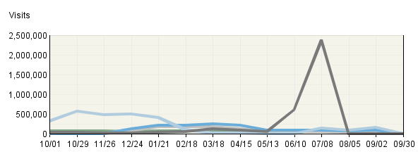

Pages
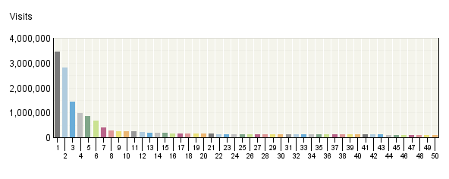

Pages
 | Pages | Visits | Views | Average Time Viewed (seconds) | Average Time to Serve (ms)
1. | Stay Cool, Save Money: Weekly Summer Energy Saving Tip  http:/​/​www.​energysavers​.​gov/​includes/​widgetbox.​html | 3,435,222 | 5,388,088 | 273 | 0
2. | EERE: Kids Home Page  http:/​/​www.​eere.​energy.​gov/​kids/​ | 2,819,139 | 3,248,572 | 108 | 0
3. | Energy Savers: Approved Energy Efficient Appliance Rebate Programs  http:/​/​www.​energysavers​.​gov/​financial/​70022.​html | 1,433,467 | 2,208,908 | 26 | 0
4. | Energy Savers: Rebates for ENERGY STAR Appliances  http:/​/​www.​energysavers​.​gov/​financial/​70020.​html | 963,604 | 1,405,445 | 69 | 0
5. | U.S. DOE Energy Efficiency and Renewable Energy (EERE) Home Page  http:/​/​www.​eere.​energy.​gov/​ | 854,913 | 1,591,635 | 165 | 0
6. | EERE: Energy Savers Home Page  http:/​/​www.​energysavers​.​gov/​ | 659,061 | 890,005 | 62 | 0
7. | Energy Savers: Tax Credits for Energy Efficiency  http:/​/​www.​energysavers​.​gov/​financial/​70010.​html | 401,843 | 596,793 | 136 | 0
8. | EERE Kids: TV Ads  http:/​/​www.​eere.​energy.​gov/​kids/​tvads.​html | 260,711 | 320,003 | 94 | 0
9. | EERE Kids: Games and Activities  http:/​/​www.​eere.​energy.​gov/​kids/​games.​html | 257,957 | 344,162 | 101 | 0
10. | Wind and Water Power Program: How Wind Turbines Work  http:/​/​www1.​eere.​energy.​gov/​windandhydro​/​wind_​how.​html | 236,139 | 341,353 | 192 | 0
11. | Wind Powering America: Wind Maps and Wind Resource Potential Estimates  http:/​/​www.​windpowering​america.​gov/​wind_​maps.​asp | 230,933 | 381,888 | 64 | 0
12. | Energy Savers: Solar Water Heaters  http:/​/​www.​energysavers​.​gov/​your_​home/​water_​heating/​index.​cfm/​mytopic=​12850 | 216,202 | 282,578 | 162 | 0
13. | Energy Savers: Florida Appliance Rebates  http:/​/​www.​energysavers​.​gov/​financial/​rebates/​state_​FL.​cfm | 171,831 | 241,071 | 114 | 0
14. | Energy Savers: Financial Opportunities  http:/​/​www.​energysavers​.​gov/​financial/​ | 171,703 | 232,514 | 51 | 0
15. | Energy Savers: Demand (Tankless or Instantaneous) Water Heaters  http:/​/​www.​energysavers​.​gov/​your_​home/​water_​heating/​index.​cfm/​mytopic=​12820 | 168,725 | 236,927 | 123 | 0
16. | Energy Savers: Radiant Heating  http:/​/​www.​energysavers​.​gov/​your_​home/​space_​heating_​cooling/​index.​cfm/​mytopic=​12590 | 166,641 | 191,627 | 225 | 0
17. | Energy Savers: California Appliance Rebates  http:/​/​www.​energysavers​.​gov/​financial/​rebates/​state_​CA.​cfm | 155,521 | 207,917 | 84 | 0
18. | Energy Savers Tips: Insulation  http:/​/​www1.​eere.​energy.​gov/​consumer/​tips/​insulation.​html | 151,967 | 184,417 | 255 | 0
19. | EERE: Solar Energy Technologies Program Home Page  http:/​/​www1.​eere.​energy.​gov/​solar/​ | 148,695 | 222,020 | 86 | 0
20. | Energy Savers: Selecting a New Water Heater  http:/​/​www.​energysavers​.​gov/​your_​home/​water_​heating/​index.​cfm/​mytopic=​12770 | 146,485 | 230,399 | 45 | 0
21. | Energy Savers: Adding Insulation to an Existing Home  http:/​/​www.​energysavers​.​gov/​your_​home/​insulation_​airsealing/​index.​cfm/​mytopic=​11350 | 139,880 | 218,565 | 84 | 0
22. | EERE: Energy Savers Tips Home Page  http:/​/​www1.​eere.​energy.​gov/​consumer/​tips/​ | 137,076 | 195,172 | 76 | 0
23. | Wind Powering America: Washington 50-​Meter Wind Resource Map  http:/​/​www.​windpowering​america.​gov/​maps_​template.​asp | 135,400 | 259,379 | 103 | 0
24. | Energy Savers: Texas Appliance Rebates  http:/​/​www.​energysavers​.​gov/​financial/​rebates/​state_​TX.​cfm | 134,790 | 178,571 | 131 | 0
25. | Energy Savers: Heat Pump Systems  http:/​/​www.​energysavers​.​gov/​your_​home/​space_​heating_​cooling/​index.​cfm/​mytopic=​12610 | 132,921 | 186,996 | 98 | 0
26. | Energy Savers: Home Energy Assessments  http:/​/​www.​energysavers​.​gov/​your_​home/​energy_​audits/​index.​cfm/​mytopic=​11160 | 131,260 | 182,361 | 48 | 0
27. | Alternative Fuels and Advanced Vehicles Data Center: Alternative Fueling Station Locator  http:/​/​www.​afdc.​energy.​gov/​afdc/​locator/​stations/​ | 129,542 | 170,184 | 189 | 0
28. | EERE: Department of Energy Weatherization Assistance Program Home Page  http:/​/​apps1.​eere.​energy.​gov/​weatherizati​on/​ | 128,605 | 184,011 | 76 | 0
29. | Energy Savers: Estimating Appliance and Home Electronic Energy Use  http:/​/​www.​energysavers​.​gov/​your_​home/​appliances/​index.​cfm/​mytopic=​10040 | 127,089 | 152,214 | 210 | 0
30. | Energy Savers: Appliances and Home Electronics  http:/​/​www.​energysavers​.​gov/​your_​home/​appliances/​index.​cfm/​mytopic=​10020 | 121,110 | 164,441 | 42 | 0
31. | Energy Savers: Do-​It-​Yourself Home Energy Assessments  http:/​/​www.​energysavers​.​gov/​your_​home/​energy_​audits/​index.​cfm/​mytopic=​11170 | 119,255 | 145,170 | 156 | 0
32. | Energy Savers: Types of Insulation  http:/​/​www.​energysavers​.​gov/​your_​home/​insulation_​airsealing/​index.​cfm/​mytopic=​11510 | 117,794 | 185,569 | 74 | 0
33. | Building Technologies Program: EnergyPlus Energy Simulation Software  http:/​/​apps1.​eere.​energy.​gov/​buildings/​energyplus/​ | 117,741 | 168,210 | 74 | 0
34. | Energy Savers: Pennsylvania Appliance Rebates  http:/​/​www.​energysavers​.​gov/​financial/​rebates/​state_​PA.​cfm | 117,661 | 172,112 | 80 | 0
35. | Energy Savers: Your Home  http:/​/​www.​energysavers​.​gov/​your_​home/​ | 117,531 | 154,135 | 54 | 0
36. | EERE: Wind and Water Power Program Home Page  http:/​/​www1.​eere.​energy.​gov/​windandhydro​/​ | 116,901 | 172,763 | 73 | 0
37. | Energy Savers: Furnaces and Boilers  http:/​/​www.​energysavers​.​gov/​your_​home/​space_​heating_​cooling/​index.​cfm/​mytopic=​12530 | 116,359 | 148,132 | 163 | 0
38. | EERE: Alternative Fuels and Advanced Vehicles Data Center Program Home Page  http:/​/​www.​afdc.​energy.​gov/​afdc/​ | 113,804 | 166,777 | 75 | 0
39. | Energy Savers: Portable Heaters  http:/​/​www.​energysavers​.​gov/​your_​home/​space_​heating_​cooling/​index.​cfm/​mytopic=​12600 | 113,075 | 128,107 | 173 | 0
40. | Weatherization and Intergovernmental Program: Weatherization Assistance Program  http:/​/​www1.​eere.​energy.​gov/​wip/​wap.​html | 110,747 | 164,970 | 87 | 0
41. | Energy Savers: Foam Board Insulation  http:/​/​www.​energysavers​.​gov/​your_​home/​insulation_​airsealing/​index.​cfm/​mytopic=​11620 | 110,442 | 139,333 | 140 | 0
42. | Lose Your Excuse -​ Landing Page  http:/​/​www.​loseyourexcu​se.​gov/​ | 108,539 | 147,930 | 223 | 0
43. | Energy Savers: Energy-​Efficient Mortgages and Financing  http:/​/​www.​energysavers​.​gov/​financial/​index.​cfm/​mytopic=​70030 | 107,120 | 137,230 | 47 | 0
44. | EERE: Biomass Program Home Page  http:/​/​www1.​eere.​energy.​gov/​biomass/​ | 105,653 | 164,705 | 89 | 0
45. | EERE: Building Technologies Program Home Page  http:/​/​www1.​eere.​energy.​gov/​buildings/​ | 105,567 | 161,349 | 86 | 0
46. | Energy Savers: Illinois Appliance Rebates  http:/​/​www.​energysavers​.​gov/​financial/​rebates/​state_​IL.​cfm | 104,943 | 138,552 | 113 | 0
47. | Wind Powering America -​ Small Wind Electric Systems: A Washington Consumer's Guide  http:/​/​www.​windpowering​america.​gov/​filter_​detail.​asp | 104,449 | 172,072 | 93 | 0
48. | Energy Savers: Geothermal Heat Pumps  http:/​/​www.​energysavers​.​gov/​your_​home/​space_​heating_​cooling/​index.​cfm/​mytopic=​12640 | 103,983 | 168,098 | 100 | 0
49. | Energy Savers: Weatherstripping  http:/​/​www.​energysavers​.​gov/​your_​home/​insulation_​airsealing/​index.​cfm/​mytopic=​11280 | 102,250 | 118,170 | 153 | 0
50. | Wind Powering America: Washington Wind Map and Resource Potential  http:/​/​www.​windpowering​america.​gov/​wind_​resource_​maps.​asp | 102,233 | 223,761 | 90 | 0
 | Subtotal for rows 1–50 | - | 23,815,361 | - | -
 | Other | - | 39,704,851 | - | -
 | Total | - | 63,520,212 | - | -
Items 1–50 of 2,000

Pages - Help Card
Column Definitions

Pages
Any displayed page. You can specify for each profile the types of files that qualify as a page. These settings can be changed by the Webtrends administrator.

Visits
Number of visits to this page. A visit is a series of actions that begins when a visitor views the first page from the server, and ends when the visitor leaves the site or remains idle beyond the idle-time limit. The default idle-time limit is thirty minutes. This time limit can be changed by the system administrator.

Views
Number of times this page was viewed by visitors.

Average Time Viewed
Average length of time, in seconds, that the specified page was viewed.

Average Time to Serve
Average amount of time (in milliseconds) it took to serve each document during the specified time interval. The time to serve spans from the time the server got a page request until it transmitted all the data.
Note: Note that in order to show a total for this column, the value is computed to 2 decimal places. However, because the data for each row is an integer measured in milliseconds, the two decimal places are not significant for Average Time to Serve row values. If the entire column shows values of zero, your web server may not be logging Time to Serve information.

—
Report Descriptions
Pages with good content and design are more likely to attract visitors and be revisited. Less popular pages on a site can be made more appealing by improving the content or incorporating design elements similar to that on the more important pages. Always remember that people are far more interested in content than in design, and average view times can help determine which content is most important to your visitors.

Page Views Trend
This report shows activity trends on your site based on the total page view volume for the report period. You can use this information to determine high and low points of visitor activity.

Page Views Trend
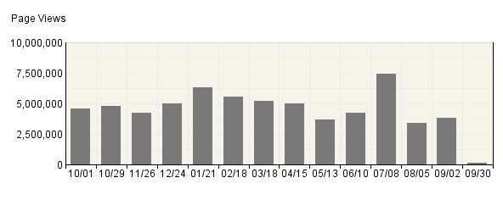

Page Views Trend
Time Interval | Page Views | % Page Views
10/​01 | 4,563,693 | 7%
10/​29 | 4,811,281 | 8%
11/​26 | 4,253,649 | 7%
12/​24 | 5,026,364 | 8%
01/​21 | 6,343,270 | 10%
02/​18 | 5,578,505 | 9%
03/​18 | 5,194,186 | 8%
04/​15 | 5,016,692 | 8%
05/​13 | 3,693,215 | 6%
06/​10 | 4,229,913 | 7%
07/​08 | 7,446,037 | 12%
08/​05 | 3,406,951 | 5%
09/​02 | 3,840,101 | 6%
09/​30 | 116,355 | 0%
Total | 63,520,212 | 100.00%

Page Views Trend - Help Card
Column Definitions

Time Interval (hour, day, etc.)
A one-year report displays monthly time increments. A one-quarter report displays weekly time increments. A one-month report or a one-week report displays daily time increments. A daily report displays hourly time increments. An hour-long interval marked 12:00, for example, includes all activity between 12:00 and 12:59.

Page View
A hit to any file classified as a page. In order to view a web page with embedded images, for example, a browser must retrieve multiple files. The page and its embedded files counts as a single page view.

%
Percentage of total page views that occurred during the specified time interval.

—
Report Descriptions
Periods of less activity can be considered good times for maintenance and content improvement.

Downloaded Files
This report identifies the most popular files downloaded from your site.

Downloaded Files Trend
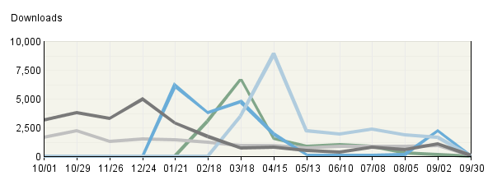

Downloaded Files
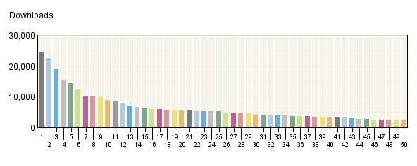

Downloaded Files
 | Downloaded Files | Downloads | % Downloads | Visits
1. | http:/​/​www.​eere.​energy.​gov/​kids/​pdfs/​EnergyAction​List.​pdf | 24,438 | 2% | 22,438
2. | http:/​/​www.​energysavers​.​gov/​financial/​rebates/​pdfs/​rebate_​summary_​CA.​pdf | 22,334 | 2% | 20,603
3. | http:/​/​www.​energysavers​.​gov/​financial/​rebates/​pdfs/​rebate_​summary_​IL.​pdf | 19,073 | 1% | 17,860
4. | http:/​/​www1.​eere.​energy.​gov/​consumer/​tips/​pdfs/​energy_​savers.​pdf | 15,458 | 1% | 14,367
5. | http:/​/​www.​energysavers​.​gov/​financial/​rebates/​pdfs/​rebate_​summary_​OH.​pdf | 14,328 | 1% | 13,595
6. | http:/​/​www.​energysavers​.​gov/​financial/​rebates/​pdfs/​rebate_​summary_​FL.​pdf | 12,373 | 1% | 11,385
7. | http:/​/​www.​energysavers​.​gov/​financial/​rebates/​pdfs/​rebate_​summary_​NY.​pdf | 10,123 | 1% | 9,561
8. | http:/​/​www.​energysavers​.​gov/​financial/​rebates/​pdfs/​rebate_​summary_​PA.​pdf | 9,989 | 1% | 9,441
9. | http:/​/​www.​eere.​energy.​gov/​/​kids/​pdfs/​EnergyAction​List.​pdf | 9,914 | 1% | 9,327
10. | http:/​/​www.​energysavers​.​gov/​financial/​rebates/​pdfs/​rebate_​summary_​GA.​pdf | 8,949 | 1% | 8,412
11. | http:/​/​www.​energysavers​.​gov/​financial/​rebates/​pdfs/​rebate_​summary_​VA.​pdf | 8,363 | 1% | 7,772
12. | http:/​/​apps1.​eere.​energy.​gov/​buildings/​energyplus/​download/​SetEPlusV400​024-​win.​exe | 7,805 | 1% | 6,620
13. | http:/​/​www.​energysavers​.​gov/​financial/​rebates/​pdfs/​rebate_​summary_​TX.​pdf | 7,014 | 1% | 6,526
14. | http:/​/​www.​energysavers​.​gov/​financial/​rebates/​pdfs/​rebate_​summary_​NJ.​pdf | 6,610 | 0% | 6,297
15. | http:/​/​www.​energysavers​.​gov/​financial/​rebates/​pdfs/​rebate_​summary_​NC.​pdf | 6,499 | 0% | 6,133
16. | http:/​/​www.​energysavers​.​gov/​financial/​rebates/​pdfs/​rebate_​summary_​MA.​pdf | 6,017 | 0% | 5,265
17. | http:/​/​www.​energysavers​.​gov/​financial/​rebates/​pdfs/​rebate_​summary_​CT.​pdf | 5,976 | 0% | 5,670
18. | http:/​/​www.​energysavers​.​gov/​financial/​rebates/​pdfs/​rebate_​summary_​MI.​pdf | 5,830 | 0% | 5,519
19. | http:/​/​apps1.​eere.​energy.​gov/​buildings/​energyplus/​pdfs/​gettingstart​ed.​pdf | 5,652 | 0% | 5,186
20. | http:/​/​www.​eecbg.​energy.​gov/​Downloads/​EECBGCompeti​tiveFOA148MO​N.​pdf | 5,451 | 0% | 4,733
21. | http:/​/​www.​energysavers​.​gov/​pdfs/​48148.​pdf | 5,436 | 0% | 5,206
22. | http:/​/​www.​energysavers​.​gov/​financial/​rebates/​pdfs/​rebate_​summary_​WI.​pdf | 5,331 | 0% | 5,090
23. | http:/​/​www.​energysavers​.​gov/​financial/​rebates/​pdfs/​rebate_​summary_​MD.​pdf | 5,278 | 0% | 4,927
24. | http:/​/​www1.​eere.​energy.​gov/​office_​eere/​pdfs/​eere_​orgchart.​pdf | 5,249 | 0% | 4,686
25. | http:/​/​www.​energysavers​.​gov/​financial/​rebates/​pdfs/​rebate_​summary_​LA.​pdf | 5,191 | 0% | 4,793
26. | http:/​/​www1.​eere.​energy.​gov/​hydrogenandf​uelcells/​fuelcells/​pdfs/​fc_​comparison_​chart.​pdf | 4,865 | 0% | 4,616
27. | http:/​/​www.​windpowering​america.​gov/​pdfs/​wind_​maps/​us_​windmap_​80meters.​pdf | 4,858 | 0% | 4,507
28. | http:/​/​www.​energysavers​.​gov/​financial/​rebates/​pdfs/​rebate_​summary_​CO.​pdf | 4,688 | 0% | 4,393
29. | http:/​/​www.​energysavers​.​gov/​financial/​rebates/​pdfs/​rebate_​summary_​WA.​pdf | 4,484 | 0% | 4,259
30. | http:/​/​apps1.​eere.​energy.​gov/​buildings/​energyplus/​download/​SetEPlusV500​031-​win.​exe | 4,217 | 0% | 3,592
31. | http:/​/​www.​energysavers​.​gov/​financial/​rebates/​pdfs/​rebate_​summary_​TN.​pdf | 4,210 | 0% | 3,950
32. | http:/​/​www.​energysavers​.​gov/​financial/​rebates/​pdfs/​rebate_​summary_​AL.​pdf | 4,175 | 0% | 3,921
33. | http:/​/​www.​energysavers​.​gov/​financial/​rebates/​pdfs/​rebate_​summary_​IN.​pdf | 3,968 | 0% | 3,762
34. | http:/​/​www.​windpowering​america.​gov/​pdfs/​wind_​maps/​us_​windmap.​pdf | 3,806 | 0% | 3,548
35. | http:/​/​www.​energysavers​.​gov/​financial/​rebates/​pdfs/​rebate_​summary_​KY.​pdf | 3,771 | 0% | 3,566
36. | http:/​/​www.​windpowering​america.​gov/​pdfs/​small_​wind/​small_​wind_​guide.​pdf | 3,686 | 0% | 3,494
37. | http:/​/​apps1.​eere.​energy.​gov/​buildings/​energyplus/​download/​OpenStudio-​1-​0-​4.​exe | 3,584 | 0% | 3,160
38. | http:/​/​apps1.​eere.​energy.​gov/​buildings/​publications​/​pdfs/​ssl/​caliper_​round-​9_​summary.​pdf | 3,475 | 0% | 3,172
39. | http:/​/​www.​annualmeritr​eview.​energy.​gov/​pdfs/​2010_​amr_​meeting_​agenda.​pdf | 3,333 | 0% | 2,841
40. | http:/​/​www.​afdc.​energy.​gov/​afdc/​pdfs/​afpr_​jul_​09.​pdf | 3,273 | 0% | 2,984
41. | http:/​/​www.​eere.​energy.​gov/​kids/​pdfs/​activity_​book_​color.​pdf | 3,180 | 0% | 2,892
42. | http:/​/​www.​energysavers​.​gov/​financial/​rebates/​pdfs/​rebate_​summary_​MN.​pdf | 3,098 | 0% | 2,887
43. | http:/​/​www.​energysavers​.​gov/​financial/​rebates/​pdfs/​rebate_​summary_​AZ.​pdf | 3,020 | 0% | 2,848
44. | http:/​/​www.​eecbg.​energy.​gov/​Downloads/​Post_​Award_​Questions_​10_​27_​09.​pdf | 2,827 | 0% | 2,627
45. | http:/​/​www.​afdc.​energy.​gov/​afdc/​pdfs/​afpr_​oct_​09.​pdf | 2,795 | 0% | 2,571
46. | http:/​/​www1.​eere.​energy.​gov/​recovery/​pdfs/​eere_​program_​guidance_​buy_​american.​pdf | 2,479 | 0% | 2,238
47. | http:/​/​www.​eecbg.​energy.​gov/​Downloads/​EECBG_​Competitive_​FOA148_​Amendment3.​pdf | 2,430 | 0% | 2,148
48. | http:/​/​www.​energysavers​.​gov/​financial/​rebates/​pdfs/​rebate_​summary_​SC.​pdf | 2,427 | 0% | 2,293
49. | http:/​/​apps1.​eere.​energy.​gov/​weatherizati​on/​pdfs/​wx_​recovery_​fact_​sheet.​pdf | 2,417 | 0% | 2,337
50. | http:/​/​www.​energysavers​.​gov/​financial/​rebates/​pdfs/​rebate_​summary_​NE.​pdf | 2,404 | 0% | 2,245
 | Subtotal for rows 1–50 | 326,151 | 24.02% | 302,263
 | Other | 1,031,688 | 75.98% | 945,660
 | Total | 1,357,839 | 100.00% | 1,247,923
Items 1–50 of 2,000

Downloaded Files - Help Card
Column Definitions

Files
The path and filename of the file being analyzed.

Downloads
Number of times the specified file was downloaded by a visitor. If an error occurred during a transfer, the transfer is not counted. Note that downloaded PDF files may cause an inflated count.

Visits
Number of visits that accessed the specified files. A visit is a series of actions that begins when a visitor views their first page from the server, and ends when the visitor leaves the site or remains idle beyond the idle-time limit. The default idle-time limit is thirty minutes. This time limit can be changed by the system administrator.

—
Report Descriptions
If you are using an SDC data source, then this report is not applicable.

This information shows you the most popular downloadable files on your web site. Files that don't appear on the list, or appear low on the list, may require maintenance such as decreasing the file size, improving link placement, or elimination to make room for more popular content.

Entry Pages
This report focuses on pages that were most often the first or "entry" page of a visit. Each visit can have only one entry page. You can use this report to determine whether visitors are entering your web site using the pages you expect.

Entry Pages: Trend Over Time
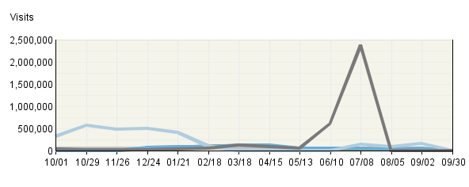

Entry Pages
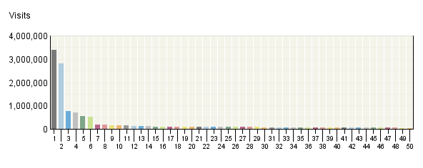

Entry Pages
 | Pages | Visits | % Visits
1. | Stay Cool, Save Money: Weekly Summer Energy Saving Tip  http:/​/​www.​energysavers​.​gov/​includes/​widgetbox.​html | 3,403,250 | 16%
2. | EERE: Kids Home Page  http:/​/​www.​eere.​energy.​gov/​kids/​ | 2,800,935 | 13%
3. | Energy Savers: Approved Energy Efficient Appliance Rebate Programs  http:/​/​www.​energysavers​.​gov/​financial/​70022.​html | 775,543 | 4%
4. | U.S. DOE Energy Efficiency and Renewable Energy (EERE) Home Page  http:/​/​www.​eere.​energy.​gov/​ | 692,558 | 3%
5. | Energy Savers: Rebates for ENERGY STAR Appliances  http:/​/​www.​energysavers​.​gov/​financial/​70020.​html | 546,035 | 3%
6. | EERE: Energy Savers Home Page  http:/​/​www.​energysavers​.​gov/​ | 517,489 | 2%
7. | Wind and Water Power Program: How Wind Turbines Work  http:/​/​www1.​eere.​energy.​gov/​windandhydro​/​wind_​how.​html | 186,476 | 1%
8. | Energy Savers: Solar Water Heaters  http:/​/​www.​energysavers​.​gov/​your_​home/​water_​heating/​index.​cfm/​mytopic=​12850 | 169,851 | 1%
9. | Wind Powering America: Wind Maps and Wind Resource Potential Estimates  http:/​/​www.​windpowering​america.​gov/​wind_​maps.​asp | 165,062 | 1%
10. | Energy Savers: Tax Credits for Energy Efficiency  http:/​/​www.​energysavers​.​gov/​financial/​70010.​html | 159,282 | 1%
11. | Energy Savers: Radiant Heating  http:/​/​www.​energysavers​.​gov/​your_​home/​space_​heating_​cooling/​index.​cfm/​mytopic=​12590 | 145,403 | 1%
12. | Energy Savers Tips: Insulation  http:/​/​www1.​eere.​energy.​gov/​consumer/​tips/​insulation.​html | 125,441 | 1%
13. | Energy Savers: Demand (Tankless or Instantaneous) Water Heaters  http:/​/​www.​energysavers​.​gov/​your_​home/​water_​heating/​index.​cfm/​mytopic=​12820 | 112,283 | 1%
14. | EERE: Energy Savers Tips Home Page  http:/​/​www1.​eere.​energy.​gov/​consumer/​tips/​ | 109,850 | 1%
15. | Lose Your Excuse -​ Landing Page  http:/​/​www.​loseyourexcu​se.​gov/​ | 105,705 | 0%
16. | Energy Savers: Portable Heaters  http:/​/​www.​energysavers​.​gov/​your_​home/​space_​heating_​cooling/​index.​cfm/​mytopic=​12600 | 103,216 | 0%
17. | Energy Savers: Estimating Appliance and Home Electronic Energy Use  http:/​/​www.​energysavers​.​gov/​your_​home/​appliances/​index.​cfm/​mytopic=​10040 | 101,739 | 0%
18. | EERE: Department of Energy Weatherization Assistance Program Home Page  http:/​/​apps1.​eere.​energy.​gov/​weatherizati​on/​ | 100,431 | 0%
19. | Energy Savers: Heat Pump Systems  http:/​/​www.​energysavers​.​gov/​your_​home/​space_​heating_​cooling/​index.​cfm/​mytopic=​12610 | 91,650 | 0%
20. | Weatherization and Intergovernmental Program: Weatherization Assistance Program  http:/​/​www1.​eere.​energy.​gov/​wip/​wap.​html | 88,249 | 0%
21. | Building Technologies Program: EnergyPlus Energy Simulation Software  http:/​/​apps1.​eere.​energy.​gov/​buildings/​energyplus/​ | 86,859 | 0%
22. | Energy Savers: Weatherstripping  http:/​/​www.​energysavers​.​gov/​your_​home/​insulation_​airsealing/​index.​cfm/​mytopic=​11280 | 86,629 | 0%
23. | Energy Savers: Furnaces and Boilers  http:/​/​www.​energysavers​.​gov/​your_​home/​space_​heating_​cooling/​index.​cfm/​mytopic=​12530 | 84,424 | 0%
24. | Energy Savers: Selecting a New Water Heater  http:/​/​www.​energysavers​.​gov/​your_​home/​water_​heating/​index.​cfm/​mytopic=​12770 | 82,776 | 0%
25. | Alternative Fuels and Advanced Vehicles Data Center: Alternative Fueling Station Locator  http:/​/​www.​afdc.​energy.​gov/​afdc/​locator/​stations/​ | 81,345 | 0%
26. | EERE: Alternative Fuels and Advanced Vehicles Data Center Program Home Page  http:/​/​www.​afdc.​energy.​gov/​afdc/​ | 80,648 | 0%
27. | EERE: Solar Energy Technologies Program Home Page  http:/​/​www1.​eere.​energy.​gov/​solar/​ | 80,633 | 0%
28. | Energy Savers: Foam Board Insulation  http:/​/​www.​energysavers​.​gov/​your_​home/​insulation_​airsealing/​index.​cfm/​mytopic=​11620 | 77,215 | 0%
29. | Energy Savers: Florida Appliance Rebates  http:/​/​www.​energysavers​.​gov/​financial/​rebates/​state_​FL.​cfm | 76,394 | 0%
30. | Energy Savers: Crawl Space Insulation  http:/​/​www.​energysavers​.​gov/​your_​home/​insulation_​airsealing/​index.​cfm/​mytopic=​11480 | 75,572 | 0%
31. | Wind Powering America: Washington 50-​Meter Wind Resource Map  http:/​/​www.​windpowering​america.​gov/​maps_​template.​asp | 73,302 | 0%
32. | Energy Savers: Geothermal Heat Pumps  http:/​/​www.​energysavers​.​gov/​your_​home/​space_​heating_​cooling/​index.​cfm/​mytopic=​12640 | 71,869 | 0%
33. | U.S. Department of Energy Solar Decathlon Home Page  http:/​/​www.​solardecathl​on.​gov/​ | 71,587 | 0%
34. | EnergyPlus Energy Simulation Software: Weather Data  http:/​/​apps1.​eere.​energy.​gov/​buildings/​energyplus/​cfm/​weather_​data.​cfm | 67,896 | 0%
35. | Energy Savers: Attic Insulation  http:/​/​www.​energysavers​.​gov/​your_​home/​insulation_​airsealing/​index.​cfm/​mytopic=​11390 | 67,488 | 0%
36. | EERE: Wind and Water Power Program Home Page  http:/​/​www1.​eere.​energy.​gov/​windandhydro​/​ | 66,619 | 0%
37. | Energy Savers: Your Home  http:/​/​www.​energysavers​.​gov/​your_​home/​ | 65,361 | 0%
38. | Energy Savers: Central Air Conditioners  http:/​/​www.​energysavers​.​gov/​your_​home/​space_​heating_​cooling/​index.​cfm/​mytopic=​12440 | 63,364 | 0%
39. | EERE: Energy Efficiency and Conservation Block Grants Program Home Page  http:/​/​www.​eecbg.​energy.​gov/​ | 63,271 | 0%
40. | Energy Savers: Thermostats and Control Systems  http:/​/​www.​energysavers​.​gov/​your_​home/​space_​heating_​cooling/​index.​cfm/​mytopic=​12720 | 62,912 | 0%
41. | EERE: Biomass Program Home Page  http:/​/​www1.​eere.​energy.​gov/​biomass/​ | 60,419 | 0%
42. | Wind and Water Power Program: Wind Powering America  http:/​/​www.​windpowering​america.​gov/​ | 57,712 | 0%
43. | Energy Savers: Do-​It-​Yourself Home Energy Assessments  http:/​/​www.​energysavers​.​gov/​your_​home/​energy_​audits/​index.​cfm/​mytopic=​11170 | 52,993 | 0%
44. | Energy Savers: Insulate Your Water Heater Tank for Energy Savings  http:/​/​www.​energysavers​.​gov/​your_​home/​water_​heating/​index.​cfm/​mytopic=​13070 | 50,168 | 0%
45. | EERE: Document Not Found  http:/​/​www1.​eere.​energy.​gov/​solar/​photovoltaic​s.​html | 48,339 | 0%
46. | Energy Savers: Air-​Source Heat Pumps  http:/​/​www.​energysavers​.​gov/​your_​home/​space_​heating_​cooling/​index.​cfm/​mytopic=​12620 | 47,385 | 0%
47. | EERE: Federal Energy Management Program Home Page  http:/​/​www1.​eere.​energy.​gov/​femp/​ | 46,931 | 0%
48. | EERE: Geothermal Technologies Program Home Page  http:/​/​www1.​eere.​energy.​gov/​geothermal/​ | 46,350 | 0%
49. | Energy Savers: Basement Insulation  http:/​/​www.​energysavers​.​gov/​your_​home/​insulation_​airsealing/​index.​cfm/​mytopic=​11470 | 45,241 | 0%
50. | Energy Savers: Home Energy Assessments  http:/​/​www.​energysavers​.​gov/​your_​home/​energy_​audits/​index.​cfm/​mytopic=​11160 | 44,526 | 0%
 | Subtotal for rows 1–50 | 12,486,676 | 58.93%
 | Other | 8,703,257 | 41.07%
 | Total | 21,189,933 | 100.00%
Items 1–50 of 1,000

Entry Pages - Help Card
Column Definitions

Entry Page
The first page in a given visit. Every visit has one and only one entry page.

Visits
For each entry page, the total number of visits that began with that entry page, during this time period.

%
For each page (row), the percentage of all visits to the site that went to that particular page during the report time period.

—
Report Descriptions

Briefly:

A visit can begin on a given page if a visitor:

- types the URL of the page in their browser then clicks on "Go"
- clicks on a bookmark to the page (stored from a previous visit)
- clicks on a link on a different site that points to the file. The link can appear to be text or an image, such as a banner ad.
- clicks on a link to the page in an e-mail. Again, the link can appear to be text or an image.
- clicks on a link on a search engine results page that points to this page
- activates an applet on another site or in a program that transfers them to this page

Finally, a visit can seem to begin on a given page if a visitor was already on the site, but allowed more than 30 minutes to elapse between clicks. When such a pause occurs, Webtrends counts two visits, one before and one after the pause. In other words, Webtrends considers a timeout of more than 30 minutes to be a de facto end of a visit. Consequently, the first page visited after the long pause will appear as an Entry Page for a new visit. Likewise, the last Page Viewed before the long pause will appear in the Exit Pages report.(Note: You can configure the session timeout in the Webtrends Admin Console. In the left pane, select Web Analysis>Options, and select the Session Tracking tab).

If your site has more than one URL for a certain page, for example, /home.html and /home.asp, consider combining their statistics to get an accurate picture of how frequently that page's content is seen.

Uses and Interpretation:

Look at each page on the Entry Pages report and ask yourself whether it is suitable as the first page a visitor sees. For example, it can be argued that entry pages should:

- identify the site and/or brand
- have a clear link to the home page
- show the same navigation bars as the rest of the site

If a page that's frequently an entry page doesn't do all these things, consider modifying it to conform with best practices.

Other relevant reports and analyses:

- Referring URLs for these entry pages.
- Relationship to Exit Pages and Single Page Visits.
- Correcting for multiple URLs for the same Page View.

Exit Pages
This report focuses on pages that were most often the final or "exit" page of a visit. You can use this report to determine whether visitors are exiting your web site using the pages you expect, such as a specially designed Thank You page, or whether certain pages are causing visitors to abandon the visit prematurely.

Exit Pages: Trend Over Time
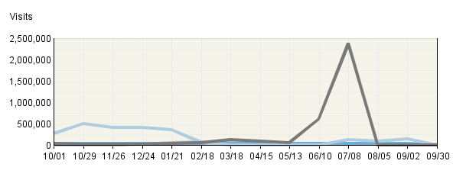

Exit Pages
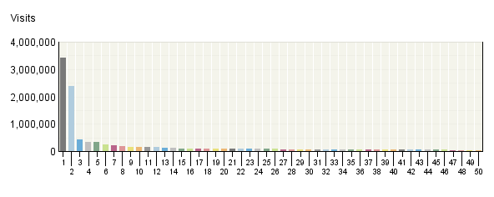

Exit Pages
 | Pages | Visits | % Visits
1. | Stay Cool, Save Money: Weekly Summer Energy Saving Tip  http:/​/​www.​energysavers​.​gov/​includes/​widgetbox.​html | 3,407,037 | 16%
2. | EERE: Kids Home Page  http:/​/​www.​eere.​energy.​gov/​kids/​ | 2,394,467 | 11%
3. | U.S. DOE Energy Efficiency and Renewable Energy (EERE) Home Page  http:/​/​www.​eere.​energy.​gov/​ | 415,368 | 2%
4. | Energy Savers: Rebates for ENERGY STAR Appliances  http:/​/​www.​energysavers​.​gov/​financial/​70020.​html | 344,356 | 2%
5. | Energy Savers: Approved Energy Efficient Appliance Rebate Programs  http:/​/​www.​energysavers​.​gov/​financial/​70022.​html | 333,708 | 2%
6. | Energy Savers: Tax Credits for Energy Efficiency  http:/​/​www.​energysavers​.​gov/​financial/​70010.​html | 236,708 | 1%
7. | EERE: Energy Savers Home Page  http:/​/​www.​energysavers​.​gov/​ | 206,409 | 1%
8. | Wind and Water Power Program: How Wind Turbines Work  http:/​/​www1.​eere.​energy.​gov/​windandhydro​/​wind_​how.​html | 168,544 | 1%
9. | Energy Savers: Solar Water Heaters  http:/​/​www.​energysavers​.​gov/​your_​home/​water_​heating/​index.​cfm/​mytopic=​12850 | 149,241 | 1%
10. | EERE Kids: TV Ads  http:/​/​www.​eere.​energy.​gov/​kids/​tvads.​html | 146,585 | 1%
11. | EERE Kids: Games and Activities  http:/​/​www.​eere.​energy.​gov/​kids/​games.​html | 145,829 | 1%
12. | Energy Savers: Radiant Heating  http:/​/​www.​energysavers​.​gov/​your_​home/​space_​heating_​cooling/​index.​cfm/​mytopic=​12590 | 139,231 | 1%
13. | Energy Savers Tips: Insulation  http:/​/​www1.​eere.​energy.​gov/​consumer/​tips/​insulation.​html | 125,710 | 1%
14. | Energy Savers: Florida Appliance Rebates  http:/​/​www.​energysavers​.​gov/​financial/​rebates/​state_​FL.​cfm | 117,832 | 1%
15. | Energy Savers: Demand (Tankless or Instantaneous) Water Heaters  http:/​/​www.​energysavers​.​gov/​your_​home/​water_​heating/​index.​cfm/​mytopic=​12820 | 102,000 | 0%
16. | Energy Savers: Portable Heaters  http:/​/​www.​energysavers​.​gov/​your_​home/​space_​heating_​cooling/​index.​cfm/​mytopic=​12600 | 101,069 | 0%
17. | Lose Your Excuse -​ Landing Page  http:/​/​www.​loseyourexcu​se.​gov/​ | 99,903 | 0%
18. | Energy Savers: Estimating Appliance and Home Electronic Energy Use  http:/​/​www.​energysavers​.​gov/​your_​home/​appliances/​index.​cfm/​mytopic=​10040 | 99,515 | 0%
19. | Alternative Fuels and Advanced Vehicles Data Center: Alternative Fueling Station Locator  http:/​/​www.​afdc.​energy.​gov/​afdc/​locator/​stations/​ | 96,322 | 0%
20. | Wind Powering America: Wind Maps and Wind Resource Potential Estimates  http:/​/​www.​windpowering​america.​gov/​wind_​maps.​asp | 95,444 | 0%
21. | Wind Powering America: Washington 50-​Meter Wind Resource Map  http:/​/​www.​windpowering​america.​gov/​maps_​template.​asp | 91,823 | 0%
22. | Energy Savers: Texas Appliance Rebates  http:/​/​www.​energysavers​.​gov/​financial/​rebates/​state_​TX.​cfm | 89,183 | 0%
23. | Energy Savers: California Appliance Rebates  http:/​/​www.​energysavers​.​gov/​financial/​rebates/​state_​CA.​cfm | 87,294 | 0%
24. | Energy Savers: Weatherstripping  http:/​/​www.​energysavers​.​gov/​your_​home/​insulation_​airsealing/​index.​cfm/​mytopic=​11280 | 85,515 | 0%
25. | Energy Savers: Furnaces and Boilers  http:/​/​www.​energysavers​.​gov/​your_​home/​space_​heating_​cooling/​index.​cfm/​mytopic=​12530 | 81,853 | 0%
26. | Energy Savers: Foam Board Insulation  http:/​/​www.​energysavers​.​gov/​your_​home/​insulation_​airsealing/​index.​cfm/​mytopic=​11620 | 77,970 | 0%
27. | Energy Savers: Heat Pump Systems  http:/​/​www.​energysavers​.​gov/​your_​home/​space_​heating_​cooling/​index.​cfm/​mytopic=​12610 | 73,520 | 0%
28. | EERE: Energy Savers Tips Home Page  http:/​/​www1.​eere.​energy.​gov/​consumer/​tips/​ | 69,262 | 0%
29. | Energy Savers: Crawl Space Insulation  http:/​/​www.​energysavers​.​gov/​your_​home/​insulation_​airsealing/​index.​cfm/​mytopic=​11480 | 65,608 | 0%
30. | Energy Savers: Illinois Appliance Rebates  http:/​/​www.​energysavers​.​gov/​financial/​rebates/​state_​IL.​cfm | 64,299 | 0%
31. | Energy Savers: Pennsylvania Appliance Rebates  http:/​/​www.​energysavers​.​gov/​financial/​rebates/​state_​PA.​cfm | 63,162 | 0%
32. | Energy Savers: Thermostats and Control Systems  http:/​/​www.​energysavers​.​gov/​your_​home/​space_​heating_​cooling/​index.​cfm/​mytopic=​12720 | 62,521 | 0%
33. | Energy Savers: Do-​It-​Yourself Home Energy Assessments  http:/​/​www.​energysavers​.​gov/​your_​home/​energy_​audits/​index.​cfm/​mytopic=​11170 | 62,156 | 0%
34. | Energy Savers: Central Air Conditioners  http:/​/​www.​energysavers​.​gov/​your_​home/​space_​heating_​cooling/​index.​cfm/​mytopic=​12440 | 61,704 | 0%
35. | Energy Savers: Ohio Appliance Rebates  http:/​/​www.​energysavers​.​gov/​financial/​rebates/​state_​OH.​cfm | 60,144 | 0%
36. | EERE: Solar Energy Technologies Program Home Page  http:/​/​www1.​eere.​energy.​gov/​solar/​ | 59,547 | 0%
37. | Energy Savers: Massachusetts Appliance Rebates  http:/​/​www.​energysavers​.​gov/​financial/​rebates/​state_​MA.​cfm | 56,696 | 0%
38. | Weatherization and Intergovernmental Program: Weatherization Assistance Program  http:/​/​www1.​eere.​energy.​gov/​wip/​wap.​html | 55,569 | 0%
39. | Energy Savers: Geothermal Heat Pumps  http:/​/​www.​energysavers​.​gov/​your_​home/​space_​heating_​cooling/​index.​cfm/​mytopic=​12640 | 54,615 | 0%
40. | Energy Savers: Air-​Source Heat Pumps  http:/​/​www.​energysavers​.​gov/​your_​home/​space_​heating_​cooling/​index.​cfm/​mytopic=​12620 | 54,593 | 0%
41. | Wind Powering America -​ Small Wind Electric Systems: A Washington Consumer's Guide  http:/​/​www.​windpowering​america.​gov/​filter_​detail.​asp | 53,598 | 0%
42. | Wind Powering America: Washington Wind Map and Resource Potential  http:/​/​www.​windpowering​america.​gov/​wind_​resource_​maps.​asp | 53,314 | 0%
43. | Energy Savers: Selecting a New Water Heater  http:/​/​www.​energysavers​.​gov/​your_​home/​water_​heating/​index.​cfm/​mytopic=​12770 | 52,871 | 0%
44. | EERE: Department of Energy Weatherization Assistance Program Home Page  http:/​/​apps1.​eere.​energy.​gov/​weatherizati​on/​ | 52,194 | 0%
45. | Energy Savers: New York Appliance Rebates  http:/​/​www.​energysavers​.​gov/​financial/​rebates/​state_​NY.​cfm | 49,592 | 0%
46. | Energy Savers: North Carolina Appliance Rebates  http:/​/​www.​energysavers​.​gov/​financial/​rebates/​state_​NC.​cfm | 47,427 | 0%
47. | Energy Savers: Your Home  http:/​/​www.​energysavers​.​gov/​your_​home/​ | 45,572 | 0%
48. | Wind and Water Power Program: How Does a Wind Turbine Work?  http:/​/​www1.​eere.​energy.​gov/​windandhydro​/​wind_​animation.​html | 43,885 | 0%
49. | Energy Savers: Attic Insulation  http:/​/​www.​energysavers​.​gov/​your_​home/​insulation_​airsealing/​index.​cfm/​mytopic=​11390 | 43,360 | 0%
50. | Energy Savers: Adding Insulation to an Existing Home  http:/​/​www.​energysavers​.​gov/​your_​home/​insulation_​airsealing/​index.​cfm/​mytopic=​11350 | 43,149 | 0%
 | Subtotal for rows 1–50 | 10,787,274 | 50.91%
 | Other | 10,402,324 | 49.09%
 | Total | 21,189,598 | 100.00%
Items 1–50 of 1,000

Exit Pages - Help Card
Column Definitions

Exit Page
The last page viewed in a given visit. Every visit has one and only one exit page.

Visits
For each exit page, the total number of visits that ended with that page. Note that visits for exit pages are calculated at the end of the visit, which may differ from the count at the start of the visit. Therefore, exit visits may differ from visits in other reports such as the Overview Dashboard or the Entry Pages report.

%
For each page (row), the percentage of all visits to the site that went to that particular page during the report time period.

—
Report Descriptions

Briefly:

If a visitor leaves your site or is inactive for a long time, Webtrends counts the visit as "ended" after 30 minutes of inaction. Visitors may have:

- Browsed to a different site
- Closed their browser
- Remained inactive for more than 30 minutes but did not leave your site. Note that if a visitor resumes clicking on your site after 30 minutes of inactivity, Webtrends records two visits, one before and one after the pause. Consequently, the last page viewed before the long pause will appear as an Exit Page, the first page viewed after the long pause will appear in the Entry Pages report, and your own domain will be the referring domain.

It's usually not possible to know where a visitor went after your site. Log files only record those clicks that are requests for files housed onyourservers. If your site has links to other sites, it is possible to find out if visitors left the site using those links if you modify those links so that, when clicked on, they request a redirect page from your server that in turn takes them to the destination site.

It's usually not possible to know how long a visitor stayed on the exit page before leaving. All that is known is that the visitor had no activity (clicks) for at least 30 minutes.

Uses and Interpretation:

Examine each exit page in the report and ask yourself whether it can be considered a desirable or undesirable ending point for a visit. For example, a purchase thank-you page would be a desirable end of a visit, but a page in the middle of a registration process would be undesirable as a last page.

Undesirable exit pages may indicate a problem needing addressing, such as:

- a difficult multi-step process
- a page that takes too long to load
- content that does not hold the visitor's interest
- confusing navigation

Other relevant reports and analyses:

Relationship to Entry Pages and Single-Page Visits.

Single-Page Visits
This report focuses on pages that were most often viewed during a visit consisting of exactly one page view. You can use this report to determine the success of certain pages designed to provide visitors with all needed information on a single page, or whether certain pages are causing visitors to abandon the visit prematurely.

Single-​Page Visits: Trend Over Time
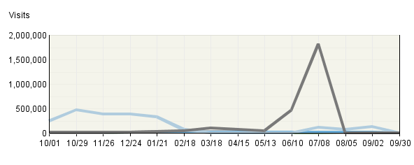

Single-​Page Visits
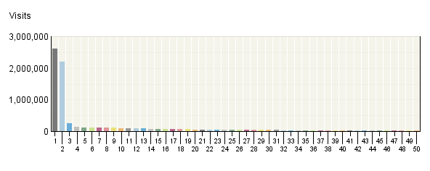

Single-​Page Visits
 | Pages | Visits | % Visits
1. | Stay Cool, Save Money: Weekly Summer Energy Saving Tip  http:/​/​www.​energysavers​.​gov/​includes/​widgetbox.​html | 2,618,027 | 21%
2. | EERE: Kids Home Page  http:/​/​www.​eere.​energy.​gov/​kids/​ | 2,207,014 | 18%
3. | U.S. DOE Energy Efficiency and Renewable Energy (EERE) Home Page  http:/​/​www.​eere.​energy.​gov/​ | 251,771 | 2%
4. | Energy Savers: Rebates for ENERGY STAR Appliances  http:/​/​www.​energysavers​.​gov/​financial/​70020.​html | 148,564 | 1%
5. | EERE: Energy Savers Home Page  http:/​/​www.​energysavers​.​gov/​ | 120,257 | 1%
6. | Energy Savers: Radiant Heating  http:/​/​www.​energysavers​.​gov/​your_​home/​space_​heating_​cooling/​index.​cfm/​mytopic=​12590 | 117,780 | 1%
7. | Wind and Water Power Program: How Wind Turbines Work  http:/​/​www1.​eere.​energy.​gov/​windandhydro​/​wind_​how.​html | 113,101 | 1%
8. | Energy Savers: Solar Water Heaters  http:/​/​www.​energysavers​.​gov/​your_​home/​water_​heating/​index.​cfm/​mytopic=​12850 | 107,190 | 1%
9. | Energy Savers: Approved Energy Efficient Appliance Rebate Programs  http:/​/​www.​energysavers​.​gov/​financial/​70022.​html | 105,624 | 1%
10. | Energy Savers: Tax Credits for Energy Efficiency  http:/​/​www.​energysavers​.​gov/​financial/​70010.​html | 94,503 | 1%
11. | Energy Savers Tips: Insulation  http:/​/​www1.​eere.​energy.​gov/​consumer/​tips/​insulation.​html | 91,872 | 1%
12. | Energy Savers: Portable Heaters  http:/​/​www.​energysavers​.​gov/​your_​home/​space_​heating_​cooling/​index.​cfm/​mytopic=​12600 | 87,828 | 1%
13. | Lose Your Excuse -​ Landing Page  http:/​/​www.​loseyourexcu​se.​gov/​ | 82,896 | 1%
14. | Energy Savers: Estimating Appliance and Home Electronic Energy Use  http:/​/​www.​energysavers​.​gov/​your_​home/​appliances/​index.​cfm/​mytopic=​10040 | 78,405 | 1%
15. | Energy Savers: Weatherstripping  http:/​/​www.​energysavers​.​gov/​your_​home/​insulation_​airsealing/​index.​cfm/​mytopic=​11280 | 70,107 | 1%
16. | Alternative Fuels and Advanced Vehicles Data Center: Alternative Fueling Station Locator  http:/​/​www.​afdc.​energy.​gov/​afdc/​locator/​stations/​ | 68,685 | 1%
17. | http:/​/​apps3.​eere.​energy.​gov/​greenpower/​gpn_​rss.​php | 65,812 | 1%
18. | Energy Savers: Demand (Tankless or Instantaneous) Water Heaters  http:/​/​www.​energysavers​.​gov/​your_​home/​water_​heating/​index.​cfm/​mytopic=​12820 | 63,448 | 1%
19. | Energy Savers: Furnaces and Boilers  http:/​/​www.​energysavers​.​gov/​your_​home/​space_​heating_​cooling/​index.​cfm/​mytopic=​12530 | 57,620 | 0%
20. | Energy Savers: Foam Board Insulation  http:/​/​www.​energysavers​.​gov/​your_​home/​insulation_​airsealing/​index.​cfm/​mytopic=​11620 | 55,508 | 0%
21. | Energy Savers: Thermostats and Control Systems  http:/​/​www.​energysavers​.​gov/​your_​home/​space_​heating_​cooling/​index.​cfm/​mytopic=​12720 | 52,791 | 0%
22. | Energy Savers: Central Air Conditioners  http:/​/​www.​energysavers​.​gov/​your_​home/​space_​heating_​cooling/​index.​cfm/​mytopic=​12440 | 49,555 | 0%
23. | Energy Savers: Florida Appliance Rebates  http:/​/​www.​energysavers​.​gov/​financial/​rebates/​state_​FL.​cfm | 49,342 | 0%
24. | Energy Savers: Crawl Space Insulation  http:/​/​www.​energysavers​.​gov/​your_​home/​insulation_​airsealing/​index.​cfm/​mytopic=​11480 | 47,244 | 0%
25. | Wind Powering America: Wind Maps and Wind Resource Potential Estimates  http:/​/​www.​windpowering​america.​gov/​wind_​maps.​asp | 47,114 | 0%
26. | Energy Savers: Heat Pump Systems  http:/​/​www.​energysavers​.​gov/​your_​home/​space_​heating_​cooling/​index.​cfm/​mytopic=​12610 | 45,041 | 0%
27. | EERE: Energy Savers Tips Home Page  http:/​/​www1.​eere.​energy.​gov/​consumer/​tips/​ | 42,944 | 0%
28. | Wind Powering America: Washington 50-​Meter Wind Resource Map  http:/​/​www.​windpowering​america.​gov/​maps_​template.​asp | 38,558 | 0%
29. | Energy Savers: Air-​Source Heat Pumps  http:/​/​www.​energysavers​.​gov/​your_​home/​space_​heating_​cooling/​index.​cfm/​mytopic=​12620 | 36,675 | 0%
30. | Weatherization and Intergovernmental Program: Weatherization Assistance Program  http:/​/​www1.​eere.​energy.​gov/​wip/​wap.​html | 35,935 | 0%
31. | Energy Savers: Do-​It-​Yourself Home Energy Assessments  http:/​/​www.​energysavers​.​gov/​your_​home/​energy_​audits/​index.​cfm/​mytopic=​11170 | 34,611 | 0%
32. | EERE: Solar Energy Technologies Program Home Page  http:/​/​www1.​eere.​energy.​gov/​solar/​ | 32,959 | 0%
33. | EERE: Department of Energy Weatherization Assistance Program Home Page  http:/​/​apps1.​eere.​energy.​gov/​weatherizati​on/​ | 31,524 | 0%
34. | Energy Savers: Insulate Your Water Heater Tank for Energy Savings  http:/​/​www.​energysavers​.​gov/​your_​home/​water_​heating/​index.​cfm/​mytopic=​13070 | 31,410 | 0%
35. | FCT Fuel Cells: Types of Fuel Cells  http:/​/​www1.​eere.​energy.​gov/​hydrogenandf​uelcells/​fuelcells/​fc_​types.​html | 31,095 | 0%
36. | Energy Savers: When to Turn Off Your Lights  http:/​/​www.​energysavers​.​gov/​your_​home/​lighting_​daylighting/​index.​cfm/​mytopic=​12280 | 31,057 | 0%
37. | Energy Savers: Texas Appliance Rebates  http:/​/​www.​energysavers​.​gov/​financial/​rebates/​state_​TX.​cfm | 29,860 | 0%
38. | Energy Savers: Lower Water Heating Temperature for Energy Savings  http:/​/​www.​energysavers​.​gov/​your_​home/​water_​heating/​index.​cfm/​mytopic=​13090 | 29,654 | 0%
39. | U.S. Department of Energy Solar Decathlon Home Page  http:/​/​www.​solardecathl​on.​gov/​ | 29,034 | 0%
40. | Energy Savers: Geothermal Heat Pumps  http:/​/​www.​energysavers​.​gov/​your_​home/​space_​heating_​cooling/​index.​cfm/​mytopic=​12640 | 28,913 | 0%
41. | Energy Savers: Storm Windows  http:/​/​www.​energysavers​.​gov/​your_​home/​windows_​doors_​skylights/​index.​cfm/​mytopic=​13490 | 28,521 | 0%
42. | Energy Savers: Ductless, Mini-​Split Heat Pumps  http:/​/​www.​energysavers​.​gov/​your_​home/​space_​heating_​cooling/​index.​cfm/​mytopic=​12630 | 26,388 | 0%
43. | Building Technologies Program: EnergyPlus Energy Simulation Software  http:/​/​apps1.​eere.​energy.​gov/​buildings/​energyplus/​ | 26,120 | 0%
44. | Wind Powering America -​ Small Wind Electric Systems: A Washington Consumer's Guide  http:/​/​www.​windpowering​america.​gov/​filter_​detail.​asp | 26,071 | 0%
45. | Energy Savers: Radiant Barriers  http:/​/​www.​energysavers​.​gov/​your_​home/​insulation_​airsealing/​index.​cfm/​mytopic=​11680 | 26,020 | 0%
46. | Energy Savers: Wood and Pellet Heating  http:/​/​www.​energysavers​.​gov/​your_​home/​space_​heating_​cooling/​index.​cfm/​mytopic=​12570 | 25,906 | 0%
47. | Energy Savers: Your Home  http:/​/​www.​energysavers​.​gov/​your_​home/​ | 25,790 | 0%
48. | Energy Savers: Electric Resistance Heating  http:/​/​www.​energysavers​.​gov/​your_​home/​space_​heating_​cooling/​index.​cfm/​mytopic=​12520 | 25,720 | 0%
49. | EERE: Alternative Fuels and Advanced Vehicles Data Center Program Home Page  http:/​/​www.​afdc.​energy.​gov/​afdc/​ | 25,568 | 0%
50. | EERE: Energy Efficiency and Conservation Block Grants Program Home Page  http:/​/​www.​eecbg.​energy.​gov/​ | 25,563 | 0%
 | Subtotal for rows 1–50 | 7,622,995 | 61.91%
 | Other | 4,690,984 | 38.09%
 | Total | 12,313,979 | 100.00%
Items 1–50 of 1,000

Single-Page Visits - Help Card
Column Definitions

Pages
Any displayed page. You can specify for each profile the types of files that qualify as a page. These settings can be changed by the Webtrends administrator.

Visits
Number of visits where the specified page was the exit page. A visit is a series of actions that begins when a visitor views their first page from the server, and ends when the visitor leaves the site or remains idle beyond the idle-time limit. The default idle-time limit is thirty minutes. This time limit can be changed by the system administrator.

%
For each page (row), the percentage of all visits to the site that went to that particular page during the report time period.

—
Report Descriptions

Briefly:

The proportion of all visits that are single page visits can be surprisingly high, although this phenomenon is experienced on most public websites. But the Single Page Visit statistic is easily skewed by certain site structures. The most common is an arrival page that automatically redirects the visitor to the "real" home page. Single-Page Visits will be underestimated in these cases, because visitors have requested two pages by the time they reach the home page. Any visitor who leaves immediately will be counted as a two-page visit. Their single-page experience will not appear in the Single-Page Visits report.

The Single Page Visits report can be made more accurate by filtering out the arrival page (losing, unfortunately, important referrer information). A better solution is to change the URL of the redirect page into the URL of the target page, using the URL Search and Replace function or Webtrends Scripting Language. Parameters can be different in the two log lines as long as the stem is the same. In the logs, the session will appear to be two consecutive hits to the target page, which Webtrends perceives as a Single-Page Visit to the target page.

Uses and Interpretation:

Before using Single Page Visits (SPVs) to evaluate a site's success, be clear about which Single-Page Visits are desirable or undesirable. For example, are some of your pages intended to be self-sufficient, such as a "What's New" page?

SPVs can be part of a set of overall site metrics called "Percent of all Visits that are Single-Page Visits." Ideally, undesirable SPVs should be low, and desirable SPVs should be high.

Pages in which undesirable SPVs more than expected should be evaluated for possible content or design flaws. Examples:

- There is no obvious way to go further into the site.
- The page doesn't convey what the site is about.
- The visitor is overwhelmed by complexity of the page.
- The page takes too long to load.

In a marketing context, high numbers of Single-Page Visits can indicate that visitors are coming to the site for the wrong reason. Do new visitors have accurate perceptions about what the site offers? Are your ads or search engine listings giving the correct impression?

Other relevant reports and analyses:

Separate SPV Statistics for New and Returning Visitors

Path Analysis: All Entry Pages
This report tracks visitor activity for the paths to and from a specified page. It includes all previous and subsequent pages. The default definition of a page in this context is any document ending with the extension .htm, .html, or .asp. This definition can be changed by the system administrator .

Path Analysis: All Entry Pages (Linear View)
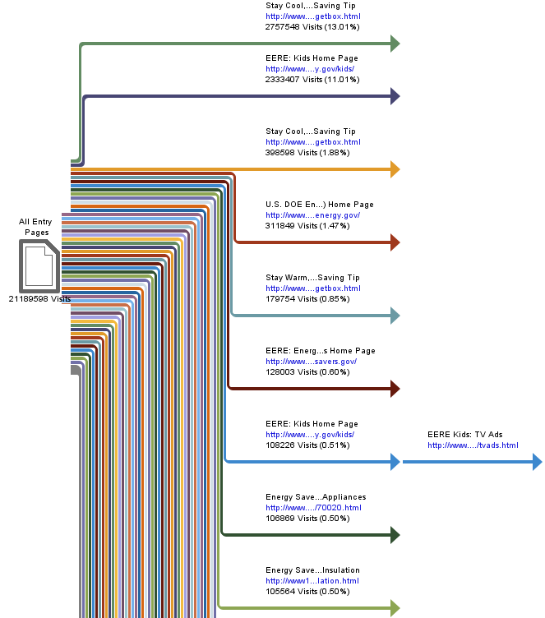

Path Analysis: All Entry Pages (Linear View)
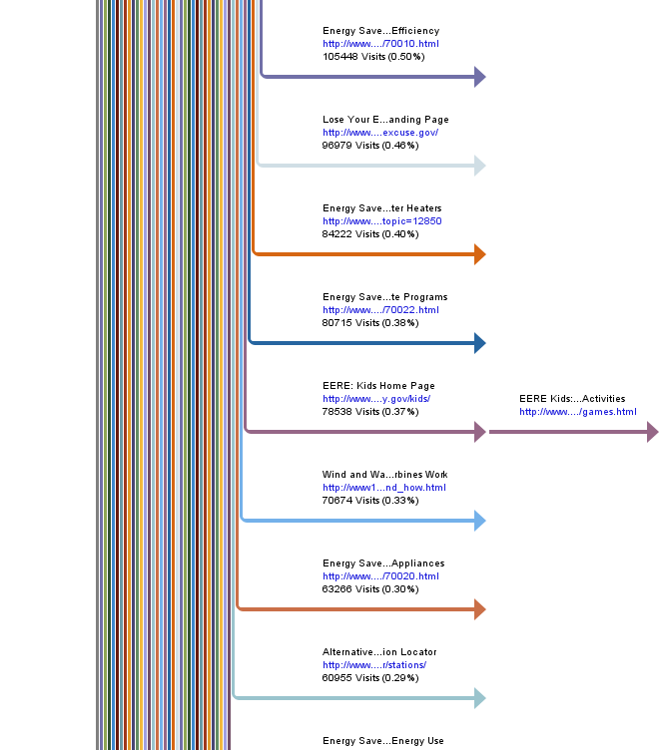

Path Analysis: All Entry Pages (Linear View)
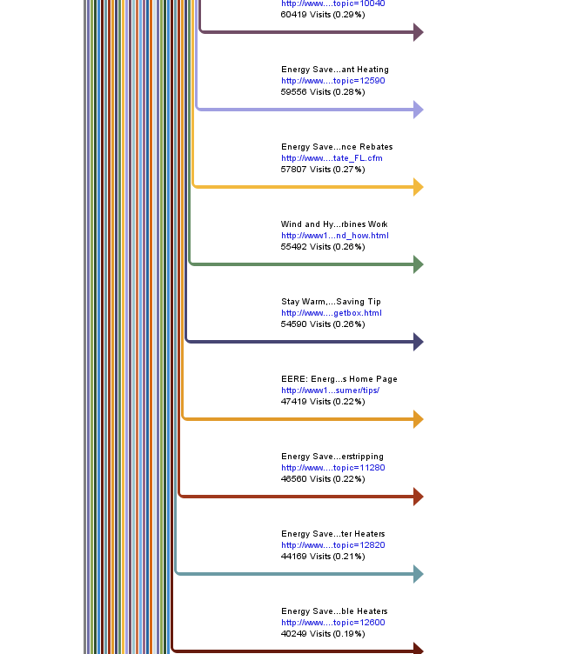

Path Analysis: All Entry Pages (Linear View)
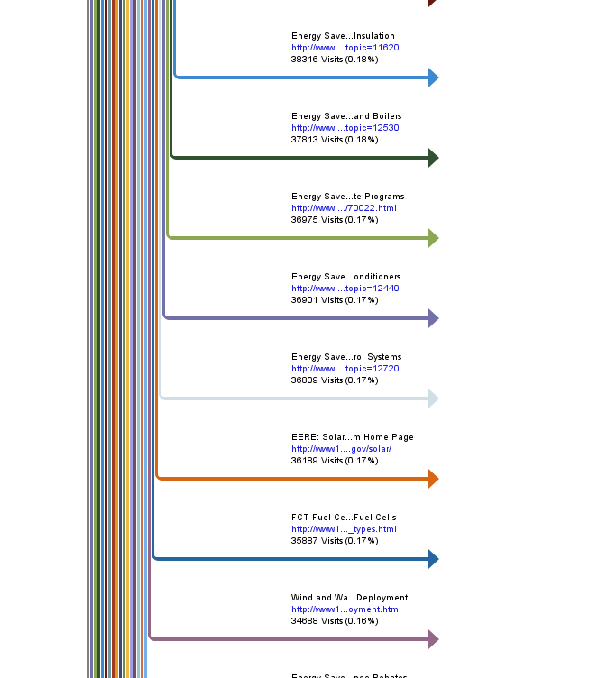

Path Analysis: All Entry Pages (Linear View)
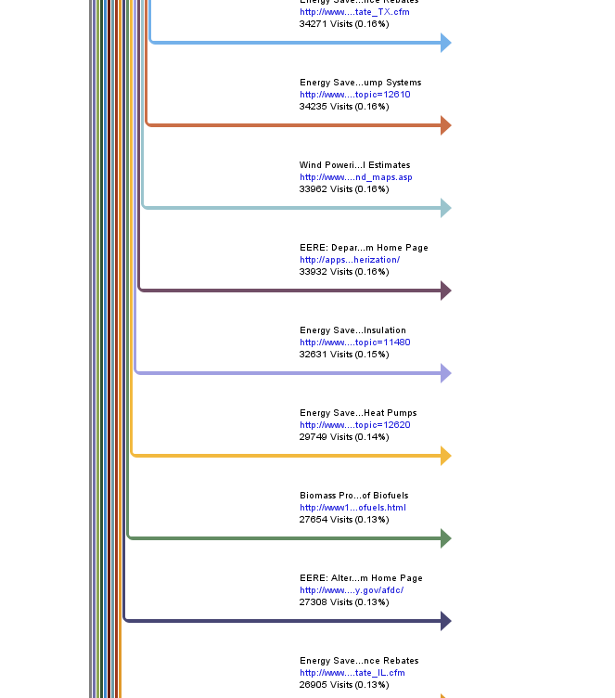

Path Analysis: All Entry Pages (Linear View)
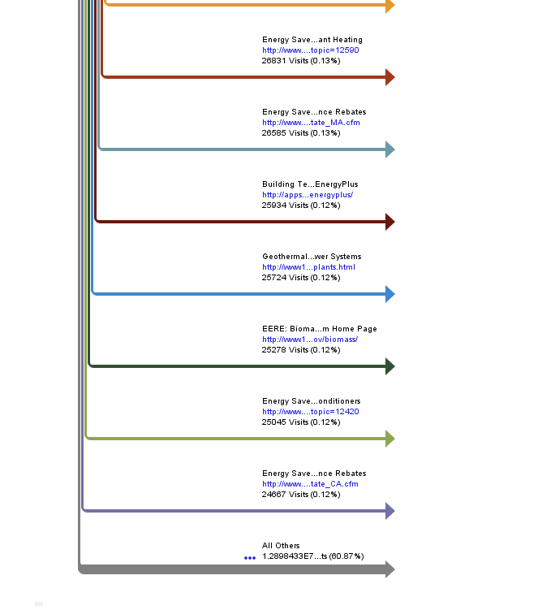

Path Analysis: All Entry Pages
 | Paths from Start | Visits | % Visits
1. | - Stay Cool, Save Money: Weekly Summer Energy Saving Tip  http:/​/​www.​energysavers​.​gov/​includes/​widgetbox.​html | 2,757,548 | 13%
2. | - EERE: Kids Home Page  http:/​/​www.​eere.​energy.​gov/​kids/​ | 2,333,407 | 11%
3. | - Stay Cool, Save Money: Weekly Spring Energy Saving Tip  http:/​/​www.​energysavers​.​gov/​includes/​widgetbox.​html | 398,598 | 2%
4. | - U.S. DOE Energy Efficiency and Renewable Energy (EERE) Home Page  http:/​/​www.​eere.​energy.​gov/​ | 311,849 | 1%
5. | - Stay Warm, Save Money: Weekly Winter Energy Saving Tip  http:/​/​www.​energysavers​.​gov/​includes/​widgetbox.​html | 179,754 | 1%
6. | - EERE: Energy Savers Home Page  http:/​/​www.​energysavers​.​gov/​ | 128,003 | 1%
7. | - EERE: Kids Home Page  http:/​/​www.​eere.​energy.​gov/​kids/​  - EERE Kids: TV Ads  http:/​/​www.​eere.​energy.​gov/​kids/​tvads.​html | 108,226 | 1%
8. | - Energy Savers: Rebates for ENERGY STAR Appliances  http:/​/​www.​energysavers​.​gov/​financial/​70020.​html | 106,869 | 1%
9. | - Energy Savers Tips: Insulation  http:/​/​www1.​eere.​energy.​gov/​consumer/​tips/​insulation.​html | 105,564 | 0%
10. | - Energy Savers: Tax Credits for Energy Efficiency  http:/​/​www.​energysavers​.​gov/​financial/​70010.​html | 105,448 | 0%
11. | - Lose Your Excuse -​ Landing Page  http:/​/​www.​loseyourexcu​se.​gov/​ | 96,979 | 0%
12. | - Energy Savers: Solar Water Heaters  http:/​/​www.​energysavers​.​gov/​your_​home/​water_​heating/​index.​cfm/​mytopic=​12850 | 84,222 | 0%
13. | - Energy Savers: Approved Energy Efficient Appliance Rebate Programs  http:/​/​www.​energysavers​.​gov/​financial/​70022.​html | 80,715 | 0%
14. | - EERE: Kids Home Page  http:/​/​www.​eere.​energy.​gov/​kids/​  - EERE Kids: Games and Activities  http:/​/​www.​eere.​energy.​gov/​kids/​games.​html | 78,538 | 0%
15. | - Wind and Water Power Program: How Wind Turbines Work  http:/​/​www1.​eere.​energy.​gov/​windandhydro​/​wind_​how.​html | 70,674 | 0%
16. | - Energy Savers: Rebates for ENERGY STAR Appliances  http:/​/​www.​energysavers​.​gov/​financial/​70020.​html | 63,266 | 0%
17. | - Alternative Fuels and Advanced Vehicles Data Center: Alternative Fueling Station Locator  http:/​/​www.​afdc.​energy.​gov/​afdc/​locator/​stations/​ | 60,955 | 0%
18. | - Energy Savers: Estimating Appliance and Home Electronic Energy Use  http:/​/​www.​energysavers​.​gov/​your_​home/​appliances/​index.​cfm/​mytopic=​10040 | 60,419 | 0%
19. | - Energy Savers: Radiant Heating  http:/​/​www.​energysavers​.​gov/​your_​home/​space_​heating_​cooling/​index.​cfm/​mytopic=​12590 | 59,556 | 0%
20. | - Energy Savers: Florida Appliance Rebates  http:/​/​www.​energysavers​.​gov/​financial/​rebates/​state_​FL.​cfm | 57,807 | 0%
21. | - Wind and Hydropower Technologies Program: How Wind Turbines Work  http:/​/​www1.​eere.​energy.​gov/​windandhydro​/​wind_​how.​html | 55,492 | 0%
22. | - Stay Warm, Save Money: Weekly Fall Energy Saving Tip  http:/​/​www.​energysavers​.​gov/​includes/​widgetbox.​html | 54,590 | 0%
23. | - EERE: Energy Savers Tips Home Page  http:/​/​www1.​eere.​energy.​gov/​consumer/​tips/​ | 47,419 | 0%
24. | - Energy Savers: Weatherstripping  http:/​/​www.​energysavers​.​gov/​your_​home/​insulation_​airsealing/​index.​cfm/​mytopic=​11280 | 46,560 | 0%
25. | - Energy Savers: Demand (Tankless or Instantaneous) Water Heaters  http:/​/​www.​energysavers​.​gov/​your_​home/​water_​heating/​index.​cfm/​mytopic=​12820 | 44,169 | 0%
26. | - Energy Savers: Portable Heaters  http:/​/​www.​energysavers​.​gov/​your_​home/​space_​heating_​cooling/​index.​cfm/​mytopic=​12600 | 40,249 | 0%
27. | - Energy Savers: Foam Board Insulation  http:/​/​www.​energysavers​.​gov/​your_​home/​insulation_​airsealing/​index.​cfm/​mytopic=​11620 | 38,316 | 0%
28. | - Energy Savers: Furnaces and Boilers  http:/​/​www.​energysavers​.​gov/​your_​home/​space_​heating_​cooling/​index.​cfm/​mytopic=​12530 | 37,813 | 0%
29. | - Energy Savers: Approved Energy Efficient Appliance Rebate Programs  http:/​/​www.​energysavers​.​gov/​financial/​70022.​html | 36,975 | 0%
30. | - Energy Savers: Central Air Conditioners  http:/​/​www.​energysavers​.​gov/​your_​home/​space_​heating_​cooling/​index.​cfm/​mytopic=​12440 | 36,901 | 0%
31. | - Energy Savers: Thermostats and Control Systems  http:/​/​www.​energysavers​.​gov/​your_​home/​space_​heating_​cooling/​index.​cfm/​mytopic=​12720 | 36,809 | 0%
32. | - EERE: Solar Energy Technologies Program Home Page  http:/​/​www1.​eere.​energy.​gov/​solar/​ | 36,189 | 0%
33. | - FCT Fuel Cells: Types of Fuel Cells  http:/​/​www1.​eere.​energy.​gov/​hydrogenandf​uelcells/​fuelcells/​fc_​types.​html | 35,887 | 0%
34. | - Wind and Water Power Program: Deployment  http:/​/​www1.​eere.​energy.​gov/​windandhydro​/​deployment.​html | 34,688 | 0%
35. | - Energy Savers: Texas Appliance Rebates  http:/​/​www.​energysavers​.​gov/​financial/​rebates/​state_​TX.​cfm | 34,271 | 0%
36. | - Energy Savers: Heat Pump Systems  http:/​/​www.​energysavers​.​gov/​your_​home/​space_​heating_​cooling/​index.​cfm/​mytopic=​12610 | 34,235 | 0%
37. | - Wind Powering America: Wind Maps and Wind Resource Potential Estimates  http:/​/​www.​windpowering​america.​gov/​wind_​maps.​asp | 33,962 | 0%
38. | - EERE: Department of Energy Weatherization Assistance Program Home Page  http:/​/​apps1.​eere.​energy.​gov/​weatherizati​on/​ | 33,932 | 0%
39. | - Energy Savers: Crawl Space Insulation  http:/​/​www.​energysavers​.​gov/​your_​home/​insulation_​airsealing/​index.​cfm/​mytopic=​11480 | 32,631 | 0%
40. | - Energy Savers: Air-​Source Heat Pumps  http:/​/​www.​energysavers​.​gov/​your_​home/​space_​heating_​cooling/​index.​cfm/​mytopic=​12620 | 29,749 | 0%
41. | - Biomass Program: ABC's of Biofuels  http:/​/​www1.​eere.​energy.​gov/​biomass/​abcs_​biofuels.​html | 27,654 | 0%
42. | - EERE: Alternative Fuels and Advanced Vehicles Data Center Program Home Page  http:/​/​www.​afdc.​energy.​gov/​afdc/​ | 27,308 | 0%
43. | - Energy Savers: Illinois Appliance Rebates  http:/​/​www.​energysavers​.​gov/​financial/​rebates/​state_​IL.​cfm | 26,905 | 0%
44. | - Energy Savers: Radiant Heating  http:/​/​www.​energysavers​.​gov/​your_​home/​space_​heating_​cooling/​index.​cfm/​mytopic=​12590 | 26,831 | 0%
45. | - Energy Savers: Massachusetts Appliance Rebates  http:/​/​www.​energysavers​.​gov/​financial/​rebates/​state_​MA.​cfm | 26,585 | 0%
46. | - Building Technologies Program: EnergyPlus  http:/​/​apps1.​eere.​energy.​gov/​buildings/​energyplus/​ | 25,934 | 0%
47. | - Geothermal Technologies Program: Hydrothermal Power Systems  http:/​/​www1.​eere.​energy.​gov/​geothermal/​powerplants.​html | 25,724 | 0%
48. | - EERE: Biomass Program Home Page  http:/​/​www1.​eere.​energy.​gov/​biomass/​ | 25,278 | 0%
49. | - Energy Savers: Room Air Conditioners  http:/​/​www.​energysavers​.​gov/​your_​home/​space_​heating_​cooling/​index.​cfm/​mytopic=​12420 | 25,045 | 0%
50. | - Energy Savers: California Appliance Rebates  http:/​/​www.​energysavers​.​gov/​financial/​rebates/​state_​CA.​cfm | 24,667 | 0%
51. | All Others | 12,898,433 | 61%
 | Total | 21,189,598 | 100.00%
Items 1–50 of 3,000

Path Analysis: All Entry Pages - Help Card
Column Definitions

Path Analysis
This represents the specified root page with the various paths your visitors took to it and from it. Pages listed are limited to the paths configured for analysis in this profile.

Visits
Number of visits where the specified path was followed.

%
Percentage of times that the specified path through your site was taken compared to all other listed paths through your site.

—
Report Descriptions

Briefly:

This report shows the sequence of pages viewed before and after a specified page is viewed. In other words, it's the routes taken to and from a specified page.

It helps to know the path analysis limit of your report. The length of paths displayed in the path analysis is limited to a number of steps specified in the report setup. This means that paths in this table are actually likely to be longer than the number of steps displayed.

Note that if a visitor views a page twice during a visit, a path report containing this page will show one visit for each instance. This applies to all Path Analysis reports, but not to Paths of Entry reports (Paths of Entry and Content Paths from Entry).

Uses and Interpretation:

Use this report to look for weaknesses and to understand visitor content and navigation preferences:

- Compare the most common paths in this report to those you expected when planning your site. Are they the same? If not, perhaps visitors are confused by your navigation ... or perhaps you predicted their paths incorrectly.
- Ask if your visitors are leaving the site earlier than you would like. Pay special attention to the short paths. Are too many visitors leaving the site before they know what your site is about? Does knowing the exit pages help you understand why?
- Notice which content topics are being visiting right away. Forward paths help you understand what content is most important to visitors in the sense of where they go first. If just a few of your content topics seem to be the first destination of most visitors, perhaps those topics should be made more prominent in the home page navigation.
- Notice whether visitors drill down deeply right away, or instead look at a number of same-level pages before going deeper. If they're drilling down several levels, perhaps you should reduce the number of clicks needed to get to the depth they seem to want. Should you bring some pages up higher in the navigation tree? If they're looking at a variety of top-level pages before going deeper, check whether they are using the home page as a hub - often returning to it between jumps to second-level pages. Is this "pogo-sticking" navigation being forced on them? If your second-level pages can't be reached directly from each other, consider reducing the number of clicks by adding "sideways" links.
- An "important" page might be a Customer Service page (indicating a possible desire for assistance resulting from the previous pages), a Contact-Us page (indicating possible frustration caused by previous pages), or the Site Map (indicating a need for navigation help caused by confusion on the previous pages).
- Also use this report to find out which of several possible routes led to a key positive event. For example, a particular product page might be reached several ways: through navigation, search, and through a "featured product" link on the home page. Reverse Paths with that product page as the destination will show how common each approach was.

Other relevant reports and analyses:

The Content Paths reports shows paths in which the individual steps are not page views, but content group views.

Paths, Forward: All Entry Pages
This report shows the most common page-by-page sequence followed by visitors after the specified start page. The paths may or may not include a visit's Exit Page.

Paths, Forward: All Entry Pages (Linear View)

Paths, Forward: All Entry Pages (Linear View)

Paths, Forward: All Entry Pages (Linear View)

Paths, Forward: All Entry Pages (Linear View)

Paths, Forward: All Entry Pages (Linear View)

Paths, Forward: All Entry Pages (Linear View)

Paths, Forward: All Entry Pages
 | Paths from Start | Visits | % Visits
1. | - Stay Cool, Save Money: Weekly Summer Energy Saving Tip  http:/​/​www.​energysavers​.​gov/​includes/​widgetbox.​html | 2,757,548 | 13%
2. | - EERE: Kids Home Page  http:/​/​www.​eere.​energy.​gov/​kids/​ | 2,333,407 | 11%
3. | - Stay Cool, Save Money: Weekly Spring Energy Saving Tip  http:/​/​www.​energysavers​.​gov/​includes/​widgetbox.​html | 398,598 | 2%
4. | - U.S. DOE Energy Efficiency and Renewable Energy (EERE) Home Page  http:/​/​www.​eere.​energy.​gov/​ | 311,849 | 1%
5. | - Stay Warm, Save Money: Weekly Winter Energy Saving Tip  http:/​/​www.​energysavers​.​gov/​includes/​widgetbox.​html | 179,754 | 1%
6. | - EERE: Energy Savers Home Page  http:/​/​www.​energysavers​.​gov/​ | 128,003 | 1%
7. | - EERE: Kids Home Page  http:/​/​www.​eere.​energy.​gov/​kids/​  - EERE Kids: TV Ads  http:/​/​www.​eere.​energy.​gov/​kids/​tvads.​html | 108,226 | 1%
8. | - Energy Savers: Rebates for ENERGY STAR Appliances  http:/​/​www.​energysavers​.​gov/​financial/​70020.​html | 106,869 | 1%
9. | - Energy Savers Tips: Insulation  http:/​/​www1.​eere.​energy.​gov/​consumer/​tips/​insulation.​html | 105,564 | 0%
10. | - Energy Savers: Tax Credits for Energy Efficiency  http:/​/​www.​energysavers​.​gov/​financial/​70010.​html | 105,448 | 0%
11. | - Lose Your Excuse -​ Landing Page  http:/​/​www.​loseyourexcu​se.​gov/​ | 96,979 | 0%
12. | - Energy Savers: Solar Water Heaters  http:/​/​www.​energysavers​.​gov/​your_​home/​water_​heating/​index.​cfm/​mytopic=​12850 | 84,222 | 0%
13. | - Energy Savers: Approved Energy Efficient Appliance Rebate Programs  http:/​/​www.​energysavers​.​gov/​financial/​70022.​html | 80,715 | 0%
14. | - EERE: Kids Home Page  http:/​/​www.​eere.​energy.​gov/​kids/​  - EERE Kids: Games and Activities  http:/​/​www.​eere.​energy.​gov/​kids/​games.​html | 78,538 | 0%
15. | - Wind and Water Power Program: How Wind Turbines Work  http:/​/​www1.​eere.​energy.​gov/​windandhydro​/​wind_​how.​html | 70,674 | 0%
16. | - Energy Savers: Rebates for ENERGY STAR Appliances  http:/​/​www.​energysavers​.​gov/​financial/​70020.​html | 63,266 | 0%
17. | - Alternative Fuels and Advanced Vehicles Data Center: Alternative Fueling Station Locator  http:/​/​www.​afdc.​energy.​gov/​afdc/​locator/​stations/​ | 60,955 | 0%
18. | - Energy Savers: Estimating Appliance and Home Electronic Energy Use  http:/​/​www.​energysavers​.​gov/​your_​home/​appliances/​index.​cfm/​mytopic=​10040 | 60,419 | 0%
19. | - Energy Savers: Radiant Heating  http:/​/​www.​energysavers​.​gov/​your_​home/​space_​heating_​cooling/​index.​cfm/​mytopic=​12590 | 59,556 | 0%
20. | - Energy Savers: Florida Appliance Rebates  http:/​/​www.​energysavers​.​gov/​financial/​rebates/​state_​FL.​cfm | 57,807 | 0%
21. | - Wind and Hydropower Technologies Program: How Wind Turbines Work  http:/​/​www1.​eere.​energy.​gov/​windandhydro​/​wind_​how.​html | 55,492 | 0%
22. | - Stay Warm, Save Money: Weekly Fall Energy Saving Tip  http:/​/​www.​energysavers​.​gov/​includes/​widgetbox.​html | 54,590 | 0%
23. | - EERE: Energy Savers Tips Home Page  http:/​/​www1.​eere.​energy.​gov/​consumer/​tips/​ | 47,419 | 0%
24. | - Energy Savers: Weatherstripping  http:/​/​www.​energysavers​.​gov/​your_​home/​insulation_​airsealing/​index.​cfm/​mytopic=​11280 | 46,560 | 0%
25. | - Energy Savers: Demand (Tankless or Instantaneous) Water Heaters  http:/​/​www.​energysavers​.​gov/​your_​home/​water_​heating/​index.​cfm/​mytopic=​12820 | 44,169 | 0%
26. | - Energy Savers: Portable Heaters  http:/​/​www.​energysavers​.​gov/​your_​home/​space_​heating_​cooling/​index.​cfm/​mytopic=​12600 | 40,249 | 0%
27. | - Energy Savers: Foam Board Insulation  http:/​/​www.​energysavers​.​gov/​your_​home/​insulation_​airsealing/​index.​cfm/​mytopic=​11620 | 38,316 | 0%
28. | - Energy Savers: Furnaces and Boilers  http:/​/​www.​energysavers​.​gov/​your_​home/​space_​heating_​cooling/​index.​cfm/​mytopic=​12530 | 37,813 | 0%
29. | - Energy Savers: Approved Energy Efficient Appliance Rebate Programs  http:/​/​www.​energysavers​.​gov/​financial/​70022.​html | 36,975 | 0%
30. | - Energy Savers: Central Air Conditioners  http:/​/​www.​energysavers​.​gov/​your_​home/​space_​heating_​cooling/​index.​cfm/​mytopic=​12440 | 36,901 | 0%
31. | - Energy Savers: Thermostats and Control Systems  http:/​/​www.​energysavers​.​gov/​your_​home/​space_​heating_​cooling/​index.​cfm/​mytopic=​12720 | 36,809 | 0%
32. | - EERE: Solar Energy Technologies Program Home Page  http:/​/​www1.​eere.​energy.​gov/​solar/​ | 36,189 | 0%
33. | - FCT Fuel Cells: Types of Fuel Cells  http:/​/​www1.​eere.​energy.​gov/​hydrogenandf​uelcells/​fuelcells/​fc_​types.​html | 35,887 | 0%
34. | - Wind and Water Power Program: Deployment  http:/​/​www1.​eere.​energy.​gov/​windandhydro​/​deployment.​html | 34,688 | 0%
35. | - Energy Savers: Texas Appliance Rebates  http:/​/​www.​energysavers​.​gov/​financial/​rebates/​state_​TX.​cfm | 34,271 | 0%
36. | - Energy Savers: Heat Pump Systems  http:/​/​www.​energysavers​.​gov/​your_​home/​space_​heating_​cooling/​index.​cfm/​mytopic=​12610 | 34,235 | 0%
37. | - Wind Powering America: Wind Maps and Wind Resource Potential Estimates  http:/​/​www.​windpowering​america.​gov/​wind_​maps.​asp | 33,962 | 0%
38. | - EERE: Department of Energy Weatherization Assistance Program Home Page  http:/​/​apps1.​eere.​energy.​gov/​weatherizati​on/​ | 33,932 | 0%
39. | - Energy Savers: Crawl Space Insulation  http:/​/​www.​energysavers​.​gov/​your_​home/​insulation_​airsealing/​index.​cfm/​mytopic=​11480 | 32,631 | 0%
40. | - Energy Savers: Air-​Source Heat Pumps  http:/​/​www.​energysavers​.​gov/​your_​home/​space_​heating_​cooling/​index.​cfm/​mytopic=​12620 | 29,749 | 0%
41. | - Biomass Program: ABC's of Biofuels  http:/​/​www1.​eere.​energy.​gov/​biomass/​abcs_​biofuels.​html | 27,654 | 0%
42. | - EERE: Alternative Fuels and Advanced Vehicles Data Center Program Home Page  http:/​/​www.​afdc.​energy.​gov/​afdc/​ | 27,308 | 0%
43. | - Energy Savers: Illinois Appliance Rebates  http:/​/​www.​energysavers​.​gov/​financial/​rebates/​state_​IL.​cfm | 26,905 | 0%
44. | - Energy Savers: Radiant Heating  http:/​/​www.​energysavers​.​gov/​your_​home/​space_​heating_​cooling/​index.​cfm/​mytopic=​12590 | 26,831 | 0%
45. | - Energy Savers: Massachusetts Appliance Rebates  http:/​/​www.​energysavers​.​gov/​financial/​rebates/​state_​MA.​cfm | 26,585 | 0%
46. | - Building Technologies Program: EnergyPlus  http:/​/​apps1.​eere.​energy.​gov/​buildings/​energyplus/​ | 25,934 | 0%
47. | - Geothermal Technologies Program: Hydrothermal Power Systems  http:/​/​www1.​eere.​energy.​gov/​geothermal/​powerplants.​html | 25,724 | 0%
48. | - EERE: Biomass Program Home Page  http:/​/​www1.​eere.​energy.​gov/​biomass/​ | 25,278 | 0%
49. | - Energy Savers: Room Air Conditioners  http:/​/​www.​energysavers​.​gov/​your_​home/​space_​heating_​cooling/​index.​cfm/​mytopic=​12420 | 25,045 | 0%
50. | - Energy Savers: California Appliance Rebates  http:/​/​www.​energysavers​.​gov/​financial/​rebates/​state_​CA.​cfm | 24,667 | 0%
51. | All Others | 12,898,433 | 61%
 | Total | 21,189,598 | 100.00%
Items 1–50 of 3,000

Paths, Forward: All Entry Pages - Help Card
Column Definitions

Paths, Forward
This represents the specified start page with the various paths your visitors took from it. Pages listed are limited to the paths configured for analysis in this profile.

Visits
Number of visits where the specified path was followed.

% of All Visits
Percentage of times that the specified path through your site was taken compared to all other listed paths through your site.

—
Report Descriptions

Briefly:

This report displays the critical first few clicks on your site, during which your new visitors are getting their first impression and your returning visitors are probably heading to a destination.

The length of paths displayed in the path analysis is limited to a number of steps specified in the report setup. This means that paths in this table are likely to be longer in actuality than the number of steps displayed.

Note that if a visitor views a page twice during a visit, a path report containing this page will show one visit for each instance. This applies to all Path Analysis reports, but not to Paths of Entry reports (Paths of Entry and Content Paths from Entry).

Uses and Interpretation:

Use this report to look for weaknesses and to understand visitor content and navigation preferences:

- Compare the most common paths in this report to those you expected when planning your site. Are they the same? If not, perhaps visitors are confused by your navigation ... or perhaps you predicted their paths incorrectly.
- Ask if your visitors are leaving the site earlier than you would like. Pay special attention to the short paths. Are too many visitors leaving the site before they know what your site is about? Does knowing the exit pages help you understand why?
- Notice which content topics are being visiting right away. Forward paths help you understand what content is most important to visitors in the sense of where they go first. If just a few of your content topics seem to be the first destination of most visitors, perhaps those topics should be made more prominent in the home page navigation.
- Notice whether visitors drill down deeply right away, or instead look at a number of same-level pages before going deeper. If they're drilling down several levels, perhaps you should reduce the number of clicks needed to get to the depth they seem to want. Should you bring some pages up higher in the navigation tree? If they're looking at a variety of top-level pages before going deeper, check whether they are using the home page as a hub - often returning to it between jumps to second-level pages. Is this "pogo-sticking" navigation being forced on them? If your second-level pages can't be reached directly from each other, consider reducing the number of clicks by adding "sideways" links.

Referring Site
This report identifies web sites that refer visitors to your site. The top referrers are your site's primary acquisition channels, and may include a partner sites, search engines, portals or marketing programs.

Referring Site
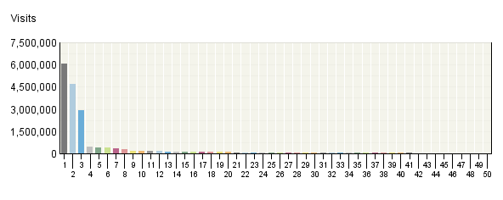

Referring Site
 | Site | Visits | % Visits
1. | Direct Traffic | 6,054,769 | 29%
2. | http:/​/​www.​google.​com/​ | 4,713,189 | 22%
3. | http:/​/​www.​greenguide77​.​com/​ | 2,900,209 | 14%
4. | http:/​/​search.​yahoo.​com/​ | 453,756 | 2%
5. | http:/​/​www.​bing.​com/​ | 424,022 | 2%
6. | http:/​/​www.​energy.​gov/​ | 394,620 | 2%
7. | http:/​/​www.​energysavers​.​gov/​ | 325,765 | 2%
8. | http:/​/​www1.​eere.​energy.​gov/​ | 284,771 | 1%
9. | http:/​/​the-​green-​guide.​info/​ | 172,402 | 1%
10. | http:/​/​www.​google.​ca/​ | 149,234 | 1%
11. | http:/​/​www.​google.​co.​uk/​ | 147,354 | 1%
12. | http:/​/​www.​bestbuy.​com/​ | 146,369 | 1%
13. | http:/​/​www.​the-​green-​guide.​info/​ | 125,954 | 1%
14. | http:/​/​images.​google.​com/​ | 115,398 | 1%
15. | http:/​/​www.​geappliances​.​com/​ | 109,068 | 1%
16. | http:/​/​www.​energystar.​gov/​ | 103,647 | 0%
17. | http:/​/​apps1.​eere.​energy.​gov/​ | 92,285 | 0%
18. | http:/​/​www.​google.​co.​in/​ | 90,780 | 0%
19. | http:/​/​search.​aol.​com/​ | 87,217 | 0%
20. | http:/​/​www.​eere.​energy.​gov/​ | 86,527 | 0%
21. | http:/​/​www.​nrel.​gov/​ | 85,056 | 0%
22. | http:/​/​en.​wikipedia.​org/​ | 74,562 | 0%
23. | http:/​/​energystar.​custhelp.​com/​ | 74,487 | 0%
24. | http:/​/​www.​google.​com.​au/​ | 66,152 | 0%
25. | http:/​/​www.​afdc.​energy.​gov/​ | 61,609 | 0%
26. | http:/​/​green.​yahoo.​com/​ | 49,995 | 0%
27. | http:/​/​www.​dsireusa.​org/​ | 48,669 | 0%
28. | http:/​/​www.​ask.​com/​ | 45,533 | 0%
29. | http:/​/​www.​fueleconomy.​gov/​ | 45,023 | 0%
30. | http:/​/​www.​walletpop.​com/​ | 41,521 | 0%
31. | http:/​/​9d9e7441.​placepicture​s.​com/​ | 36,459 | 0%
32. | http:/​/​ab357c34.​qvvo.​com/​ | 34,211 | 0%
33. | http:/​/​afdcmap2.​nrel.​gov/​ | 33,823 | 0%
34. | http:/​/​www.​usatoday.​com/​ | 32,840 | 0%
35. | http:/​/​www.​usa.​gov/​ | 32,092 | 0%
36. | http:/​/​search.​doe.​gov/​ | 30,598 | 0%
37. | http:/​/​72964574.​realfiles.​net/​ | 30,513 | 0%
38. | http:/​/​abcnews.​go.​com/​ | 30,195 | 0%
39. | http:/​/​blogs.​consumerrepo​rts.​org/​ | 29,663 | 0%
40. | http:/​/​search.​comcast.​net/​ | 29,341 | 0%
41. | http:/​/​www.​builditsolar​.​com/​ | 29,124 | 0%
42. | http:/​/​tonto.​eia.​doe.​gov/​ | 27,086 | 0%
43. | http:/​/​www.​google.​es/​ | 26,135 | 0%
44. | http:/​/​www.​mascoutah.​com/​ | 24,775 | 0%
45. | http:/​/​www.​windpowering​america.​gov/​ | 24,739 | 0%
46. | http:/​/​www.​google.​de/​ | 23,610 | 0%
47. | http:/​/​www.​netl.​doe.​gov/​ | 23,165 | 0%
48. | http:/​/​www.​epa.​gov/​ | 22,555 | 0%
49. | http:/​/​links.​govdelivery.​com/​ | 20,992 | 0%
50. | http:/​/​www.​whitehouse.​gov/​ | 20,813 | 0%
 | Subtotal for rows 1–50 | 18,132,672 | 85.57%
 | Other | 3,057,261 | 14.43%
 | Total | 21,189,933 | 100.00%
Items 1–50 of 1,000

Referring Site - Help Card
Column Definitions

Referring Sites
A web site that refers a visitor to your site by linking to it.

Site
The specific referring site being analyzed.

Visits
Number of times the specified site referred visitors to your site.

%
Percentage of referrals that came from the specified site.

Direct Traffic
Represents traffic to the web site with no referrer as one of the following: 1) the visitor typed the domain name directly into their browser, 2) the visitor bookmarked the site, 3) the visitor clicked on an email, shortcut, or other direct link, 4) Firewalls and/or proxies stripped out the referrer and replaced it with a dash "-".

Note: If "Direct Traffic" is 100% of all your traffic, then you are probably not logging the "referrer" field in your log files. Please see your manual or the Webtrends Knowledgebase to enable extended logging on your web servers.

Hidden-Referrer
A value indicating that Internet security software such as Zone Alarm Pro, Symantec's Norton Internet Security, or a proxy server modified a web request to mask the referring URL.

—
Report Descriptions
You can use this page to determine which sites are referring the most visitors to your site. This can help when considering the most effective ways and places to attract visitors.

Referring Domain
This report identifies domains that refer visitors to your web site. The top referring domains are your site's primary acquisition channels and may include partner sites, search engines, portals or marketing programs.

Referring Domain
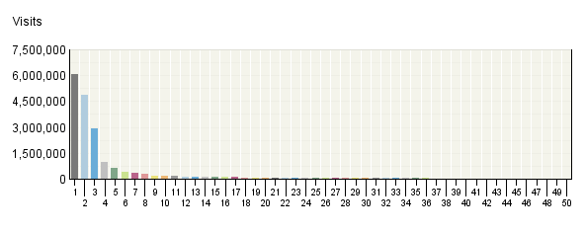

Referring Domain
 | Domain | Visits | % Visits
1. | Direct Traffic | 6,057,178 | 29%
2. | google.com | 4,851,275 | 23%
3. | greenguide77.com | 2,900,268 | 14%
4. | energy.gov | 978,716 | 5%
5. | yahoo.com | 622,178 | 3%
6. | bing.com | 424,816 | 2%
7. | energysavers.gov | 333,514 | 2%
8. | the-​green-​guide.info | 298,359 | 1%
9. | google.ca | 160,579 | 1%
10. | google.co.uk | 159,729 | 1%
11. | bestbuy.com | 147,336 | 1%
12. | nrel.gov | 134,811 | 1%
13. | aol.com | 133,375 | 1%
14. | geappliances.com | 109,117 | 1%
15. | energystar.gov | 103,656 | 0%
16. | google.co.in | 95,866 | 0%
17. | doe.gov | 93,482 | 0%
18. | wikipedia.org | 79,700 | 0%
19. | custhelp.com | 75,252 | 0%
20. | google.com.au | 68,776 | 0%
21. | dsireusa.org | 51,935 | 0%
22. | ask.com | 51,383 | 0%
23. | fueleconomy.gov | 47,155 | 0%
24. | comcast.net | 45,258 | 0%
25. | consumerreports.org | 43,149 | 0%
26. | walletpop.com | 41,521 | 0%
27. | usa.gov | 40,978 | 0%
28. | about.com | 38,656 | 0%
29. | usatoday.com | 37,058 | 0%
30. | placepictures.com | 36,459 | 0%
31. | qvvo.com | 34,211 | 0%
32. | go.com | 30,915 | 0%
33. | realfiles.net | 30,513 | 0%
34. | msn.com | 29,682 | 0%
35. | mascoutah.com | 29,645 | 0%
36. | builditsolar.com | 29,530 | 0%
37. | google.es | 27,411 | 0%
38. | google.de | 25,860 | 0%
39. | govdelivery.com | 25,175 | 0%
40. | windpoweringamerica.gov | 24,739 | 0%
41. | epa.gov | 24,712 | 0%
42. | live.com | 22,542 | 0%
43. | aarp.org | 21,837 | 0%
44. | whitehouse.gov | 20,821 | 0%
45. | bartlettec.coop | 20,472 | 0%
46. | google.com.ph | 19,883 | 0%
47. | google.com.mx | 19,826 | 0%
48. | lbl.gov | 19,580 | 0%
49. | honda.com | 18,628 | 0%
50. | google.it | 18,151 | 0%
 | Subtotal for rows 1–50 | 18,755,668 | 88.51%
 | Other | 2,434,265 | 11.49%
 | Total | 21,189,933 | 100.00%
Items 1–50 of 1,000

Referring Domain - Help Card
Column Definitions

Referring Domain
A web site that refers a visitor to your site by linking to it.

Domain
Top-level domains to which belong the web sites which refer visitors to your site by linking to it.

Visits
Number of times the specified domain referred visitors to your site.

%
Percentage of referrals that came from the specified domain.

Direct Traffic
Represents traffic to the web site with no referrer as one of the following: 1) the visitor typed the domain name directly into their browser, 2) the visitor bookmarked the site, 3) the visitor clicked on an email, shortcut, or other direct link, 4) Firewalls and/or proxies stripped out the referrer and replaced it with a dash "-".

Note: If "Direct Traffic" is 100% of all your traffic, then you are probably not logging the "referrer" field in your log files. Please see your manual or the Webtrends Knowledgebase to enable extended logging on your web servers.

Hidden-Referrer
A value indicating that Internet security software such as Zone Alarm Pro, Symantec's Norton Internet Security, or a proxy server modified a web request to mask the referring URL.

Unknown
Represents traffic for which a referrer was logged, but the referring domain was blocked or otherwise could not be resolved to a valid domain.

—
Report Descriptions
You can use this page to determine which domains are referring the most visitors to your site. This can help when considering the most effective ways and places to attract visitors.

Referring Page
This report shows the pages from which visitors accessed your site. You can use this report together with the Referring Domains report to identify which pages on your top domains are sending the most traffic to your site.

Referring Page
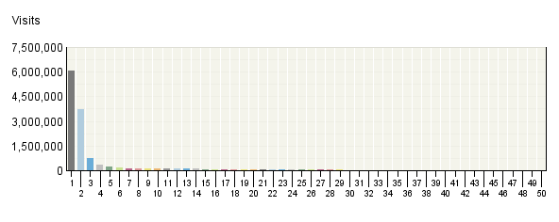

Referring Page
 | Page | Visits | % Visits
1. | Direct Traffic | 6,054,769 | 29%
2. | http:/​/​www.​google.​com/​search | 3,736,971 | 18%
3. | http:/​/​www.​google.​com/​url | 746,673 | 4%
4. | http:/​/​www.​bing.​com/​search | 327,566 | 2%
5. | http:/​/​search.​yahoo.​com/​search | 237,923 | 1%
6. | http:/​/​www.​bestbuy.​com/​site/​Electronics Promotions/​Energy-​Efficient-​Appliance-​Rebate-​Programs/​pcmcat199800​050000.​c | 146,266 | 1%
7. | http:/​/​the-​green-​guide.​info/​renewal/​VarC.​htm | 122,130 | 1%
8. | http:/​/​www.​the-​green-​guide.​info/​ | 121,903 | 1%
9. | http:/​/​images.​google.​com/​imgres | 114,825 | 1%
10. | http:/​/​www.​google.​co.​uk/​search | 113,132 | 1%
11. | http:/​/​www.​google.​ca/​search | 110,937 | 1%
12. | http:/​/​www.​geappliances​.​com/​rebates_​promotions/​american-​recovery-​act-​state-​appliance-​rebates.​htm | 108,999 | 1%
13. | http:/​/​www.​google.​com/​imgres | 98,194 | 0%
14. | http:/​/​search.​aol.​com/​aol/​search | 86,724 | 0%
15. | http:/​/​energystar.​custhelp.​com/​cgi-​bin/​energystar.​cfg/​php/​enduser/​std_​adp.​php | 73,324 | 0%
16. | http:/​/​www.​energysavers​.​gov/​financial/​70022.​html | 66,893 | 0%
17. | http:/​/​www.​google.​co.​in/​search | 61,080 | 0%
18. | http:/​/​www.​google.​com.​au/​search | 48,190 | 0%
19. | http:/​/​www.​energy.​gov/​energyeffici​ency/​index.​htm | 47,131 | 0%
20. | http:/​/​www.​energystar.​gov/​index.​cfm | 45,124 | 0%
21. | http:/​/​www.​energy.​gov/​tink/​ | 44,581 | 0%
22. | http:/​/​www.​ask.​com/​web | 40,631 | 0%
23. | http:/​/​green.​yahoo.​com/​blog/​the_​conscious_​consumer/​120/​when-​does-​cash-​for-​refrigerator​s-​start-​in-​your-​state.​html | 39,670 | 0%
24. | http:/​/​www.​energy.​gov/​ | 31,846 | 0%
25. | http:/​/​www.​energy.​gov/​kids/​ | 30,890 | 0%
26. | http:/​/​search.​doe.​gov/​search | 30,596 | 0%
27. | http:/​/​www.​energysavers​.​gov/​financial/​70020.​html | 29,939 | 0%
28. | http:/​/​www.​google.​com/​m/​search | 29,557 | 0%
29. | http:/​/​www.​energy.​gov/​yourhome.​htm | 29,294 | 0%
30. | http:/​/​afdcmap2.​nrel.​gov/​locator/​ | 28,094 | 0%
31. | http:/​/​www.​eere.​energy.​gov/​ | 27,674 | 0%
32. | http:/​/​search.​comcast.​net/​ | 27,246 | 0%
33. | http:/​/​the-​green-​guide.​info/​renewal/​ | 26,864 | 0%
34. | http:/​/​abcnews.​go.​com/​GMA/​YourMoney/​cash-​appliances-​rebate-​energy-​saving-​purchases/​story | 26,644 | 0%
35. | http:/​/​www.​usatoday.​com/​tech/​news/​2010-​02-​23-​energyrebate​s23_​ST_​N.​htm | 25,294 | 0%
36. | http:/​/​www.​google.​ca/​url | 24,697 | 0%
37. | http:/​/​www.​dsireusa.​org/​incentives/​index.​cfm | 24,081 | 0%
38. | http:/​/​www.​mascoutah.​com/​ | 23,940 | 0%
39. | http:/​/​www.​netl.​doe.​gov/​redirect/​ | 21,671 | 0%
40. | http:/​/​www.​energysavers​.​gov/​ | 21,354 | 0%
41. | http:/​/​www.​google.​co.​uk/​url | 20,979 | 0%
42. | http:/​/​links.​govdelivery.​com/​track | 20,942 | 0%
43. | http:/​/​www.​eere.​energy.​gov/​kids/​ | 20,123 | 0%
44. | http:/​/​www.​google.​com/​custom | 19,993 | 0%
45. | http:/​/​www.​energy.​gov/​energysource​s/​solar.​htm | 19,227 | 0%
46. | http:/​/​www.​google.​es/​search | 18,947 | 0%
47. | http:/​/​www.​bartlettec.​coop/​ | 18,196 | 0%
48. | http:/​/​us.​yhs.​search.​yahoo.​com/​avg/​search | 17,773 | 0%
49. | http:/​/​www.​usa.​gov/​Citizen/​Topics/​Benefits.​shtml | 17,768 | 0%
50. | http:/​/​www.​google.​com/​ | 17,712 | 0%
 | Subtotal for rows 1–50 | 13,244,977 | 62.51%
 | Other | 7,944,956 | 37.49%
 | Total | 21,189,933 | 100.00%
Items 1–50 of 1,000

Referring Page - Help Card
Column Definitions

Pages
Any displayed page. You can specify for each profile the types of files that qualify as a page. These settings can be changed by the Webtrends administrator.

Visits
Number of visitors referred from the specified URL.

%
Percentage of referred visitors who came from the specified site.

Direct Traffic
Represents traffic to the web site with no referrer as one of the following: 1) the visitor typed the domain name directly into their browser, 2) the visitor bookmarked the site, 3) the visitor clicked on an email, shortcut, or other direct link, 4) Firewalls and/or proxies stripped out the referrer and replaced it with a dash "-".

Note: If "Direct Traffic" is 100% of all your traffic, then you are probably not logging the "referrer" field in your log files. Please see your manual or the Webtrends Knowledgebase to enable extended logging on your web servers.

Hidden-Referrer
A value indicating that Internet security software such as Zone Alarm Pro, Symantec's Norton Internet Security, or a proxy server modified a web request to mask the referring URL.

—
Report Descriptions
You can use this information to determine the sites that provide the most referrals to your site. This can help when considering the most effective ways to attract visitors.

Search Phrases
This report shows the most popular search engine and search phrase combinations that drive visitors to your site. Use this report to determine the best-performing keywords across all search engines.

Search Phrases
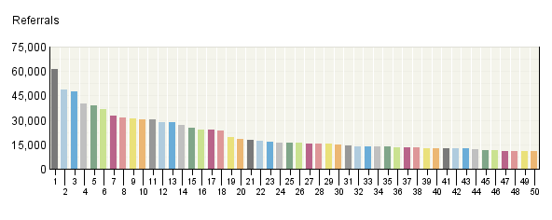

Search Phrases
 | Phrases  Engines | Referrals | % Referrals
1. | energysavers.gov | 61,441 | 0.65%
 | Google | 39,593 | 0.42%
 | Yahoo | 12,820 | 0.13%
 | Bing | 6,857 | 0.07%
 | AOL NetFind | 571 | 0.01%
 | Ask | 312 | 0.00%
2. | cash for appliances | 48,404 | 0.51%
 | Yahoo | 41,310 | 0.43%
 | Google | 6,764 | 0.07%
 | Bing | 132 | 0.00%
 | AOL NetFind | 74 | 0.00%
 | AltaVista | 37 | 0.00%
3. | solar water heater | 47,676 | 0.50%
 | Google | 36,333 | 0.38%
 | Yahoo | 4,592 | 0.05%
 | Bing | 3,060 | 0.03%
 | Google Hong Kong | 321 | 0.00%
 | AOL NetFind | 248 | 0.00%
4. | appliance rebates | 39,959 | 0.42%
 | Google | 33,144 | 0.35%
 | Yahoo | 4,509 | 0.05%
 | Bing | 1,286 | 0.01%
 | AOL NetFind | 603 | 0.01%
 | Ask | 288 | 0.00%
5. | weatherization assistance program | 38,944 | 0.41%
 | Google | 30,540 | 0.32%
 | Yahoo | 4,005 | 0.04%
 | Bing | 3,396 | 0.04%
 | Ask | 428 | 0.00%
 | AOL NetFind | 195 | 0.00%
6. | attic insulation | 36,402 | 0.38%
 | Google | 27,976 | 0.29%
 | Yahoo | 4,124 | 0.04%
 | Bing | 2,545 | 0.03%
 | AOL NetFind | 578 | 0.01%
 | Ask | 428 | 0.00%
7. | eere | 32,849 | 0.34%
 | Google | 25,202 | 0.26%
 | Bing | 2,599 | 0.03%
 | Yahoo | 1,069 | 0.01%
 | Google Spain | 400 | 0.00%
 | Google Canada | 331 | 0.00%
8. | insulation | 31,372 | 0.33%
 | Google | 25,128 | 0.26%
 | Yahoo | 2,226 | 0.02%
 | Bing | 1,009 | 0.01%
 | AOL NetFind | 655 | 0.01%
 | Google Canada | 365 | 0.00%
9. | heat pump | 30,977 | 0.33%
 | Google | 23,875 | 0.25%
 | Yahoo | 2,840 | 0.03%
 | Bing | 1,724 | 0.02%
 | AOL NetFind | 367 | 0.00%
 | Google Taiwan | 118 | 0.00%
10. | energy plus | 30,583 | 0.32%
 | Google | 12,367 | 0.13%
 | Google Italy | 2,979 | 0.03%
 | Google Spain | 1,818 | 0.02%
 | Google Brazil | 1,316 | 0.01%
 | Google UK | 1,293 | 0.01%
11. | appliance rebate | 30,177 | 0.32%
 | Google | 19,612 | 0.21%
 | Yahoo | 8,950 | 0.09%
 | AOL NetFind | 684 | 0.01%
 | Bing | 535 | 0.01%
 | Ask | 228 | 0.00%
12. | wind turbines | 28,728 | 0.30%
 | Google | 20,528 | 0.22%
 | Bing | 4,576 | 0.05%
 | Yahoo | 2,348 | 0.02%
 | AOL NetFind | 240 | 0.00%
 | Ask | 103 | 0.00%
13. | storm windows | 28,358 | 0.30%
 | Google | 23,051 | 0.24%
 | Bing | 2,634 | 0.03%
 | Yahoo | 1,249 | 0.01%
 | AOL NetFind | 617 | 0.01%
 | Google UK | 193 | 0.00%
14. | radiant floor heating | 26,894 | 0.28%
 | Google | 22,982 | 0.24%
 | Yahoo | 3,044 | 0.03%
 | Bing | 316 | 0.00%
 | AOL NetFind | 142 | 0.00%
 | Yahoo Canada | 63 | 0.00%
15. | alternative fuels | 25,266 | 0.27%
 | Google | 22,067 | 0.23%
 | Yahoo | 1,272 | 0.01%
 | Bing | 945 | 0.01%
 | Ask | 329 | 0.00%
 | Google UK | 83 | 0.00%
16. | energy saving tips | 24,078 | 0.25%
 | Google | 15,178 | 0.16%
 | Yahoo | 5,289 | 0.06%
 | Bing | 1,176 | 0.01%
 | Yahoo UK & Ireland | 733 | 0.01%
 | Ask | 171 | 0.00%
17. | energy star rebates | 23,774 | 0.25%
 | Google | 16,680 | 0.18%
 | Yahoo | 4,065 | 0.04%
 | Bing | 2,673 | 0.03%
 | AOL NetFind | 196 | 0.00%
 | Ask | 74 | 0.00%
18. | energyplus | 23,698 | 0.25%
 | Google | 9,254 | 0.10%
 | Google Italy | 1,336 | 0.01%
 | Google Spain | 1,150 | 0.01%
 | Google UK | 1,016 | 0.01%
 | Google Portugal | 980 | 0.01%
19. | heat pumps | 19,642 | 0.21%
 | Google | 13,373 | 0.14%
 | Bing | 3,208 | 0.03%
 | Yahoo | 1,504 | 0.02%
 | AOL NetFind | 546 | 0.01%
 | Ask | 114 | 0.00%
20. | energy audit | 18,433 | 0.19%
 | Google | 15,903 | 0.17%
 | Bing | 869 | 0.01%
 | Yahoo | 494 | 0.01%
 | Google UK | 146 | 0.00%
 | AOL NetFind | 109 | 0.00%
21. | water heaters | 17,652 | 0.19%
 | Google | 12,747 | 0.13%
 | Bing | 2,613 | 0.03%
 | Yahoo | 1,189 | 0.01%
 | AOL NetFind | 700 | 0.01%
 | Earthlink | 60 | 0.00%
22. | solar energy | 17,000 | 0.18%
 | Google | 10,280 | 0.11%
 | Yahoo | 3,936 | 0.04%
 | Bing | 1,521 | 0.02%
 | Google India | 214 | 0.00%
 | AOL NetFind | 137 | 0.00%
23. | femp | 16,529 | 0.17%
 | Google | 12,813 | 0.13%
 | Bing | 2,124 | 0.02%
 | Yahoo | 817 | 0.01%
 | Google Canada | 161 | 0.00%
 | Google Taiwan | 49 | 0.00%
24. | insulation types | 16,198 | 0.17%
 | Google | 14,917 | 0.16%
 | Google Ireland | 413 | 0.00%
 | Google UK | 261 | 0.00%
 | Bing | 144 | 0.00%
 | Yahoo | 116 | 0.00%
25. | renewable energy | 16,023 | 0.17%
 | Google | 11,222 | 0.12%
 | Yahoo | 2,430 | 0.03%
 | Bing | 1,220 | 0.01%
 | Ask | 112 | 0.00%
 | AOL NetFind | 76 | 0.00%
26. | rebates for energy efficient appliances | 15,985 | 0.17%
 | Google | 15,684 | 0.16%
 | Bing | 130 | 0.00%
 | Yahoo | 105 | 0.00%
 | Ask | 17 | 0.00%
 | AOL NetFind | 13 | 0.00%
27. | on demand water heater | 15,534 | 0.16%
 | Google | 13,390 | 0.14%
 | Yahoo | 1,409 | 0.01%
 | Bing | 364 | 0.00%
 | AOL NetFind | 123 | 0.00%
 | Google UK | 75 | 0.00%
28. | appliance rebates 2010 | 15,425 | 0.16%
 | Google | 15,363 | 0.16%
 | Bing | 15 | 0.00%
 | Google Canada | 13 | 0.00%
 | Ask | 10 | 0.00%
 | Google Australia | 8 | 0.00%
29. | how do wind turbines work | 15,258 | 0.16%
 | Google | 6,693 | 0.07%
 | Google UK | 3,952 | 0.04%
 | Google Australia | 1,202 | 0.01%
 | Google Canada | 837 | 0.01%
 | Bing | 677 | 0.01%
30. | radiant heat | 14,749 | 0.15%
 | Google | 11,042 | 0.12%
 | Yahoo | 1,935 | 0.02%
 | Bing | 1,245 | 0.01%
 | AOL NetFind | 214 | 0.00%
 | Google UK | 81 | 0.00%
31. | www.energysavers.gov | 14,549 | 0.15%
 | Google | 8,483 | 0.09%
 | Yahoo | 2,951 | 0.03%
 | Bing | 2,264 | 0.02%
 | AOL NetFind | 302 | 0.00%
 | Ask | 193 | 0.00%
32. | wind energy | 13,872 | 0.15%
 | Google | 11,666 | 0.12%
 | Bing | 1,016 | 0.01%
 | Yahoo | 466 | 0.00%
 | Google Egypt | 106 | 0.00%
 | Ask | 82 | 0.00%
33. | florida appliance rebate | 13,732 | 0.14%
 | Google | 9,836 | 0.10%
 | Yahoo | 2,004 | 0.02%
 | Bing | 1,382 | 0.01%
 | AOL NetFind | 327 | 0.00%
 | Ask | 96 | 0.00%
34. | geothermal energy | 13,610 | 0.14%
 | Google | 9,407 | 0.10%
 | Yahoo | 1,658 | 0.02%
 | Bing | 1,524 | 0.02%
 | Google Egypt | 106 | 0.00%
 | AOL NetFind | 81 | 0.00%
35. | solar water heaters | 13,479 | 0.14%
 | Google | 9,662 | 0.10%
 | Yahoo | 1,255 | 0.01%
 | Bing | 1,064 | 0.01%
 | AOL NetFind | 228 | 0.00%
 | Google Hong Kong | 120 | 0.00%
36. | home energy audit | 13,420 | 0.14%
 | Google | 11,014 | 0.12%
 | Bing | 921 | 0.01%
 | Yahoo | 851 | 0.01%
 | Google UK | 185 | 0.00%
 | AOL NetFind | 64 | 0.00%
37. | energysavers.gov/​rebates | 13,308 | 0.14%
 | Google | 12,181 | 0.13%
 | Yahoo | 547 | 0.01%
 | Bing | 373 | 0.00%
 | AOL NetFind | 68 | 0.00%
 | Ask | 56 | 0.00%
38. | attic insulation guide | 12,952 | 0.14%
 | Google | 12,353 | 0.13%
 | Google Ireland | 227 | 0.00%
 | Google Canada | 217 | 0.00%
 | Google UK | 95 | 0.00%
 | Yahoo | 14 | 0.00%
39. | energy efficiency | 12,859 | 0.14%
 | Google | 9,164 | 0.10%
 | Bing | 1,095 | 0.01%
 | Yahoo | 995 | 0.01%
 | Google Spain | 119 | 0.00%
 | Ask | 106 | 0.00%
40. | how wind turbines work | 12,831 | 0.13%
 | Google | 6,528 | 0.07%
 | Google UK | 2,431 | 0.03%
 | Google Australia | 906 | 0.01%
 | Google Canada | 738 | 0.01%
 | Bing | 578 | 0.01%
41. | geothermal heat pump | 12,829 | 0.13%
 | Google | 9,046 | 0.09%
 | Yahoo | 2,430 | 0.03%
 | Bing | 596 | 0.01%
 | Google UK | 69 | 0.00%
 | Yahoo Canada | 64 | 0.00%
42. | how does a wind turbine work | 12,753 | 0.13%
 | Google | 4,988 | 0.05%
 | Google UK | 3,660 | 0.04%
 | Google Australia | 1,089 | 0.01%
 | Google Canada | 974 | 0.01%
 | Bing | 618 | 0.01%
43. | solar hot water heater | 12,637 | 0.13%
 | Google | 11,016 | 0.12%
 | Yahoo | 678 | 0.01%
 | Bing | 654 | 0.01%
 | AOL NetFind | 71 | 0.00%
 | Ask | 23 | 0.00%
44. | biomass | 12,267 | 0.13%
 | Google | 10,134 | 0.11%
 | Bing | 598 | 0.01%
 | Ask | 191 | 0.00%
 | Yahoo | 156 | 0.00%
 | Google Germany | 104 | 0.00%
45. | weatherization | 11,626 | 0.12%
 | Google | 8,856 | 0.09%
 | Yahoo | 1,136 | 0.01%
 | Bing | 1,069 | 0.01%
 | AOL NetFind | 238 | 0.00%
 | Ask | 144 | 0.00%
46. | energy savers | 11,521 | 0.12%
 | Google | 7,382 | 0.08%
 | Yahoo | 1,051 | 0.01%
 | Bing | 973 | 0.01%
 | Google UK | 313 | 0.00%
 | Google Canada | 223 | 0.00%
47. | tankless water heater | 11,017 | 0.12%
 | Google | 10,131 | 0.11%
 | Yahoo | 399 | 0.00%
 | AOL NetFind | 189 | 0.00%
 | Bing | 70 | 0.00%
 | Google UK | 47 | 0.00%
48. | crawl space insulation | 10,977 | 0.12%
 | Google | 8,931 | 0.09%
 | Bing | 1,119 | 0.01%
 | Yahoo | 559 | 0.01%
 | Ask | 98 | 0.00%
 | Google Canada | 87 | 0.00%
49. | heat pump water heater | 10,804 | 0.11%
 | Google | 6,917 | 0.07%
 | Bing | 1,472 | 0.02%
 | Yahoo | 1,145 | 0.01%
 | Google Hong Kong | 153 | 0.00%
 | Google Canada | 152 | 0.00%
50. | geothermal heating and cooling | 10,777 | 0.11%
 | Google | 10,603 | 0.11%
 | Bing | 35 | 0.00%
 | Google Australia | 31 | 0.00%
 | AOL NetFind | 29 | 0.00%
 | Yahoo | 12 | 0.00%
 | Subtotal for rows 1–50 | 1,059,828 | 11.13%
 | Other | 8,464,367 | 88.87%
 | Total | 9,524,195 | 100.00%
Items 1–50 of 1,000

Search Phrases - Help Card
Column Definitions

Phrase
The search phrase a visitor used to find your site. "Search term not provided" means that the information was not provided by the search engine, usually because the visitor is using a secure search site.

Engines
The specific search engine being analyzed in conjunction with the phrase in the adjacent column.

Referrals
The number of visits to your site from visitors, who were referred by using the specified search engine and search phrases.

%
Percentage of visitors referred from search engines who used the specified search engine and phrase.

—
Report Descriptions
How are people getting to your site? Use this report to find out if your visitors are using the search phrases you expect. Do you need to use different phrases in page titles to make it easier for people to find your site with search engines?

Search Keywords
This report identifies keywords that led the most visitors to the site and, for each keyword, which search engines led visitors to the site.

Search Keywords
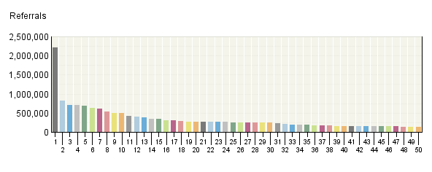

Search Keywords
 | Keywords  Engines | Referrals | % Referrals
1. | energy | 2,222,590 | 5.58%
 | Google | 1,573,106 | 3.95%
 | Yahoo | 155,729 | 0.39%
 | Bing | 152,805 | 0.38%
 | Google UK | 47,381 | 0.12%
 | Google Canada | 41,320 | 0.10%
2. | water | 828,855 | 2.08%
 | Google | 621,301 | 1.56%
 | Bing | 58,660 | 0.15%
 | Yahoo | 52,366 | 0.13%
 | Google Canada | 22,590 | 0.06%
 | Google UK | 12,019 | 0.03%
3. | solar | 711,750 | 1.79%
 | Google | 492,053 | 1.24%
 | Yahoo | 48,014 | 0.12%
 | Bing | 44,210 | 0.11%
 | Google Canada | 13,664 | 0.03%
 | Google India | 13,173 | 0.03%
4. | wind | 699,842 | 1.76%
 | Google | 497,382 | 1.25%
 | Bing | 48,187 | 0.12%
 | Yahoo | 43,548 | 0.11%
 | Google UK | 31,347 | 0.08%
 | Google Canada | 14,027 | 0.04%
5. | of | 685,872 | 1.72%
 | Google | 467,894 | 1.17%
 | Yahoo | 42,818 | 0.11%
 | Bing | 41,381 | 0.10%
 | Google India | 21,075 | 0.05%
 | Google UK | 19,652 | 0.05%
6. | for | 622,558 | 1.56%
 | Google | 425,499 | 1.07%
 | Yahoo | 81,132 | 0.20%
 | Bing | 37,245 | 0.09%
 | Google UK | 13,918 | 0.03%
 | Google Canada | 13,579 | 0.03%
7. | insulation | 617,178 | 1.55%
 | Google | 475,169 | 1.19%
 | Yahoo | 43,268 | 0.11%
 | Bing | 40,555 | 0.10%
 | Google Canada | 14,900 | 0.04%
 | Google UK | 11,951 | 0.03%
8. | heat | 537,237 | 1.35%
 | Google | 396,071 | 0.99%
 | Yahoo | 39,383 | 0.10%
 | Bing | 37,405 | 0.09%
 | Google Canada | 15,072 | 0.04%
 | Google UK | 10,010 | 0.03%
9. | appliance | 500,656 | 1.26%
 | Google | 389,091 | 0.98%
 | Yahoo | 54,942 | 0.14%
 | Bing | 39,862 | 0.10%
 | AOL NetFind | 6,453 | 0.02%
 | Ask | 3,363 | 0.01%
10. | heater | 495,693 | 1.24%
 | Google | 391,961 | 0.98%
 | Bing | 29,219 | 0.07%
 | Yahoo | 28,641 | 0.07%
 | Google Canada | 11,416 | 0.03%
 | Google UK | 5,081 | 0.01%
11. | rebate | 420,368 | 1.06%
 | Google | 316,260 | 0.79%
 | Yahoo | 51,592 | 0.13%
 | Bing | 40,603 | 0.10%
 | AOL NetFind | 6,007 | 0.02%
 | Ask | 3,318 | 0.01%
12. | how | 408,158 | 1.02%
 | Google | 272,895 | 0.69%
 | Google UK | 30,364 | 0.08%
 | Bing | 20,422 | 0.05%
 | Yahoo | 18,696 | 0.05%
 | Google Canada | 16,497 | 0.04%
13. | heating | 375,570 | 0.94%
 | Google | 277,319 | 0.70%
 | Yahoo | 24,995 | 0.06%
 | Bing | 22,436 | 0.06%
 | Google Canada | 9,944 | 0.02%
 | Google UK | 9,468 | 0.02%
14. | in | 346,969 | 0.87%
 | Google | 244,100 | 0.61%
 | Bing | 22,636 | 0.06%
 | Yahoo | 22,207 | 0.06%
 | Google India | 9,451 | 0.02%
 | Google Canada | 9,153 | 0.02%
15. | to | 338,334 | 0.85%
 | Google | 244,044 | 0.61%
 | Bing | 18,642 | 0.05%
 | Yahoo | 17,931 | 0.05%
 | Google Canada | 13,065 | 0.03%
 | Google UK | 10,070 | 0.03%
16. | rebates | 302,945 | 0.76%
 | Google | 235,889 | 0.59%
 | Yahoo | 35,799 | 0.09%
 | Bing | 23,785 | 0.06%
 | AOL NetFind | 3,618 | 0.01%
 | Ask | 2,296 | 0.01%
17. | program | 299,940 | 0.75%
 | Google | 218,925 | 0.55%
 | Yahoo | 35,228 | 0.09%
 | Bing | 25,811 | 0.06%
 | AOL NetFind | 2,576 | 0.01%
 | Google Canada | 2,389 | 0.01%
18. | home | 283,096 | 0.71%
 | Google | 205,995 | 0.52%
 | Yahoo | 21,166 | 0.05%
 | Bing | 18,882 | 0.05%
 | Google Canada | 6,501 | 0.02%
 | Google UK | 6,022 | 0.02%
19. | power | 276,028 | 0.69%
 | Google | 183,799 | 0.46%
 | Yahoo | 17,685 | 0.04%
 | Bing | 14,073 | 0.04%
 | Google India | 8,799 | 0.02%
 | Google UK | 8,134 | 0.02%
20. | efficiency | 274,424 | 0.69%
 | Google | 213,501 | 0.54%
 | Bing | 13,020 | 0.03%
 | Yahoo | 12,441 | 0.03%
 | Google Canada | 6,726 | 0.02%
 | Google UK | 5,658 | 0.01%
21. | efficient | 273,376 | 0.69%
 | Google | 221,024 | 0.55%
 | Bing | 14,883 | 0.04%
 | Yahoo | 14,398 | 0.04%
 | Google Canada | 5,374 | 0.01%
 | Google UK | 4,000 | 0.01%
22. | a | 265,649 | 0.67%
 | Google | 185,010 | 0.46%
 | Bing | 15,762 | 0.04%
 | Google UK | 14,960 | 0.04%
 | Yahoo | 12,104 | 0.03%
 | Google Canada | 11,334 | 0.03%
23. | appliances | 263,988 | 0.66%
 | Google | 175,378 | 0.44%
 | Yahoo | 62,313 | 0.16%
 | Bing | 10,420 | 0.03%
 | Google UK | 2,321 | 0.01%
 | Google Canada | 1,997 | 0.01%
24. | geothermal | 262,615 | 0.66%
 | Google | 192,136 | 0.48%
 | Yahoo | 19,783 | 0.05%
 | Bing | 13,875 | 0.03%
 | Google Canada | 6,945 | 0.02%
 | Google UK | 4,284 | 0.01%
25. | hot | 256,860 | 0.64%
 | Google | 189,252 | 0.48%
 | Bing | 20,303 | 0.05%
 | Yahoo | 18,155 | 0.05%
 | Google Canada | 9,358 | 0.02%
 | Google UK | 3,926 | 0.01%
26. | heaters | 254,900 | 0.64%
 | Google | 190,410 | 0.48%
 | Bing | 20,998 | 0.05%
 | Yahoo | 17,797 | 0.04%
 | AOL NetFind | 4,884 | 0.01%
 | Google Canada | 4,867 | 0.01%
27. | pump | 254,331 | 0.64%
 | Google | 185,725 | 0.47%
 | Yahoo | 20,723 | 0.05%
 | Bing | 17,037 | 0.04%
 | Google Canada | 6,726 | 0.02%
 | Google UK | 4,007 | 0.01%
28. | air | 250,333 | 0.63%
 | Google | 188,706 | 0.47%
 | Yahoo | 14,719 | 0.04%
 | Bing | 14,046 | 0.04%
 | Google Canada | 7,464 | 0.02%
 | Google UK | 4,164 | 0.01%
29. | the | 246,030 | 0.62%
 | Google | 176,466 | 0.44%
 | Bing | 12,358 | 0.03%
 | Yahoo | 10,918 | 0.03%
 | Google UK | 8,968 | 0.02%
 | Google Canada | 7,593 | 0.02%
30. | isch:1 | 241,186 | 0.61%
 | Google | 15,578 | 0.04%
 | Google UK | 1,458 | 0.00%
 | Google Canada | 1,219 | 0.00%
 | Google Australia | 316 | 0.00%
 | Google Germany | 249 | 0.00%
31. | tax | 234,107 | 0.59%
 | Google | 199,497 | 0.50%
 | Yahoo | 18,056 | 0.05%
 | Bing | 11,514 | 0.03%
 | AOL NetFind | 2,041 | 0.01%
 | Ask | 1,408 | 0.00%
32. | 1&hl | 200,976 | 0.50%
 | Google | 84,468 | 0.21%
 | Google Canada | 7,641 | 0.02%
 | Google UK | 7,484 | 0.02%
 | Google Australia | 1,950 | 0.00%
 | Google Germany | 1,594 | 0.00%
33. | doe | 198,927 | 0.50%
 | Google | 160,923 | 0.40%
 | Bing | 10,153 | 0.03%
 | Yahoo | 7,366 | 0.02%
 | Google Canada | 3,068 | 0.01%
 | Google Japan | 2,194 | 0.01%
34. | on | 197,326 | 0.50%
 | Google | 134,665 | 0.34%
 | Bing | 16,185 | 0.04%
 | Yahoo | 15,246 | 0.04%
 | Google India | 7,140 | 0.02%
 | Google Canada | 5,757 | 0.01%
35. | systems | 193,862 | 0.49%
 | Google | 136,287 | 0.34%
 | Bing | 17,460 | 0.04%
 | Yahoo | 17,425 | 0.04%
 | Google UK | 3,538 | 0.01%
 | Google Canada | 3,303 | 0.01%
36. | electric | 180,126 | 0.45%
 | Google | 132,484 | 0.33%
 | Yahoo | 11,102 | 0.03%
 | Bing | 10,639 | 0.03%
 | Google Canada | 5,765 | 0.01%
 | Google UK | 4,440 | 0.01%
37. | 2010 | 165,778 | 0.42%
 | Google | 144,732 | 0.36%
 | Yahoo | 6,615 | 0.02%
 | Bing | 5,810 | 0.01%
 | Google Canada | 854 | 0.00%
 | Google Germany | 500 | 0.00%
38. | renewable | 164,240 | 0.41%
 | Google | 119,937 | 0.30%
 | Bing | 9,129 | 0.02%
 | Yahoo | 8,625 | 0.02%
 | Google UK | 4,936 | 0.01%
 | Google Canada | 2,722 | 0.01%
39. | cost | 159,049 | 0.40%
 | Google | 123,695 | 0.31%
 | Yahoo | 8,835 | 0.02%
 | Bing | 8,490 | 0.02%
 | Google Canada | 4,865 | 0.01%
 | Google UK | 3,157 | 0.01%
40. | attic | 158,106 | 0.40%
 | Google | 127,980 | 0.32%
 | Yahoo | 11,517 | 0.03%
 | Bing | 9,463 | 0.02%
 | Google Canada | 2,823 | 0.01%
 | Ask | 1,429 | 0.00%
41. | radiant | 157,646 | 0.40%
 | Google | 125,388 | 0.31%
 | Yahoo | 14,152 | 0.04%
 | Bing | 8,670 | 0.02%
 | Google Canada | 3,054 | 0.01%
 | AOL NetFind | 1,318 | 0.00%
42. | weatherization | 156,608 | 0.39%
 | Google | 114,837 | 0.29%
 | Bing | 18,589 | 0.05%
 | Yahoo | 18,038 | 0.05%
 | AOL NetFind | 1,879 | 0.00%
 | Ask | 1,751 | 0.00%
43. | star | 155,663 | 0.39%
 | Google | 117,103 | 0.29%
 | Yahoo | 16,714 | 0.04%
 | Bing | 15,815 | 0.04%
 | AOL NetFind | 1,898 | 0.00%
 | Ask | 1,140 | 0.00%
44. | fuel | 152,984 | 0.38%
 | Google | 101,713 | 0.26%
 | Yahoo | 10,279 | 0.03%
 | Bing | 9,618 | 0.02%
 | Google UK | 4,777 | 0.01%
 | Google India | 4,463 | 0.01%
45. | credit | 150,150 | 0.38%
 | Google | 130,124 | 0.33%
 | Yahoo | 11,130 | 0.03%
 | Bing | 5,975 | 0.02%
 | AOL NetFind | 1,172 | 0.00%
 | Ask | 769 | 0.00%
46. | what | 144,042 | 0.36%
 | Google | 103,467 | 0.26%
 | Bing | 7,995 | 0.02%
 | Yahoo | 7,858 | 0.02%
 | Ask | 5,566 | 0.01%
 | Google UK | 4,880 | 0.01%
47. | en&sa | 143,602 | 0.36%
 | Google | 108,173 | 0.27%
 | Google Canada | 10,997 | 0.03%
 | Google UK | 10,796 | 0.03%
 | Google India | 4,897 | 0.01%
 | Google Australia | 3,357 | 0.01%
48. | 1 | 142,635 | 0.36%
 | Google | 117,003 | 0.29%
 | Google UK | 9,290 | 0.02%
 | Google Canada | 8,478 | 0.02%
 | Google Australia | 1,722 | 0.00%
 | Google Germany | 1,677 | 0.00%
49. | is | 140,058 | 0.35%
 | Google | 100,609 | 0.25%
 | Bing | 7,070 | 0.02%
 | Yahoo | 6,801 | 0.02%
 | Ask | 4,946 | 0.01%
 | Google UK | 4,587 | 0.01%
50. | pool | 136,153 | 0.34%
 | Google | 99,104 | 0.25%
 | Bing | 8,060 | 0.02%
 | Yahoo | 7,031 | 0.02%
 | Google Canada | 5,754 | 0.01%
 | Google UK | 3,600 | 0.01%
 | Subtotal for rows 1–50 | 17,149,369 | 43.06%
 | Other | 22,676,119 | 56.94%
 | Total | 39,825,488 | 100.00%
Items 1–50 of 1,000

Search Keywords - Help Card
Column Definitions

Keywords
The specific keywords being analyzed. To see the entire search strings entered by visitors, see the Search Phrases report.

Engines
The specific search engine being analyzed in conjunction with the keyword in the adjacent column.

Referrals
The number of visits from visitors referred to your site with the specified keywords.

%Percentage of referred visitors who used the specified search engine and keyword.

—
Report Descriptions
At the most basic level, this section tells you which search keywords are being used most frequently to find your site. You also may find that some search engines are referring visitors to your site with the words you expect and that other search engines are not.

This report was generated by Webtrends 8, Version: 10.2, Build 263 .
Thursday, December 15, 2011 2:39:09 PM
Final report conversion by WebTrends Report Exporter, Version 9.5 (build 1056)
Copyright (C) 1996-2009 Webtrends Inc. All rights reserved.

