
EERE Web Site Statistics - Solar Decathlon

Custom View: 10/1/06 - 9/30/07
October 1, 2006 12:00:00 AM – September 30, 2007 11:59:59 PM
Table of Contents
Overview Dashboard 3
By Number of Visits 4
Domain Names 12
Top-Level Domain Types 15
Countries 17
Visits Trend 20
Visits by Number of Pages Viewed 22
Visit Duration by Visits 25
Visit Duration by Page Views 28
Pages 31
Page Views Trend 36
File Downloads 38
Entry Pages 42
Exit Pages 47
Single-Page Visits 53
Paths, Forward 59
Referring Site 83
Referring Domain 86
Referring Page 89
Search Phrases 92
Search Keywords 99

Overview Dashboard
This dashboard provides an overview of the data available in the report template. You can click a graph title to navigate to the corresponding report page.

Visits Trend
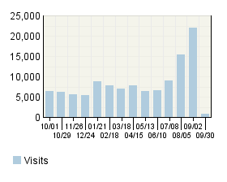

Visitor Summary
Visitors | 86,965

Visit Summary
Visits | 114,953
Average per Day | 314
Average Visit Duration | 00:03:51
Median Visit Duration | -
International Visits | 2.49%
Visits of Unknown Origin | 78.85%
Visits from Your Country: United States (US) | 18.66%

Page Views Trend
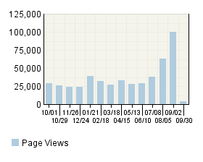

Visitors Trend
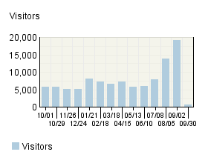

Page View Summary
Page Views | 496,413
Average per Day | 1,360
Page Views per Visit | 4.32

By Number of Visits
This report shows the visit frequency of your top visitors, allowing you to evaluate overall site loyalty.

By Number of Visits
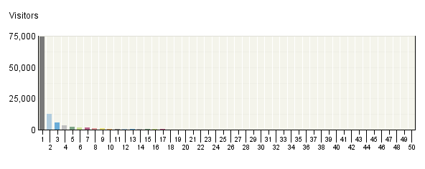

By Number of Visits
Number of Visits | Visitors | % Visitors
1 visit | 74,148 | 65%
2 visits | 12,716 | 11%
3 visits | 5,724 | 5%
4 visits | 3,520 | 3%
5 visits | 2,478 | 2%
6 visits | 1,863 | 2%
7 visits | 1,458 | 1%
8 visits | 1,189 | 1%
9 visits | 999 | 1%
10 visits | 853 | 1%
11 visits | 742 | 1%
12 visits | 640 | 1%
13 visits | 562 | 0%
14 visits | 491 | 0%
15 visits | 430 | 0%
16 visits | 370 | 0%
17 visits | 327 | 0%
18 visits | 285 | 0%
19 visits | 254 | 0%
20 visits | 231 | 0%
21 visits | 205 | 0%
22 visits | 182 | 0%
23 visits | 159 | 0%
24 visits | 141 | 0%
25 visits | 132 | 0%
26 visits | 121 | 0%
27 visits | 112 | 0%
28 visits | 108 | 0%
29 visits | 101 | 0%
30 visits | 97 | 0%
31 visits | 95 | 0%
32 visits | 92 | 0%
33 visits | 89 | 0%
34 visits | 86 | 0%
35 visits | 86 | 0%
36 visits | 81 | 0%
37 visits | 78 | 0%
38 visits | 75 | 0%
39 visits | 71 | 0%
40 visits | 69 | 0%
41 visits | 67 | 0%
42 visits | 65 | 0%
43 visits | 64 | 0%
44 visits | 63 | 0%
45 visits | 60 | 0%
46 visits | 58 | 0%
47 visits | 55 | 0%
48 visits | 54 | 0%
49 visits | 53 | 0%
50 visits | 50 | 0%
51 visits | 49 | 0%
52 visits | 49 | 0%
53 visits | 48 | 0%
54 visits | 48 | 0%
55 visits | 48 | 0%
56 visits | 46 | 0%
57 visits | 46 | 0%
58 visits | 46 | 0%
59 visits | 45 | 0%
60 visits | 44 | 0%
61 visits | 42 | 0%
62 visits | 41 | 0%
63 visits | 39 | 0%
64 visits | 38 | 0%
65 visits | 36 | 0%
66 visits | 35 | 0%
67 visits | 35 | 0%
68 visits | 35 | 0%
69 visits | 32 | 0%
70 visits | 32 | 0%
71 visits | 32 | 0%
72 visits | 28 | 0%
73 visits | 26 | 0%
74 visits | 24 | 0%
75 visits | 22 | 0%
76 visits | 22 | 0%
77 visits | 22 | 0%
78 visits | 22 | 0%
79 visits | 21 | 0%
80 visits | 20 | 0%
81 visits | 19 | 0%
82 visits | 19 | 0%
83 visits | 18 | 0%
84 visits | 18 | 0%
85 visits | 16 | 0%
86 visits | 16 | 0%
87 visits | 16 | 0%
88 visits | 15 | 0%
89 visits | 15 | 0%
90 visits | 15 | 0%
91 visits | 15 | 0%
92 visits | 15 | 0%
93 visits | 15 | 0%
94 visits | 15 | 0%
95 visits | 15 | 0%
96 visits | 14 | 0%
97 visits | 14 | 0%
98 visits | 14 | 0%
99 visits | 14 | 0%
100 visits | 14 | 0%
101 visits | 14 | 0%
102 visits | 14 | 0%
103 visits | 13 | 0%
104 visits | 13 | 0%
105 visits | 13 | 0%
106 visits | 13 | 0%
107 visits | 13 | 0%
108 visits | 13 | 0%
109 visits | 13 | 0%
110 visits | 13 | 0%
111 visits | 13 | 0%
112 visits | 13 | 0%
113 visits | 13 | 0%
114 visits | 13 | 0%
115 visits | 13 | 0%
116 visits | 12 | 0%
117 visits | 12 | 0%
118 visits | 12 | 0%
119 visits | 11 | 0%
120 visits | 11 | 0%
121 visits | 11 | 0%
122 visits | 11 | 0%
123 visits | 11 | 0%
124 visits | 11 | 0%
125 visits | 10 | 0%
126 visits | 9 | 0%
127 visits | 9 | 0%
128 visits | 9 | 0%
129 visits | 9 | 0%
130 visits | 8 | 0%
131 visits | 8 | 0%
132 visits | 8 | 0%
133 visits | 7 | 0%
134 visits | 7 | 0%
135 visits | 7 | 0%
136 visits | 7 | 0%
137 visits | 7 | 0%
138 visits | 7 | 0%
139 visits | 7 | 0%
140 visits | 7 | 0%
141 visits | 7 | 0%
142 visits | 7 | 0%
143 visits | 7 | 0%
144 visits | 6 | 0%
145 visits | 6 | 0%
146 visits | 6 | 0%
147 visits | 6 | 0%
148 visits | 6 | 0%
149 visits | 6 | 0%
150 visits | 6 | 0%
151 visits | 6 | 0%
152 visits | 6 | 0%
153 visits | 6 | 0%
154 visits | 6 | 0%
155 visits | 6 | 0%
156 visits | 6 | 0%
157 visits | 6 | 0%
158 visits | 6 | 0%
159 visits | 6 | 0%
160 visits | 6 | 0%
161 visits | 6 | 0%
162 visits | 6 | 0%
163 visits | 6 | 0%
164 visits | 6 | 0%
165 visits | 6 | 0%
166 visits | 6 | 0%
167 visits | 6 | 0%
168 visits | 6 | 0%
169 visits | 6 | 0%
170 visits | 6 | 0%
171 visits | 6 | 0%
172 visits | 6 | 0%
173 visits | 6 | 0%
174 visits | 6 | 0%
175 visits | 6 | 0%
176 visits | 6 | 0%
177 visits | 5 | 0%
178 visits | 5 | 0%
179 visits | 5 | 0%
180 visits | 5 | 0%
181 visits | 5 | 0%
182 visits | 5 | 0%
183 visits | 5 | 0%
184 visits | 5 | 0%
185 visits | 5 | 0%
186 visits | 5 | 0%
187 visits | 5 | 0%
188 visits | 5 | 0%
189 visits | 5 | 0%
190 visits | 5 | 0%
191 visits | 5 | 0%
192 visits | 5 | 0%
193 visits | 5 | 0%
194 visits | 5 | 0%
195 visits | 5 | 0%
196 visits | 5 | 0%
197 visits | 5 | 0%
198 visits | 5 | 0%
199 visits | 5 | 0%
200 visits | 5 | 0%
220 visits | 2 | 0%
201 visits | 3 | 0%
202 visits | 3 | 0%
203 visits | 3 | 0%
204 visits | 3 | 0%
205 visits | 3 | 0%
206 visits | 3 | 0%
207 visits | 3 | 0%
208 visits | 3 | 0%
209 visits | 3 | 0%
210 visits | 3 | 0%
211 visits | 3 | 0%
267 visits | 2 | 0%
268 visits | 2 | 0%
269 visits | 2 | 0%
270 visits | 2 | 0%
271 visits | 2 | 0%
272 visits | 2 | 0%
273 visits | 2 | 0%
274 visits | 2 | 0%
275 visits | 2 | 0%
276 visits | 2 | 0%
277 visits | 2 | 0%
278 visits | 2 | 0%
279 visits | 2 | 0%
280 visits | 2 | 0%
281 visits | 2 | 0%
282 visits | 2 | 0%
242 visits | 2 | 0%
243 visits | 2 | 0%
244 visits | 2 | 0%
245 visits | 2 | 0%
246 visits | 2 | 0%
247 visits | 2 | 0%
248 visits | 2 | 0%
249 visits | 2 | 0%
250 visits | 2 | 0%
251 visits | 2 | 0%
252 visits | 2 | 0%
253 visits | 2 | 0%
254 visits | 2 | 0%
255 visits | 2 | 0%
256 visits | 2 | 0%
257 visits | 2 | 0%
258 visits | 2 | 0%
259 visits | 2 | 0%
260 visits | 2 | 0%
261 visits | 2 | 0%
262 visits | 2 | 0%
263 visits | 2 | 0%
264 visits | 2 | 0%
265 visits | 2 | 0%
266 visits | 2 | 0%
307 visits | 1 | 0%
308 visits | 1 | 0%
309 visits | 1 | 0%
310 visits | 1 | 0%
311 visits | 1 | 0%
312 visits | 1 | 0%
313 visits | 1 | 0%
314 visits | 1 | 0%
315 visits | 1 | 0%
316 visits | 1 | 0%
317 visits | 1 | 0%
318 visits | 1 | 0%
319 visits | 1 | 0%
320 visits | 1 | 0%
321 visits | 1 | 0%
322 visits | 1 | 0%
323 visits | 1 | 0%
324 visits | 1 | 0%
325 visits | 1 | 0%
326 visits | 1 | 0%
327 visits | 1 | 0%
328 visits | 1 | 0%
329 visits | 1 | 0%
330 visits | 1 | 0%
331 visits | 1 | 0%
332 visits | 1 | 0%
333 visits | 1 | 0%
334 visits | 1 | 0%
335 visits | 1 | 0%
336 visits | 1 | 0%
337 visits | 1 | 0%
338 visits | 1 | 0%
221 visits | 2 | 0%
222 visits | 2 | 0%
223 visits | 2 | 0%
224 visits | 2 | 0%
225 visits | 2 | 0%
226 visits | 2 | 0%
227 visits | 2 | 0%
228 visits | 2 | 0%
229 visits | 2 | 0%
230 visits | 2 | 0%
231 visits | 2 | 0%
232 visits | 2 | 0%
233 visits | 2 | 0%
234 visits | 2 | 0%
235 visits | 2 | 0%
236 visits | 2 | 0%
237 visits | 2 | 0%
238 visits | 2 | 0%
239 visits | 2 | 0%
240 visits | 2 | 0%
241 visits | 2 | 0%
283 visits | 1 | 0%
284 visits | 1 | 0%
285 visits | 1 | 0%
286 visits | 1 | 0%
287 visits | 1 | 0%
288 visits | 1 | 0%
289 visits | 1 | 0%
290 visits | 1 | 0%
291 visits | 1 | 0%
292 visits | 1 | 0%
293 visits | 1 | 0%
294 visits | 1 | 0%
295 visits | 1 | 0%
296 visits | 1 | 0%
297 visits | 1 | 0%
298 visits | 1 | 0%
299 visits | 1 | 0%
300 visits | 1 | 0%
301 visits | 1 | 0%
302 visits | 1 | 0%
303 visits | 1 | 0%
304 visits | 1 | 0%
305 visits | 1 | 0%
306 visits | 1 | 0%
212 visits | 2 | 0%
213 visits | 2 | 0%
214 visits | 2 | 0%
215 visits | 2 | 0%
216 visits | 2 | 0%
217 visits | 2 | 0%
218 visits | 2 | 0%
219 visits | 2 | 0%
Other | 524 | 0.46%
Total | 114,953 | 100.00%

By Number of Visits - Help Card
Column Definitions

Number of Visits
The number of visits by each visitor during the period of the report.

Visitors
Number of individuals who came to your site the amount of times specified in the Number of Visits column.

%
Percentage of visitors who came to your site the amount of times specified in the Number of Visits column.

—
Report Descriptions
This information can indicate whether or not your site compels visitors to return. Updating web site content is one way to draw return visitors.

Domain Names
This report lists the domain names that generate the most activity to your web site. Because the data for this report is obtained solely from DNS lookups, it can differ from the data presented in the Organizations report, which is based on both GeoTrends and DNS lookups.

Domain Names
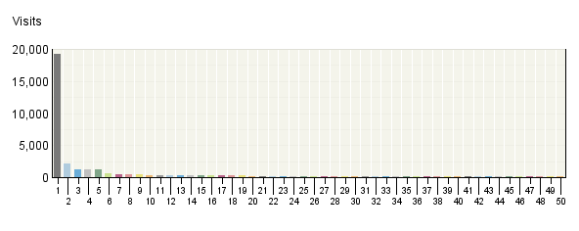

Domain Names
 | Domain Name | Visits | % Visits | Hits
1. | Unresolved IP Address | 19,199 | 17% | 82,939
2. | comcast.​net | 2,125 | 2% | 25,519
3. | rr.​com | 1,248 | 1% | 13,578
4. | verizon.​net | 1,187 | 1% | 13,387
5. | nrel.​gov | 1,180 | 1% | 10,168
6. | doe.​gov | 648 | 1% | 4,763
7. | cox.​net | 455 | 0% | 5,676
8. | nyit.​edu | 403 | 0% | 2,784
9. | umd.​edu | 403 | 0% | 3,787
10. | tu-​darmstadt.​de | 350 | 0% | 2,027
11. | sbcglobal.​net | 329 | 0% | 3,886
12. | optonline.​net | 296 | 0% | 3,317
13. | psu.​edu | 291 | 0% | 2,895
14. | gatech.​edu | 280 | 0% | 2,946
15. | bellsouth.​net | 267 | 0% | 2,994
16. | bell.​ca | 265 | 0% | 2,758
17. | uiuc.​edu | 248 | 0% | 2,774
18. | charter.​com | 240 | 0% | 3,107
19. | pacbell.​net | 232 | 0% | 2,414
20. | umr.​edu | 226 | 0% | 2,042
21. | swbell.​net | 220 | 0% | 3,147
22. | shawcable.​net | 210 | 0% | 1,949
23. | qwest.​net | 194 | 0% | 2,638
24. | rima-​tde.​net | 192 | 0% | 2,530
25. | cmu.​edu | 190 | 0% | 1,618
26. | covad.​net | 189 | 0% | 1,677
27. | stuba.​sk | 187 | 0% | 378
28. | tamu.​edu | 176 | 0% | 2,185
29. | insightbb.​com | 167 | 0% | 1,605
30. | videotron.​ca | 150 | 0% | 2,236
31. | atlantech.​net | 146 | 0% | 735
32. | mit.​edu | 145 | 0% | 1,432
33. | utexas.​edu | 143 | 0% | 1,446
34. | upm.​es | 140 | 0% | 1,544
35. | cornell.​edu | 138 | 0% | 1,650
36. | uc.​edu | 132 | 0% | 1,522
37. | ameritech.​net | 125 | 0% | 1,588
38. | mindspring.​com | 124 | 0% | 1,549
39. | uwyo.​edu | 123 | 0% | 2,080
40. | net.​au | 122 | 0% | 504
41. | colorado.​edu | 112 | 0% | 1,207
42. | rcn.​com | 107 | 0% | 1,196
43. | vt.​edu | 97 | 0% | 1,196
44. | comcastbusin​ess.​net | 97 | 0% | 1,183
45. | ksu.​edu | 97 | 0% | 975
46. | honeywell.​com | 96 | 0% | 561
47. | xo.​net | 95 | 0% | 894
48. | nih.​gov | 88 | 0% | 402
49. | ti.​com | 86 | 0% | 447
50. | grandenetwor​ks.​net | 84 | 0% | 535
 | Subtotal for rows 1–50 | 34,044 | 29.62% | 236,370
 | Other | 80,909 | 70.38% | 260,054
 | Total | 114,953 | 100.00% | 496,424
Items 1–50 of 1,006

Domain Names - Help Card
Column Definitions

Domain Name
The text name (for example, webtrends.com) corresponding to the visitor's IP address. The domain name can be determined from any of the following methods:

- The domain was logged by the web server.
- The IP address matched an Intranet Domain configuration within the Admin Console.
- DNS resolution.

IP addresses that do not resolve to a domain by these methods are categorized as follows:

- Reserved IP Address - The IP address falls within a block of reserved addresses. For example, 192.168.x.x and 10.x.x.x addresses are reserved for private networks.
- Unresolved IP Address - Category for IP addresses that did not resolve to a domain (perhaps because DNS resolution was disabled).

The domain name shown is the second-level domain name, such as webtrends.com. For example, all visitors from sales.webtrends.com, us.sales.webtrends.com, and service.webtrends.com are combined in the statistics for webtrends.com. If the top-level domain name is a country code, then the third-level domain name is shown also (for example, anycompany.com.au).

To search for information about who owns a domain, including how to contact the owner, perform a WHOIS lookup for the domain name atwww.networksolutions.com.

Visits
Number of visits to your site from this domain name. A visit is a series of actions that begins when a visitor views their first page from the server, and ends when the visitor leaves the site or remains idle beyond the idle-time limit. The default idle-time limit is thirty minutes. This time limit can be changed by the system administrator.

Hits
Number of hits to your site from this domain name. Each file requested by a visitor registers as a hit. There can be several hits on each page. While the volume of hits reflects the amount of server traffic, it is not an accurate reflection of the number of pages viewed.

—
Report Descriptions
Use this information when you are interested in high-level domain names of visitors generating the most activity to your web site.

Top-Level Domain Types
This report provides a breakdown of top-level domain types.

Top-​Level Domain Types
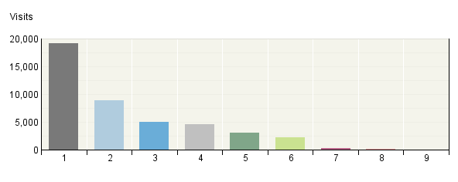

Top-​Level Domain Types
Top-Level Domain Types | Visits | % Visits | Hits
Unresolved IP Address | 19,199 | 17% | 82,939
Network (.net) | 8,924 | 8% | 102,770
Commercial (.com, .co, .firm, .ltd) | 4,974 | 4% | 51,128
Educational (.edu, .school, .ac) | 4,642 | 4% | 50,059
Country Specific | 3,028 | 3% | 32,028
Government (.gov, .go) | 2,276 | 2% | 18,731
Organization (.org, .or) | 307 | 0% | 3,311
Military (.mil) | 161 | 0% | 1,850
Unknown Country | 50 | 0% | 360
Other | 71,392 | 62.11% | 153,248
Total | 114,953 | 100.00% | 496,424

Top-Level Domain Types - Help Card
Column Definitions

Reserved IP Address
The IP address falls within a block of reserved addresses. For example, 192.168.x.x and 10.x.x.x addresses are reserved for private networks.

Unresolved IP Address
Category for IP addresses that did not resolve to a domain (perhaps because DNS resolution was disabled).

Unknown
The domain suffix did not match any of the top-level domain categories.

Top-Level Domain
The suffix of a domain name. A top-level domain can be based on the type of organization (.com, .edu, .museum, .name, etc) or it can be a country code (.uk, .de, .jp, .us, etc.). The top-level domain can be used to identify the type of web site. The following is a partial list of how this report categorizes top-level domains:

- ARPANET: .arpa
- Commercial: .com .co .com.[country code] .co.[country code] .firm.co .firm.ve .ltd.uk .info .biz
- Education: .edu .edu.[country-code] .ed.[country code] .ac.[country code] .school.[country code] .k12.[country code] .re.kr .sch.uk .edunet.tn
- International: .int .int.co .int.ve .intl.tn
- Government: .gov .gov.[country code] .gove.[country code] .go.[country code]
- Military: .mil .mil.[country code]
- Network: .net .ad.jp .ne.kr .net.[country code]
- Organization: .org .or .org.[country code] .or.[country code]
- Personal: .name

Visits
Number of visits to your site from the specified top-level domain. A visit is a series of actions that begins when a visitor views their first page from the server, and ends when the visitor leaves the site or remains idle beyond the idle-time limit. The default idle-time limit is thirty minutes. This time limit can be changed by the system administrator.

Hits
Number of hits to your site from the specified top-level domain. Each file requested by a visitor registers as a hit. There can be several hits on each page. While the volume of hits reflects the amount of server traffic, it is not an accurate reflection of the number of pages viewed.

—
Report Descriptions
Consider which types of organizations are interested in your site, and consider how you can interest other types of organizations.

Note:This information can be displayed only if reverse DNS lookups have been performed. Even when DNS lookups are performed, some IP addresses cannot be resolved to a domain name.

Total- This represents the total visits or hits where there was sufficient information to identify the top-level domain. This number may be less than the total activity overall.

Countries
This report identifies the top countries of the visitors to your site. Use this report to understand how broadly your site is used.

Countries
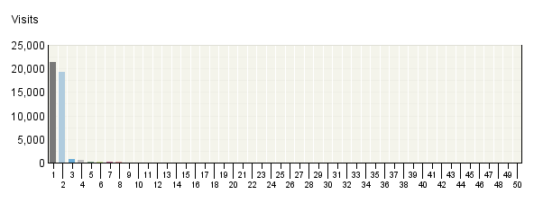

Countries
 | Countries | Visits | % Visits
1. | United States | 21,452 | 19%
2. | Unknown Country | 19,249 | 17%
3. | Canada | 743 | 1%
4. | Germany | 631 | 1%
5. | Spain | 197 | 0%
6. | Australia | 195 | 0%
7. | Slovak Republic | 188 | 0%
8. | Mexico | 99 | 0%
9. | France | 85 | 0%
10. | United Kingdom | 62 | 0%
11. | Brazil | 60 | 0%
12. | New Zealand | 53 | 0%
13. | Italy | 40 | 0%
14. | Japan | 37 | 0%
15. | Malaysia | 35 | 0%
16. | Netherlands | 35 | 0%
17. | Singapore | 28 | 0%
18. | Argentina | 25 | 0%
19. | India | 22 | 0%
20. | Turkey | 21 | 0%
21. | Thailand | 20 | 0%
22. | Romania | 20 | 0%
23. | Austria | 18 | 0%
24. | Sweden | 16 | 0%
25. | Switzerland | 16 | 0%
26. | Peru | 16 | 0%
27. | Portugal | 16 | 0%
28. | Greece | 15 | 0%
29. | Russian Federation | 15 | 0%
30. | Denmark | 13 | 0%
31. | China | 11 | 0%
32. | Taiwan | 11 | 0%
33. | Czech Republic | 10 | 0%
34. | Hungary | 9 | 0%
35. | Virgin Islands (USA) | 8 | 0%
36. | Belgium | 7 | 0%
37. | Ireland | 7 | 0%
38. | Poland | 7 | 0%
39. | Croatia | 6 | 0%
40. | Latvia | 6 | 0%
41. | Chile | 5 | 0%
42. | Ukraine | 5 | 0%
43. | Israel | 4 | 0%
44. | Norway | 4 | 0%
45. | Pakistan | 3 | 0%
46. | Samoa | 3 | 0%
47. | Hong Kong | 3 | 0%
48. | Estonia | 3 | 0%
49. | Bulgaria | 3 | 0%
50. | Yugoslavia | 2 | 0%
 | Subtotal for rows 1–50 | 43,539 | 37.88%
 | Other | 71,414 | 62.12%
 | Total | 114,953 | 100.00%
Items 1–50 of 69

Countries - Help Card
Column Definitions

Countries
If the Webtrends GeoTrends Database is turned on for this profile, the country is determined by looking up the visitor's IP address in this database. If GeoTrends is not enabled, the country will be determined from the domain name.

Visits
Number of visits from the specified country. A visit is a series of actions that begins when a visitor views their first page from the server, and ends when the visitor leaves the site or remains idle beyond the idle-time limit. The default idle-time limit is thirty minutes. This time limit can be changed by the system administrator.

%
Percentage of total visits from the specified country.

Unknown Country
The country associated with the visitor's domain name could not be determined.

—
Report Descriptions
This information can help you meet the needs of your target audience as well as discover new audiences. Consider how you can make the content comprehensive and relevant to an international audience.

Note:Use this information carefully because it is based on Internet registration, and may not always be an accurate identifier of the visitor's actual location.

Visits Trend
This report helps you determine traffic patterns within the day, week, or month so you can adjust your web site strategy to anticipate peaks and times of low activity. The trend intervals displayed depend on the selected report period.

Visits Trend
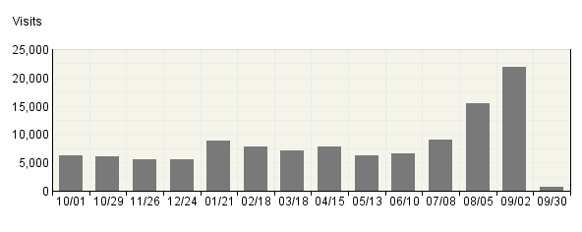

Visits Trend
Time Interval | Visits | % Visits
10/​01 | 6,311 | 5%
10/​29 | 6,111 | 5%
11/​26 | 5,536 | 5%
12/​24 | 5,474 | 5%
01/​21 | 8,810 | 8%
02/​18 | 7,818 | 7%
03/​18 | 7,045 | 6%
04/​15 | 7,890 | 7%
05/​13 | 6,335 | 6%
06/​10 | 6,667 | 6%
07/​08 | 8,943 | 8%
08/​05 | 15,383 | 13%
09/​02 | 21,930 | 19%
09/​30 | 700 | 1%
Total | 114,953 | 100.00%

Visits Trend - Help Card
Column Definitions

Time Interval (hour, day, etc.)
A one-year report displays monthly time increments. A one-quarter report displays weekly time increments. A one-month report or a one-week report displays daily time increments. A daily report displays hourly time increments. An hour-long interval marked 12:00, for example, includes all activity between 12:00 and 12:59.

Visits
Number of visits to your site during the specified time interval. A visit is a series of actions that begins when a visitor views their first page from the server, and ends when the visitor leaves the site or remains idle beyond the idle-time limit. The default idle-time limit is thirty minutes. This time limit can be changed by the system administrator.

%
Percentage of visits to your site during the specified time interval compared with all visits to your site during the report period.

—
Report Descriptions
Browser data can help you determine how to configure your site for optimal viewing. This information will only be displayed if your server is logging the browser/platform information.

Note:Hits identified as originating from a spider (an automated program that searches the Internet) are included in a single row called "Spiders". Also, if a browser does not identify itself in its request to the Web server, it will get counted on this page as an "Other."

Visits by Number of Pages Viewed
This report shows you how many times visitors viewed one page, how many viewed two pages, etc.

Visits by Number of Pages Viewed
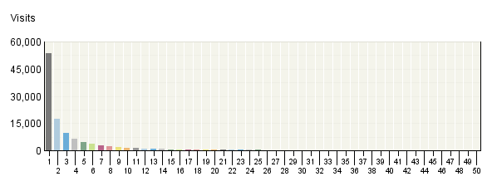

Visits by Number of Pages Viewed
 | Number of Pages Viewed | Visits | % Visits
1. | 1 Page | 53,596 | 47%
2. | 2 Pages | 17,377 | 15%
3. | 3 Pages | 9,837 | 9%
4. | 4 Pages | 6,455 | 6%
5. | 5 Pages | 4,804 | 4%
6. | 6 Pages | 3,440 | 3%
7. | 7 Pages | 2,861 | 2%
8. | 8 Pages | 2,143 | 2%
9. | 9 Pages | 1,881 | 2%
10. | 10 Pages | 1,392 | 1%
11. | 11 Pages | 1,322 | 1%
12. | 12 Pages | 1,029 | 1%
13. | 13 Pages | 957 | 1%
14. | 14 Pages | 788 | 1%
15. | 15 Pages | 674 | 1%
16. | 16 Pages | 634 | 1%
17. | 17 Pages | 545 | 0%
18. | 18 Pages | 476 | 0%
19. | 19 Pages | 408 | 0%
20. | 20 Pages | 404 | 0%
21. | 21 Pages | 344 | 0%
22. | 22 Pages | 335 | 0%
23. | 23 Pages | 285 | 0%
24. | 24 Pages | 267 | 0%
25. | 25 Pages | 232 | 0%
26. | 26 Pages | 192 | 0%
27. | 27 Pages | 195 | 0%
28. | 28 Pages | 151 | 0%
29. | 29 Pages | 143 | 0%
30. | 30 Pages | 128 | 0%
31. | 31 Pages | 120 | 0%
32. | 32 Pages | 102 | 0%
33. | 33 Pages | 103 | 0%
34. | 34 Pages | 84 | 0%
35. | 35 Pages | 77 | 0%
36. | 36 Pages | 73 | 0%
37. | 37 Pages | 73 | 0%
38. | 38 Pages | 63 | 0%
39. | 39 Pages | 49 | 0%
40. | 40 Pages | 57 | 0%
41. | 41 Pages | 61 | 0%
42. | 42 Pages | 53 | 0%
43. | 43 Pages | 33 | 0%
44. | 44 Pages | 33 | 0%
45. | 45 Pages | 38 | 0%
46. | 46 Pages | 29 | 0%
47. | 47 Pages | 34 | 0%
48. | 48 Pages | 36 | 0%
49. | 49 Pages | 31 | 0%
50. | 50 Pages | 29 | 0%
 | Subtotal for rows 1–50 | 114,473 | 99.58%
 | Other | 480 | 0.42%
 | Total | 114,953 | 100.00%
Items 1–50 of 99

Visits by Number of Pages Viewed - Help Card
Column Definitions

Number of Pages Viewed
The number of pages viewed during a visit. If the visitor viewed only non-page files such as a .gif or a .jpeg, the count of pages viewed is zero for that visit.

Visits
Number of visits by visitors who viewed the specified number of pages. A visit is a series of actions that begins when a visitor views their first page from the server, and ends when the visitor leaves the site or remains idle beyond the idle-time limit. The default idle-time limit is thirty minutes. This time limit can be changed by the system administrator.

%
Percentage of total visits by people who viewed the specified number of pages.

—
Report Descriptions
You can use this information to quickly find out the number and percentages of viewers who read a given number of pages on your site. If most visitors only view a few pages, it may indicate that they cannot find the content they are looking for.

Visits with 0 pages are visits where the only hits are to files that do not constitute pages, such as images.

Visit Duration by Visits
This report shows the number and percentages of pages views over selected visit lengths.

Visit Duration by Visits
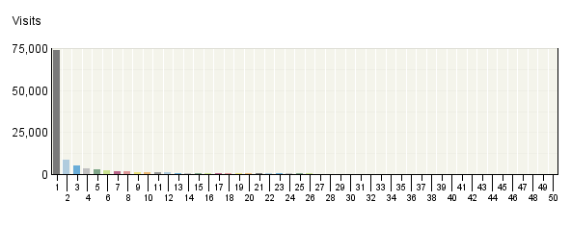

Visit Duration by Visits
 | Visit Duration in Minutes | Visits | % Visits
1. | 0-​1 | 73,662 | 64%
2. | 1-​2 | 8,546 | 7%
3. | 2-​3 | 5,063 | 4%
4. | 3-​4 | 3,671 | 3%
5. | 4-​5 | 2,761 | 2%
6. | 5-​6 | 2,240 | 2%
7. | 6-​7 | 1,856 | 2%
8. | 7-​8 | 1,532 | 1%
9. | 8-​9 | 1,301 | 1%
10. | 9-​10 | 1,101 | 1%
11. | 10-​11 | 1,041 | 1%
12. | 11-​12 | 913 | 1%
13. | 12-​13 | 783 | 1%
14. | 13-​14 | 735 | 1%
15. | 14-​15 | 715 | 1%
16. | 15-​16 | 618 | 1%
17. | 16-​17 | 546 | 0%
18. | 17-​18 | 519 | 0%
19. | 18-​19 | 494 | 0%
20. | 19-​20 | 446 | 0%
21. | 20-​21 | 413 | 0%
22. | 21-​22 | 439 | 0%
23. | 22-​23 | 366 | 0%
24. | 23-​24 | 336 | 0%
25. | 24-​25 | 346 | 0%
26. | 25-​26 | 330 | 0%
27. | 26-​27 | 276 | 0%
28. | 27-​28 | 283 | 0%
29. | 28-​29 | 263 | 0%
30. | 29-​30 | 279 | 0%
31. | 30-​31 | 214 | 0%
32. | 31-​32 | 169 | 0%
33. | 32-​33 | 167 | 0%
34. | 33-​34 | 162 | 0%
35. | 34-​35 | 156 | 0%
36. | 35-​36 | 129 | 0%
37. | 36-​37 | 113 | 0%
38. | 37-​38 | 117 | 0%
39. | 38-​39 | 98 | 0%
40. | 39-​40 | 96 | 0%
41. | 40-​41 | 77 | 0%
42. | 41-​42 | 92 | 0%
43. | 42-​43 | 78 | 0%
44. | 43-​44 | 70 | 0%
45. | 44-​45 | 65 | 0%
46. | 45-​46 | 68 | 0%
47. | 46-​47 | 77 | 0%
48. | 47-​48 | 68 | 0%
49. | 48-​49 | 56 | 0%
50. | 49-​50 | 46 | 0%
 | Subtotal for rows 1–50 | 113,992 | 99.16%
 | Other | 961 | 0.84%
 | Total | 114,953 | 100.00%
Items 1–50 of 61

Visit Duration by Visits - Help Card
Column Definitions

Visit Duration in Minutes
The number of minutes your web site was viewed.

Visits
Number of visitors who viewed your page for the specified duration of time. A visit is a series of actions that begins when a visitor views their first page from the server, and ends when the visitor leaves the site or remains idle beyond the idle-time limit. The default idle-time limit is thirty minutes. This time limit can be changed by the system administrator.

%
Percentage of visitors who viewed your page for the specified duration of time.

—
Report Descriptions
This information tells you how many visitors view your site for specific intervals of time.

Visit Duration by Page Views
This report shows the number and percentages of visits over selected visit lengths.

Visit Duration by Page Views
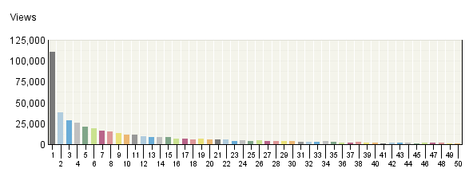

Visit Duration by Page Views
 | Visit Duration in Minutes | Views | % Views
1. | 0-​1 | 110,440 | 22%
2. | 1-​2 | 38,132 | 8%
3. | 2-​3 | 28,846 | 6%
4. | 3-​4 | 25,364 | 5%
5. | 4-​5 | 20,772 | 4%
6. | 5-​6 | 19,303 | 4%
7. | 6-​7 | 16,578 | 3%
8. | 7-​8 | 14,841 | 3%
9. | 8-​9 | 13,305 | 3%
10. | 9-​10 | 11,101 | 2%
11. | 10-​11 | 11,023 | 2%
12. | 11-​12 | 9,970 | 2%
13. | 12-​13 | 8,484 | 2%
14. | 13-​14 | 8,314 | 2%
15. | 14-​15 | 8,805 | 2%
16. | 15-​16 | 7,100 | 1%
17. | 16-​17 | 6,358 | 1%
18. | 17-​18 | 6,140 | 1%
19. | 18-​19 | 6,265 | 1%
20. | 19-​20 | 5,255 | 1%
21. | 20-​21 | 5,405 | 1%
22. | 21-​22 | 5,617 | 1%
23. | 22-​23 | 3,988 | 1%
24. | 23-​24 | 4,941 | 1%
25. | 24-​25 | 4,193 | 1%
26. | 25-​26 | 4,461 | 1%
27. | 26-​27 | 4,031 | 1%
28. | 27-​28 | 3,810 | 1%
29. | 28-​29 | 3,564 | 1%
30. | 29-​30 | 3,764 | 1%
31. | 30-​31 | 3,334 | 1%
32. | 31-​32 | 2,892 | 1%
33. | 32-​33 | 2,817 | 1%
34. | 33-​34 | 3,435 | 1%
35. | 34-​35 | 2,733 | 1%
36. | 35-​36 | 2,257 | 0%
37. | 36-​37 | 2,161 | 0%
38. | 37-​38 | 2,485 | 1%
39. | 38-​39 | 2,001 | 0%
40. | 39-​40 | 1,788 | 0%
41. | 40-​41 | 1,255 | 0%
42. | 41-​42 | 2,036 | 0%
43. | 42-​43 | 1,739 | 0%
44. | 43-​44 | 1,707 | 0%
45. | 44-​45 | 1,280 | 0%
46. | 45-​46 | 1,518 | 0%
47. | 46-​47 | 2,133 | 0%
48. | 47-​48 | 1,465 | 0%
49. | 48-​49 | 1,371 | 0%
50. | 49-​50 | 1,230 | 0%
 | Subtotal for rows 1–50 | 461,807 | 93.03%
 | Other | 34,617 | 6.97%
 | Total | 496,424 | 100.00%
Items 1–50 of 61

Visit Duration by Page Views - Help Card
Column Definitions

Visit Duration in Minutes
The number of minutes your web site was viewed.

Views
A page view is a hit to any file classified as a page. Contrast page views with hits, which counts files of every type.

%
Percentage of visitors who viewed your page for the specified duration of time.

—
Report Descriptions
This information tells you how many visitors view your site for specific intervals of time.

Pages
This report identifies the most popular pages on your site and shows you key metrics for each page such as Visits, Page Views and Average Time Viewed.

Pages Trend
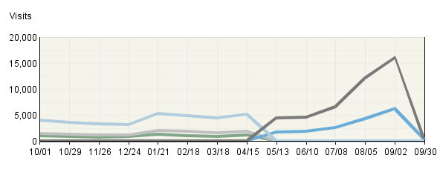

Pages
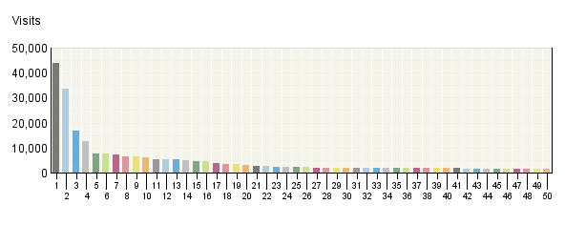

Pages
 | Pages | Visits | Views
1. | Department of Energy Solar Decathlon Home Page  http:/​/​www.​solardecathl​on.​org/​ | 43,756 | 61,116
2. | EERE: Department of Energy Solar Decathlon Home Page  http:/​/​www.​eere.​energy.​gov/​solar_​decathlon/​ | 33,568 | 46,780
3. | DOE Solar Decathlon: Teams  http:/​/​www.​solardecathl​on.​org/​teams.​html | 16,842 | 38,921
4. | DOE Solar Decathlon: Teams  http:/​/​www.​eere.​energy.​gov/​solar_​decathlon/​teams.​html | 12,497 | 27,293
5. | DOE Solar Decathlon: About Solar Decathlon  http:/​/​www.​eere.​energy.​gov/​solar_​decathlon/​about.​html | 7,761 | 11,127
6. | DOE Solar Decathlon: About Solar Decathlon  http:/​/​www.​solardecathl​on.​org/​about.​html | 7,450 | 10,351
7. | DOE Solar Decathlon: 2007 Schedule of Events  http:/​/​www.​solardecathl​on.​org/​schedule.​html | 7,128 | 9,755
8. | DOE Solar Decathlon: Past Decathlons  http:/​/​www.​eere.​energy.​gov/​solar_​decathlon/​past_​decathlons.​html | 6,545 | 8,909
9. | DOE Solar Decathlon: Past Decathlons  http:/​/​www.​solardecathl​on.​org/​past_​decathlons.​html | 6,425 | 8,548
10. | DOE Solar Decathlon: Photo Gallery of Homes  http:/​/​www.​eere.​energy.​gov/​solar_​decathlon/​homes_​gallery.​html | 5,928 | 7,110
11. | DOE Solar Decathlon: Highlights from 2005  http:/​/​www.​eere.​energy.​gov/​solar_​decathlon/​highlights_​2005.​html | 5,463 | 8,442
12. | DOE Solar Decathlon: Information for Teams  http:/​/​www.​solardecathl​on.​org/​teams_​information.​html | 5,335 | 7,211
13. | DOE Solar Decathlon: Highlights from 2005  http:/​/​www.​solardecathl​on.​org/​highlights_​2005.​html | 5,296 | 7,992
14. | DOE Solar Decathlon: Contests and Scoring  http:/​/​www.​eere.​energy.​gov/​solar_​decathlon/​contests_​scoring.​html | 4,897 | 9,665
15. | DOE Solar Decathlon: Highlights from 2005 -​ Photo Gallery of Homes  http:/​/​www.​eere.​energy.​gov/​solar_​decathlon/​2005/​homes_​gallery.​html | 4,742 | 6,618
16. | DOE Solar Decathlon: Contests and Scoring  http:/​/​www.​solardecathl​on.​org/​contests_​scoring.​html | 4,630 | 8,713
17. | DOE Solar Decathlon: Highlights from 2005 -​ Photo Gallery of Homes  http:/​/​www.​solardecathl​on.​org/​2005/​homes_​gallery.​html | 3,816 | 5,262
18. | DOE Solar Decathlon: Highlights from 2005 -​ Technical Report  http:/​/​www.​eere.​energy.​gov/​solar_​decathlon/​2005/​technical_​report.​html | 3,382 | 7,145
19. | DOE Solar Decathlon: Sponsors  http:/​/​www.​solardecathl​on.​org/​sponsors.​html | 3,302 | 4,600
20. | DOE Solar Decathlon: Information for Teams  http:/​/​www.​eere.​energy.​gov/​solar_​decathlon/​teams_​information.​html | 3,086 | 4,074
21. | DOE Solar Decathlon: Sponsors  http:/​/​www.​eere.​energy.​gov/​solar_​decathlon/​sponsors.​html | 2,503 | 3,498
22. | DOE Solar Decathlon: Information for Media  http:/​/​www.​solardecathl​on.​org/​for_​media.​html | 2,487 | 3,513
23. | DOE Solar Decathlon: Solar Decathlon 2007  http:/​/​www.​eere.​energy.​gov/​solar_​decathlon/​solar_​decathlon_​2007.​html | 2,360 | 2,956
24. | DOE Solar Decathlon: Highlights from 2005 -​ Final Results  http:/​/​www.​eere.​energy.​gov/​solar_​decathlon/​2005/​final_​results.​html | 2,242 | 3,747
25. | DOE Solar Decathlon: Information for Media  http:/​/​www.​eere.​energy.​gov/​solar_​decathlon/​for_​media.​html | 2,188 | 3,001
26. | DOE Solar Decathlon: Rules and Regulations  http:/​/​www.​eere.​energy.​gov/​solar_​decathlon/​rules_​regs.​html | 2,104 | 3,431
27. | DOE Solar Decathlon: Photo Gallery of Homes  http:/​/​www.​solardecathl​on.​org/​homes_​gallery.​html | 2,086 | 2,530
28. | DOE Solar Decathlon: Highlights from 2005 -​ Final Results  http:/​/​www.​solardecathl​on.​org/​2005/​final_​results.​html | 2,076 | 3,255
29. | DOE Solar Decathlon: Frequently Asked Questions  http:/​/​www.​solardecathl​on.​org/​faqs.​html | 2,075 | 2,818
30. | DOE Solar Decathlon: Rules and Regulations  http:/​/​www.​solardecathl​on.​org/​rules_​regs.​html | 1,986 | 3,155
31. | DOE Solar Decathlon: Highlights from 2005 -​ Teams  http:/​/​www.​eere.​energy.​gov/​solar_​decathlon/​2005/​teams.​html | 1,978 | 3,194
32. | DOE Solar Decathlon: Information for Consumers  http:/​/​www.​solardecathl​on.​org/​for_​consumers.​html | 1,961 | 2,671
33. | DOE Solar Decathlon: Highlights from 2002  http:/​/​www.​eere.​energy.​gov/​solar_​decathlon/​highlights_​2002.​html | 1,914 | 2,697
34. | DOE Solar Decathlon: Registration  http:/​/​www.​solardecathl​on.​org/​registration​.​html | 1,900 | 3,391
35. | DOE Solar Decathlon: Frequently Asked Questions  http:/​/​www.​eere.​energy.​gov/​solar_​decathlon/​faqs.​html | 1,871 | 2,505
36. | DOE Solar Decathlon: Highlights from 2002  http:/​/​www.​solardecathl​on.​org/​highlights_​2002.​html | 1,871 | 2,574
37. | DOE Solar Decathlon: Information for Teachers  http:/​/​www.​eere.​energy.​gov/​solar_​decathlon/​for_​teachers.​html | 1,835 | 2,926
38. | DOE Solar Decathlon: Information for Consumers  http:/​/​www.​eere.​energy.​gov/​solar_​decathlon/​for_​consumers.​html | 1,805 | 2,514
39. | DOE Solar Decathlon: Architecture  http:/​/​www.​eere.​energy.​gov/​solar_​decathlon/​contest_​architecture​.​html | 1,799 | 2,342
40. | DOE Solar Decathlon: Information for Volunteers  http:/​/​www.​solardecathl​on.​org/​for_​volunteers.​html | 1,758 | 2,581
41. | DOE Solar Decathlon: Contacts  http:/​/​www.​solardecathl​on.​org/​contacts.​html | 1,754 | 2,374
42. | DOE Solar Decathlon: Contacts  http:/​/​www.​eere.​energy.​gov/​solar_​decathlon/​contacts.​html | 1,707 | 2,224
43. | DOE Solar Decathlon: Architecture  http:/​/​www.​solardecathl​on.​org/​contest_​architecture​.​html | 1,684 | 2,100
44. | DOE Solar Decathlon: Highlights from 2005 -​ Daily Photos  http:/​/​www.​eere.​energy.​gov/​solar_​decathlon/​2005/​daily_​photos.​html | 1,541 | 3,821
45. | DOE Solar Decathlon: Fulfilling a Purpose  http:/​/​www.​eere.​energy.​gov/​solar_​decathlon/​purpose.​html | 1,539 | 2,137
46. | DOE Solar Decathlon: 404 -​ Document Not Found  http:/​/​www.​solardecathl​on.​org/​solar_​decathlon_​2007.​html | 1,530 | 1,883
47. | DOE Solar Decathlon: Information for Kids  http:/​/​www.​eere.​energy.​gov/​solar_​decathlon/​for_​kids.​html | 1,512 | 2,460
48. | DOE Solar Decathlon: Highlights from 2005 -​ Teams  http:/​/​www.​solardecathl​on.​org/​2005/​teams.​html | 1,485 | 2,127
49. | Department of Energy Solar Decathlon Home Page  http:/​/​solardecathl​on.​org/​ | 1,484 | 1,915
50. | DOE Solar Decathlon: Fulfilling a Purpose  http:/​/​www.​solardecathl​on.​org/​purpose.​html | 1,483 | 2,029
 | Subtotal for rows 1–50 | - | 382,001
 | Other | - | 114,412
 | Total | - | 496,413
Items 1–50 of 550

Pages - Help Card
Column Definitions

Pages
Any displayed page. You can specify for each profile the types of files that qualify as a page. These settings can be changed by the Webtrends administrator.

Visits
Number of visits to this page. A visit is a series of actions that begins when a visitor views the first page from the server, and ends when the visitor leaves the site or remains idle beyond the idle-time limit. The default idle-time limit is thirty minutes. This time limit can be changed by the system administrator.

Views
Number of times this page was viewed by visitors.

Average Time Viewed
Average length of time, in seconds, that the specified page was viewed.

Average Time to Serve
Average amount of time (in milliseconds) it took to serve each document during the specified time interval. The time to serve spans from the time the server got a page request until it transmitted all the data.
Note: Note that in order to show a total for this column, the value is computed to 2 decimal places. However, because the data for each row is an integer measured in milliseconds, the two decimal places are not significant for Average Time to Serve row values. If the entire column shows values of zero, your web server may not be logging Time to Serve information.

—
Report Descriptions
Pages with good content and design are more likely to attract visitors and be revisited. Less popular pages on a site can be made more appealing by improving the content or incorporating design elements similar to that on the more important pages. Always remember that people are far more interested in content than in design, and average view times can help determine which content is most important to your visitors.

Page Views Trend
This report shows activity trends on your site based on the total page view volume for the report period. You can use this information to determine high and low points of visitor activity.

Page Views Trend
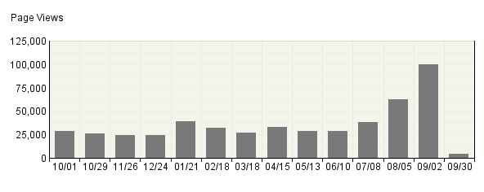

Page Views Trend
Time Interval | Page Views | % Page Views
10/​01 | 29,069 | 6%
10/​29 | 26,103 | 5%
11/​26 | 24,272 | 5%
12/​24 | 23,900 | 5%
01/​21 | 38,861 | 8%
02/​18 | 32,354 | 7%
03/​18 | 26,800 | 5%
04/​15 | 32,920 | 7%
05/​13 | 28,353 | 6%
06/​10 | 28,858 | 6%
07/​08 | 37,802 | 8%
08/​05 | 62,828 | 13%
09/​02 | 100,241 | 20%
09/​30 | 4,052 | 1%
Total | 496,413 | 100.00%

Page Views Trend - Help Card
Column Definitions

Time Interval (hour, day, etc.)
A one-year report displays monthly time increments. A one-quarter report displays weekly time increments. A one-month report or a one-week report displays daily time increments. A daily report displays hourly time increments. An hour-long interval marked 12:00, for example, includes all activity between 12:00 and 12:59.

Page View
A hit to any file classified as a page. In order to view a web page with embedded images, for example, a browser must retrieve multiple files. The page and its embedded files counts as a single page view.

%
Percentage of total page views that occurred during the specified time interval.

—
Report Descriptions
Periods of less activity can be considered good times for maintenance and content improvement.

File Downloads

File Downloads Trend
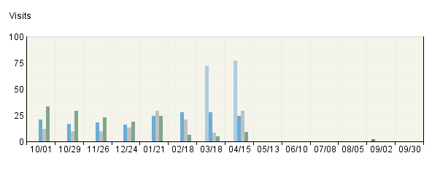

File Downloads
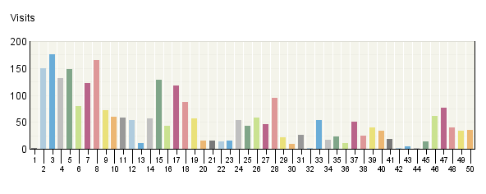

File Downloads
 | File Name | Visits | Page Views
1. | schedule.html | 2 | 2
2. | www.eere.energy.gov/​solar_​decathlon/​pdfs/​sd07_​rules_​regs.pdf | 149 | 174
3. | www.eere.energy.gov/​solar_​decathlon/​pdfs/​2007_​rfp.pdf | 176 | 187
4. | www.eere.energy.gov/​solar_​decathlon/​pdfs/​customer_​workshops_​handout.pdf | 132 | 145
5. | www.eere.energy.gov/​solar_​decathlon/​download/​final_​scoring_​2005.zip | 148 | 174
6. | www.eere.energy.gov/​solar_​decathlon/​pdfs/​sponosorship_​opportunities.pdf | 79 | 99
7. | www.eere.energy.gov/​solar_​decathlon/​pdfs/​techreport05/​38264tp_​equipment_​summaries.pdf | 122 | 132
8. | www.eere.energy.gov/​solar_​decathlon/​pdfs/​techreport05/​calpoly_​floor_​plan.pdf | 165 | 178
9. | www.eere.energy.gov/​solar_​decathlon/​pdfs/​techreport05/​va_​tech_​floor_​plan.pdf | 72 | 77
10. | www.eere.energy.gov/​solar_​decathlon/​pdfs/​techreport05/​madrid_​floor_​plan.pdf | 59 | 61
11. | www.eere.energy.gov/​solar_​decathlon/​pdfs/​techreport05/​nyit_​floor_​plan.pdf | 58 | 60
12. | www.eere.energy.gov/​solar_​decathlon/​pdfs/​2007_​rfp_​amend1.pdf | 53 | 53
13. | www.eere.energy.gov/​/​solar_​decathlon/​pdfs/​sd07_​rules_​regs.pdf | 11 | 12
14. | www.eere.energy.gov/​solar_​decathlon/​pdfs/​techreport05/​mo_​rolla_​floor_​plan.pdf | 56 | 59
15. | www.eere.energy.gov/​solar_​decathlon/​pdfs/​techreport05/​co_​floor_​plan.pdf | 128 | 131
16. | www.eere.energy.gov/​solar_​decathlon/​pdfs/​techreport05/​puerto_​rico_​floor_​plan.pdf | 43 | 48
17. | www.eere.energy.gov/​solar_​decathlon/​pdfs/​techreport05/​va_​tech_​architecture_​report.pdf | 117 | 119
18. | www.eere.energy.gov/​solar_​decathlon/​pdfs/​techreport05/​canada_​floor_​plan.pdf | 87 | 91
19. | www.eere.energy.gov/​solar_​decathlon/​pdfs/​techreport05/​wa_​floor_​plan.pdf | 56 | 61
20. | www.eere.energy.gov/​solar_​decathlon/​pdfs/​techreport05/​nyit_​architecture_​report.pdf | 16 | 17
21. | www.eere.energy.gov/​solar_​decathlon/​pdfs/​techreport05/​madrid_​electric_​lighting_​report.pdf | 16 | 17
22. | www.eere.energy.gov/​solar_​decathlon/​pdfs/​techreport05/​madrid_​hot_​water_​report.pdf | 14 | 14
23. | www.eere.energy.gov/​solar_​decathlon/​download/​techreport05/​mo_​rolla_​asbuilt.zip | 16 | 20
24. | www.eere.energy.gov/​solar_​decathlon/​pdfs/​techreport05/​pittsburgh_​floor_​plan.pdf | 54 | 55
25. | www.eere.energy.gov/​solar_​decathlon/​pdfs/​techreport05/​wa_​thermal_​comfort_​report.pdf | 43 | 46
26. | www.eere.energy.gov/​solar_​decathlon/​pdfs/​techreport05/​fl_​intl_​floor_​plan.pdf | 58 | 58
27. | www.eere.energy.gov/​solar_​decathlon/​pdfs/​techreport05/​risd_​floor_​plan.pdf | 46 | 49
28. | www.eere.energy.gov/​solar_​decathlon/​pdfs/​techreport05/​cornell_​floor_​plan.pdf | 94 | 98
29. | www.eere.energy.gov/​solar_​decathlon/​download/​techreport05/​nyit_​asbuilt.zip | 22 | 28
30. | www.eere.energy.gov/​solar_​decathlon/​pdfs/​techreport05/​cornell_​hot_​water_​report.pdf | 9 | 9
31. | www.eere.energy.gov/​solar_​decathlon/​pdfs/​techreport05/​tx_​hot_​water_​report.pdf | 26 | 28
32. | www.eere.energy.gov/​solar_​decathlon/​pdfs/​sd05rr_​cont07.pdf | 2 | 2
33. | www.eere.energy.gov/​solar_​decathlon/​pdfs/​techreport05/​tx_​floor_​plan.pdf | 53 | 55
34. | www.eere.energy.gov/​solar_​decathlon/​pdfs/​techreport05/​co_​hot_​water_​report.pdf | 17 | 17
35. | www.eere.energy.gov/​solar_​decathlon/​download/​techreport05/​madrid_​asbuilt.zip | 23 | 25
36. | www.eere.energy.gov/​solar_​decathlon/​pdfs/​techreport05/​calpoly_​hot_​water_​report.pdf | 10 | 10
37. | www.eere.energy.gov/​solar_​decathlon/​pdfs/​techreport05/​mi_​floor_​plan.pdf | 50 | 57
38. | www.eere.energy.gov/​solar_​decathlon/​pdfs/​techreport05/​co_​thermal_​comfort_​report.pdf | 25 | 27
39. | www.eere.energy.gov/​solar_​decathlon/​pdfs/​techreport05/​calpoly_​architecture_​report.pdf | 39 | 40
40. | www.eere.energy.gov/​solar_​decathlon/​pdfs/​techreport05/​cornell_​thermal_​comfort_​report.pdf | 34 | 35
41. | www.eere.energy.gov/​solar_​decathlon/​pdfs/​sd05rr_​update.pdf | 19 | 21
42. | www.eere.energy.gov/​/​solar_​decathlon/​pdfs/​sponosorship_​opportunities.pdf | 2 | 2
43. | www.eere.energy.gov/​/​solar_​decathlon/​download/​techreport05/​canada_​asbuilt.zip | 4 | 4
44. | www.eere.energy.gov/​solar_​decathlon/​pdfs/​sd05rr_​batt.pdf | 2 | 2
45. | www.eere.energy.gov/​solar_​decathlon/​pdfs/​techreport05/​va_​tech_​hot_​water_​report.pdf | 13 | 13
46. | www.eere.energy.gov/​solar_​decathlon/​pdfs/​map_​mall.pdf | 61 | 66
47. | www.eere.energy.gov/​solar_​decathlon/​download/​techreport05/​calpoly_​asbuilt.zip | 77 | 92
48. | www.eere.energy.gov/​solar_​decathlon/​download/​techreport05/​cornell_​asbuilt.zip | 40 | 53
49. | www.eere.energy.gov/​solar_​decathlon/​pdfs/​techreport05/​38264tp_​daily_​event_​schedule.pdf | 34 | 34
50. | www.eere.energy.gov/​solar_​decathlon/​download/​techreport05/​va_​tech_​asbuilt.zip | 35 | 39
 | Subtotal for rows 1–50 | 2,667 | 2,896
 | Other | 2,009 | 2,209
 | Total | N/A | 5,105
Items 1–50 of 246

File Downloads - Help Card
Column Definitions

File Name
A list of unique dimension values for this parameter.

Page Views
A hit to any file classified as a page. In order to view a web page with embedded images, for example, a browser must retrieve multiple files. The page and its embedded files counts as a single page view.

Visits
A visit is a series of actions that begins when a visitor views their first page from the server, and ends when the visitor leaves the site or remains idle beyond the idle-time limit. The default idle-time limit is thirty minutes. This time limit can be changed by the system administrator.

Note that if the dimension changes state during the course of a visit (such as a visitor changing from non-customer to customer), the visit will be recorded for both states. In such cases, the total of visits in this report may be greater than the number of visits reported in the Overview. In the Key Metrics Summary report for example, if a visit spans several hours, it is recorded in each of the hours.

Entry Pages
This report focuses on pages that were most often the first or "entry" page of a visit. Each visit can have only one entry page. You can use this report to determine whether visitors are entering your web site using the pages you expect.

Entry Pages: Trend Over Time
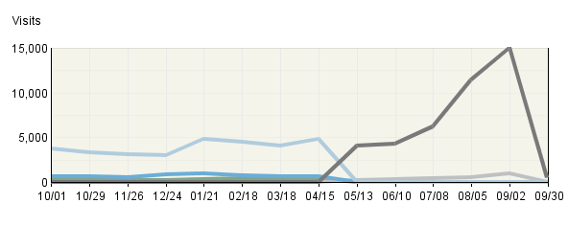

Entry Pages
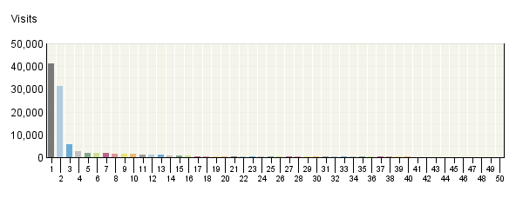

Entry Pages
 | Pages | Visits | % Visits
1. | Department of Energy Solar Decathlon Home Page  http:/​/​www.​solardecathl​on.​org/​ | 41,275 | 36%
2. | EERE: Department of Energy Solar Decathlon Home Page  http:/​/​www.​eere.​energy.​gov/​solar_​decathlon/​ | 31,267 | 27%
3. | DOE Solar Decathlon: Photo Gallery of Homes  http:/​/​www.​eere.​energy.​gov/​solar_​decathlon/​homes_​gallery.​html | 5,651 | 5%
4. | DOE Solar Decathlon: Teams  http:/​/​www.​solardecathl​on.​org/​teams.​html | 2,483 | 2%
5. | DOE Solar Decathlon: Solar Decathlon 2007  http:/​/​www.​eere.​energy.​gov/​solar_​decathlon/​solar_​decathlon_​2007.​html | 2,091 | 2%
6. | DOE Solar Decathlon: Photo Gallery of Homes  http:/​/​www.​solardecathl​on.​org/​homes_​gallery.​html | 1,906 | 2%
7. | DOE Solar Decathlon: About Solar Decathlon  http:/​/​www.​eere.​energy.​gov/​solar_​decathlon/​about.​html | 1,883 | 2%
8. | DOE Solar Decathlon: Teams  http:/​/​www.​eere.​energy.​gov/​solar_​decathlon/​teams.​html | 1,595 | 1%
9. | DOE Solar Decathlon: 404 -​ Document Not Found  http:/​/​www.​solardecathl​on.​org/​solar_​decathlon_​2007.​html | 1,418 | 1%
10. | Department of Energy Solar Decathlon Home Page  http:/​/​solardecathl​on.​org/​ | 1,359 | 1%
11. | DOE Solar Decathlon: 2007 Schedule of Events  http:/​/​www.​solardecathl​on.​org/​schedule.​html | 1,308 | 1%
12. | DOE Solar Decathlon: Registration  http:/​/​www.​solardecathl​on.​org/​registration​.​html | 1,249 | 1%
13. | DOE Solar Decathlon: About Solar Decathlon  http:/​/​www.​solardecathl​on.​org/​about.​html | 1,010 | 1%
14. | DOE Solar Decathlon: Information for Teachers  http:/​/​www.​eere.​energy.​gov/​solar_​decathlon/​for_​teachers.​html | 865 | 1%
15. | DOE Solar Decathlon: Highlights from 2005 -​ Photo Gallery of Homes  http:/​/​www.​eere.​energy.​gov/​solar_​decathlon/​2005/​homes_​gallery.​html | 800 | 1%
16. | DOE Solar Decathlon: Information for Kids  http:/​/​www.​eere.​energy.​gov/​solar_​decathlon/​for_​kids.​html | 751 | 1%
17. | DOE Solar Decathlon: Graphics and Photos  http:/​/​www.​eere.​energy.​gov/​solar_​decathlon/​graphics.​html | 549 | 0%
18. | DOE Solar Decathlon: Contests and Scoring  http:/​/​www.​eere.​energy.​gov/​solar_​decathlon/​contests_​scoring.​html | 524 | 0%
19. | DOE Solar Decathlon: Highlights from 2005 -​ Technical Report  http:/​/​www.​eere.​energy.​gov/​solar_​decathlon/​2005/​technical_​report.​html | 506 | 0%
20. | DOE Solar Decathlon: Map of the Solar Village  http:/​/​www.​eere.​energy.​gov/​solar_​decathlon/​map.​html | 485 | 0%
21. | DOE Solar Decathlon: Contests and Scoring  http:/​/​www.​solardecathl​on.​org/​contests_​scoring.​html | 472 | 0%
22. | DOE Solar Decathlon: Information for Volunteers  http:/​/​www.​solardecathl​on.​org/​for_​volunteers.​html | 421 | 0%
23. | DOE Solar Decathlon: Rules and Regulations  http:/​/​www.​eere.​energy.​gov/​solar_​decathlon/​rules_​regs.​html | 409 | 0%
24. | DOE Solar Decathlon: Highlights from 2005 -​ Photo Gallery of Homes  http:/​/​www.​solardecathl​on.​org/​2005/​homes_​gallery.​html | 369 | 0%
25. | DOE Solar Decathlon: Information for Teams  http:/​/​www.​solardecathl​on.​org/​teams_​information.​html | 334 | 0%
26. | DOE Solar Decathlon: Rules and Regulations  http:/​/​www.​solardecathl​on.​org/​rules_​regs.​html | 322 | 0%
27. | DOE Solar Decathlon: 2005 Schedule of Events  http:/​/​www.​eere.​energy.​gov/​solar_​decathlon/​schedule.​html | 301 | 0%
28. | DOE Solar Decathlon: Graphics and Photos  http:/​/​www.​solardecathl​on.​org/​graphics.​html | 277 | 0%
29. | DOE Solar Decathlon: Information for Teachers  http:/​/​www.​solardecathl​on.​org/​for_​teachers.​html | 274 | 0%
30. | DOE Solar Decathlon: Frequently Asked Questions  http:/​/​www.​eere.​energy.​gov/​solar_​decathlon/​faqs.​html | 261 | 0%
31. | DOE Solar Decathlon: Past Decathlons  http:/​/​www.​solardecathl​on.​org/​past_​decathlons.​html | 260 | 0%
32. | DOE Solar Decathlon: Past Decathlons  http:/​/​www.​eere.​energy.​gov/​solar_​decathlon/​past_​decathlons.​html | 256 | 0%
33. | DOE Solar Decathlon: Sponsors  http:/​/​www.​solardecathl​on.​org/​sponsors.​html | 256 | 0%
34. | DOE Solar Decathlon: Highlights from 2005 -​ Photos of the Day -​ September 29, 2005  http:/​/​www.​eere.​energy.​gov/​solar_​decathlon/​2005/​daily_​photos_​0929.​html | 249 | 0%
35. | DOE Solar Decathlon: Frequently Asked Questions  http:/​/​www.​solardecathl​on.​org/​faqs.​html | 244 | 0%
36. | DOE Solar Decathlon: Information for Kids  http:/​/​www.​solardecathl​on.​org/​for_​kids.​html | 218 | 0%
37. | DOE Solar Decathlon: Information for Teams  http:/​/​www.​eere.​energy.​gov/​solar_​decathlon/​teams_​information.​html | 201 | 0%
38. | DOE Solar Decathlon: Highlights from 2005 -​ Cornell University  http:/​/​www.​eere.​energy.​gov/​solar_​decathlon/​2005/​team_​cornell.​html | 199 | 0%
39. | DOE Solar Decathlon: Highlights from 2005 -​ Judges and Jurors  http:/​/​www.​eere.​energy.​gov/​solar_​decathlon/​2005/​judges_​jurors.​html | 197 | 0%
40. | DOE Solar Decathlon: Fulfilling a Purpose  http:/​/​www.​eere.​energy.​gov/​solar_​decathlon/​purpose.​html | 197 | 0%
41. | DOE Solar Decathlon: Sponsors  http:/​/​www.​eere.​energy.​gov/​solar_​decathlon/​sponsors.​html | 181 | 0%
42. | DOE Solar Decathlon: Final Results  http:/​/​www.​eere.​energy.​gov/​solar_​decathlon/​final_​results.​html | 179 | 0%
43. | DOE Solar Decathlon: Highlights from 2005 -​ Technical Report  http:/​/​www.​solardecathl​on.​org/​2005/​technical_​report.​html | 178 | 0%
44. | DOE Solar Decathlon: Highlights from 2005 -​ Final Results  http:/​/​www.​solardecathl​on.​org/​2005/​final_​results.​html | 175 | 0%
45. | DOE Solar Decathlon: Highlights from 2005  http:/​/​www.​solardecathl​on.​org/​highlights_​2005.​html | 156 | 0%
46. | DOE Solar Decathlon: Information for Media  http:/​/​www.​solardecathl​on.​org/​for_​media.​html | 148 | 0%
47. | DOE Solar Decathlon: Judges and Jurors  http:/​/​www.​eere.​energy.​gov/​solar_​decathlon/​judges_​jurors.​html | 146 | 0%
48. | DOE Solar Decathlon: Highlights from 2005 -​ California Polytechnic State University  http:/​/​www.​eere.​energy.​gov/​solar_​decathlon/​2005/​team_​calpoly.​html | 145 | 0%
49. | DOE Solar Decathlon: Information for Consumers  http:/​/​www.​eere.​energy.​gov/​solar_​decathlon/​for_​consumers.​html | 136 | 0%
50. | DOE Solar Decathlon: Highlights from 2005 -​ Photos of the Day -​ October 10, 2005  http:/​/​www.​eere.​energy.​gov/​solar_​decathlon/​2005/​daily_​photos_​1010.​html | 128 | 0%
 | Subtotal for rows 1–50 | 106,264 | 92.44%
 | Other | 8,689 | 7.56%
 | Total | 114,953 | 100.00%
Items 1–50 of 717

Entry Pages - Help Card
Column Definitions

Entry Page
The first page in a given visit. Every visit has one and only one entry page.

Visits
For each entry page, the total number of visits that began with that entry page, during this time period.

%
For each page (row), the percentage of all visits to the site that went to that particular page during the report time period.

—
Report Descriptions
Pages with good content and design are more likely to attract visitors and be revisited. Less popular pages on a site can be made more appealing by improving the content or incorporating design elements similar to that on the more important pages. Always remember that people are far more interested in content than in design, and average view times can help determine which content is most important to your visitors.

Exit Pages
This report focuses on pages that were most often the final or "exit" page of a visit. You can use this report to determine whether visitors are exiting your web site using the pages you expect, such as a specially designed Thank You page, or whether certain pages are causing visitors to abandon the visit prematurely.

Exit Pages: Trend Over Time
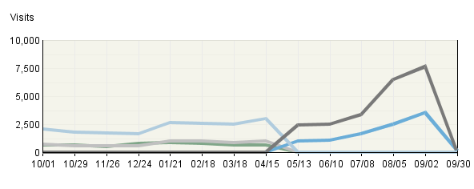

Exit Pages
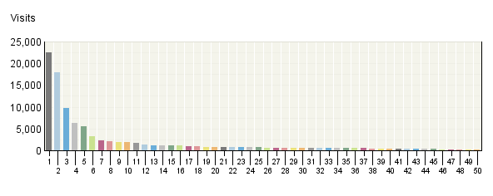

Exit Pages
 | Pages | Visits | % Visits
1. | Department of Energy Solar Decathlon Home Page  http:/​/​www.​solardecathl​on.​org/​ | 22,453 | 20%
2. | EERE: Department of Energy Solar Decathlon Home Page  http:/​/​www.​eere.​energy.​gov/​solar_​decathlon/​ | 17,880 | 16%
3. | DOE Solar Decathlon: Teams  http:/​/​www.​solardecathl​on.​org/​teams.​html | 9,809 | 9%
4. | DOE Solar Decathlon: Teams  http:/​/​www.​eere.​energy.​gov/​solar_​decathlon/​teams.​html | 6,303 | 5%
5. | DOE Solar Decathlon: Photo Gallery of Homes  http:/​/​www.​eere.​energy.​gov/​solar_​decathlon/​homes_​gallery.​html | 5,476 | 5%
6. | DOE Solar Decathlon: 2007 Schedule of Events  http:/​/​www.​solardecathl​on.​org/​schedule.​html | 3,174 | 3%
7. | DOE Solar Decathlon: Highlights from 2005 -​ Photo Gallery of Homes  http:/​/​www.​eere.​energy.​gov/​solar_​decathlon/​2005/​homes_​gallery.​html | 2,344 | 2%
8. | DOE Solar Decathlon: About Solar Decathlon  http:/​/​www.​eere.​energy.​gov/​solar_​decathlon/​about.​html | 2,080 | 2%
9. | DOE Solar Decathlon: About Solar Decathlon  http:/​/​www.​solardecathl​on.​org/​about.​html | 1,872 | 2%
10. | DOE Solar Decathlon: Photo Gallery of Homes  http:/​/​www.​solardecathl​on.​org/​homes_​gallery.​html | 1,826 | 2%
11. | DOE Solar Decathlon: Highlights from 2005 -​ Photo Gallery of Homes  http:/​/​www.​solardecathl​on.​org/​2005/​homes_​gallery.​html | 1,722 | 1%
12. | DOE Solar Decathlon: Registration  http:/​/​www.​solardecathl​on.​org/​registration​.​html | 1,428 | 1%
13. | DOE Solar Decathlon: Highlights from 2005 -​ Technical Report  http:/​/​www.​eere.​energy.​gov/​solar_​decathlon/​2005/​technical_​report.​html | 1,203 | 1%
14. | DOE Solar Decathlon: Solar Decathlon 2007  http:/​/​www.​eere.​energy.​gov/​solar_​decathlon/​solar_​decathlon_​2007.​html | 1,120 | 1%
15. | DOE Solar Decathlon: Information for Teachers  http:/​/​www.​eere.​energy.​gov/​solar_​decathlon/​for_​teachers.​html | 1,082 | 1%
16. | DOE Solar Decathlon: Sponsors  http:/​/​www.​solardecathl​on.​org/​sponsors.​html | 1,081 | 1%
17. | DOE Solar Decathlon: Rules and Regulations  http:/​/​www.​eere.​energy.​gov/​solar_​decathlon/​rules_​regs.​html | 987 | 1%
18. | DOE Solar Decathlon: Information for Kids  http:/​/​www.​eere.​energy.​gov/​solar_​decathlon/​for_​kids.​html | 946 | 1%
19. | DOE Solar Decathlon: Contests and Scoring  http:/​/​www.​solardecathl​on.​org/​contests_​scoring.​html | 822 | 1%
20. | DOE Solar Decathlon: Information for Volunteers  http:/​/​www.​solardecathl​on.​org/​for_​volunteers.​html | 793 | 1%
21. | DOE Solar Decathlon: Contests and Scoring  http:/​/​www.​eere.​energy.​gov/​solar_​decathlon/​contests_​scoring.​html | 787 | 1%
22. | DOE Solar Decathlon: Rules and Regulations  http:/​/​www.​solardecathl​on.​org/​rules_​regs.​html | 741 | 1%
23. | DOE Solar Decathlon: Information for Teams  http:/​/​www.​solardecathl​on.​org/​teams_​information.​html | 729 | 1%
24. | DOE Solar Decathlon: Graphics and Photos  http:/​/​www.​eere.​energy.​gov/​solar_​decathlon/​graphics.​html | 713 | 1%
25. | DOE Solar Decathlon: Information for Consumers  http:/​/​www.​eere.​energy.​gov/​solar_​decathlon/​for_​consumers.​html | 685 | 1%
26. | DOE Solar Decathlon: Sponsors  http:/​/​www.​eere.​energy.​gov/​solar_​decathlon/​sponsors.​html | 662 | 1%
27. | DOE Solar Decathlon: Information for Media  http:/​/​www.​solardecathl​on.​org/​for_​media.​html | 647 | 1%
28. | Department of Energy Solar Decathlon Home Page  http:/​/​solardecathl​on.​org/​ | 600 | 1%
29. | DOE Solar Decathlon: Information for Consumers  http:/​/​www.​solardecathl​on.​org/​for_​consumers.​html | 561 | 0%
30. | DOE Solar Decathlon: Frequently Asked Questions  http:/​/​www.​eere.​energy.​gov/​solar_​decathlon/​faqs.​html | 559 | 0%
31. | DOE Solar Decathlon: Frequently Asked Questions  http:/​/​www.​solardecathl​on.​org/​faqs.​html | 524 | 0%
32. | DOE Solar Decathlon: Information for Media  http:/​/​www.​eere.​energy.​gov/​solar_​decathlon/​for_​media.​html | 518 | 0%
33. | DOE Solar Decathlon: Information for Teachers  http:/​/​www.​solardecathl​on.​org/​for_​teachers.​html | 512 | 0%
34. | DOE Solar Decathlon: 404 -​ Document Not Found  http:/​/​www.​solardecathl​on.​org/​solar_​decathlon_​2007.​html | 501 | 0%
35. | DOE Solar Decathlon: Graphics and Photos  http:/​/​www.​solardecathl​on.​org/​graphics.​html | 492 | 0%
36. | DOE Solar Decathlon: Past Decathlons  http:/​/​www.​solardecathl​on.​org/​past_​decathlons.​html | 488 | 0%
37. | PDF 1.9 MB  http:/​/​www.​solardecathl​on.​org/​pdfs/​sd07_​rules_​regs.​pdf | 481 | 0%
38. | DOE Solar Decathlon: Past Decathlons  http:/​/​www.​eere.​energy.​gov/​solar_​decathlon/​past_​decathlons.​html | 433 | 0%
39. | DOE Solar Decathlon: Highlights from 2005 -​ Final Results  http:/​/​www.​solardecathl​on.​org/​2005/​final_​results.​html | 410 | 0%
40. | DOE Solar Decathlon: Fulfilling a Purpose  http:/​/​www.​eere.​energy.​gov/​solar_​decathlon/​purpose.​html | 392 | 0%
41. | DOE Solar Decathlon: Highlights from 2005 -​ Final Results  http:/​/​www.​eere.​energy.​gov/​solar_​decathlon/​2005/​final_​results.​html | 386 | 0%
42. | DOE Solar Decathlon: Information for Kids  http:/​/​www.​solardecathl​on.​org/​for_​kids.​html | 383 | 0%
43. | DOE Solar Decathlon: Information for Teams  http:/​/​www.​eere.​energy.​gov/​solar_​decathlon/​teams_​information.​html | 377 | 0%
44. | DOE Solar Decathlon: Map of the Solar Village  http:/​/​www.​eere.​energy.​gov/​solar_​decathlon/​map.​html | 375 | 0%
45. | DOE Solar Decathlon: Highlights from 2005 -​ Technical Report  http:/​/​www.​solardecathl​on.​org/​2005/​technical_​report.​html | 297 | 0%
46. | DOE Solar Decathlon: Teams  http:/​/​solardecathl​on.​org/​teams.​html | 285 | 0%
47. | DOE Solar Decathlon: Highlights from 2005 -​ Photos of the Day -​ September 29, 2005  http:/​/​www.​eere.​energy.​gov/​solar_​decathlon/​2005/​daily_​photos_​0929.​html | 269 | 0%
48. | DOE Solar Decathlon: Highlights from 2005 -​ Daily Photos  http:/​/​www.​eere.​energy.​gov/​solar_​decathlon/​2005/​daily_​photos.​html | 266 | 0%
49. | DOE Solar Decathlon: 2005 Schedule of Events  http:/​/​www.​eere.​energy.​gov/​solar_​decathlon/​schedule.​html | 265 | 0%
50. | DOE Solar Decathlon: Fulfilling a Purpose  http:/​/​www.​solardecathl​on.​org/​purpose.​html | 264 | 0%
 | Subtotal for rows 1–50 | 99,003 | 86.12%
 | Other | 15,950 | 13.88%
 | Total | 114,953 | 100.00%
Items 1–50 of 697

Exit Pages - Help Card
Column Definitions

Exit Page
The last page viewed in a given visit. Every visit has one and only one exit page.

Visits
For each exit page, the total number of visits that ended with that page. Note that visits for exit pages are calculated at the end of the visit, which may differ from the count at the start of the visit. Therefore, exit visits may differ from visits in other reports such as the Overview Dashboard or the Entry Pages report.

%
For each page (row), the percentage of all visits to the site that went to that particular page during the report time period.

—
Report Descriptions

Briefly:

If a visitor leaves your site or is inactive for a long time, Webtrends counts the visit as "ended" after 30 minutes of inaction. Visitors may have:

- Browsed to a different site
- Closed their browser
- Remained inactive for more than 30 minutes but did not leave your site. Note that if a visitor resumes clicking on your site after 30 minutes of inactivity, Webtrends records two visits, one before and one after the pause. Consequently, the last page viewed before the long pause will appear as an Exit Page, the first page viewed after the long pause will appear in the Entry Pages report, and your own domain will be the referring domain.

It's usually not possible to know where a visitor went after your site. Log files only record those clicks that are requests for files housed onyourservers. If your site has links to other sites, it is possible to find out if visitors left the site using those links if you modify those links so that, when clicked on, they request a redirect page from your server that in turn takes them to the destination site.

It's usually not possible to know how long a visitor stayed on the exit page before leaving. All that is known is that the visitor had no activity (clicks) for at least 30 minutes.

Uses and Interpretation:

Examine each exit page in the report and ask yourself whether it can be considered a desirable or undesirable ending point for a visit. For example, a purchase thank-you page would be a desirable end of a visit, but a page in the middle of a registration process would be undesirable as a last page.

Undesirable exit pages may indicate a problem needing addressing, such as:

- a difficult multi-step process
- a page that takes too long to load
- content that does not hold the visitor's interest
- confusing navigation

Other relevant reports and analyses:

Relationship to Entry Pages and Single-Page Visits.

Single-Page Visits
This report focuses on pages that were most often viewed during a visit consisting of exactly one page view. You can use this report to determine the success of certain pages designed to provide visitors with all needed information on a single page, or whether certain pages are causing visitors to abandon the visit prematurely.

Single-​Page Visits: Trend Over Time
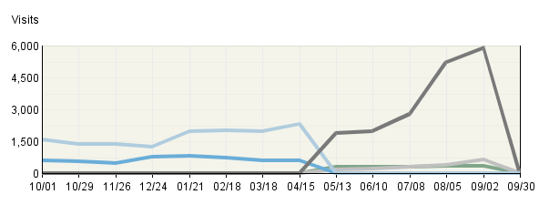

Single-​Page Visits
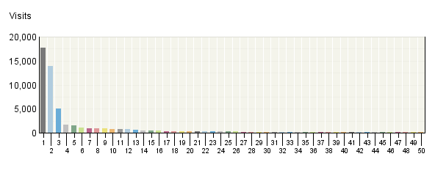

Single-​Page Visits
 | Pages | Visits | % Visits
1. | Department of Energy Solar Decathlon Home Page  http:/​/​www.​solardecathl​on.​org/​ | 17,768 | 30%
2. | EERE: Department of Energy Solar Decathlon Home Page  http:/​/​www.​eere.​energy.​gov/​solar_​decathlon/​ | 13,853 | 23%
3. | DOE Solar Decathlon: Photo Gallery of Homes  http:/​/​www.​eere.​energy.​gov/​solar_​decathlon/​homes_​gallery.​html | 5,100 | 9%
4. | DOE Solar Decathlon: Teams  http:/​/​www.​solardecathl​on.​org/​teams.​html | 1,684 | 3%
5. | DOE Solar Decathlon: Photo Gallery of Homes  http:/​/​www.​solardecathl​on.​org/​homes_​gallery.​html | 1,570 | 3%
6. | DOE Solar Decathlon: Teams  http:/​/​www.​eere.​energy.​gov/​solar_​decathlon/​teams.​html | 1,077 | 2%
7. | DOE Solar Decathlon: Registration  http:/​/​www.​solardecathl​on.​org/​registration​.​html | 889 | 1%
8. | DOE Solar Decathlon: 2007 Schedule of Events  http:/​/​www.​solardecathl​on.​org/​schedule.​html | 873 | 1%
9. | DOE Solar Decathlon: Solar Decathlon 2007  http:/​/​www.​eere.​energy.​gov/​solar_​decathlon/​solar_​decathlon_​2007.​html | 851 | 1%
10. | DOE Solar Decathlon: Information for Teachers  http:/​/​www.​eere.​energy.​gov/​solar_​decathlon/​for_​teachers.​html | 785 | 1%
11. | DOE Solar Decathlon: About Solar Decathlon  http:/​/​www.​eere.​energy.​gov/​solar_​decathlon/​about.​html | 766 | 1%
12. | DOE Solar Decathlon: Information for Kids  http:/​/​www.​eere.​energy.​gov/​solar_​decathlon/​for_​kids.​html | 708 | 1%
13. | DOE Solar Decathlon: Highlights from 2005 -​ Photo Gallery of Homes  http:/​/​www.​eere.​energy.​gov/​solar_​decathlon/​2005/​homes_​gallery.​html | 649 | 1%
14. | DOE Solar Decathlon: Graphics and Photos  http:/​/​www.​eere.​energy.​gov/​solar_​decathlon/​graphics.​html | 514 | 1%
15. | Department of Energy Solar Decathlon Home Page  http:/​/​solardecathl​on.​org/​ | 494 | 1%
16. | DOE Solar Decathlon: About Solar Decathlon  http:/​/​www.​solardecathl​on.​org/​about.​html | 461 | 1%
17. | DOE Solar Decathlon: 404 -​ Document Not Found  http:/​/​www.​solardecathl​on.​org/​solar_​decathlon_​2007.​html | 369 | 1%
18. | DOE Solar Decathlon: Map of the Solar Village  http:/​/​www.​eere.​energy.​gov/​solar_​decathlon/​map.​html | 302 | 1%
19. | DOE Solar Decathlon: Information for Volunteers  http:/​/​www.​solardecathl​on.​org/​for_​volunteers.​html | 295 | 0%
20. | DOE Solar Decathlon: Highlights from 2005 -​ Photo Gallery of Homes  http:/​/​www.​solardecathl​on.​org/​2005/​homes_​gallery.​html | 285 | 0%
21. | DOE Solar Decathlon: Contests and Scoring  http:/​/​www.​eere.​energy.​gov/​solar_​decathlon/​contests_​scoring.​html | 255 | 0%
22. | DOE Solar Decathlon: Highlights from 2005 -​ Technical Report  http:/​/​www.​eere.​energy.​gov/​solar_​decathlon/​2005/​technical_​report.​html | 252 | 0%
23. | DOE Solar Decathlon: Contests and Scoring  http:/​/​www.​solardecathl​on.​org/​contests_​scoring.​html | 245 | 0%
24. | DOE Solar Decathlon: 2005 Schedule of Events  http:/​/​www.​eere.​energy.​gov/​solar_​decathlon/​schedule.​html | 242 | 0%
25. | DOE Solar Decathlon: Graphics and Photos  http:/​/​www.​solardecathl​on.​org/​graphics.​html | 242 | 0%
26. | DOE Solar Decathlon: Highlights from 2005 -​ Photos of the Day -​ September 29, 2005  http:/​/​www.​eere.​energy.​gov/​solar_​decathlon/​2005/​daily_​photos_​0929.​html | 241 | 0%
27. | DOE Solar Decathlon: Information for Teachers  http:/​/​www.​solardecathl​on.​org/​for_​teachers.​html | 220 | 0%
28. | DOE Solar Decathlon: Rules and Regulations  http:/​/​www.​eere.​energy.​gov/​solar_​decathlon/​rules_​regs.​html | 217 | 0%
29. | DOE Solar Decathlon: Information for Kids  http:/​/​www.​solardecathl​on.​org/​for_​kids.​html | 179 | 0%
30. | DOE Solar Decathlon: Rules and Regulations  http:/​/​www.​solardecathl​on.​org/​rules_​regs.​html | 164 | 0%
31. | DOE Solar Decathlon: Highlights from 2005 -​ Judges and Jurors  http:/​/​www.​eere.​energy.​gov/​solar_​decathlon/​2005/​judges_​jurors.​html | 162 | 0%
32. | DOE Solar Decathlon: Sponsors  http:/​/​www.​solardecathl​on.​org/​sponsors.​html | 158 | 0%
33. | Department of Energy Solar Decathlon Home Page  http:/​/​www.​solardecathl​on.​org/​index.​html | 157 | 0%
34. | DOE Solar Decathlon: Fulfilling a Purpose  http:/​/​www.​eere.​energy.​gov/​solar_​decathlon/​purpose.​html | 155 | 0%
35. | DOE Solar Decathlon: Frequently Asked Questions  http:/​/​www.​eere.​energy.​gov/​solar_​decathlon/​faqs.​html | 155 | 0%
36. | EERE: Department of Energy Solar Decathlon Home Page  http:/​/​www.​eere.​energy.​gov/​solar_​decathlon/​index.​html | 143 | 0%
37. | DOE Solar Decathlon: Highlights from 2005 -​ Final Results  http:/​/​www.​solardecathl​on.​org/​2005/​final_​results.​html | 143 | 0%
38. | DOE Solar Decathlon: Frequently Asked Questions  http:/​/​www.​solardecathl​on.​org/​faqs.​html | 122 | 0%
39. | DOE Solar Decathlon: Judges and Jurors  http:/​/​www.​eere.​energy.​gov/​solar_​decathlon/​judges_​jurors.​html | 120 | 0%
40. | DOE Solar Decathlon: Highlights from 2005 -​ California Polytechnic State University  http:/​/​www.​eere.​energy.​gov/​solar_​decathlon/​2005/​team_​calpoly.​html | 119 | 0%
41. | DOE Solar Decathlon: Information for Teams  http:/​/​www.​solardecathl​on.​org/​teams_​information.​html | 117 | 0%
42. | DOE Solar Decathlon: Final Results  http:/​/​www.​eere.​energy.​gov/​solar_​decathlon/​final_​results.​html | 115 | 0%
43. | DOE Solar Decathlon: Sponsors  http:/​/​www.​eere.​energy.​gov/​solar_​decathlon/​sponsors.​html | 114 | 0%
44. | DOE Solar Decathlon: Highlights from 2005 -​ Photos of the Day -​ October 10, 2005  http:/​/​www.​eere.​energy.​gov/​solar_​decathlon/​2005/​daily_​photos_​1010.​html | 106 | 0%
45. | DOE Solar Decathlon: Past Decathlons  http:/​/​www.​eere.​energy.​gov/​solar_​decathlon/​past_​decathlons.​html | 104 | 0%
46. | DOE Solar Decathlon: Past Decathlons  http:/​/​www.​solardecathl​on.​org/​past_​decathlons.​html | 101 | 0%
47. | DOE Solar Decathlon: Highlights from 2002 -​ University of Texas at Austin  http:/​/​www.​eere.​energy.​gov/​solar_​decathlon/​2002/​team_​texas.​html | 100 | 0%
48. | DOE Solar Decathlon: Information for Consumers  http:/​/​www.​eere.​energy.​gov/​solar_​decathlon/​for_​consumers.​html | 95 | 0%
49. | DOE Solar Decathlon: Highlights from 2005 -​ Technical Report  http:/​/​www.​solardecathl​on.​org/​2005/​technical_​report.​html | 89 | 0%
50. | DOE Solar Decathlon: Information for Consumers  http:/​/​www.​solardecathl​on.​org/​for_​consumers.​html | 86 | 0%
 | Subtotal for rows 1–50 | 54,011 | 90.55%
 | Other | 5,640 | 9.45%
 | Total | 59,651 | 100.00%
Items 1–50 of 643

Single-Page Visits - Help Card
Column Definitions

Pages
Any displayed page. You can specify for each profile the types of files that qualify as a page. These settings can be changed by the Webtrends administrator.

Visits
Number of visits where the specified page was the exit page. A visit is a series of actions that begins when a visitor views their first page from the server, and ends when the visitor leaves the site or remains idle beyond the idle-time limit. The default idle-time limit is thirty minutes. This time limit can be changed by the system administrator.

%
For each page (row), the percentage of all visits to the site that went to that particular page during the report time period.

—
Report Descriptions

Briefly:

The proportion of all visits that are single page visits can be surprisingly high, although this phenomenon is experienced on most public websites. But the Single Page Visit statistic is easily skewed by certain site structures. The most common is an arrival page that automatically redirects the visitor to the "real" home page. Single-Page Visits will be underestimated in these cases, because visitors have requested two pages by the time they reach the home page. Any visitor who leaves immediately will be counted as a two-page visit. Their single-page experience will not appear in the Single-Page Visits report.

The Single Page Visits report can be made more accurate by filtering out the arrival page (losing, unfortunately, important referrer information). A better solution is to change the URL of the redirect page into the URL of the target page, using the URL Search and Replace function or Webtrends Scripting Language. Parameters can be different in the two log lines as long as the stem is the same. In the logs, the session will appear to be two consecutive hits to the target page, which Webtrends perceives as a Single-Page Visit to the target page.

Uses and Interpretation:

Before using Single Page Visits (SPVs) to evaluate a site's success, be clear about which Single-Page Visits are desirable or undesirable. For example, are some of your pages intended to be self-sufficient, such as a "What's New" page?

SPVs can be part of a set of overall site metrics called "Percent of all Visits that are Single-Page Visits." Ideally, undesirable SPVs should be low, and desirable SPVs should be high.

Pages in which undesirable SPVs more than expected should be evaluated for possible content or design flaws. Examples:

- There is no obvious way to go further into the site.
- The page doesn't convey what the site is about.
- The visitor is overwhelmed by complexity of the page.
- The page takes too long to load.

In a marketing context, high numbers of Single-Page Visits can indicate that visitors are coming to the site for the wrong reason. Do new visitors have accurate perceptions about what the site offers? Are your ads or search engine listings giving the correct impression?

Other relevant reports and analyses:

Separate SPV Statistics for New and Returning Visitors

Paths, Forward
This report shows the most common page-by-page sequence followed by visitors after the specified start page. The paths may or may not include a visit's Exit Page.

Paths, Forward (Linear View)
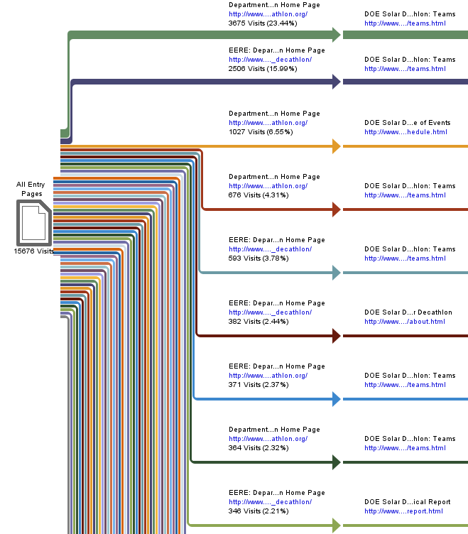

Paths, Forward (Linear View)
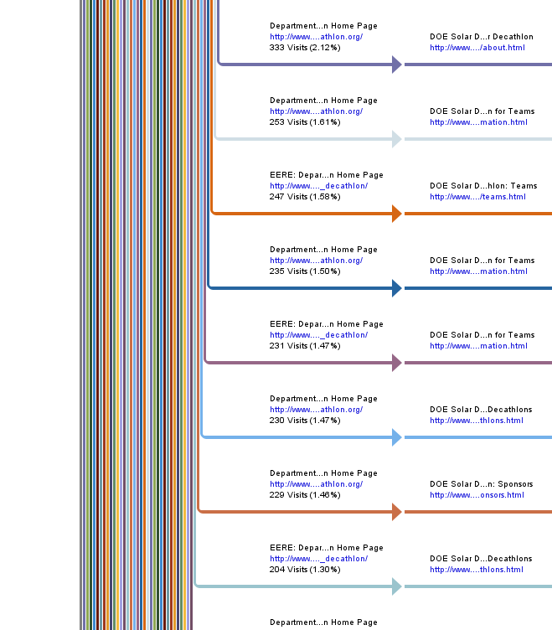

Paths, Forward (Linear View)
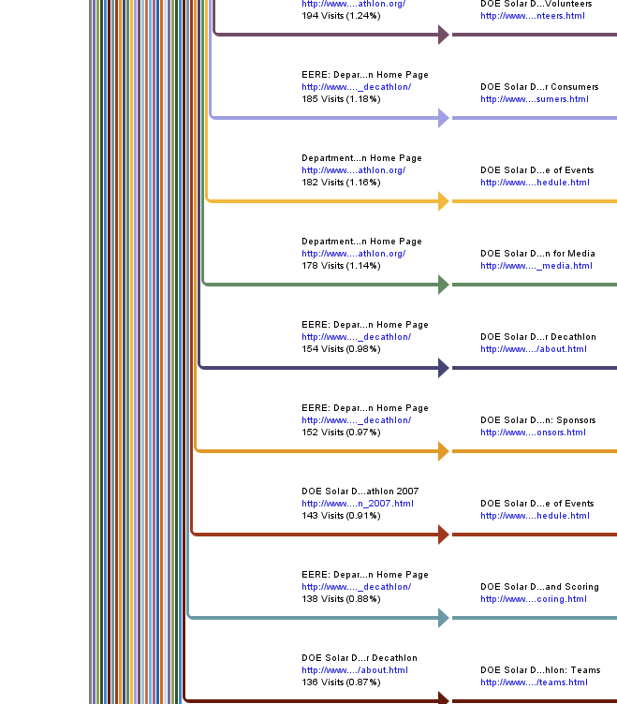

Paths, Forward (Linear View)
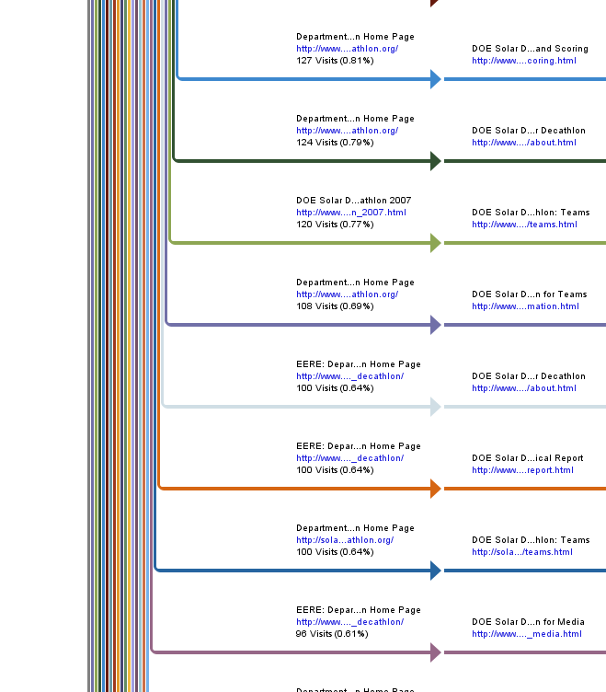

Paths, Forward (Linear View)
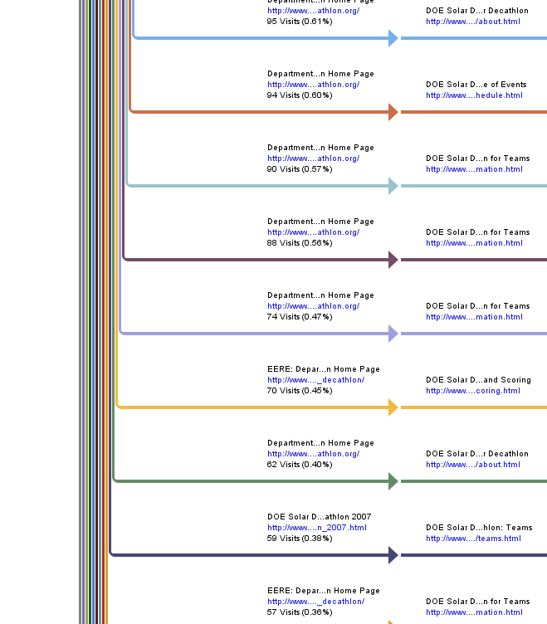

Paths, Forward (Linear View)
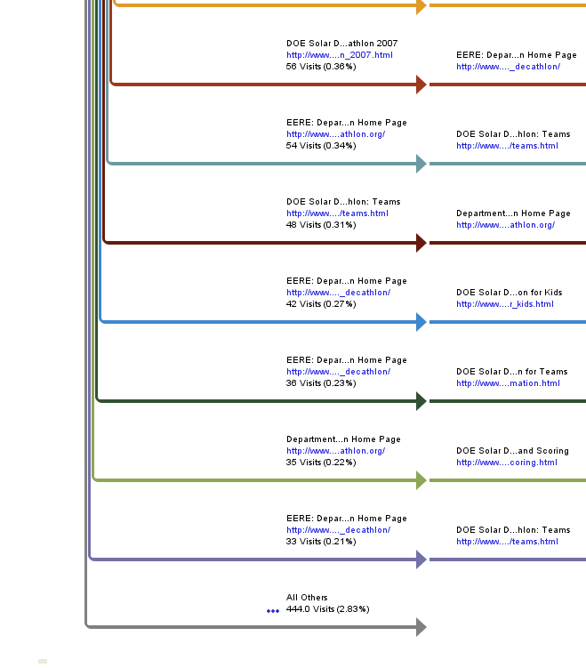

Paths, Forward (Linear View)
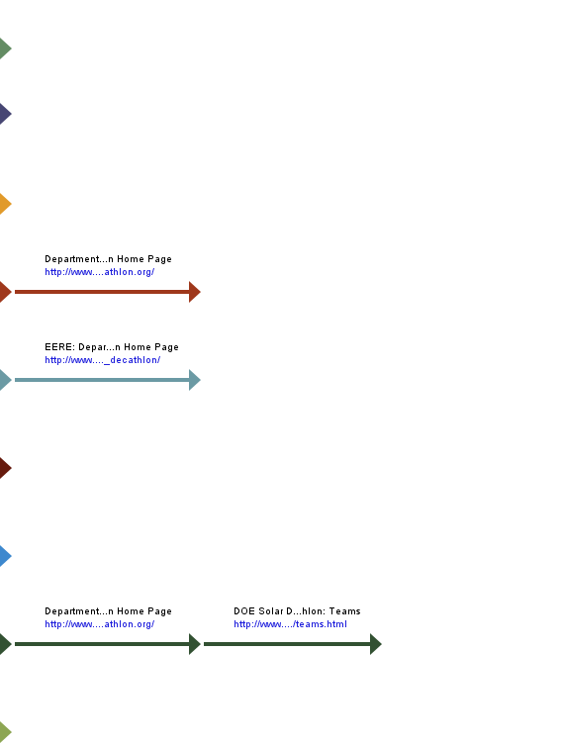

Paths, Forward (Linear View)
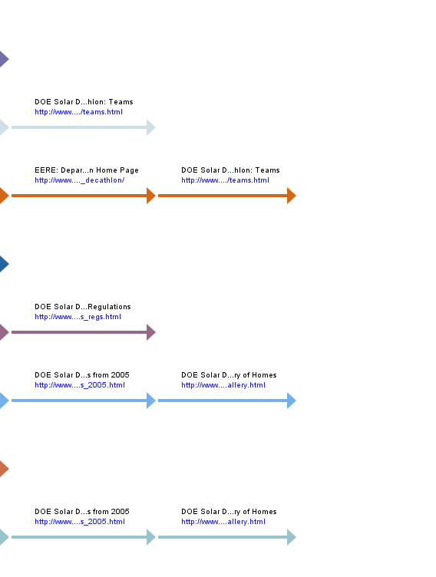

Paths, Forward (Linear View)
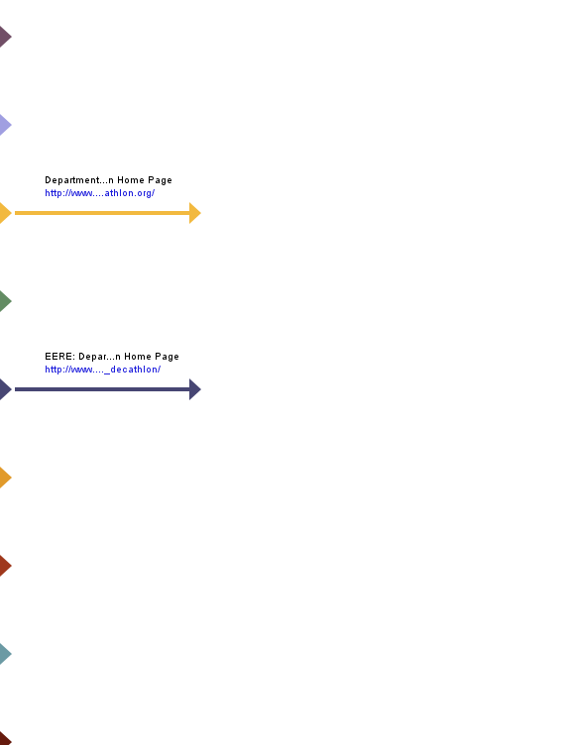

Paths, Forward (Linear View)
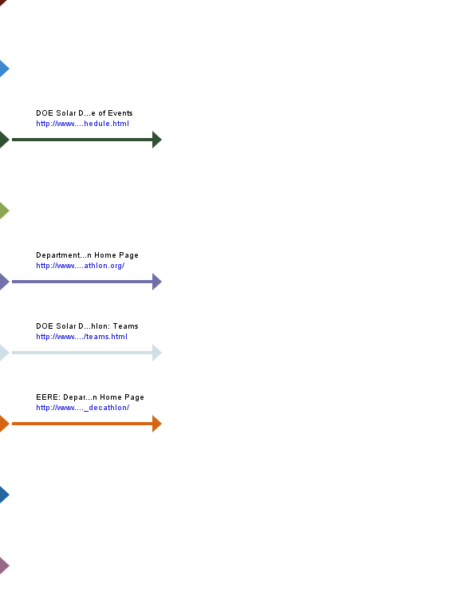

Paths, Forward (Linear View)
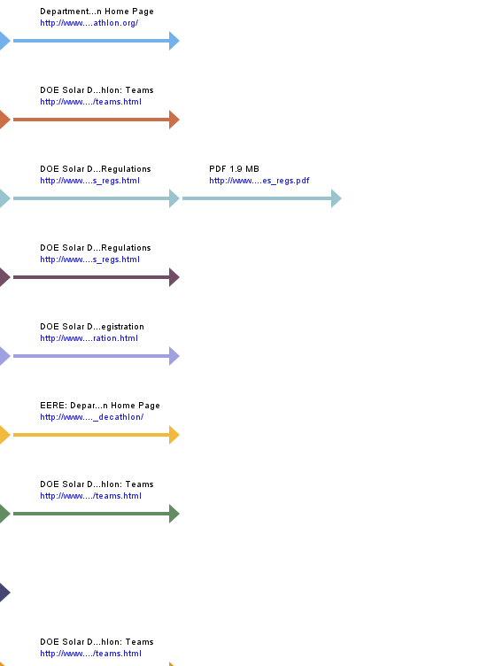

Paths, Forward (Linear View)
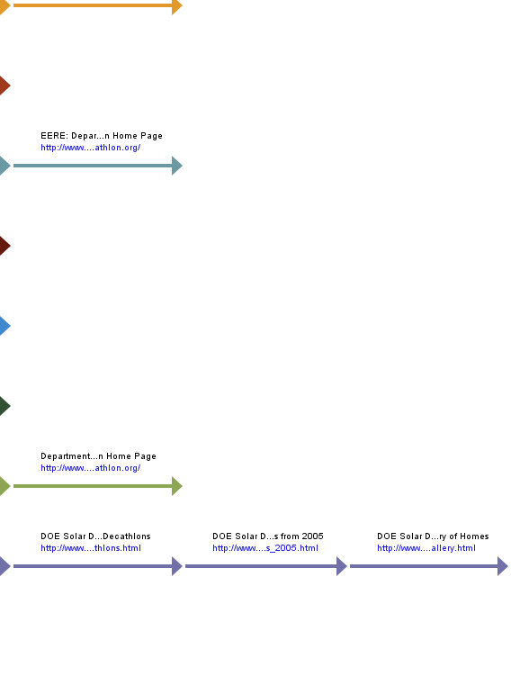

Paths, Forward
 | Paths from Start | Visits | % Visits
1. | - Department of Energy Solar Decathlon Home Page  http:/​/​www.​solardecathl​on.​org/​  - DOE Solar Decathlon: Teams  http:/​/​www.​solardecathl​on.​org/​teams.​html | 3,675 | 23%
2. | - EERE: Department of Energy Solar Decathlon Home Page  http:/​/​www.​eere.​energy.​gov/​solar_​decathlon/​  - DOE Solar Decathlon: Teams  http:/​/​www.​eere.​energy.​gov/​solar_​decathlon/​teams.​html | 2,506 | 16%
3. | - Department of Energy Solar Decathlon Home Page  http:/​/​www.​solardecathl​on.​org/​  - DOE Solar Decathlon: 2007 Schedule of Events  http:/​/​www.​solardecathl​on.​org/​schedule.​html | 1,027 | 7%
4. | - Department of Energy Solar Decathlon Home Page  http:/​/​www.​solardecathl​on.​org/​  - DOE Solar Decathlon: Teams  http:/​/​www.​solardecathl​on.​org/​teams.​html  - Department of Energy Solar Decathlon Home Page  http:/​/​www.​solardecathl​on.​org/​ | 676 | 4%
5. | - EERE: Department of Energy Solar Decathlon Home Page  http:/​/​www.​eere.​energy.​gov/​solar_​decathlon/​  - DOE Solar Decathlon: Teams  http:/​/​www.​eere.​energy.​gov/​solar_​decathlon/​teams.​html  - EERE: Department of Energy Solar Decathlon Home Page  http:/​/​www.​eere.​energy.​gov/​solar_​decathlon/​ | 593 | 4%
6. | - EERE: Department of Energy Solar Decathlon Home Page  http:/​/​www.​eere.​energy.​gov/​solar_​decathlon/​  - DOE Solar Decathlon: About Solar Decathlon  http:/​/​www.​eere.​energy.​gov/​solar_​decathlon/​about.​html | 382 | 2%
7. | - EERE: Department of Energy Solar Decathlon Home Page  http:/​/​www.​solardecathl​on.​org/​  - DOE Solar Decathlon: Teams  http:/​/​www.​solardecathl​on.​org/​teams.​html | 371 | 2%
8. | - Department of Energy Solar Decathlon Home Page  http:/​/​www.​solardecathl​on.​org/​  - DOE Solar Decathlon: Teams  http:/​/​www.​solardecathl​on.​org/​teams.​html  - Department of Energy Solar Decathlon Home Page  http:/​/​www.​solardecathl​on.​org/​  - DOE Solar Decathlon: Teams  http:/​/​www.​solardecathl​on.​org/​teams.​html | 364 | 2%
9. | - EERE: Department of Energy Solar Decathlon Home Page  http:/​/​www.​eere.​energy.​gov/​solar_​decathlon/​  - DOE Solar Decathlon: Highlights from 2005 -​ Technical Report  http:/​/​www.​eere.​energy.​gov/​solar_​decathlon/​2005/​technical_​report.​html | 346 | 2%
10. | - Department of Energy Solar Decathlon Home Page  http:/​/​www.​solardecathl​on.​org/​  - DOE Solar Decathlon: About Solar Decathlon  http:/​/​www.​solardecathl​on.​org/​about.​html | 333 | 2%
11. | - Department of Energy Solar Decathlon Home Page  http:/​/​www.​solardecathl​on.​org/​  - DOE Solar Decathlon: Information for Teams  http:/​/​www.​solardecathl​on.​org/​teams_​information.​html  - DOE Solar Decathlon: Teams  http:/​/​www.​solardecathl​on.​org/​teams.​html | 253 | 2%
12. | - EERE: Department of Energy Solar Decathlon Home Page  http:/​/​www.​eere.​energy.​gov/​solar_​decathlon/​  - DOE Solar Decathlon: Teams  http:/​/​www.​eere.​energy.​gov/​solar_​decathlon/​teams.​html  - EERE: Department of Energy Solar Decathlon Home Page  http:/​/​www.​eere.​energy.​gov/​solar_​decathlon/​  - DOE Solar Decathlon: Teams  http:/​/​www.​eere.​energy.​gov/​solar_​decathlon/​teams.​html | 247 | 2%
13. | - Department of Energy Solar Decathlon Home Page  http:/​/​www.​solardecathl​on.​org/​  - DOE Solar Decathlon: Information for Teams  http:/​/​www.​solardecathl​on.​org/​teams_​information.​html | 235 | 1%
14. | - EERE: Department of Energy Solar Decathlon Home Page  http:/​/​www.​eere.​energy.​gov/​solar_​decathlon/​  - DOE Solar Decathlon: Information for Teams  http:/​/​www.​eere.​energy.​gov/​solar_​decathlon/​teams_​information.​html  - DOE Solar Decathlon: Rules and Regulations  http:/​/​www.​eere.​energy.​gov/​solar_​decathlon/​rules_​regs.​html | 231 | 1%
15. | - Department of Energy Solar Decathlon Home Page  http:/​/​www.​solardecathl​on.​org/​  - DOE Solar Decathlon: Past Decathlons  http:/​/​www.​solardecathl​on.​org/​past_​decathlons.​html  - DOE Solar Decathlon: Highlights from 2005  http:/​/​www.​solardecathl​on.​org/​highlights_​2005.​html  - DOE Solar Decathlon: Highlights from 2005 -​ Photo Gallery of Homes  http:/​/​www.​solardecathl​on.​org/​2005/​homes_​gallery.​html | 230 | 1%
16. | - Department of Energy Solar Decathlon Home Page  http:/​/​www.​solardecathl​on.​org/​  - DOE Solar Decathlon: Sponsors  http:/​/​www.​solardecathl​on.​org/​sponsors.​html | 229 | 1%
17. | - EERE: Department of Energy Solar Decathlon Home Page  http:/​/​www.​eere.​energy.​gov/​solar_​decathlon/​  - DOE Solar Decathlon: Past Decathlons  http:/​/​www.​eere.​energy.​gov/​solar_​decathlon/​past_​decathlons.​html  - DOE Solar Decathlon: Highlights from 2005  http:/​/​www.​eere.​energy.​gov/​solar_​decathlon/​highlights_​2005.​html  - DOE Solar Decathlon: Highlights from 2005 -​ Photo Gallery of Homes  http:/​/​www.​eere.​energy.​gov/​solar_​decathlon/​2005/​homes_​gallery.​html | 204 | 1%
18. | - Department of Energy Solar Decathlon Home Page  http:/​/​www.​solardecathl​on.​org/​  - DOE Solar Decathlon: Information for Volunteers  http:/​/​www.​solardecathl​on.​org/​for_​volunteers.​html | 194 | 1%
19. | - EERE: Department of Energy Solar Decathlon Home Page  http:/​/​www.​eere.​energy.​gov/​solar_​decathlon/​  - DOE Solar Decathlon: Information for Consumers  http:/​/​www.​eere.​energy.​gov/​solar_​decathlon/​for_​consumers.​html | 185 | 1%
20. | - Department of Energy Solar Decathlon Home Page  http:/​/​www.​solardecathl​on.​org/​  - DOE Solar Decathlon: 2007 Schedule of Events  http:/​/​www.​solardecathl​on.​org/​schedule.​html  - Department of Energy Solar Decathlon Home Page  http:/​/​www.​solardecathl​on.​org/​ | 182 | 1%
21. | - Department of Energy Solar Decathlon Home Page  http:/​/​www.​solardecathl​on.​org/​  - DOE Solar Decathlon: Information for Media  http:/​/​www.​solardecathl​on.​org/​for_​media.​html | 178 | 1%
22. | - EERE: Department of Energy Solar Decathlon Home Page  http:/​/​www.​eere.​energy.​gov/​solar_​decathlon/​  - DOE Solar Decathlon: About Solar Decathlon  http:/​/​www.​eere.​energy.​gov/​solar_​decathlon/​about.​html  - EERE: Department of Energy Solar Decathlon Home Page  http:/​/​www.​eere.​energy.​gov/​solar_​decathlon/​ | 154 | 1%
23. | - EERE: Department of Energy Solar Decathlon Home Page  http:/​/​www.​eere.​energy.​gov/​solar_​decathlon/​  - DOE Solar Decathlon: Sponsors  http:/​/​www.​eere.​energy.​gov/​solar_​decathlon/​sponsors.​html | 152 | 1%
24. | - DOE Solar Decathlon: Solar Decathlon 2007  http:/​/​www.​solardecathl​on.​org/​solar_​decathlon_​2007.​html  - DOE Solar Decathlon: 2007 Schedule of Events  http:/​/​www.​solardecathl​on.​org/​schedule.​html | 143 | 1%
25. | - EERE: Department of Energy Solar Decathlon Home Page  http:/​/​www.​eere.​energy.​gov/​solar_​decathlon/​  - DOE Solar Decathlon: Contests and Scoring  http:/​/​www.​eere.​energy.​gov/​solar_​decathlon/​contests_​scoring.​html | 138 | 1%
26. | - DOE Solar Decathlon: About Solar Decathlon  http:/​/​www.​eere.​energy.​gov/​solar_​decathlon/​about.​html  - DOE Solar Decathlon: Teams  http:/​/​www.​eere.​energy.​gov/​solar_​decathlon/​teams.​html | 136 | 1%
27. | - Department of Energy Solar Decathlon Home Page  http:/​/​www.​solardecathl​on.​org/​  - DOE Solar Decathlon: Contests and Scoring  http:/​/​www.​solardecathl​on.​org/​contests_​scoring.​html | 127 | 1%
28. | - Department of Energy Solar Decathlon Home Page  http:/​/​www.​solardecathl​on.​org/​  - DOE Solar Decathlon: About Solar Decathlon  http:/​/​www.​solardecathl​on.​org/​about.​html  - DOE Solar Decathlon: 2007 Schedule of Events  http:/​/​www.​solardecathl​on.​org/​schedule.​html | 124 | 1%
29. | - DOE Solar Decathlon: Solar Decathlon 2007  http:/​/​www.​eere.​energy.​gov/​solar_​decathlon/​solar_​decathlon_​2007.​html  - DOE Solar Decathlon: Teams  http:/​/​www.​eere.​energy.​gov/​solar_​decathlon/​teams.​html | 120 | 1%
30. | - Department of Energy Solar Decathlon Home Page  http:/​/​www.​solardecathl​on.​org/​  - DOE Solar Decathlon: Information for Teams  http:/​/​www.​solardecathl​on.​org/​teams_​information.​html  - Department of Energy Solar Decathlon Home Page  http:/​/​www.​solardecathl​on.​org/​ | 108 | 1%
31. | - EERE: Department of Energy Solar Decathlon Home Page  http:/​/​www.​eere.​energy.​gov/​solar_​decathlon/​  - DOE Solar Decathlon: About Solar Decathlon  http:/​/​www.​eere.​energy.​gov/​solar_​decathlon/​about.​html  - DOE Solar Decathlon: Teams  http:/​/​www.​eere.​energy.​gov/​solar_​decathlon/​teams.​html | 100 | 1%
32. | - EERE: Department of Energy Solar Decathlon Home Page  http:/​/​www.​eere.​energy.​gov/​solar_​decathlon/​  - DOE Solar Decathlon: Highlights from 2005 -​ Technical Report  http:/​/​www.​eere.​energy.​gov/​solar_​decathlon/​2005/​technical_​report.​html  - EERE: Department of Energy Solar Decathlon Home Page  http:/​/​www.​eere.​energy.​gov/​solar_​decathlon/​ | 100 | 1%
33. | - Department of Energy Solar Decathlon Home Page  http:/​/​solardecathl​on.​org/​  - DOE Solar Decathlon: Teams  http:/​/​solardecathl​on.​org/​teams.​html | 100 | 1%
34. | - EERE: Department of Energy Solar Decathlon Home Page  http:/​/​www.​eere.​energy.​gov/​solar_​decathlon/​  - DOE Solar Decathlon: Information for Media  http:/​/​www.​eere.​energy.​gov/​solar_​decathlon/​for_​media.​html | 96 | 1%
35. | - Department of Energy Solar Decathlon Home Page  http:/​/​www.​solardecathl​on.​org/​  - DOE Solar Decathlon: About Solar Decathlon  http:/​/​www.​solardecathl​on.​org/​about.​html  - Department of Energy Solar Decathlon Home Page  http:/​/​www.​solardecathl​on.​org/​ | 95 | 1%
36. | - Department of Energy Solar Decathlon Home Page  http:/​/​www.​solardecathl​on.​org/​  - DOE Solar Decathlon: 2007 Schedule of Events  http:/​/​www.​solardecathl​on.​org/​schedule.​html  - DOE Solar Decathlon: Teams  http:/​/​www.​solardecathl​on.​org/​teams.​html | 94 | 1%
37. | - Department of Energy Solar Decathlon Home Page  http:/​/​www.​solardecathl​on.​org/​  - DOE Solar Decathlon: Information for Teams  http:/​/​www.​solardecathl​on.​org/​teams_​information.​html  - DOE Solar Decathlon: Rules and Regulations  http:/​/​www.​solardecathl​on.​org/​rules_​regs.​html  - PDF 1.9 MB  http:/​/​www.​solardecathl​on.​org/​pdfs/​sd07_​rules_​regs.​pdf | 90 | 1%
38. | - Department of Energy Solar Decathlon Home Page  http:/​/​www.​solardecathl​on.​org/​  - DOE Solar Decathlon: Information for Teams  http:/​/​www.​solardecathl​on.​org/​teams_​information.​html  - DOE Solar Decathlon: Rules and Regulations  http:/​/​www.​solardecathl​on.​org/​rules_​regs.​html | 88 | 1%
39. | - Department of Energy Solar Decathlon Home Page  http:/​/​www.​solardecathl​on.​org/​  - DOE Solar Decathlon: Information for Teams  http:/​/​www.​solardecathl​on.​org/​teams_​information.​html  - DOE Solar Decathlon: Registration  http:/​/​www.​solardecathl​on.​org/​registration​.​html | 74 | 0%
40. | - EERE: Department of Energy Solar Decathlon Home Page  http:/​/​www.​eere.​energy.​gov/​solar_​decathlon/​  - DOE Solar Decathlon: Contests and Scoring  http:/​/​www.​eere.​energy.​gov/​solar_​decathlon/​contests_​scoring.​html  - EERE: Department of Energy Solar Decathlon Home Page  http:/​/​www.​eere.​energy.​gov/​solar_​decathlon/​ | 70 | 0%
41. | - Department of Energy Solar Decathlon Home Page  http:/​/​www.​solardecathl​on.​org/​  - DOE Solar Decathlon: About Solar Decathlon  http:/​/​www.​solardecathl​on.​org/​about.​html  - DOE Solar Decathlon: Teams  http:/​/​www.​solardecathl​on.​org/​teams.​html | 62 | 0%
42. | - DOE Solar Decathlon: Solar Decathlon 2007  http:/​/​www.​solardecathl​on.​org/​solar_​decathlon_​2007.​html  - DOE Solar Decathlon: Teams  http:/​/​www.​solardecathl​on.​org/​teams.​html | 59 | 0%
43. | - EERE: Department of Energy Solar Decathlon Home Page  http:/​/​www.​eere.​energy.​gov/​solar_​decathlon/​  - DOE Solar Decathlon: Information for Teams  http:/​/​www.​eere.​energy.​gov/​solar_​decathlon/​teams_​information.​html  - DOE Solar Decathlon: Teams  http:/​/​www.​eere.​energy.​gov/​solar_​decathlon/​teams.​html | 57 | 0%
44. | - DOE Solar Decathlon: Solar Decathlon 2007  http:/​/​www.​eere.​energy.​gov/​solar_​decathlon/​solar_​decathlon_​2007.​html  - EERE: Department of Energy Solar Decathlon Home Page  http:/​/​www.​eere.​energy.​gov/​solar_​decathlon/​ | 56 | 0%
45. | - EERE: Department of Energy Solar Decathlon Home Page  http:/​/​www.​solardecathl​on.​org/​  - DOE Solar Decathlon: Teams  http:/​/​www.​solardecathl​on.​org/​teams.​html  - EERE: Department of Energy Solar Decathlon Home Page  http:/​/​www.​solardecathl​on.​org/​ | 54 | 0%
46. | - DOE Solar Decathlon: Teams  http:/​/​www.​solardecathl​on.​org/​teams.​html  - Department of Energy Solar Decathlon Home Page  http:/​/​www.​solardecathl​on.​org/​ | 48 | 0%
47. | - EERE: Department of Energy Solar Decathlon Home Page  http:/​/​www.​eere.​energy.​gov/​solar_​decathlon/​  - DOE Solar Decathlon: Information for Kids  http:/​/​www.​eere.​energy.​gov/​solar_​decathlon/​for_​kids.​html | 42 | 0%
48. | - EERE: Department of Energy Solar Decathlon Home Page  http:/​/​www.​eere.​energy.​gov/​solar_​decathlon/​  - DOE Solar Decathlon: Information for Teams  http:/​/​www.​eere.​energy.​gov/​solar_​decathlon/​teams_​information.​html | 36 | 0%
49. | - Department of Energy Solar Decathlon Home Page  http:/​/​www.​solardecathl​on.​org/​  - DOE Solar Decathlon: Contests and Scoring  http:/​/​www.​solardecathl​on.​org/​contests_​scoring.​html  - Department of Energy Solar Decathlon Home Page  http:/​/​www.​solardecathl​on.​org/​ | 35 | 0%
50. | - EERE: Department of Energy Solar Decathlon Home Page  http:/​/​www.​eere.​energy.​gov/​solar_​decathlon/​  - DOE Solar Decathlon: Teams  http:/​/​www.​eere.​energy.​gov/​solar_​decathlon/​teams.​html  - DOE Solar Decathlon: Past Decathlons  http:/​/​www.​eere.​energy.​gov/​solar_​decathlon/​past_​decathlons.​html  - DOE Solar Decathlon: Highlights from 2005  http:/​/​www.​eere.​energy.​gov/​solar_​decathlon/​highlights_​2005.​html  - DOE Solar Decathlon: Highlights from 2005 -​ Photo Gallery of Homes  http:/​/​www.​eere.​energy.​gov/​solar_​decathlon/​2005/​homes_​gallery.​html | 33 | 0%
51. | All Others | 444 | 3%
 | Total | 15,676 | 100.00%
Items 1–50 of 78

Paths, Forward - Help Card
Column Definitions

Paths, Forward
This represents the specified start page with the various paths your visitors took from it. Pages listed are limited to the paths configured for analysis in this profile.

Visits
Number of visits where the specified path was followed.

% of All Visits
Percentage of times that the specified path through your site was taken compared to all other listed paths through your site.

—
Report Descriptions

Briefly:

This report displays the critical first few clicks on your site, during which your new visitors are getting their first impression and your returning visitors are probably heading to a destination.

The length of paths displayed in the path analysis is limited to a number of steps specified in the report setup. This means that paths in this table are likely to be longer in actuality than the number of steps displayed.

Note that if a visitor views a page twice during a visit, a path report containing this page will show one visit for each instance. This applies to all Path Analysis reports, but not to Paths of Entry reports (Paths of Entry and Content Paths from Entry).

Uses and Interpretation:

Use this report to look for weaknesses and to understand visitor content and navigation preferences:

- Compare the most common paths in this report to those you expected when planning your site. Are they the same? If not, perhaps visitors are confused by your navigation ... or perhaps you predicted their paths incorrectly.
- Ask if your visitors are leaving the site earlier than you would like. Pay special attention to the short paths. Are too many visitors leaving the site before they know what your site is about? Does knowing the exit pages help you understand why?
- Notice which content topics are being visiting right away. Forward paths help you understand what content is most important to visitors in the sense of where they go first. If just a few of your content topics seem to be the first destination of most visitors, perhaps those topics should be made more prominent in the home page navigation.
- Notice whether visitors drill down deeply right away, or instead look at a number of same-level pages before going deeper. If they're drilling down several levels, perhaps you should reduce the number of clicks needed to get to the depth they seem to want. Should you bring some pages up higher in the navigation tree? If they're looking at a variety of top-level pages before going deeper, check whether they are using the home page as a hub - often returning to it between jumps to second-level pages. Is this "pogo-sticking" navigation being forced on them? If your second-level pages can't be reached directly from each other, consider reducing the number of clicks by adding "sideways" links.

Referring Site
This report identifies web sites that refer visitors to your site. The top referrers are your site's primary acquisition channels, and may include a partner sites, search engines, portals or marketing programs.

Referring Site
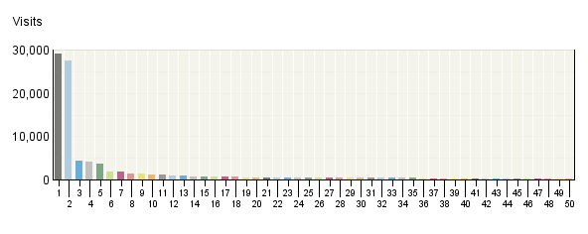

Referring Site
 | Site | Visits | % Visits
1. | Direct Traffic | 29,057 | 25%
2. | http:/​/​www.​google.​com | 27,526 | 24%
3. | http:/​/​www.​solardecathl​on.​org | 4,374 | 4%
4. | http:/​/​search.​yahoo.​com | 4,191 | 4%
5. | http:/​/​www.​eere.​energy.​gov | 3,683 | 3%
6. | http:/​/​www1.​eere.​energy.​gov | 1,896 | 2%
7. | http:/​/​images.​google.​com | 1,802 | 2%
8. | http:/​/​www.​diynetwork.​com | 1,428 | 1%
9. | http:/​/​search.​msn.​com | 1,284 | 1%
10. | http:/​/​www.​google.​ca | 1,102 | 1%
11. | http:/​/​www.​findsolar.​com | 1,071 | 1%
12. | http:/​/​www.​engadget.​com | 960 | 1%
13. | http:/​/​www.​nrel.​gov | 864 | 1%
14. | http:/​/​vtsolar.​arch.​vt.​edu | 732 | 1%
15. | http:/​/​www.​inhabitat.​com | 701 | 1%
16. | http:/​/​web.​mit.​edu | 653 | 1%
17. | http:/​/​www.​solardecathl​on.​uiuc.​edu | 644 | 1%
18. | http:/​/​www.​architecture​2030.​org | 637 | 1%
19. | http:/​/​news.​com.​com | 570 | 0%
20. | http:/​/​www.​treehugger.​com | 559 | 0%
21. | http:/​/​www.​energy.​gov | 538 | 0%
22. | http:/​/​www.​zeroenergy.​com | 538 | 0%
23. | http:/​/​cusd.​cornell.​edu | 535 | 0%
24. | http:/​/​search.​live.​com | 531 | 0%
25. | http:/​/​www.​solardecathl​on.​upm.​es | 515 | 0%
26. | http:/​/​www.​stumbleupon.​com | 510 | 0%
27. | http:/​/​www.​solarmontrea​l.​ca | 510 | 0%
28. | http:/​/​search.​nrel.​gov | 491 | 0%
29. | http:/​/​www.​google.​de | 485 | 0%
30. | http:/​/​solarhouse.​umr.​edu | 468 | 0%
31. | http:/​/​search.​doe.​gov | 448 | 0%
32. | Window-​Hidden-​Referrer | 406 | 0%
33. | http:/​/​www.​google.​co.​uk | 367 | 0%
34. | http:/​/​iris.​nyit.​edu | 358 | 0%
35. | http:/​/​barrapunto.​com | 354 | 0%
36. | http:/​/​www.​aia.​org | 337 | 0%
37. | http:/​/​www.​andrew.​cmu.​edu | 336 | 0%
38. | http:/​/​solarhouse.​umd.​edu | 330 | 0%
39. | http:/​/​mocoloco.​com | 300 | 0%
40. | http:/​/​www.​google.​com.​au | 296 | 0%
41. | http:/​/​www.​scusolar.​org | 280 | 0%
42. | http:/​/​aolsearch.​aol.​com | 269 | 0%
43. | http:/​/​www.​ar.​utexas.​edu | 260 | 0%
44. | http:/​/​archone.​tamu.​edu | 255 | 0%
45. | http:/​/​www.​ases.​org | 248 | 0%
46. | http:/​/​mit.​edu | 242 | 0%
47. | http:/​/​www.​uc.​edu | 240 | 0%
48. | http:/​/​www.​solardecathl​on.​de | 239 | 0%
49. | http:/​/​mail.​google.​com | 236 | 0%
50. | http:/​/​www.​google.​es | 235 | 0%
 | Subtotal for rows 1–50 | 94,891 | 82.55%
 | Other | 20,062 | 17.45%
 | Total | 114,953 | 100.00%
Items 1–50 of 692

Referring Site - Help Card
Column Definitions

Referring Sites
A web site that refers a visitor to your site by linking to it.

Site
The specific referring site being analyzed.

Visits
Number of times the specified site referred visitors to your site.

%
Percentage of referrals that came from the specified site.

Direct Traffic
Represents traffic to the web site with no referrer as one of the following: 1) the visitor typed the domain name directly into their browser, 2) the visitor bookmarked the site, 3) the visitor clicked on an email, shortcut, or other direct link, 4) Firewalls and/or proxies stripped out the referrer and replaced it with a dash "-".

Note: If "Direct Traffic" is 100% of all your traffic, then you are probably not logging the "referrer" field in your log files. Please see your manual or the Webtrends Knowledgebase to enable extended logging on your web servers.

Hidden-Referrer
A value indicating that Internet security software such as Zone Alarm Pro, Symantec's Norton Internet Security, or a proxy server modified a web request to mask the referring URL.

—
Report Descriptions
You can use this page to determine which sites are referring the most visitors to your site. This can help when considering the most effective ways and places to attract visitors.

Referring Domain
This report identifies domains that refer visitors to your web site. The top referring domains are your site's primary acquisition channels and may include partner sites, search engines, portals or marketing programs.

Referring Domain
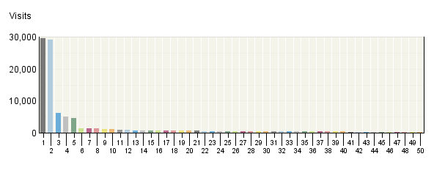

Referring Domain
 | Domain | Visits | % Visits
1. | google.com | 29,633 | 26%
2. | Direct Traffic | 29,057 | 25%
3. | energy.gov | 6,129 | 5%
4. | yahoo.com | 5,149 | 4%
5. | solardecathlon.org | 4,512 | 4%
6. | nrel.gov | 1,429 | 1%
7. | diynetwork.com | 1,428 | 1%
8. | msn.com | 1,390 | 1%
9. | google.ca | 1,229 | 1%
10. | findsolar.com | 1,171 | 1%
11. | engadget.com | 961 | 1%
12. | mit.edu | 924 | 1%
13. | uiuc.edu | 788 | 1%
14. | vt.edu | 786 | 1%
15. | cornell.edu | 760 | 1%
16. | inhabitat.com | 757 | 1%
17. | architecture2030.org | 675 | 1%
18. | live.com | 612 | 1%
19. | treehugger.com | 589 | 1%
20. | com.com | 583 | 1%
21. | doe.gov | 576 | 1%
22. | zeroenergy.com | 543 | 0%
23. | stumbleupon.com | 530 | 0%
24. | solarmontreal.ca | 526 | 0%
25. | solardecathlon.upm.es | 525 | 0%
26. | umr.edu | 519 | 0%
27. | google.de | 499 | 0%
28. | aol.com | 466 | 0%
29. | google.co.uk | 457 | 0%
30. | gatech.edu | 431 | 0%
31. | cmu.edu | 420 | 0%
32. | uc.edu | 417 | 0%
33. | aia.org | 414 | 0%
34. | umd.edu | 410 | 0%
35. | Window-​Hidden-​Referrer | 406 | 0%
36. | psu.edu | 376 | 0%
37. | nyit.edu | 358 | 0%
38. | barrapunto.com | 357 | 0%
39. | mocoloco.com | 344 | 0%
40. | solarteam.org | 344 | 0%
41. | google.com.au | 339 | 0%
42. | utexas.edu | 329 | 0%
43. | scusolar.org | 320 | 0%
44. | google.es | 260 | 0%
45. | tamu.edu | 257 | 0%
46. | google.co.in | 252 | 0%
47. | ltu.edu | 249 | 0%
48. | ases.org | 249 | 0%
49. | solardecathlon.de | 245 | 0%
50. | wikipedia.org | 240 | 0%
 | Subtotal for rows 1–50 | 100,220 | 87.18%
 | Other | 14,733 | 12.82%
 | Total | 114,953 | 100.00%
Items 1–50 of 592

Referring Domain - Help Card
Column Definitions

Referring Domain
A web site that refers a visitor to your site by linking to it.

Domain
Top-level domains to which belong the web sites which refer visitors to your site by linking to it.

Visits
Number of times the specified domain referred visitors to your site.

%
Percentage of referrals that came from the specified domain.

Direct Traffic
Represents traffic to the web site with no referrer as one of the following: 1) the visitor typed the domain name directly into their browser, 2) the visitor bookmarked the site, 3) the visitor clicked on an email, shortcut, or other direct link, 4) Firewalls and/or proxies stripped out the referrer and replaced it with a dash "-".

Note: If "Direct Traffic" is 100% of all your traffic, then you are probably not logging the "referrer" field in your log files. Please see your manual or the Webtrends Knowledgebase to enable extended logging on your web servers.

Hidden-Referrer
A value indicating that Internet security software such as Zone Alarm Pro, Symantec's Norton Internet Security, or a proxy server modified a web request to mask the referring URL.

Unknown
Represents traffic for which a referrer was logged, but the referring domain was blocked or otherwise could not be resolved to a valid domain.

—
Report Descriptions
You can use this page to determine which domains are referring the most visitors to your site. This can help when considering the most effective ways and places to attract visitors.

Referring Page
This report shows the pages from which visitors accessed your site. You can use this report together with the Referring Domains report to identify which pages on your top domains are sending the most traffic to your site.

Referring Page
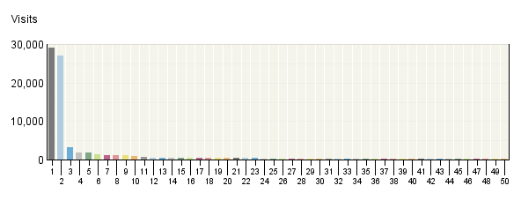

Referring Page
 | Page | Visits | % Visits
1. | Direct Traffic | 29,057 | 25%
2. | http:/​/​www.​google.​com/​search | 27,131 | 24%
3. | http:/​/​search.​yahoo.​com/​search | 3,245 | 3%
4. | http:/​/​www.​solardecathl​on.​org/​ | 1,866 | 2%
5. | http:/​/​images.​google.​com/​imgres | 1,795 | 2%
6. | http:/​/​www.​eere.​energy.​gov/​solar_​decathlon/​ | 1,347 | 1%
7. | http:/​/​www.​google.​ca/​search | 1,098 | 1%
8. | http:/​/​www.​findsolar.​com/​content.​php | 1,071 | 1%
9. | http:/​/​search.​msn.​com/​results.​aspx | 1,066 | 1%
10. | http:/​/​www1.​eere.​energy.​gov/​solar/​sh_​use.​html | 847 | 1%
11. | http:/​/​www.​engadget.​com/​ | 579 | 1%
12. | http:/​/​www.​architecture​2030.​org/​case_​studies/​index.​html | 556 | 0%
13. | http:/​/​www.​zeroenergy.​com/​individuals/​p_​decathlon.​html | 538 | 0%
14. | http:/​/​www.​stumbleupon.​com/​refer.​php | 494 | 0%
15. | http:/​/​news.​com.​com/​Energy+geeks​+compete+for​+coolest+sol​ar+home/​2100-​11392_​3-​6201743.​html | 494 | 0%
16. | http:/​/​search.​nrel.​gov/​query.​html | 491 | 0%
17. | http:/​/​www.​google.​de/​search | 485 | 0%
18. | http:/​/​search.​live.​com/​results.​aspx | 461 | 0%
19. | http:/​/​vtsolar.​arch.​vt.​edu/​ | 455 | 0%
20. | http:/​/​search.​doe.​gov/​search | 448 | 0%
21. | http:/​/​cusd.​cornell.​edu/​ | 443 | 0%
22. | Window-​Hidden-​Referrer | 406 | 0%
23. | http:/​/​www.​google.​co.​uk/​search | 365 | 0%
24. | http:/​/​solarhouse.​umd.​edu/​page.​php | 330 | 0%
25. | http:/​/​www.​solardecathl​on.​upm.​es/​index.​php | 312 | 0%
26. | http:/​/​www.​google.​com.​au/​search | 296 | 0%
27. | http:/​/​www.​nrel.​gov/​pv/​building_​integrated_​pv.​html | 273 | 0%
28. | http:/​/​www.​diynetwork.​com/​diy/​he_​diagnostics/​article/​0,​2037,​DIY_​13893_​2277457,​00.​html | 269 | 0%
29. | http:/​/​www.​solardecathl​on.​uiuc.​edu/​about/​ | 263 | 0%
30. | http:/​/​aolsearch.​aol.​com/​aol/​search | 254 | 0%
31. | http:/​/​www.​diynetwork.​com/​diy/​pac_​ctnt/​text/​0,​2019,​DIY_​14161_​35225,​00.​html | 250 | 0%
32. | http:/​/​vtsolar.​arch.​vt.​edu/​event/​ | 249 | 0%
33. | http:/​/​solarhouse.​umr.​edu/​progress.​html | 246 | 0%
34. | http:/​/​www.​uc.​edu/​news/​NR.​asp | 240 | 0%
35. | http:/​/​www.​inhabitat.​com/​2007/​08/​14/​solar-​decathlon-​passive-​solar-​house-​competition/​ | 239 | 0%
36. | http:/​/​mail.​google.​com/​mail/​ | 234 | 0%
37. | http:/​/​www.​diynetwork.​com/​diy/​he_​diagnostics/​article/​0,​2037,​DIY_​13893_​2277456,​00.​html | 233 | 0%
38. | http:/​/​www.​google.​es/​search | 231 | 0%
39. | http:/​/​www.​solardecathl​on.​org/​about.​html | 221 | 0%
40. | http:/​/​www.​solardecathl​on.​org/​schedule.​html | 221 | 0%
41. | http:/​/​solarteam.​org/​page.​php | 208 | 0%
42. | http:/​/​www.​solarmontrea​l.​ca/​ | 204 | 0%
43. | http:/​/​www1.​eere.​energy.​gov/​solar/​ | 202 | 0%
44. | http:/​/​www.​solardecathl​on.​org/​teams.​html | 197 | 0%
45. | http:/​/​www.​eere.​energy.​gov/​solar_​decathlon/​about.​html | 191 | 0%
46. | http:/​/​www.​google.​co.​in/​search | 191 | 0%
47. | http:/​/​www.​energy.​gov/​contests&​competitions​.​htm | 188 | 0%
48. | http:/​/​www.​solardecathl​on.​org/​highlights_​2005.​html | 188 | 0%
49. | http:/​/​www.​andrew.​cmu.​edu/​org/​SD2007/​project.​html | 187 | 0%
50. | http:/​/​www.​solardecathl​on.​upm.​es/​ | 187 | 0%
 | Subtotal for rows 1–50 | 81,042 | 70.50%
 | Other | 33,911 | 29.50%
 | Total | 114,953 | 100.00%
Items 1–50 of 747

Referring Page - Help Card
Column Definitions

Pages
Any displayed page. You can specify for each profile the types of files that qualify as a page. These settings can be changed by the Webtrends administrator.

Visits
Number of visitors referred from the specified URL.

%
Percentage of referred visitors who came from the specified site.

Direct Traffic
Represents traffic to the web site with no referrer as one of the following: 1) the visitor typed the domain name directly into their browser, 2) the visitor bookmarked the site, 3) the visitor clicked on an email, shortcut, or other direct link, 4) Firewalls and/or proxies stripped out the referrer and replaced it with a dash "-".

Note: If "Direct Traffic" is 100% of all your traffic, then you are probably not logging the "referrer" field in your log files. Please see your manual or the Webtrends Knowledgebase to enable extended logging on your web servers.

Hidden-Referrer
A value indicating that Internet security software such as Zone Alarm Pro, Symantec's Norton Internet Security, or a proxy server modified a web request to mask the referring URL.

—
Report Descriptions
You can use this information to determine the sites that provide the most referrals to your site. This can help when considering the most effective ways to attract visitors.

Search Phrases
This report shows the most popular search engine and search phrase combinations that drive visitors to your site. Use this report to determine the best-performing keywords across all search engines.

Search Phrases
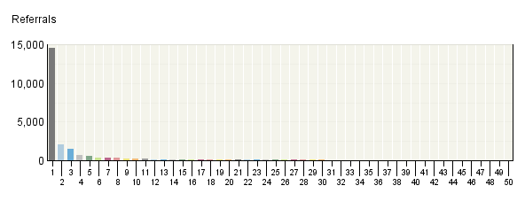

Search Phrases
 | Phrases  Engines | Referrals | % Referrals
1. | solar decathlon | 14,511 | 38.71%
 | Google | 12,220 | 32.60%
 | Yahoo | 529 | 1.41%
 | Google Canada | 465 | 1.24%
 | Google Germany | 262 | 0.70%
 | MSN | 235 | 0.63%
2. | solar decathalon | 2,014 | 5.37%
 | Google | 1,504 | 4.01%
 | Yahoo | 269 | 0.72%
 | MSN | 93 | 0.25%
 | search.live.com | 51 | 0.14%
 | Google Canada | 28 | 0.07%
3. | solar decathlon 2007 | 1,519 | 4.05%
 | Google | 1,270 | 3.39%
 | Yahoo | 93 | 0.25%
 | Google Germany | 43 | 0.11%
 | Google Canada | 36 | 0.10%
 | Google Spain | 16 | 0.04%
4. | solar homes | 653 | 1.74%
 | Google | 369 | 0.98%
 | Yahoo | 217 | 0.58%
 | Google Australia | 13 | 0.03%
 | Google Canada | 12 | 0.03%
 | AOL NetFind | 10 | 0.03%
5. | 2007 solar decathlon | 532 | 1.42%
 | Google | 420 | 1.12%
 | Yahoo | 89 | 0.24%
 | Google Canada | 7 | 0.02%
 | MSN | 7 | 0.02%
 | Google Puerto Rico | 3 | 0.01%
6. | decathlon | 374 | 1.00%
 | Google | 156 | 0.42%
 | Google Poland | 36 | 0.10%
 | Google Germany | 35 | 0.09%
 | Google UK | 22 | 0.06%
 | Google Portugal | 16 | 0.04%
7. | solar houses | 323 | 0.86%
 | Yahoo | 195 | 0.52%
 | Google | 72 | 0.19%
 | MSN | 37 | 0.10%
 | AOL NetFind | 3 | 0.01%
 | Google Australia | 3 | 0.01%
8. | solar decathlon | 287 | 0.77%
 | Google | 232 | 0.62%
 | Yahoo | 13 | 0.03%
 | Google Canada | 10 | 0.03%
 | Google Spain | 5 | 0.01%
 | Google Germany | 4 | 0.01%
9. | `solar decathlon` | 212 | 0.57%
 | Google | 177 | 0.47%
 | Yahoo | 10 | 0.03%
 | Google Canada | 7 | 0.02%
 | Google Germany | 4 | 0.01%
 | Google Brazil | 4 | 0.01%
10. | doe solar decathlon | 191 | 0.51%
 | Google | 171 | 0.46%
 | Yahoo | 7 | 0.02%
 | Google Canada | 4 | 0.01%
 | MSN | 3 | 0.01%
 | Google Spain | 2 | 0.01%
11. | solardecathlon | 190 | 0.51%
 | Google | 130 | 0.35%
 | Google Germany | 20 | 0.05%
 | search.live.com | 9 | 0.02%
 | MSN | 7 | 0.02%
 | Google Spain | 6 | 0.02%
12. | solar decathlon 2005 | 166 | 0.44%
 | Google | 117 | 0.31%
 | Google Spain | 14 | 0.04%
 | Yahoo | 9 | 0.02%
 | Google Germany | 5 | 0.01%
 | Google Brazil | 4 | 0.01%
13. | solar house competition | 140 | 0.37%
 | Google | 122 | 0.33%
 | Yahoo | 10 | 0.03%
 | Google Canada | 2 | 0.01%
 | Google India | 1 | 0.00%
 | Ask Jeeves | 1 | 0.00%
14. | solar powered homes | 122 | 0.33%
 | Yahoo | 77 | 0.21%
 | MSN | 39 | 0.10%
 | search.live.com | 6 | 0.02%
15. | solar house | 118 | 0.31%
 | Yahoo | 88 | 0.23%
 | Google | 20 | 0.05%
 | AltaVista | 2 | 0.01%
 | Ask | 2 | 0.01%
 | Google Romania | 1 | 0.00%
16. | www.solardecathlon.org | 118 | 0.31%
 | Google | 81 | 0.22%
 | Yahoo | 17 | 0.05%
 | Google Germany | 4 | 0.01%
 | MSN | 4 | 0.01%
 | search.live.com | 4 | 0.01%
17. | solardecathlon.org | 111 | 0.30%
 | Google | 75 | 0.20%
 | search.live.com | 12 | 0.03%
 | Yahoo | 11 | 0.03%
 | MSN | 5 | 0.01%
 | AOL NetFind | 3 | 0.01%
18. | 1 | 106 | 0.28%
 | dogpile | 104 | 0.28%
 | Excite | 1 | 0.00%
 | Yahoo Japan | 1 | 0.00%
19. | solar decathlon washington dc | 105 | 0.28%
 | Google | 92 | 0.25%
 | Yahoo | 9 | 0.02%
 | MSN | 1 | 0.00%
 | Google Spain | 1 | 0.00%
 | AOL NetFind | 1 | 0.00%
20. | solar decathalon 2007 | 102 | 0.27%
 | Google | 89 | 0.24%
 | Ask | 4 | 0.01%
 | MSN | 3 | 0.01%
 | Yahoo | 3 | 0.01%
 | search.live.com | 2 | 0.01%
21. | 2005 solar decathlon | 97 | 0.26%
 | Google | 80 | 0.21%
 | Yahoo | 14 | 0.04%
 | Google UK | 1 | 0.00%
 | Google Canada | 1 | 0.00%
 | MSN | 1 | 0.00%
22. | solar decathlon competition | 95 | 0.25%
 | Google | 74 | 0.20%
 | Yahoo | 11 | 0.03%
 | Google Canada | 3 | 0.01%
 | Google France | 2 | 0.01%
 | Google UK | 2 | 0.01%
23. | solar decathlon dc | 89 | 0.24%
 | Google | 86 | 0.23%
 | Yahoo | 2 | 0.01%
 | Google Hong Kong | 1 | 0.00%
24. | solar energy for homes | 80 | 0.21%
 | Yahoo | 60 | 0.16%
 | MSN | 17 | 0.05%
 | Google | 2 | 0.01%
 | Mamma | 1 | 0.00%
25. | solar decathlon house | 69 | 0.18%
 | Google | 63 | 0.17%
 | Google Canada | 2 | 0.01%
 | Yahoo | 2 | 0.01%
 | Google UK | 1 | 0.00%
 | Google Australia | 1 | 0.00%
26. | solar decatholon | 68 | 0.18%
 | Google | 43 | 0.11%
 | Yahoo | 22 | 0.06%
 | Google Australia | 1 | 0.00%
 | Google Canada | 1 | 0.00%
 | AOL NetFind | 1 | 0.00%
27. | decathlon scoring | 67 | 0.18%
 | Google | 37 | 0.10%
 | Yahoo | 16 | 0.04%
 | MSN | 5 | 0.01%
 | Google UK | 3 | 0.01%
 | Ask | 1 | 0.00%
28. | solar hot dog cooker | 66 | 0.18%
 | Yahoo | 27 | 0.07%
 | MSN | 17 | 0.05%
 | Google | 15 | 0.04%
 | search.live.com | 7 | 0.02%
29. | 2007 solar decathalon | 64 | 0.17%
 | Google | 37 | 0.10%
 | search.live.com | 14 | 0.04%
 | Yahoo | 6 | 0.02%
 | MSN | 5 | 0.01%
 | Ask | 1 | 0.00%
30. | energy efficient homes | 59 | 0.16%
 | Yahoo | 20 | 0.05%
 | Google | 20 | 0.05%
 | MSN | 16 | 0.04%
 | MSN United Kingdom | 3 | 0.01%
31. | solar village | 56 | 0.15%
 | Google | 39 | 0.10%
 | Yahoo | 4 | 0.01%
 | Google Romania | 3 | 0.01%
 | Google Germany | 3 | 0.01%
 | Google UK | 3 | 0.01%
32. | solar decathlon washington | 56 | 0.15%
 | Google | 31 | 0.08%
 | Google Canada | 10 | 0.03%
 | Google Germany | 8 | 0.02%
 | Google UK | 2 | 0.01%
 | AltaVista | 1 | 0.00%
33. | department of energy solar decathlon | 53 | 0.14%
 | Google | 48 | 0.13%
 | Google Ireland | 1 | 0.00%
 | Google Canada | 1 | 0.00%
 | Yahoo | 1 | 0.00%
 | CNET Search.com | 1 | 0.00%
34. | solar competition | 50 | 0.13%
 | Google | 38 | 0.10%
 | Yahoo | 4 | 0.01%
 | AOL NetFind | 2 | 0.01%
 | Google Germany | 2 | 0.01%
 | Google Canada | 1 | 0.00%
35. | solar | 49 | 0.13%
 | Google | 25 | 0.07%
 | Yahoo | 16 | 0.04%
 | AOL NetFind | 4 | 0.01%
 | Google Italy | 1 | 0.00%
 | Google UK | 1 | 0.00%
36. | decathlon solar | 48 | 0.13%
 | Google | 23 | 0.06%
 | Google Canada | 5 | 0.01%
 | Google Spain | 3 | 0.01%
 | Google Peru | 3 | 0.01%
 | Google Germany | 2 | 0.01%
37. | decathlon 2007 | 47 | 0.13%
 | Google | 18 | 0.05%
 | Google France | 10 | 0.03%
 | Google Peru | 4 | 0.01%
 | Google UK | 3 | 0.01%
 | Google Chile | 2 | 0.01%
38. | solar energy for kids | 47 | 0.13%
 | Yahoo | 38 | 0.10%
 | MSN | 4 | 0.01%
 | search.live.com | 2 | 0.01%
 | Google | 1 | 0.00%
 | Yahoo UK & Ireland | 1 | 0.00%
39. | pictures of solar homes | 45 | 0.12%
 | Google | 42 | 0.11%
 | Google Canada | 3 | 0.01%
40. | solar decathlon rules | 45 | 0.12%
 | Google | 44 | 0.12%
 | Yahoo | 1 | 0.00%
41. | solar energy homes | 44 | 0.12%
 | Yahoo | 32 | 0.09%
 | MSN | 11 | 0.03%
 | search.live.com | 1 | 0.00%
42. | the solar decathlon | 39 | 0.10%
 | Google | 27 | 0.07%
 | Yahoo | 4 | 0.01%
 | Google Canada | 4 | 0.01%
 | MSN | 1 | 0.00%
 | Google Australia | 1 | 0.00%
43. | solar energy facts | 38 | 0.10%
 | Google | 36 | 0.10%
 | Google Germany | 1 | 0.00%
 | Google UK | 1 | 0.00%
44. | solar decathlon 2007 | 34 | 0.09%
 | Google | 29 | 0.08%
 | Google Germany | 2 | 0.01%
 | Google Portugal | 1 | 0.00%
 | Google Canada | 1 | 0.00%
 | Google Puerto Rico | 1 | 0.00%
45. | solar home competition | 32 | 0.09%
 | Google | 28 | 0.07%
 | Yahoo | 2 | 0.01%
 | Google Canada | 1 | 0.00%
 | search.live.com | 1 | 0.00%
46. | solar powered houses | 30 | 0.08%
 | Yahoo | 13 | 0.03%
 | MSN | 11 | 0.03%
 | Google | 3 | 0.01%
 | search.live.com | 2 | 0.01%
 | AltaVista Australia | 1 | 0.00%
47. | small solar homes | 30 | 0.08%
 | Google | 21 | 0.06%
 | Yahoo | 5 | 0.01%
 | MSN | 2 | 0.01%
 | Google Canada | 2 | 0.01%
48. | solar house contest | 30 | 0.08%
 | Google | 27 | 0.07%
 | Yahoo | 1 | 0.00%
 | MSN | 1 | 0.00%
 | Google Canada | 1 | 0.00%
49. | department of energy`s 2007 solar decathlon | 30 | 0.08%
 | Google | 27 | 0.07%
 | Yahoo | 2 | 0.01%
 | Google Canada | 1 | 0.00%
50. | gallery of homes | 29 | 0.08%
 | Google | 16 | 0.04%
 | Yahoo | 9 | 0.02%
 | AOL NetFind | 1 | 0.00%
 | Google Germany | 1 | 0.00%
 | Google Canada | 1 | 0.00%
 | Subtotal for rows 1–50 | 23,480 | 62.64%
 | Other | 14,006 | 37.36%
 | Total | 37,486 | 100.00%
Items 1–50 of 1,000

Search Phrases - Help Card
Column Definitions

Phrase
The search phrase a visitor used to find your site. "Search term not provided" means that the information was not provided by the search engine, usually because the visitor is using a secure search site.

Engines
The specific search engine being analyzed in conjunction with the phrase in the adjacent column.

Referrals
The number of visits to your site from visitors, who were referred by using the specified search engine and search phrases.

%
Percentage of visitors referred from search engines who used the specified search engine and phrase.

—
Report Descriptions
How are people getting to your site? Use this report to find out if your visitors are using the search phrases you expect. Do you need to use different phrases in page titles to make it easier for people to find your site with search engines?

Search Keywords
This report identifies keywords that led the most visitors to the site and, for each keyword, which search engines led visitors to the site.

Search Keywords
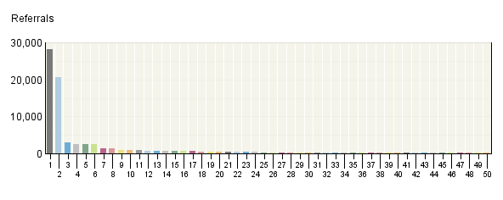

Search Keywords
 | Keywords  Engines | Referrals | % Referrals
1. | solar | 28,237 | 29.23%
 | Google | 21,322 | 22.07%
 | Yahoo | 3,061 | 3.17%
 | MSN | 883 | 0.91%
 | Google Canada | 762 | 0.79%
 | Google Germany | 354 | 0.37%
2. | decathlon | 20,626 | 21.35%
 | Google | 16,860 | 17.45%
 | Yahoo | 976 | 1.01%
 | Google Canada | 618 | 0.64%
 | Google Germany | 383 | 0.40%
 | MSN | 313 | 0.32%
3. | 2007 | 2,981 | 3.09%
 | Google | 2,392 | 2.48%
 | Yahoo | 263 | 0.27%
 | Google Canada | 62 | 0.06%
 | Google Germany | 51 | 0.05%
 | MSN | 32 | 0.03%
4. | decathalon | 2,551 | 2.64%
 | Google | 1,899 | 1.97%
 | Yahoo | 329 | 0.34%
 | MSN | 114 | 0.12%
 | search.live.com | 73 | 0.08%
 | Google Canada | 31 | 0.03%
5. | homes | 2,429 | 2.51%
 | Google | 1,337 | 1.38%
 | Yahoo | 680 | 0.70%
 | MSN | 175 | 0.18%
 | Google Canada | 59 | 0.06%
 | AOL NetFind | 28 | 0.03%
6. | energy | 2,405 | 2.49%
 | Google | 1,160 | 1.20%
 | Yahoo | 610 | 0.63%
 | MSN | 233 | 0.24%
 | Google Australia | 79 | 0.08%
 | Google Canada | 63 | 0.07%
7. | of | 1,303 | 1.35%
 | Google | 904 | 0.94%
 | Yahoo | 172 | 0.18%
 | MSN | 50 | 0.05%
 | Google Canada | 33 | 0.03%
 | Google India | 32 | 0.03%
8. | house | 1,264 | 1.31%
 | Google | 788 | 0.82%
 | Yahoo | 271 | 0.28%
 | MSN | 36 | 0.04%
 | Google Canada | 35 | 0.04%
 | Google India | 18 | 0.02%
9. | washington | 839 | 0.87%
 | Google | 660 | 0.68%
 | Yahoo | 72 | 0.07%
 | Google Canada | 30 | 0.03%
 | MSN | 18 | 0.02%
 | Google Germany | 12 | 0.01%
10. | houses | 828 | 0.86%
 | Yahoo | 364 | 0.38%
 | Google | 249 | 0.26%
 | MSN | 85 | 0.09%
 | Google Australia | 17 | 0.02%
 | Google Canada | 15 | 0.02%
11. | dc | 805 | 0.83%
 | Google | 718 | 0.74%
 | Yahoo | 50 | 0.05%
 | AOL NetFind | 7 | 0.01%
 | MSN | 5 | 0.01%
 | Google Canada | 5 | 0.01%
12. | gallery | 772 | 0.80%
 | Google | 489 | 0.51%
 | Yahoo | 62 | 0.06%
 | Google Canada | 53 | 0.05%
 | Google India | 52 | 0.05%
 | Google UK | 12 | 0.01%
13. | for | 757 | 0.78%
 | Google | 278 | 0.29%
 | Yahoo | 267 | 0.28%
 | MSN | 71 | 0.07%
 | Google Canada | 31 | 0.03%
 | Google Australia | 20 | 0.02%
14. | competition | 752 | 0.78%
 | Google | 598 | 0.62%
 | Yahoo | 85 | 0.09%
 | Google Canada | 19 | 0.02%
 | Google UK | 9 | 0.01%
 | MSN | 7 | 0.01%
15. | home | 640 | 0.66%
 | Google | 388 | 0.40%
 | Yahoo | 129 | 0.13%
 | MSN | 45 | 0.05%
 | Google Canada | 16 | 0.02%
 | search.live.com | 10 | 0.01%
16. | photo | 608 | 0.63%
 | Google | 402 | 0.42%
 | Google India | 47 | 0.05%
 | Google Canada | 42 | 0.04%
 | Yahoo | 40 | 0.04%
 | Google Australia | 6 | 0.01%
17. | in | 574 | 0.59%
 | Google | 329 | 0.34%
 | Yahoo | 134 | 0.14%
 | MSN | 37 | 0.04%
 | Google Canada | 14 | 0.01%
 | search.live.com | 9 | 0.01%
18. | 2005 | 477 | 0.49%
 | Google | 339 | 0.35%
 | Yahoo | 49 | 0.05%
 | Google Spain | 19 | 0.02%
 | Google Brazil | 12 | 0.01%
 | Google Canada | 10 | 0.01%
19. | doe | 467 | 0.48%
 | Google | 394 | 0.41%
 | Yahoo | 21 | 0.02%
 | MSN | 12 | 0.01%
 | Google Canada | 8 | 0.01%
 | Google Australia | 7 | 0.01%
20. | efficient | 392 | 0.41%
 | Google | 217 | 0.22%
 | Yahoo | 79 | 0.08%
 | MSN | 34 | 0.04%
 | Google Australia | 23 | 0.02%
 | Google Canada | 12 | 0.01%
21. | `solar | 390 | 0.40%
 | Google | 299 | 0.31%
 | Yahoo | 35 | 0.04%
 | MSN | 18 | 0.02%
 | Google Canada | 11 | 0.01%
 | Google Germany | 7 | 0.01%
22. | department | 381 | 0.39%
 | Google | 310 | 0.32%
 | Yahoo | 34 | 0.04%
 | MSN | 8 | 0.01%
 | Google Canada | 6 | 0.01%
 | Ask | 4 | 0.00%
23. | photos | 376 | 0.39%
 | Google | 223 | 0.23%
 | Yahoo | 58 | 0.06%
 | Google Canada | 24 | 0.02%
 | MSN | 14 | 0.01%
 | Google India | 12 | 0.01%
24. | kids | 350 | 0.36%
 | Yahoo | 130 | 0.13%
 | Google | 109 | 0.11%
 | MSN | 31 | 0.03%
 | Google Canada | 20 | 0.02%
 | Google Australia | 17 | 0.02%
25. | pictures | 342 | 0.35%
 | Google | 263 | 0.27%
 | Yahoo | 21 | 0.02%
 | Google Canada | 18 | 0.02%
 | AOL NetFind | 10 | 0.01%
 | Google UK | 8 | 0.01%
26. | powered | 342 | 0.35%
 | Yahoo | 163 | 0.17%
 | Google | 82 | 0.08%
 | MSN | 71 | 0.07%
 | search.live.com | 10 | 0.01%
 | Google Canada | 4 | 0.00%
27. | the | 296 | 0.31%
 | Google | 174 | 0.18%
 | Yahoo | 56 | 0.06%
 | MSN | 17 | 0.02%
 | Google Canada | 12 | 0.01%
 | AOL NetFind | 6 | 0.01%
28. | decathlon` | 291 | 0.30%
 | Google | 244 | 0.25%
 | Yahoo | 15 | 0.02%
 | Google Canada | 9 | 0.01%
 | Google Germany | 6 | 0.01%
 | Google Brazil | 4 | 0.00%
29. | mall | 263 | 0.27%
 | Google | 229 | 0.24%
 | Yahoo | 22 | 0.02%
 | search.live.com | 3 | 0.00%
 | MSN | 2 | 0.00%
 | Google South Africa | 2 | 0.00%
30. | university | 262 | 0.27%
 | Google | 147 | 0.15%
 | Yahoo | 52 | 0.05%
 | MSN | 25 | 0.03%
 | search.live.com | 9 | 0.01%
 | AOL NetFind | 4 | 0.00%
31. | and | 257 | 0.27%
 | Google | 158 | 0.16%
 | Yahoo | 44 | 0.05%
 | Google Canada | 13 | 0.01%
 | Google India | 6 | 0.01%
 | MSN | 6 | 0.01%
32. | contest | 242 | 0.25%
 | Google | 176 | 0.18%
 | Yahoo | 30 | 0.03%
 | MSN | 9 | 0.01%
 | Google Canada | 5 | 0.01%
 | AOL NetFind | 3 | 0.00%
33. | design | 236 | 0.24%
 | Google | 134 | 0.14%
 | Yahoo | 47 | 0.05%
 | Google Canada | 12 | 0.01%
 | MSN | 9 | 0.01%
 | Google India | 7 | 0.01%
34. | texas | 222 | 0.23%
 | Google | 116 | 0.12%
 | Yahoo | 80 | 0.08%
 | MSN | 18 | 0.02%
 | search.live.com | 2 | 0.00%
 | Google Netherlands | 1 | 0.00%
35. | solardecathlon | 209 | 0.22%
 | Google | 143 | 0.15%
 | Google Germany | 22 | 0.02%
 | search.live.com | 9 | 0.01%
 | MSN | 8 | 0.01%
 | Google Spain | 7 | 0.01%
36. | dog | 191 | 0.20%
 | Google | 93 | 0.10%
 | Yahoo | 49 | 0.05%
 | MSN | 33 | 0.03%
 | search.live.com | 11 | 0.01%
 | Google Canada | 1 | 0.00%
37. | national | 181 | 0.19%
 | Google | 154 | 0.16%
 | Yahoo | 17 | 0.02%
 | AOL NetFind | 3 | 0.00%
 | Google South Africa | 2 | 0.00%
 | Google France | 1 | 0.00%
38. | kitchen | 181 | 0.19%
 | Google | 132 | 0.14%
 | Google Canada | 21 | 0.02%
 | Yahoo | 6 | 0.01%
 | Google India | 4 | 0.00%
 | Google Australia | 3 | 0.00%
39. | small | 181 | 0.19%
 | Google | 115 | 0.12%
 | Yahoo | 37 | 0.04%
 | Google Canada | 11 | 0.01%
 | MSN | 7 | 0.01%
 | Google India | 5 | 0.01%
40. | hot | 176 | 0.18%
 | Google | 76 | 0.08%
 | Yahoo | 48 | 0.05%
 | MSN | 32 | 0.03%
 | search.live.com | 13 | 0.01%
 | Google Canada | 2 | 0.00%
41. | on | 174 | 0.18%
 | Google | 108 | 0.11%
 | Yahoo | 24 | 0.02%
 | MSN | 11 | 0.01%
 | Google Canada | 7 | 0.01%
 | Google India | 4 | 0.00%
42. | puerto | 167 | 0.17%
 | Google | 65 | 0.07%
 | Yahoo | 31 | 0.03%
 | MSN | 25 | 0.03%
 | Yahoo Spain | 14 | 0.01%
 | search.live.com | 13 | 0.01%
43. | power | 167 | 0.17%
 | Google | 100 | 0.10%
 | Yahoo | 44 | 0.05%
 | MSN | 7 | 0.01%
 | search.live.com | 4 | 0.00%
 | Google UK | 3 | 0.00%
44. | rico | 164 | 0.17%
 | Google | 64 | 0.07%
 | Yahoo | 30 | 0.03%
 | MSN | 25 | 0.03%
 | Yahoo Spain | 14 | 0.01%
 | search.live.com | 12 | 0.01%
45. | cooker | 164 | 0.17%
 | Google | 61 | 0.06%
 | Yahoo | 56 | 0.06%
 | MSN | 30 | 0.03%
 | search.live.com | 12 | 0.01%
 | Google Australia | 2 | 0.00%
46. | renewable | 162 | 0.17%
 | Google | 100 | 0.10%
 | Yahoo | 20 | 0.02%
 | Google UK | 14 | 0.01%
 | Google Australia | 9 | 0.01%
 | AOL NetFind | 4 | 0.00%
47. | plans | 161 | 0.17%
 | Google | 102 | 0.11%
 | Yahoo | 23 | 0.02%
 | MSN | 13 | 0.01%
 | Google Australia | 8 | 0.01%
 | Google Canada | 7 | 0.01%
48. | information | 160 | 0.17%
 | Google | 55 | 0.06%
 | Yahoo | 37 | 0.04%
 | Google Australia | 14 | 0.01%
 | MSN | 14 | 0.01%
 | Google Canada | 9 | 0.01%
49. | colorado | 157 | 0.16%
 | Google | 110 | 0.11%
 | MSN | 18 | 0.02%
 | Yahoo | 18 | 0.02%
 | AOL NetFind | 4 | 0.00%
 | Yahoo UK & Ireland | 1 | 0.00%
50. | florida | 154 | 0.16%
 | Google | 91 | 0.09%
 | Yahoo | 36 | 0.04%
 | MSN | 9 | 0.01%
 | AOL NetFind | 4 | 0.00%
 | Google Canada | 4 | 0.00%
 | Subtotal for rows 1–50 | 76,706 | 79.40%
 | Other | 19,902 | 20.60%
 | Total | 96,608 | 100.00%
Items 1–50 of 530

Search Keywords - Help Card
Column Definitions

Keywords
The specific keywords being analyzed. To see the entire search strings entered by visitors, see the Search Phrases report.

Engines
The specific search engine being analyzed in conjunction with the keyword in the adjacent column.

Referrals
The number of visits from visitors referred to your site with the specified keywords.

%Percentage of referred visitors who used the specified search engine and keyword.

—
Report Descriptions
At the most basic level, this section tells you which search keywords are being used most frequently to find your site. You also may find that some search engines are referring visitors to your site with the words you expect and that other search engines are not.

This report was generated by Webtrends 8, Version: 10.2, Build 263 .
Thursday, December 15, 2011 3:38:43 PM
Final report conversion by WebTrends Report Exporter, Version 9.5 (build 1056)
Copyright (C) 1996-2009 Webtrends Inc. All rights reserved.

